MySQL Activity Joins Problems
Database: Cuysona_Jhayem
PART I: Database Tables
Table 1: Appointments
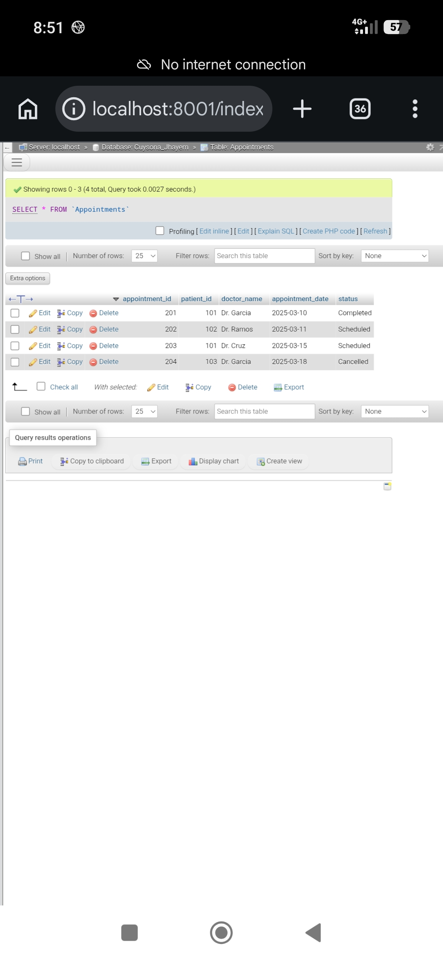
Table 2: Patients
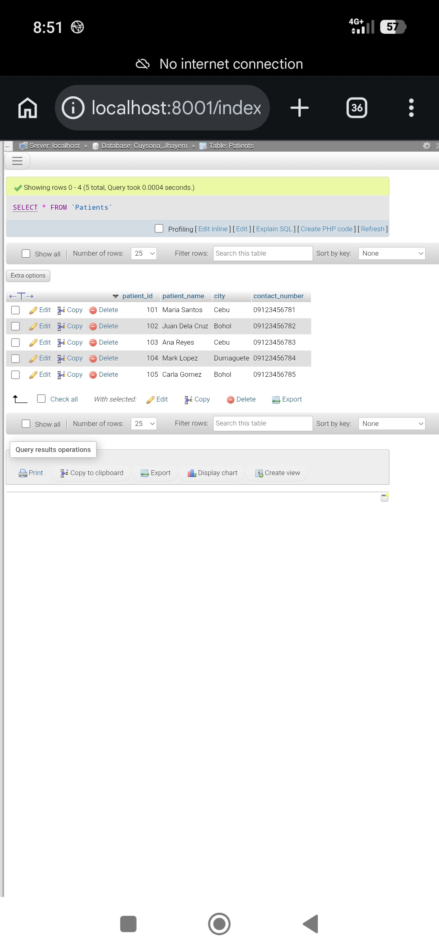
PART II: SQL Query Results
Part A & B: INNER JOIN Queries
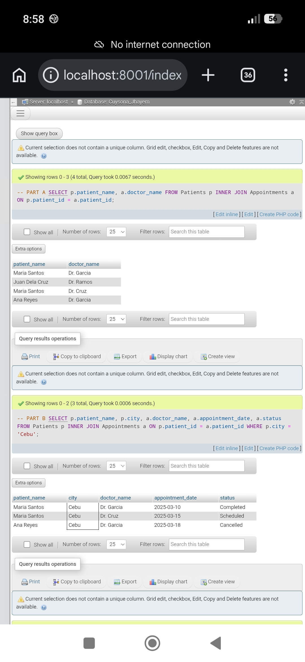
Part C: LEFT JOIN & RIGHT JOIN Queries (Part 1)
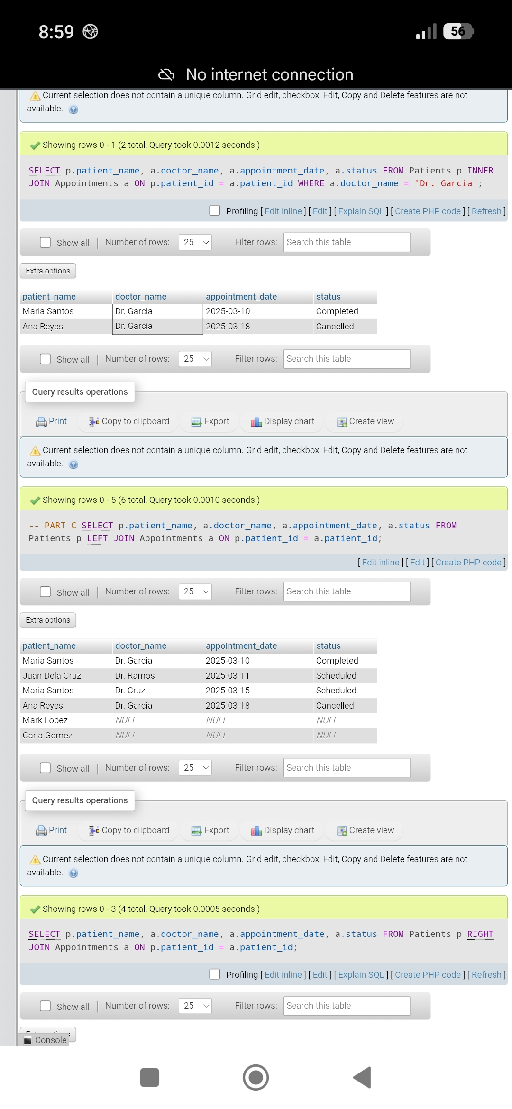
Part C: LEFT JOIN & RIGHT JOIN Queries (Part 2)
