Explanation



*Figure: [0-9]+, one or more digit between [0-9]*

The pattern [0-9]+ is a regular expression (regex) pattern used in Flex to match numeric sequences. Let’s break it down:

#### Pattern Breakdown: [0-9]+

1. [0-9] → This defines a character class that matches any single digit from 0 to 9. In other words, it will match one occurrence of any of these digits: {0,1,2,3,4,5,6,7,8,9}.
2. + → This is a quantifier that means "one or more occurrences" of the preceding character class ([0-9]).
3. Together [0-9]+ means:
   * Match a sequence of one or more consecutive digits.
   * It will match numbers like 0, 23, 789, 10000, etc.
   * It will not match words like "Machine",”Blue”, or "a566K", because those contain non-digit characters.

#### ++no_of_numbers;

* This increments the no_of_numbers variable.
* This variable keeps track of how many numerical sequences (numbers) have been detected so far.

#### printf("Número detectado: %s\n", yytext);

* The function printf() prints the detected number to the console.
* yytext is a special variable in Flex that holds the current matched text.
* Since [0-9]+ matches numbers, yytext will contain the exact number found in the input.

Example:

The input that we are going to test is the following: 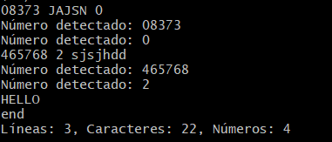

The output would be:



After seeing the output we are able to identify that our pattern was implemented in a correct way, we have 4 numbers detected, three lines and a total of 22 characters.