ELECTRICAL SCHEMATIC

Orascan System

System Overview

This document presents the final corrected electrical schematic for the Oral Image Capture System, showing the proper power distribution and signal connections between all components. The system uses a Suswe 12V 6A

ACDC switching power supply to power a Waveshare Stepper Motor HAT (B), which contains integrated HR8825 stepper motor drivers and an onboard 5V regulator that powers the Raspberry Pi 5.

Electrical Schematic Diagram

The following electrical schematic shows the complete system connections with proper power flow and signal routing:

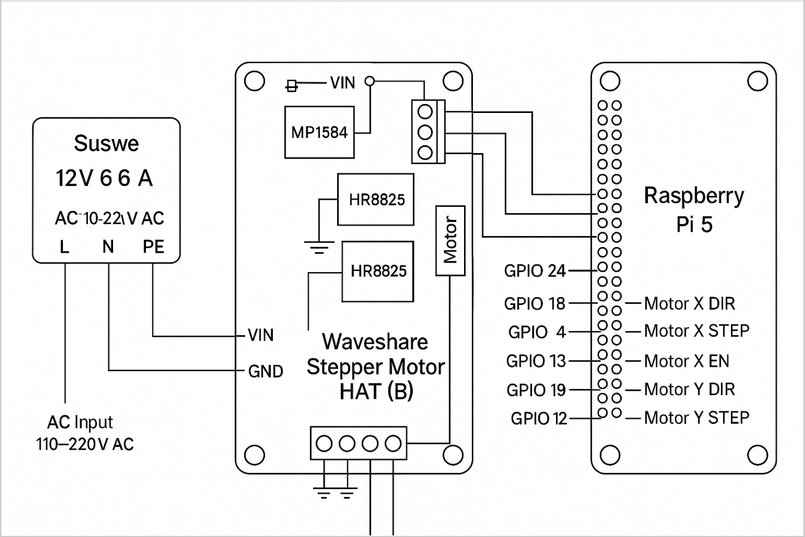

Power Flow Architecture

The power distribution follows this hierarchy:
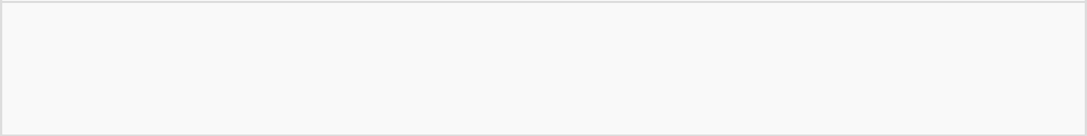
AC Mains (110220V) → Suswe 12V 6A SMPS → 12V DC Output ↓ Stepper Motor HAT VIN Terminal ↓ 12V Rail
HR8825 Drivers → NEMA 17 Motors │
MP1584 5V Regulator → Raspberry Pi 5V ↓ Pi GPIO 5V → Servo Motors

Component Connections

Power Supply Connections

Component | Connection Point |  | Wire/Terminal | Voltage/Current
AC Mains | Suswe SMPS Input | L, N, PE terminals |  | 110220V AC
Suswe SMPS Output | Stepper HAT VIN | +12V, GND screw terminals |  | 12V DC, 6A max
HAT 5V Regulator | Raspberry Pi | GPIO Pins 2, |  | 5V DC, 3A max
HAT Ground | Raspberry Pi | GPIO Pins 6, |  | Ground reference

Raspberry Pi 5 GPIO Connections

GPIO Pin | Physical Pin | Connection | Signal Type | Function
GPIO 24 | Pin 18 | HAT Motor X DIR | Digital Output | Xaxis direction control
GPIO 18 | Pin 12 | HAT Motor X STEP | Digital Output | Xaxis step pulses
GPIO 5 | Pin 16 | HAT Motor X EN | Digital Output | Xaxis enable/disable
GPIO 13 | Pin 33 | HAT Motor Y DIR | Digital Output | Yaxis direction control
GPIO 19 | Pin 35 | HAT Motor Y STEP | Digital Output | Yaxis step pulses
GPIO 12 | Pin 32 | HAT Motor Y EN | Digital Output | Yaxis enable/disable
GPIO 27 | Pin 13 | Pan Servo Signal | PWM Output | Pan servo control
GPIO 17 | Pin 11 | Tilt Servo Signal | PWM Output | Tilt servo control
5V | Pin 2 | Servo VCC | Power Output | Servo motor power
GND | Pin 6 | Servo GND | Ground | Servo ground reference

Stepper Motor HAT Connections

HAT Terminal | Motor Connection | Wire Color | Function
A1 | Motor X Phase A+ | Red | Xmotor coil A positive
A2 | Motor X Phase A | Green | Xmotor coil A negative
B1 | Motor X Phase B+ | Blue | Xmotor coil B positive
B2 | Motor X Phase B | Black | Xmotor coil B negative
A3 | Motor Y Phase A+ | Red | Ymotor coil A positive
A4 | Motor Y Phase A | Green | Ymotor coil A negative
B3 | Motor Y Phase B+ | Blue | Ymotor coil B positive
B4 | Motor Y Phase B | Black | Ymotor coil B negative

Servo Motor Connections

Servo Motor | Wire Color |  | Pi Connection | Function
Pan Servo (MG90S) | Red | GPIO Pin 2 | (5V) | Power supply
 | Brown/Black | GPIO Pin 6 | (GND) | Ground reference
 | Orange | GPIO 27 (Pin 13) |  | PWM control signal
Tilt Servo (MG90S) | Red | GPIO Pin 2 | (5V) | Power supply
 | Brown/Black | GPIO Pin 6 | (GND) | Ground reference
 | Orange | GPIO 17 (Pin 11) |  | PWM control signal

Component Specifications

Waveshare Stepper Motor HAT (B)

NEMA 17 Stepper Motors

- Steps per Revolution: 200 (1.8° per step)

- Rated Current: 2A per phase

- Holding Torque: 0.48 0.83 Nm (depending on stack)

- Winding Resistance: 1.04 1.49 Ω

- Winding Inductance: 2.2 3.8 mH

- Operating Temperature: 20°C to +40°C

- Connection: 4wire bipolar configuration

MG90S Servo Motors

- Operating Voltage: 4.8V 6V

- Operating Current: 220mA (no load), 650mA (stall)

- Stall Torque: 1.8 kg/cm (4.8V), 2.2 kg/cm (6V)

- Operating Speed: 0.1s/60° (4.8V), 0.08s/60° (6V)

- Rotation Range: 180° (±90°)

- Pulse Width Range: 1ms 2ms

- Control Signal: PWM (50Hz frequency)

10.1" Capacitive Touch Display

- Resolution: 1280 × 800 pixels

- Display Technology: IPS LCD

- Touch Technology: Capacitive (up to 10 points)

- Video Interface: HDMI

- Touch Interface: USB TypeC

- Power: Via USB connection or external adapter

- Viewing Angle: 178° (horizontal and vertical)

Power Budget Analysis

Component | Voltage | Current | Power | Notes
Raspberry Pi 5 | 5V | 3A max | 15W | Powered by HAT regulator
NEMA 17 Motors (2×) | 12V | 2A each | 48W total | Direct from 12V rail
MG90S Servos (2×) | 5V | 1.3A total | 6.5W | From Pi 5V pins
Touch Display | 5V | 2A max | 10W | Via USB connection
Total System Power |  |  | 79.5W | Within 72W SMPS capacity


Important Power Considerations: The total calculated power (79.5W) exceeds the SMPS capacity (72W). In practice, not all components operate at maximum power simultaneously. Monitor actual

power consumption and consider upgrading to a higher capacity SMPS if needed.

GAS sensor

Pin of Sensor | Connection to Raspberry pi
Tx | GPIO15 rx
Rx | GPIO14 tx
Vs | Vcc / 5v
G | Gnd

Assembly Instructions

Step 1: Power Supply Installation

Install the Suswe 12V 6A SMPS in a suitable enclosure with proper ventilation. Connect AC mains to

the input terminals (L, N, PE) following local electrical codes and safety regulations.

Step 2: HAT Installation

Mount the Waveshare Stepper Motor HAT (B) directly onto the Raspberry Pi 5's 40pin GPIO header.

Ensure proper alignment and secure connection. The HAT will provide power to the Pi through the GPIO pins.

Step 3: SMPS to HAT Connection

Connect the 12V output from the Suswe SMPS to the HAT's VIN terminal using appropriate gauge wire

(1416 AWG for 6A capacity). Ensure proper polarity: positive to VIN, negative to GND.

Step 4: Stepper Motor Connections

Connect the NEMA 17 stepper motors to the HAT's motor terminal blocks according to the motor wire

colors and phase assignments shown in the connection table above.

Step 5: Servo Motor Connections

Connect the MG90S servo motors directly to the Raspberry Pi GPIO pins as specified. Use dupont

jumper wires or solder connections for reliable contact.

Step 6: Display Connection

Connect the 10.1" touch display to the Raspberry Pi using the provided HDMI cable for video and USB

cable for touch functionality.

Step 7: Gas sensor Connection

Connect the Gas sensor as per the instruction . and pin diagram
.

Step 8: Mic Connection

Connect the MIcrophone as per the available port .

Safety and Protection

The system includes several protection mechanisms:

- SMPS internal protection: Overvoltage, overcurrent, and short circuit protection

- HAT protection: HR8825 drivers include thermal shutdown and overcurrent protection

- GPIO protection: Pi GPIO pins are protected through the HAT interface

- Ground isolation: All components share a common ground reference


Safety Warning: Always disconnect AC power before making any connections. Ensure proper grounding of all components. Never exceed the current ratings of any component.

Troubleshooting

Common issues and solutions:

- Pi not powering on: Check 12V supply to HAT and HAT power switch position

- Stepper motors not moving: Verify GPIO connections and motor wiring phases

- Servos not responding: Check 5V power availability and PWM signal connections

- Display not working: Verify HDMI and USB connections, check display power

Schematic explanation of components

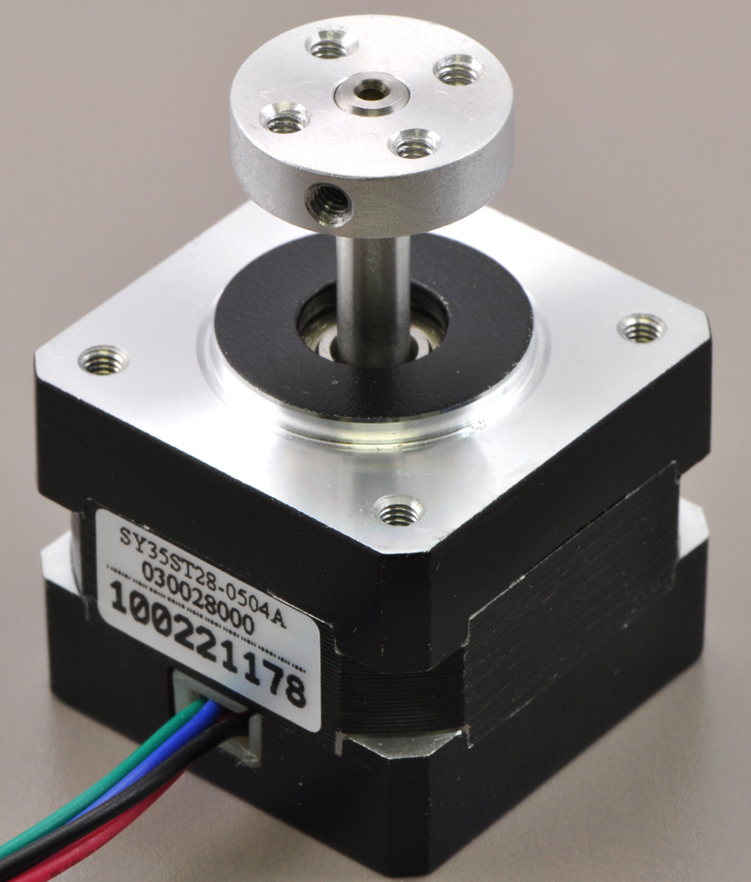
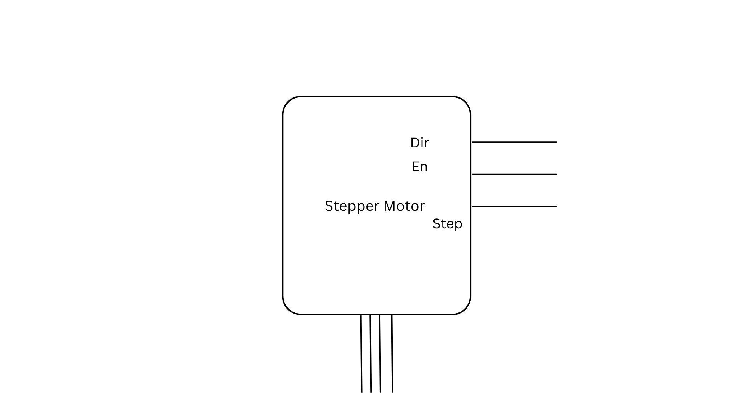

Stepper Motor
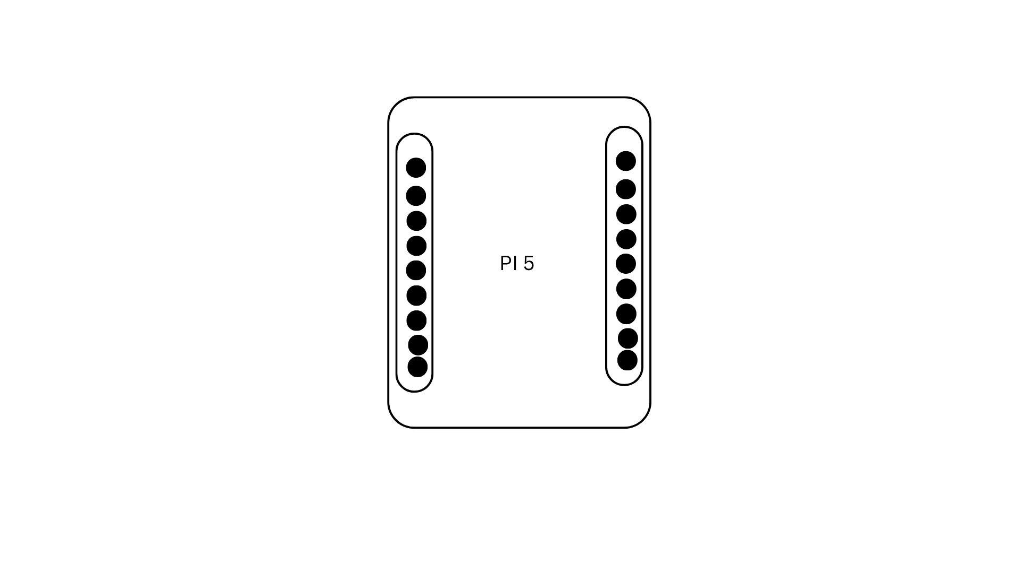
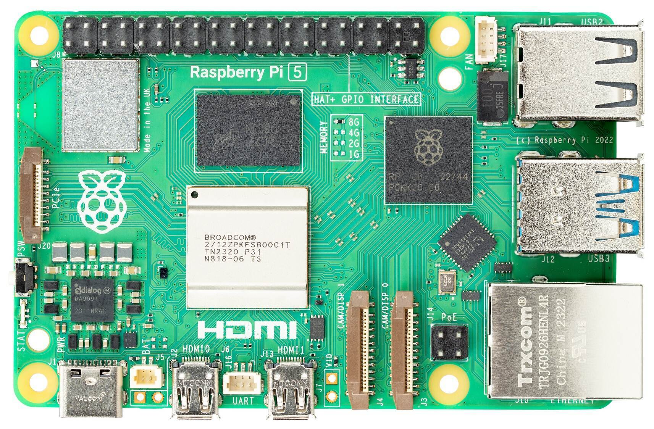

Pi5
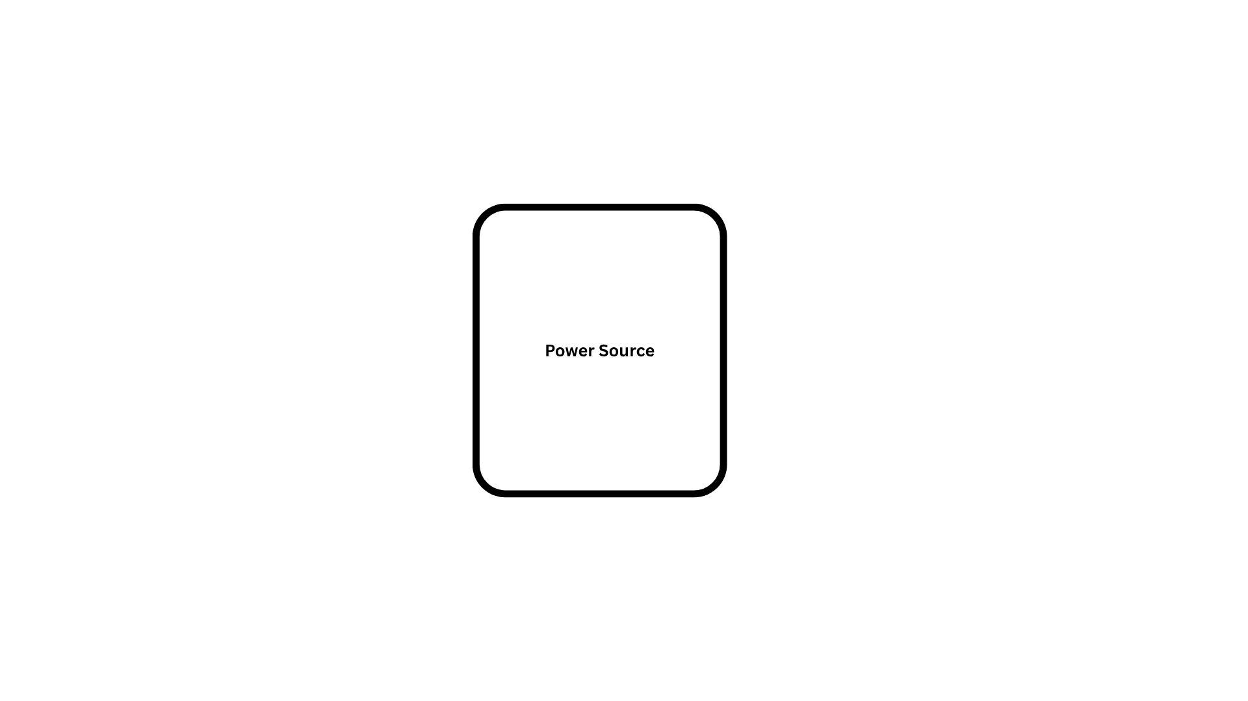
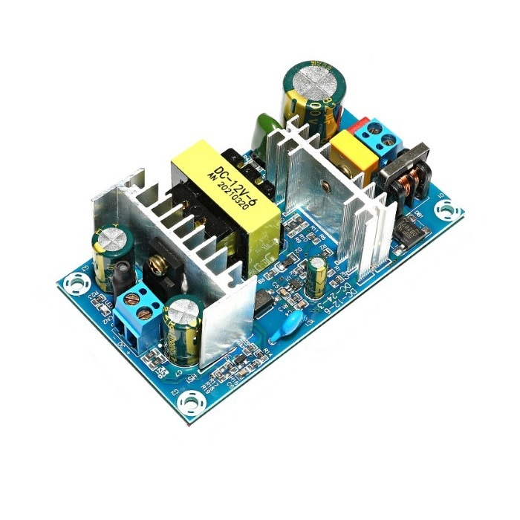

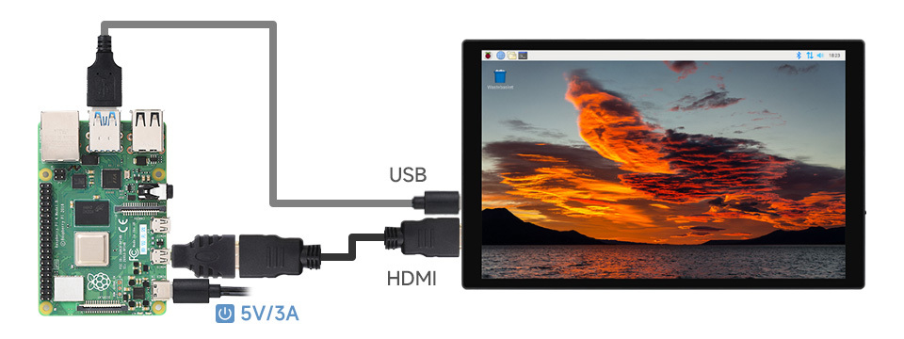
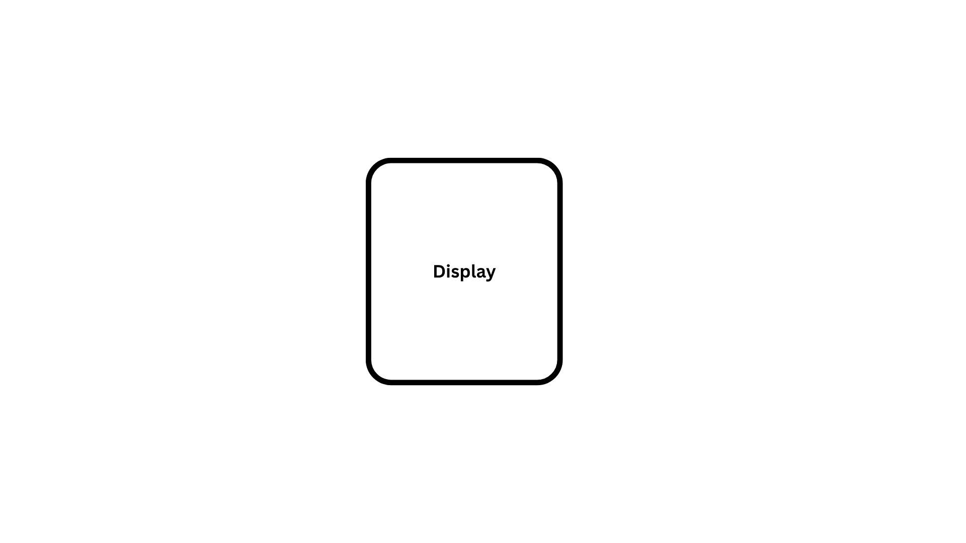
Power supply SMPS 12v 6 A

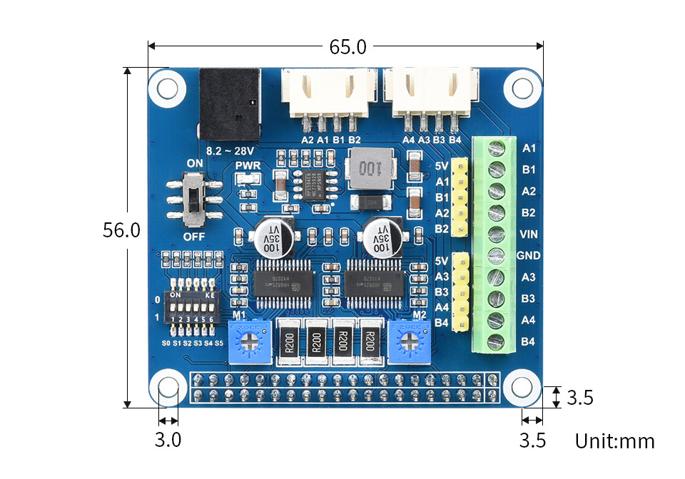
Display

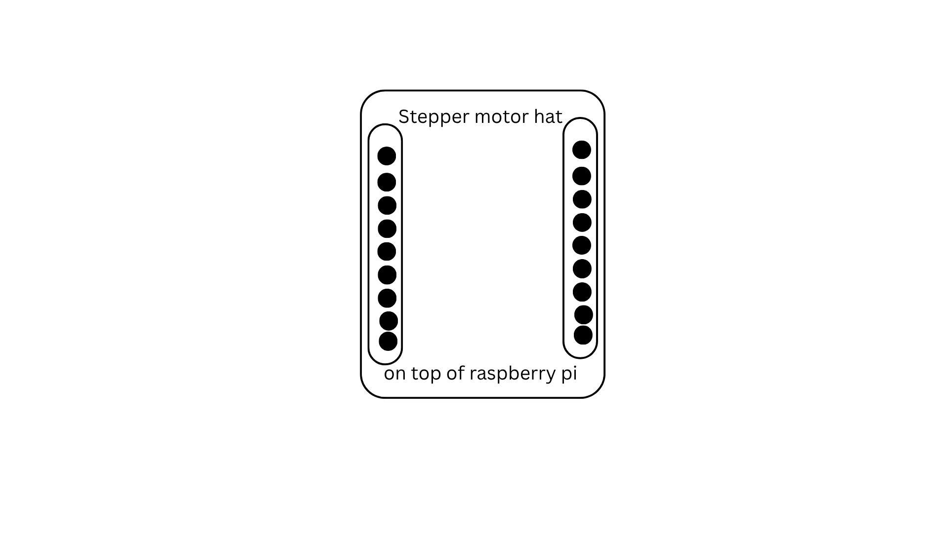

Stepper motor Hat HR8825

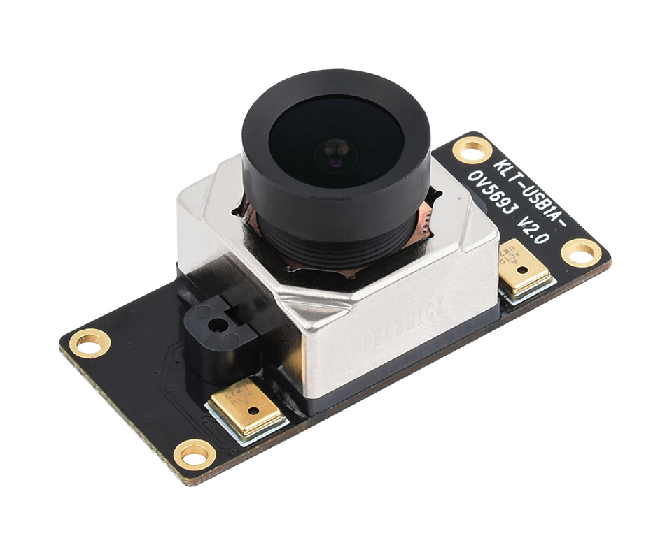

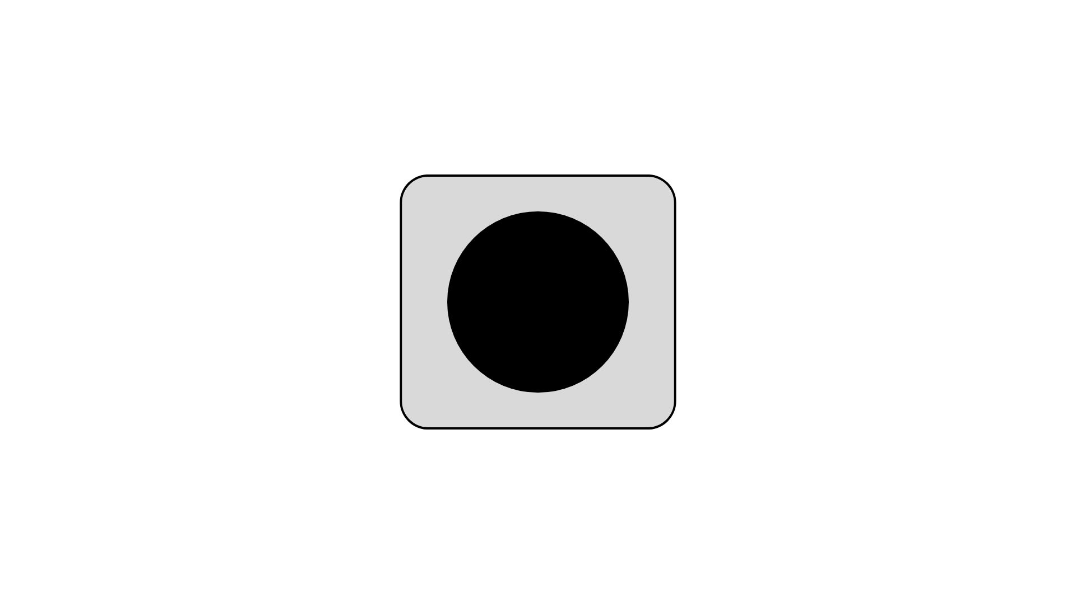

Camera module

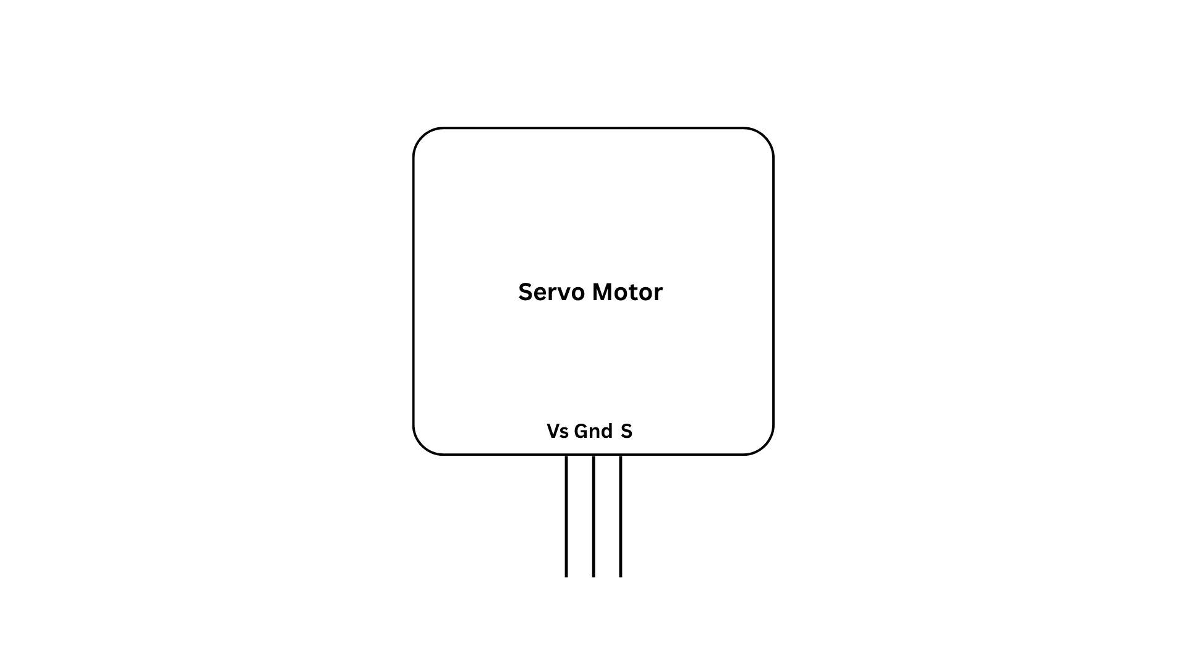

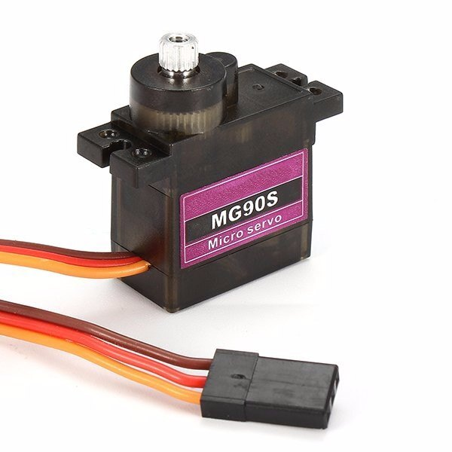
Servo motor

Wiring Diagram
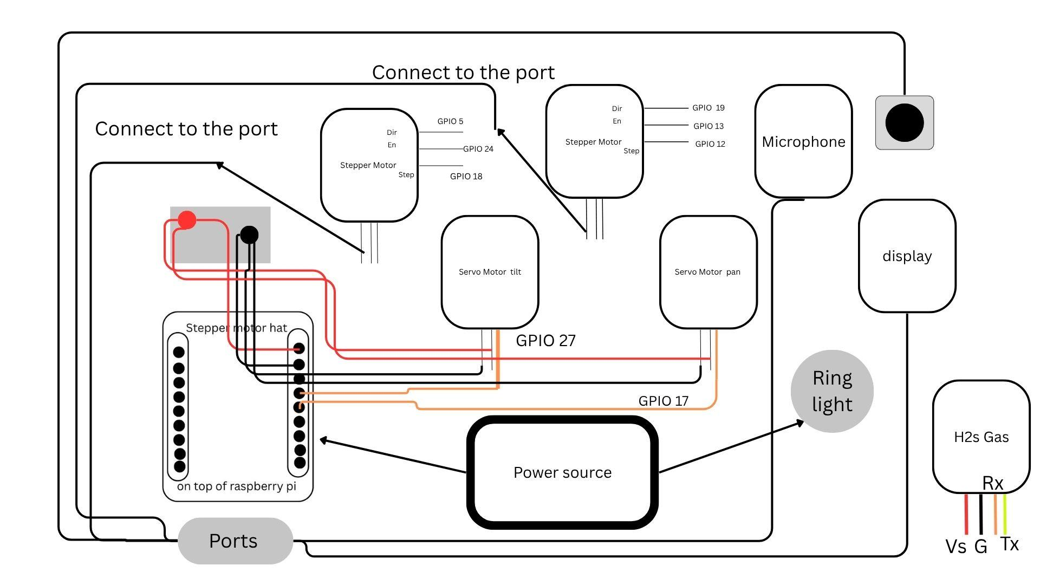

How to operate Orascan ?

Orascan Usage Guide

Based on the schematics and manual provided, here's a comprehensive guide on how to use the Orascan oral image capture system:

System Overview
- Orascan is an oral imaging system that combines:
- Raspberry Pi 5 as the control unit
- Stepper motors for precise movement (NEMA 17)
- Servo motors for positioning (MO508S)
- 12.1" capacitive touch display
- Camera module for image capture
- Additional sensors (gas sensor, microphone)

Setup Instructions

1. Hardware Assembly
Follow these steps to assemble the system:

1. Power Supply Installation
- Install the 12V 6A SMPS in a ventilated enclosure
- Connect AC mains to L, N, PE terminals following local regulations

2. HAT Installation
- Mount the Waveshare Stepper Motor HAT onto Raspberry Pi 5's GPIO header
- Ensure proper alignment and secure connection

3. Power Connections
- Connect SMPS 12V output to HAT's VIN terminal (positive to VIN, negative to GND)
- Use 1416 AWG wires for 6A capacity

4. Motor Connections
- Connect NEMA 17 stepper motors to HAT terminals according to wire colors:
- X Motor: A+ (Red), A (Green), B+ (Red), B (Black)
- Y Motor: A+ (Red), A (Green), B+ (Red), B (Black)
- Connect servo motors to specified GPIO pins:
- Power (Red) to 5V
- Ground (Black/Brown) to GND
- Signal (Orange/Yellow) to PWM GPIO pins

5. Display Connection
- Connect via HDMI for video
- Connect via USB for touch functionality

6. Sensor Connections
- Gas sensor to GPIO14
- Microphone to available audio input port

2. Power Considerations
- The system has a calculated maximum power draw of 73.8W
- SMPS capacity is 72W
- Monitor power consumption during operation
- Consider upgrading to higher capacity SMPS if experiencing power issues

Operating the System

1. Power On Sequence
1. Ensure all connections are secure
2. Power on the SMPS
3. Raspberry Pi should boot automatically (powered through HAT)
4. Display should show the Orascan interface for registration

5. Using the Touch Interface
- Insert you information
- Login through the same information
- Open Submit data
- And click on submit image data
6. Motor Control
- The system uses stepper motors for precise movement in manual mode doctor will handle the moment and in automated it handles automatically
- Servo motors handle positioning adjustments there are 13 of those position , and 13 set instruction to follow
- All motor controls can be accessible through the touch interface case of manually controlled
7. Image Capture
- Use the interface to position the camera
- Capture and review images
- Save or export as needed and can be exported in pdf , to email as preferred
8. Audio Capture
- Uses microphone to collect audio
- Record 10-12 sec
- Saved to patient id
9. Breath (gas h2s) data
- Saved the concentration of h2s data
- Taken average of 12 data’s and save the result in database.

Safety Precautions
1. Always disconnect AC power before making connections
2. Ensure proper grounding of all components
3. Never exceed component current ratings
4. Monitor system temperature during operation
5. Follow all local electrical safety regulations

Troubleshooting

Common Issues and Solutions:
1. Pi not powering on
- Check 12V supply to HAT
- Verify HAT power switch position
- Check GPIO header connection

2. Stepper motors not moving
- Verify GPIO connections
- Check motor wiring phases
- Confirm power to HAT

3. Servos not responding
- Check 5V power availability
- Verify PWM signal connections
- Confirm servo limits in software

4. Display issues
- Check HDMI and USB connections
- Verify display power
- Confirm display settings in Raspberry Pi config

Maintenance
1. Regularly check all electrical connections
2. Keep the system clean and dustfree
3. Monitor component temperatures during use
4. Periodically verify motor performance
5. Check for software updates

Technical Specifications

Key Components:
1. Raspberry Pi 5
- Primary control unit
- Powered through HAT's 5V regulator

2. NEMA 17 Stepper Motors
- 200 steps/revolution (1.8° per step)
- 2A per phase current
- 0.480.53 Nm holding torque

3. MO508S Servo Motors
- 4.8V6V operating voltage
- 1.82.2 kg/cm stall torque
- 105° rotation range
- PWM control (50Hz)

4. 12.1" Capacitive Touch Display
- 1280×800 resolution
- 10point multitouch
- HDMI/USB connectivity

5. H2S Gas Sensor

- Connected to GPIO14 and 15
- Detects hydrogen sulfide concentrations
- Typical use: Oral environment monitoring
- Output: Digital (1x) and analog (8x) via GPIO

6. Microphone

- Connected to USB input port
- Used for audio feedback
- Verify compatibility with Raspberry Pi's audio subsystem

