MAT 303 Module Five Problem Set Report

Logistic Regression

Christopher Brugnoli
Christopher.Brugnoli@snhu.edu
Southern New Hampshire University

1. Introduction

Discuss the statement of the problem regarding the statistical analyses that are being performed. Address the following questions in your analysis:

It's historical data that can be used to study the relationships between customer characteristics and whether they are likely to default on their credit. This is used for risk analysts working for a credit card company. A logistic regression model in R. Some variables in the set are age, sex, education, marriage, assets, missed payment, credit utilize and default.

2. Data Preparation
The important variables in the data set that will be used in the models are education, credit utilization, assets, and missed payment and whether they have defaulted on their credit line.
There are 8 columns and 6 rows in the data set.

3. First Logistic Regression Model

Reporting Results
The general form equation of a logistic regression model for defaulting on credit, using credit utilization and education as independent variables is:
$$E\left(Y\right)=\frac{e^{\left(β_{0}+β_{1}X_{1}+β_{2}X_{2}β_{3}X_{3}\right)}}{1+e^{\left(β_{0}+β_{1}X_{1}+β_{2}X_{2}β_{3}X_{3}\right)}}$$
Y is 1 for defaulting on credit and 0 for not defaulting on credit. X1 is credit utilization. X2 is education

The equation transformed to form a model that is linear in the beta terms is:

$$\ln\left(\frac{π}{1-π}\right)=β_{0}+β_{1}X_{1}+β_{2}X_{2}+β_{3}X_{3}$$
The left side of the equation above is the natural log of odds, so this can be written as:
$$\ln\left(odds\right)=β_{0}+β_{1}X_{1}+β_{2}X_{2}+β_{3}β_{3}$$

Where ‘odds’ is the odds of defaulting on the credit line (default = 1).$π$ is the probability of an event happening, in this case defaulting on the credit line. $\frac{π}{1-π}$ is the ratio of the probability of an event happening, where $π$ is the probability of it happening.
The equation for this logistic regression model is:
$$E\left(Y\right)=\frac{e\left(-8.8488+34.3869X_{1}-1.4975X_{2}-4.2540X_{3}\right)}{1+{e(-8.8488+34.3869X_{1}-1.4975X_{2}-4.2540X_{3}}^{)}}$$

The equation for this model in terms of natural log of odds is:

$$\ln\left(odds\right)=-8.8488+34.3869X_{1}-1.4975X_{2}-4.2540X_{3}$$

The estimated coefficient of credit utilization is $34.3869$. This means that on average, the change in log odds for defaulting is 0.343869 for each percentage increase in credit utilization, holding all other variables constant. This is found by dividing the coefficient of credit utilization by 100 because credit utilization is expressed as a percentage.

An alternative way to express this is in terms of odds (and not log odds), would be to calculate:

$e^{\left(0.343869\right)}-1=$0.4104
The odds of defaulting increase by 41.04% for each percentage increase in credit utilization, holding all other variables constant. Again, the figure 0.343869 is found by dividing 34.3869 by 100 because credit utilization is expressed as a percentage. The figure 41.04% is obtained by multiplying the decimal value (0.31582) by 100, to turn the decimal into a percentage.

The general form table output of a confusion matrix is:

Prediction = 0 Prediction = 1
Actual = 0 True Negatives False Positives
Actual = 1 False Negatives True Positives

The output of the confusion matrix for this model is:

Prediction: default = 0 Prediction: default = 1
Actual : default= 0 254 22
Actual: default = 1 21 303

The confusion matrix results are:
- True positives: 303
- True negatives: 254
- False positives: 22
- False negatives: 21
- True Positive (TP): The actual value is 1 (default = 1) and the predicted value is 1 (default = 1). Hence a true positive.
- True Negative (TN): The actual value is 0 (default = 0) and the predicted value is 0 (default = 0). Hence a true negative.
- False Positive (FP): The actual value is 0 (default = 0) and the predicted value is 1 (default = 1). Hence a false positive. This is also a Type 1 Error.
- False Negative (FN): The actual value is 1 (default = 1) and the predicted value is 0 (default = 0). Hence a false negative. This is also a Type 2 Error.
Accuracy is the ratio of the number of correct predictions to the total number of observations.

$$Accuracy=\frac{TP+TN}{TP+TN+FP+FN}$$

$$Accuracy=\frac{303+254}{303+254+22+21}$$

$Accuracy=$0.9283 or 92.83%

Precision is the ratio of correct positive predictions to the total predicted positives.

$$Precision=\frac{TP}{TP+FP}$$

$$Precision=\frac{303}{303+22}$$

$$Precision=0.9323 or 93.23\%$$

Recall is the ratio of correct positive predictions to the total positives examples.

$$Recall=\frac{TP}{TP+FN}$$

$$Recall=\frac{303}{303+21}$$

$$Recall=0.9351 or 93.51\%$$

Evaluating Model Significance
The Hosmer-Lemeshow goodness of fit (GOF) test assesses whether the model predictions are close to the observed values of Y, which are either 0 or 1. In this model it is used to assess if the model fits the data or not.

The null and alternative hypotheses are:

$$H_{0} :The model fits the data$$

$$H_{a} :The model does not fit the data$$
The test statistic ($X^{2})$ is 31.582. The P-value is 0.9588. The level of significance is 5%. The P-value of 0.9588 is higher than the level of significance of 0.05. Therefore, the null hypothesis should not be rejected. The conclusion is that the model is appropriate for the data set. The p-value of education 2 is 0.00134 and education 3 9.72e-13. Both are below 0.05, making them statistically significant.

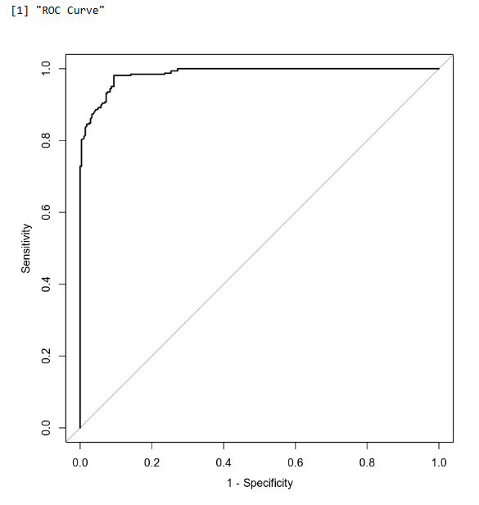
The area under the curve (AUC) is 0.9859 This is an indicator of how well the model distinguishes between Y = 0 and Y = 1. In general, the larger the AUC the better, because the larger the area under the curve, the better it is at predicting binary classes.

Making Predictions Using Model

The probability of an individual defaulting on credit who has a credit utilization of 35% and has high school education is 0.9603 or 96%. This means that an individual with a credit utilization of 35% and has a high school education has a 96% chance of defaulting on their credit line. The probability of an individual defaulting on credit who has a credit utilization of 35% and has post graduate education is 0.2559 or 25.59 %. This means that an individual with a credit utilization of 35% and has a post grade school education has a 25.59% chance of defaulting on their credit line.

4. Second Logistic Regression Model

Reporting Results
The general form equation of a logistic regression model for defaulting on credit, using credit utilization, assets and missed payment as independent variables is:

$$E\left(Y\right)=\frac{e^{(β_{0}+β_{1}X_{1}+β_{2}X_{2}+β_{3}X_{3}+β_{4}X_{4}+β_{5}X_{5})}}{1+e^{(β_{0}+β_{1}X_{1}+β_{2}X_{2}+β_{3}X_{3}+β_{4}X_{4}+β_{5}X_{5})}}$$

Y is 1 for defaulting on credit and 0 for not defaulting on credit. $X_{1}$ is the variable for credit utilization. $X_{2}, X_{3} and X_{4}$ are the dummy variables for car, house, and car + house. $X_{5}$ missed payments.

The equation transformed to form a model that is linear in the beta terms is:

$$\ln\left(\frac{π}{1-π}\right)=β_{0}+β_{1}X_{1}+β_{2}X_{2}+β_{4}X_{4}+β_{5}X_{5}$$
The left side of the equation above is the natural log of odds, so this can be written as
$$\ln\left(odds\right)=β_{0}+β_{1}X_{1}+β_{2}X_{2}+β_{4}X_{4}+β_{5}X_{5}$$
Where ‘odds’ is the odds of defaulting on the credit line (default = 1).
The equation for this logistic regression model is:

$$E\left(Y\right)=\frac{e^{(-9.2371+32.2826X_{1}-0.4827x2-3.0334X_{3}-3.4568X_{4}-1.4276x5)}}{1+e^{(-9.2371+32.2826X_{1}-0.4827x2-3.0334X_{3}-3.4568X_{4}-1.4276x5)}}$$
The equation for this model in terms of natural log of odds is:

$$\ln\left(odds\right)=-9.2371+32.2826X_{1}-0.4827x2-3.0334X_{3}-3.4568X_{4}-1.4276x5$$
The estimated coefficient of credit utilization is 32.2826. This means that on average, the change in log odds for defaulting is 0.322826 for each percentage increase in credit utilization, holding all other variables constant. This is found by dividing the coefficient of credit utilization by 100 because credit utilization is expressed as a percentage.

An alternative way to express this is in terms of odds (and not log odds), would be to calculate:

$$e^{(0.322826)}-1=0477174$$
The odds of defaulting increase by 47.7% for each percentage increase in credit utilization, holding all other variables constant. Again, the figure 0.$322826$ is found by dividing $32.2826\%$ by 100 because credit utilization is expressed as a percentage. The figure 43.79% is obtained by multiplying the decimal value (0.4379) by 100, to turn the decimal into a percentage.

Prediction = 0 Prediction = 1
Actual = 0 True Negatives False Positives
Actual = 1 False Negatives True Positives

The output of the confusion matrix for this model is:

Prediction: default = 0 Prediction: default = 1
Actual : default= 0 262 14
Actual: default = 1 21 303

The confusion matrix results are:
- True positives: 303
- True negatives: 262
- False positives: 14
- False negatives: 21
- True Positive (TP): The actual value is 1 (default = 1) and the predicted value is 1 (default = 1). Hence a true positive.
- True Negative (TN): The actual value is 0 (default = 0) and the predicted value is 0 (default = 0). Hence a true negative.
- False Positive (FP): The actual value is 0 (default = 0) and the predicted value is 1 (default = 1). Hence a false positive. This is also a Type 1 Error.
- False Negative (FN): The actual value is 1 (default = 1) and the predicted value is 0 (default = 0). Hence a false negative. This is also a Type 2 Error.

Accuracy is the ratio of the number of correct predictions to the total number of observations.

$$Accuracy=\frac{TP+TN}{TP+TN+FP+FN}$$

$$Accuracy=\frac{303+262}{303+262+14+21}$$

$$Accuracy=0.9416 or 94.16\%$$

565
Precision is the ratio of correct positive predictions to the total predicted positives.

$$Precision=\frac{TP}{TP+FP}$$

$$Precision=\frac{303}{303+14}$$

$$Precision=0.9558 or 95.58\%$$

Recall is the ratio of correct positive predictions to the total positives examples.

$$Recall=\frac{TP}{TP+FN}$$

$$Recall=\frac{303}{303+21}$$

$$Recall= 0.93518or 93.51 \%$$

Evaluating Model Significance
The Hosmer-Lemeshow goodness of fit (GOF) test assesses whether the model predictions are close to the observed values of Y, which are either 0 or 1. In this model it is used to assess if the model fits the data or not.

The null and alternative hypotheses are:

$$H_{0} :The model fits the data$$

$$H_{a} :The model does not fit the data$$

The test statistic ($X^{2})$ is 26.733 . The P-value is 0.9924. The level of significance is 5%. The P-value of 0.9924 is higher than the level of significance of 0.05. Thus the null hypothesis should not be rejected. The conclusion is that the model is appropriate for the data set. The P-value for assets=car owned is 0.33. The P-value for assets=house owned 5.05e-07. The P-value for assets=car + house owned is 2.61e-09 . The P-value for missed payments = payments behind is 0.000549. The P-value for credit utilized = 6.51e16 . All but assets being only a car are statistically significant.

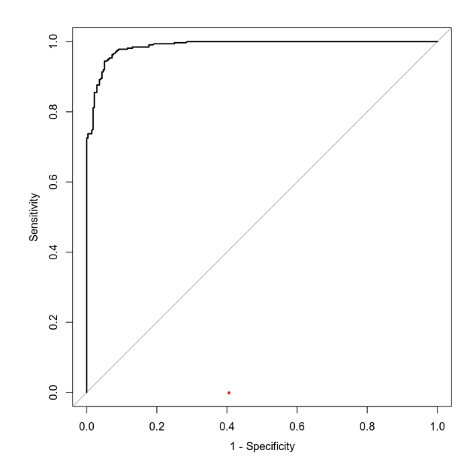

The area under the curve (AUC) is 0.9874or 98.74%. This is an indicator of how well the model distinguishes between Y = 0 and Y = 1. In general, the larger the AUC the better, because the larger the area under the curve, the better it is at predicting binary classes.

Making Predictions Using Model

The probability of an individual who has a credit utilization of 35%, owns only a car, and has missed payments in the last 3 months is 0. 9529. This means that an individual with a credit utilization of 35%, owns a car and missed a payment has a 95.29% chance of defaulting on their credit line. The probability of an individual who has a credit utilization of 35%, owns a car and a house, and has not missed payments in the last 3 months is 0.1986. This means that an individual with a credit utilization of 35%, owns a car and a house, and has not missed a payment has a 19.86% chance of defaulting on their credit line.

5. Conclusion
Based on the analysis performed and assuming that the sample size is sufficiently large, I would recommend using these models. They both have sufficient area under the curve (AUC), every term is statistically significant in each model except for assets car owned, and the models show a strong correlation between the variables being analyzed. The important variables in the data set that will be used in the models are education, credit utilization, assets, and missed payment and whether they have defaulted on their credit line. We looked at Logistic Regression, Hosmer-Lemeshow goodness of fit (GOF) and predictive analysis to see who is more likely to default on their loans. Also, with what variables seem to have more of an impact on the defaulting prosses. Not missing a payment vs missing one in the predictive showed a massive swing in the results. The practical importance of the analyses performed is that credit companies can use the models to determine the risk involved in extending credit to individuals using the variables in this data set. If they have certain variables that are too high, they do not lend money to them since the likelihood is too low.

