RURAL CLINIC
ELECTRONIC PATIENT RECORD SYSTEM
PROJECT PROPOSAL



Cwaka Hlalumi Dlayika 202433827@spu.ac.za
Nontuthuko Fortunate Mthimkhulu 202503694@spu.ac.za
Gofaone Myataza 202582174@spu.ac.za

1. Introduction and System Overview
1.1 The Setting
The system models a rural primary healthcare clinic: a single clinic that serves five surrounding villages located between 8 km and 42 km away. The clinic is staffed by two doctors, two nurses and a receptionist. Most patients travel long distances, many depend on chronic medication (hypertension, diabetes, asthma, HIV and TB treatment) and the clinic must carefully manage a small stock of medicines that is refilled by external suppliers. Patients who need specialist care are referred to district hospitals.
1.2 Problems with the Manual Process
- Paper patient cards are lost, duplicated or damaged by fire or water, so a patient's history is not available on the next visit.
- Stock is counted by hand, medicines run out without warning and orders are placed late.
- Patients who were told to return for chronic care and follow-ups are not reminded and are not tracked.
1.3 Aim and Objectives
To design and build an automated database management system that stores all clinic data in one normalized database and automates as many routine processes as possible. Specifically, the system must:
- Keep one complete, searchable record per patient, with every visit, diagnosis and prescription.
- Let an authorised user create, change and delete data and even create or remove tables without writing SQL.
- Produce management reports that support decisions about stock, appointments and outreach.

1.4 Expected Benefits
- Reduced dependence on physical paper files.
- Offline operation because the clinic is in a rural area where connectivity can be a problem.
- Faster retrieval of patient information.
- Better continuity of patient records over multiple visits.
- Reduced risk of permanent loss caused by damaged or missing paper records.
- Controlled access to confidential information.
- Improved accountability through audit logs.
- More organised management of appointments, diagnoses and prescriptions.
- Improved disaster recovery through database backups.

1.5 System Users
User | What they do in the system
Receptionist | Registers patients, books and updates appointments, records payments.
Nurse / Doctor | Records consultations: symptoms, diagnoses, prescriptions, referrals and follow-up dates.
Administrator | Manage users, system configuration, backups and audit information.

1.6 Automated Processes
Process | How the system automates it
Stock control | Prescribing a medicine deducts the stock automatically and records a stock movement. Removing a prescription returns the stock. A prescription larger than the stock on hand is refused.
Appointments | Saving a consultation linked to an appointment mark that appointment as Completed automatically.
Reminders | A reminder list shows every follow-up and scheduled appointment due in the next N days, with the patient's phone number and village.
Data entry | Dropdowns are built automatically from foreign keys and allowed-value lists, so users pick values instead of typing IDs.

1.7 Business Rules
- A patient lives in exactly one village; a village can have many patients.
- A patient can have many appointments and many visits. A visit is conducted by one staff member and may be linked to an appointment.
- A visit can have many diagnoses, many prescribed medicines, zero or more referrals, and exactly one invoice.
- A medicine is supplied by at most one supplier. Its stock level only changes through recorded stock movements.
- An invoice can be settled by several payments, but the total paid may not exceed the amount due.
- Each diagnosis can only be recorded once per visit, and each medicine can only be prescribed once per visit.
2. Database Design
2.1 Entity Relationship Diagram
The diagram below shows the entities of the system, their attributes and the relationships between them. Primary keys (PK) and foreign keys (FK) are identified in the diagram.
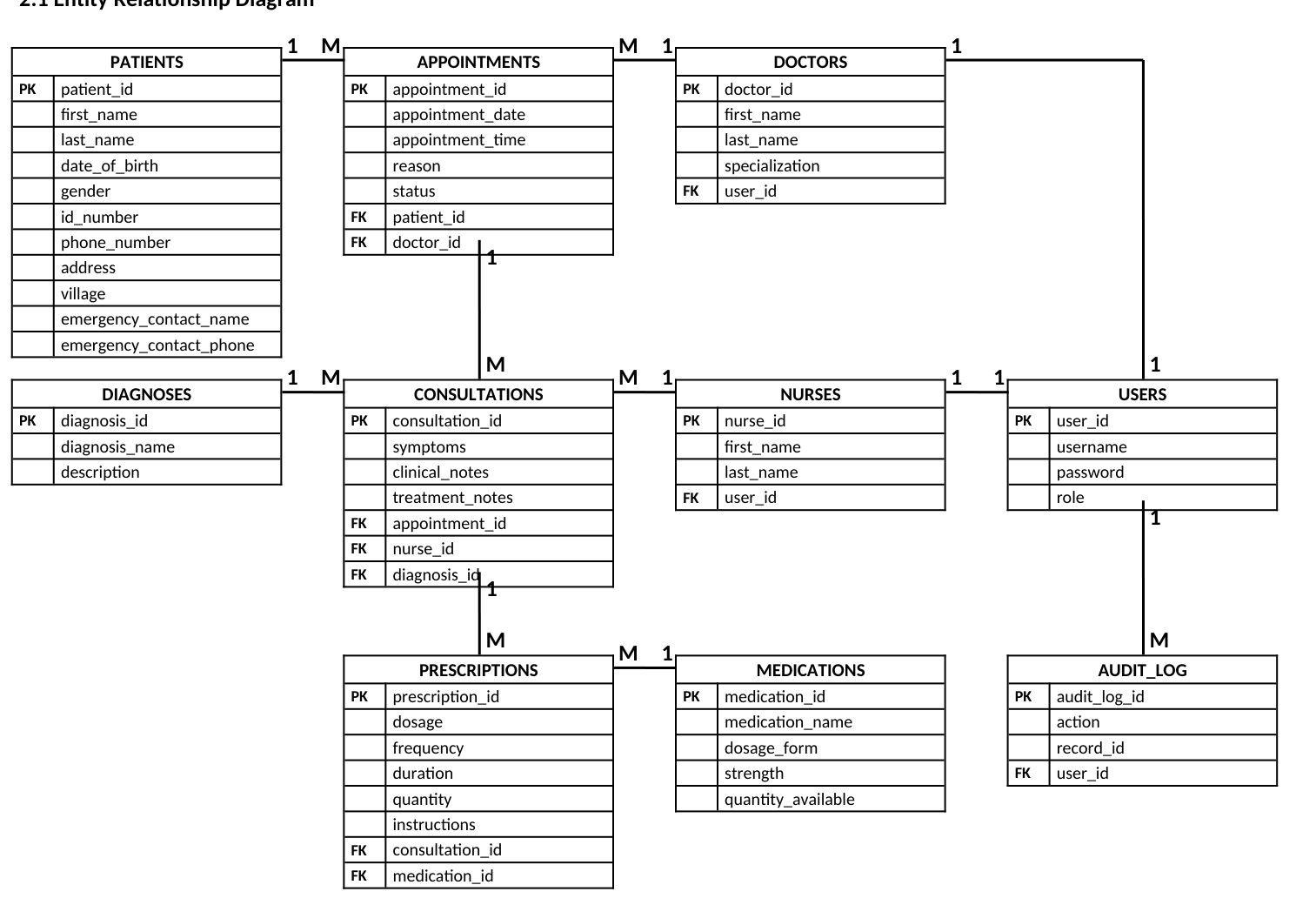
2.2 Relationships and Cardinality
Relationships ensure information stays connected without repeating data. For example, a patient’s details are stored once in Patients, while multiple appointments and consultations can refer back to that patient using patient_id.
Entity A | Entity B | Cardinality | Explanation
Patients | Appointments | 1 : M | One patient can have many appointments.
Doctors | Appointments | 1 : M | One doctor can have many appointments.
Patients | Consultations | 1 : M | One patient can have many consultations.
Doctors | Consultations | 1 : M | One doctor can conduct many consultations.
Nurses | Consultations1 | 1 : M | One nurse can participate in many consultations.
Consultations | Diagnoses | 1 : M | A consultation can have one or more diagnoses.
Consultations | Prescriptions | 1 : M | A consultation can result in multiple prescriptions.
Medications | Prescriptions | 1 : M | A medication can appear in many prescriptions.
Doctors | Users | 1 : 1 | A doctor may have a system user account.
Nurses | Users | 1 :1 | A nurse may have a system user account.
Users | Audit_Log | 1 : M | One user can generate many audit-log records.

2.3 Normalization: From Unnormalized Form to 3NF
The proposed structure separates different types of information into related tables. This reduces duplication and makes the database easier to maintain.
UNF | 1NF | 2NF | 3NF
Patient ID  First name  Last name  Date of birth  Gender  ID number  Phone number  Address  Village  Emergency contact  Appointment ID  Appointment date  Appointment time  Reason  Status  Doctor ID  Doctor first name  Doctor last name  Specialization  Nurse ID  Nurse first name  Nurse last name  Consultation ID  Symptoms  Clinical notes  Treatment notes  Diagnosis ID  Diagnosis name  Description  Medication ID  Medication name  Dosage form  Strength  Quantity available  Prescription ID  Dosage  Frequency  Duration  Quantity  Instructions  User ID  Username  Password  Role  Audit_log ID  Action  Record ID | Patient ID  First name  Last name  Date of birth  Gender  ID number  Phone number  Address  Village  Emergency contact name  Emergency contact phone | Patient ID  First name  Last name  Date of birth  Gender  ID number  Phone number  Address  Village  Emergency contact name  Emergency contact phone | Patient ID  First name  Last name  Date of birth  Gender  ID number  Phone number  Address  Village  Emergency contact name  Emergency contact phone
 | Appointment ID  Appointment date  Appointment time  Reason  Status | Appointment ID  Appointment date  Appointment time  Reason  Status  Patient ID*  Doctor ID* | Appointment ID  Appointment date  Appointment time  Reason  Status  Patient ID*  Doctor ID*
 | Doctor ID  Doctor first name  Doctor last name  Specialization | Doctor ID  Doctor first name  Doctor last name  Specialization  User ID* | Doctor ID  Doctor first name  Doctor last name  Specialization  User ID*
 | Nurse ID  Nurse first name  Nurse last name | Nurse ID  Nurse first name  Nurse last name  User ID* | Nurse ID  Nurse first name  Nurse last name  User ID*
 | Consultation ID  Symptoms  Clinical notes  Treatment notes | Consultation ID  Symptoms  Clinical notes  Treatment notes  Appointment ID*  Nurse ID*  Diagnosis ID* | Consultation ID  Symptoms  Clinical notes  Treatment notes  Appointment ID*  Nurse ID*  Diagnosis ID*
 | Diagnosis ID  Diagnosis name  Description | Diagnosis ID  Diagnosis name  Description | Diagnosis ID  Diagnosis name  Description
 | Medication ID  Medication name  Dosage form  Strength  Quantity available | Medication ID  Medication name  Dosage form  Strength  Quantity available | Medication ID  Medication name  Dosage form  Strength  Quantity available
 | Prescription ID  Dosage  Frequency  Duration  Quantity  Instructions | Prescription ID  Dosage  Frequency  Duration  Quantity  Instructions  Consultation ID*  Medication ID* | Prescription ID  Dosage  Frequency  Duration  Quantity  Instructions  Consultation ID*  Medication ID*
 | User ID  Username  Password  Role | User ID  Username  Password  Role | User ID  Username  Password  Role
 | Audit_log ID  Action  Record ID | Audit_log ID  Action  Record ID  User ID* | Audit_log ID  Action  Record ID  User ID*

3. System Workflow and Implementation
3.1 Example of How the System Works
Step | Process
1. Patient registration | A patient is registered and assigned a unique patient_id.
2. Appointment | A receptionist creates an appointment and links it to the patient and doctor.
3. Consultation | During the visit, the doctor/nurse creates a consultation record linked to the patient.
4. Diagnosis | The diagnosis is stored and linked to the consultation.
5. Prescription | Medication prescribed during the consultation is recorded in Prescriptions and linked to Medications.
6. Audit | Important changes are recorded in Audit_Log together with the user who performed the action.
7. Recovery | If a paper file is lost or destroyed, authorised staff can retrieve the electronic record from the database and its backups.

4. Security and Access Control
Patient information is confidential and should only be available to authorised personnel. The Users table supports role-based access. Passwords should never be stored as plain text; the system should store secure password hashes.
Role | Suggested Access
Administrator | Manage users, system configuration, backups and audit information.
Doctor | View patient records and create/update clinical records, diagnoses and prescriptions.
Nurse | View relevant patient information and record clinical information.
Receptionist | Register patients and manage appointments; limited access to clinical information.

5. Data Backup and Recovery
The database should not be treated as the only copy of the information. A backup strategy is required so that the clinic can recover if the database server fails, data is corrupted, or another disaster occurs.
The central idea is that the loss of a paper file should no longer mean the permanent loss of the patient's digitised record. Recovery depends on maintaining reliable backups and being able to restore the database.
To mitigate the above issue, frequent backup schedules are to be created, and the database should be backed up on a hard drive kept at a separate location.

6. Limitations and Important Considerations
- Digitising records does not automatically guarantee security.
- The clinic still needs suitable hardware, reliable electricity and connectivity where required.
- Staff training and secure authentication are required.
- Recovery depends on backups being made and tested regularly.
- The design is a proposal and must be adapted to the clinic's real workflow.
- The database design should also be adapted to applicable healthcare and data-protection requirements before real patient information is used.
7. Recommendations
- Protect the Data- Schedule frequent backups, keep a copy off-site, and test restores.
- Train Staff- Teach secure logins, role limits and how to handle confidential information.
- Check Readiness- Confirm power, connectivity, and legal data protection requirements.
  - 8. Proposed Budget and Cost Justification
This budget estimates the initial cost of equipping and preparing a small rural clinic prototype for the Electronic Patient Record System. The laptop price of R5,699 is the specified cost; all other amounts are planning estimates and should be confirmed with supplier quotations.
Item | Purpose | Estimated Cost (ZAR)
Laptop | Main computer for running the system | R5,699
External hard drive (1 TB) | Backup copies of the patient database | R1,000
UPS / power protection | Temporary power during interruptions and safe shutdown | R700
Flash drive (64 GB) | Additional backup and file transfer | R150
Internet/data | Initial downloads, updates and setup | R300
Software and database | Free development tools, database and browser | R0
System development and configuration | Installation, database setup and testing | R1,000
Staff training | Training clinic staff to use the system securely | R500
Contingency allowance | Reserve for unexpected expenses | R935
TOTAL ESTIMATED BUDGET |  | R10,284

8.1 Budget assumptions
• The laptop is budgeted at the lowest and most feasible retail price of R5,699.
• The external drive, UPS, flash drive, data, configuration and training costs are estimates, not supplier quotations.
• The software and database allowance is R0 because the proposal assumes suitable free/open-source tools are used.
• The contingency is money reserved for unexpected costs and does not necessarily need to be spent.
• This budget is for a small prototype or initial single-computer setup. A full clinic-wide rollout may require additional computers, maintenance and stronger backup arrangements.
8.2 Cost justification
The laptop is the main equipment expense. An external hard drive and flash drive support the project's backup and recovery objective, while a UPS can provide temporary power to save work and shut down safely during a power interruption. Free software keeps licensing costs low. Configuration and training allowances recognise that the database must be installed, tested and used correctly. The contingency provides a buffer if actual prices differ from the estimates.
9. Conclusion
The Rural Clinic Electronic Patient Record System provides a structured solution to a records-management and data-recovery problem. By moving important patient information from vulnerable paper files into a controlled electronic database, the clinic can improve the availability and organisation of records.
The ten-table design connects patients, healthcare staff, appointments, consultations, diagnoses, prescriptions and medications while the Users and Audit_Log tables address access control and accountability. Combined with regular backups and tested recovery procedures, the system can help ensure that the loss or theft of a physical patient file does not result in permanent loss of the patient's digitised information.
The source document also describes the Rural Clinic Management System as replacing paper cards with a normalized, enforced and automated database. It notes that billing, stock control, appointment tracking and reminders can happen as a side-effect of normal work, and that management can view stock, disease and finance information with a few clicks. The design is described as being in 3NF, with a prototype that allows data and tables to be added, changed and removed through a simple browser interface.

