## **Lab-1: Setup Environment**

# Introduction

This lab will set up the Watson Studio environment for subsequent labs and introduce you to the Project features of Watson Studio. Watson Studio is an integrated platform of tools, services, data, and meta-data to help companies and agencies accelerate their shift to be data driven organizations. The platform enables data professionals such as data scientists, data engineers, business analysts, and application developers collaboratively work with data to build, train, deploy machine learning and deep learning models at scale to infuse AI into business to drive innovation. Watson Studio is designed to support the development and deployment of data and analytics assets for the enterprise.

# Objectives

The goal of this lab is to familiarize the user with the Project features of Watson Studio, and to set up the environment for subsequent labs. Projects are a core component of Watson Studio. Projects enable you to organize your analytic and data assets in one place. Projects are also the home base for collaboration. Colleagues can be added as collaborators on a project with administrator, editor, or viewer access.

After completing this lab, you will be familiar with these features of Watson Studio.

1. Create a project
2. Create an object storage instance and associate it with the project
3. Associate an existing Watson Machine Learning service instance with the project
4. Add a collaborator to the project

# Lab Flow

1. User creates a Watson Studio project. Object storage instance will be created if one does not exist.
2. User associates a Machine Learning service with the Watson Studio project.
3. User adds a collaborator to the project.

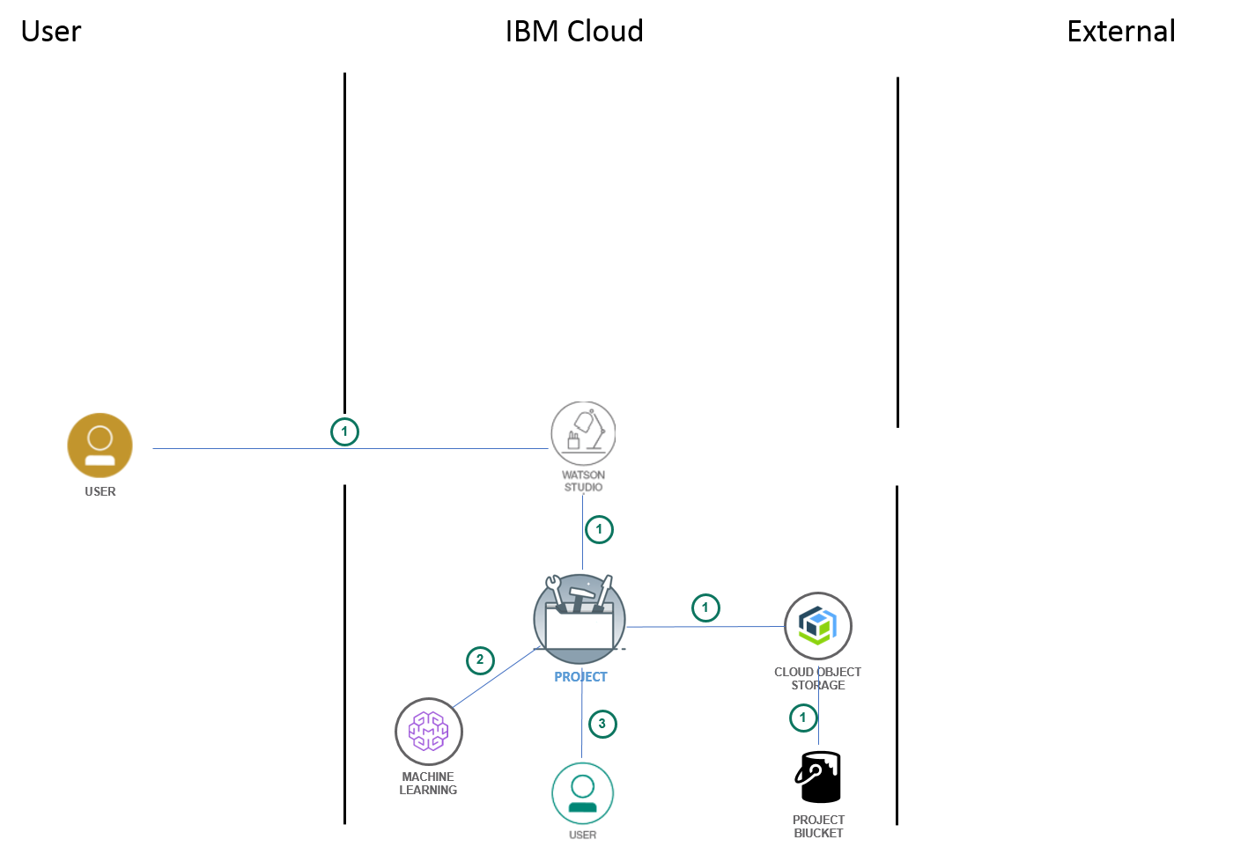

# Create a Project

1. Log into your Watson Studio account by typing in the url **datascience.ibm.com** in your Firefox or Chrome browser.
2. Click on **Sign into Watson Studio Cloud** (not Cloud sign-up/log-in)

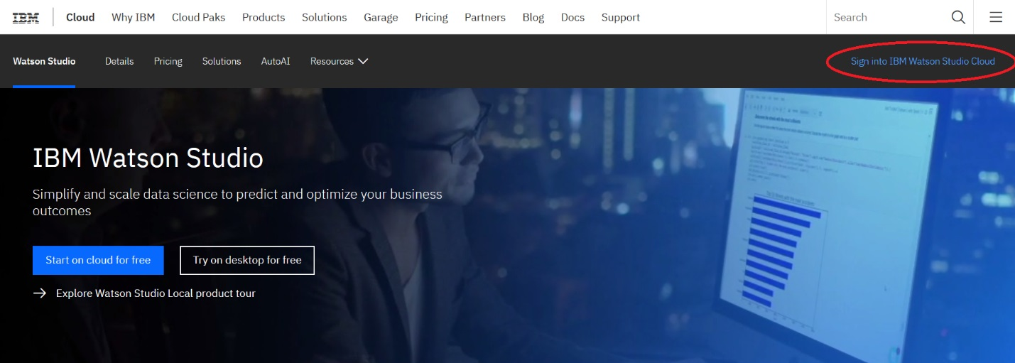

1. Enter your Watson Studio user id and click **Continue.**

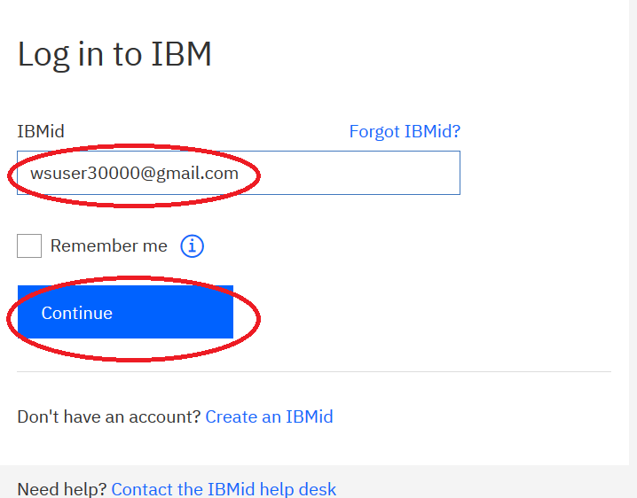

1. Enter your **Password** and click **Log in**.

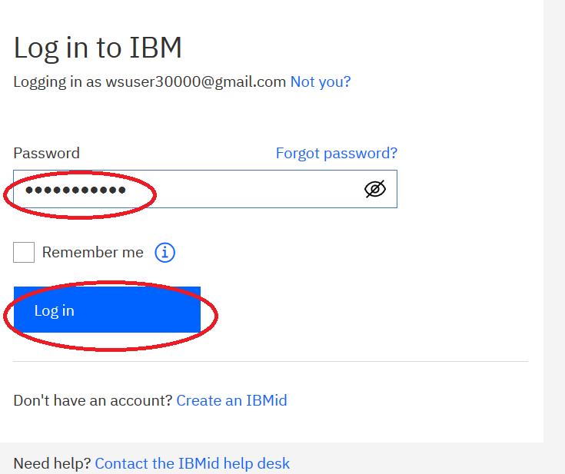

1. Click on the hamburger icon .



1. Click on **Projects**, and the click on **View All Projects**

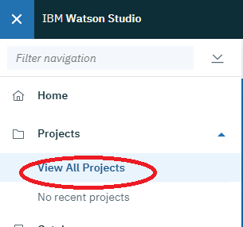

1. Click on **New Project**.

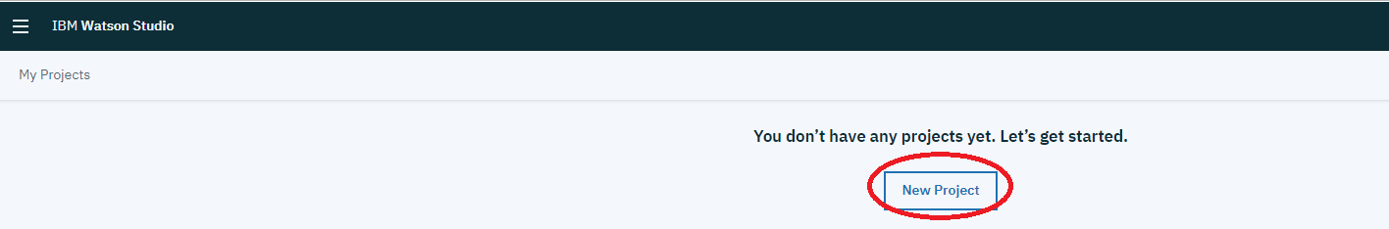

1. Click on **Create an empty project**.

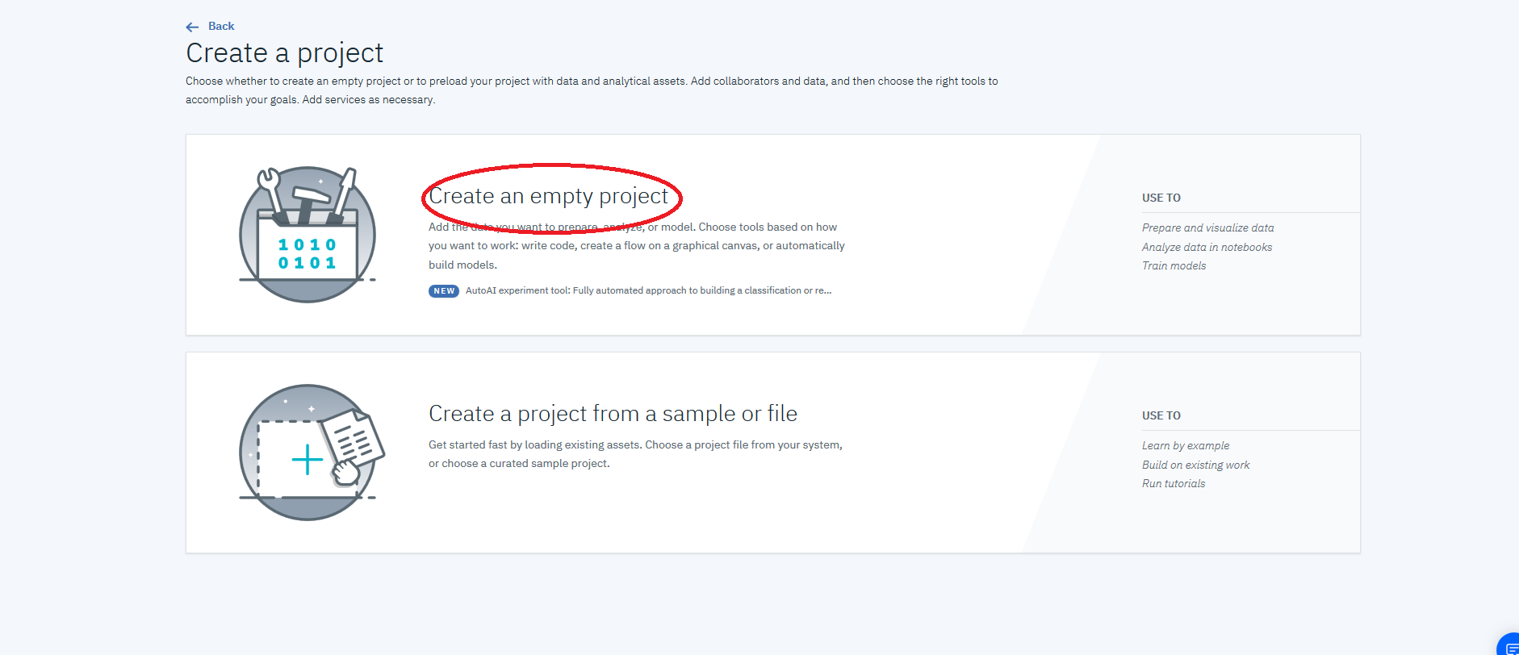

1. Enter “Watson Studio Labs” for the **Name,** optionally enter a **Description,** make sure to uncheck **Restrict who can be a collaborator** (if it’s checked), and in **Define Storage** click on **Add** to add an object storage instance.

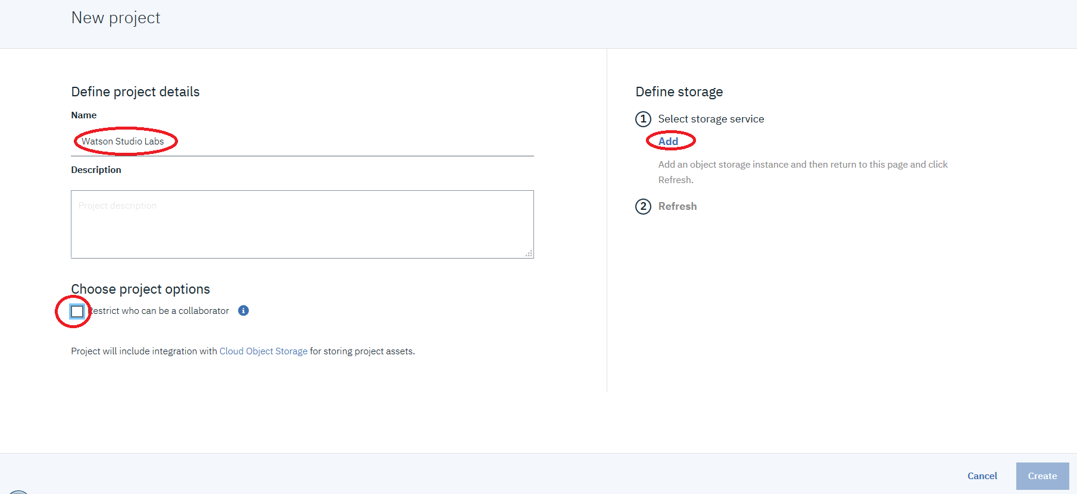

1. Click on **Lite,** and then click on **Create**

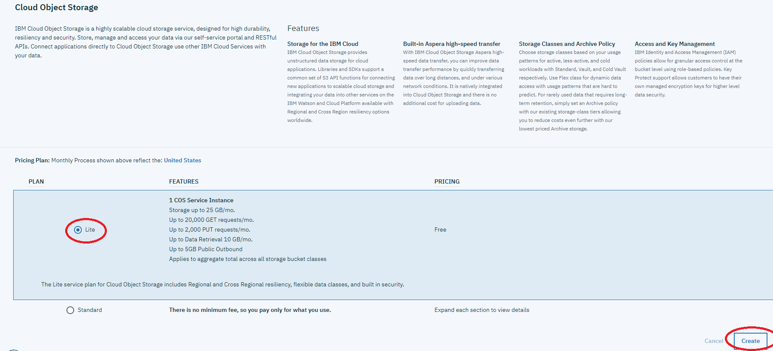

1. Click **Confirm**.

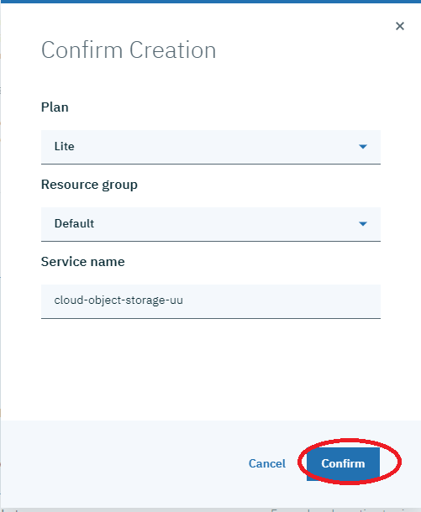

1. Click **Refresh**.

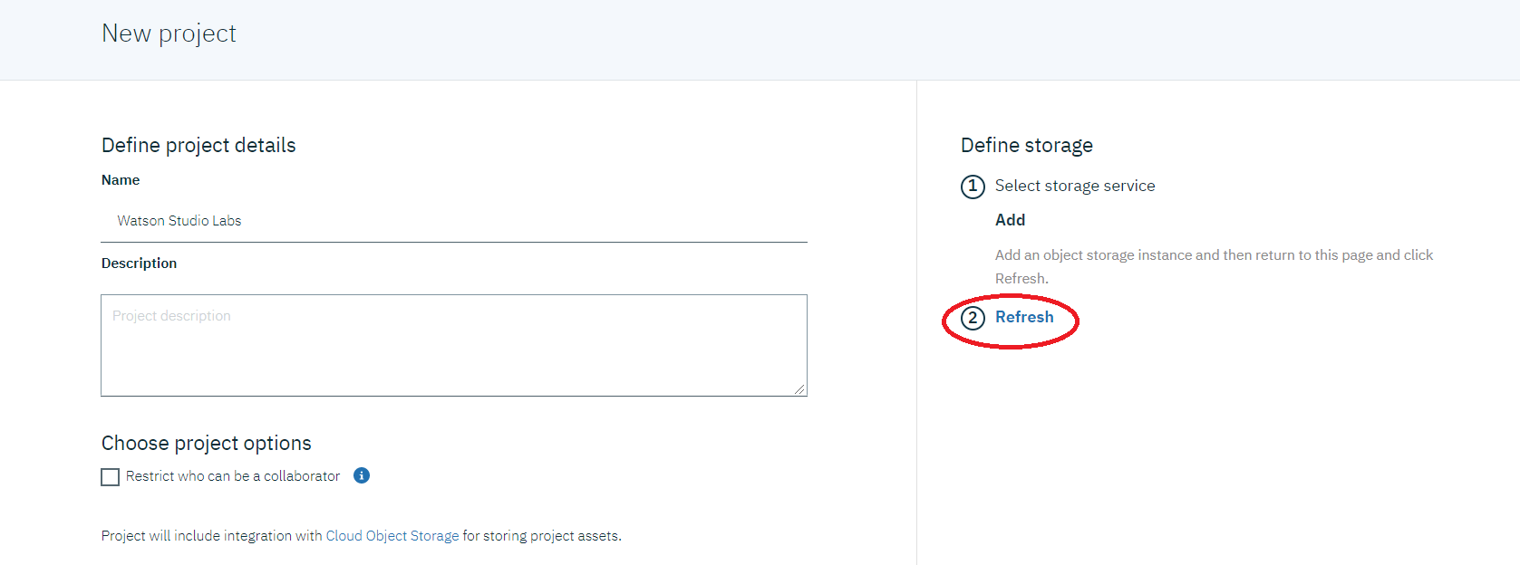

1. Click **Create**.

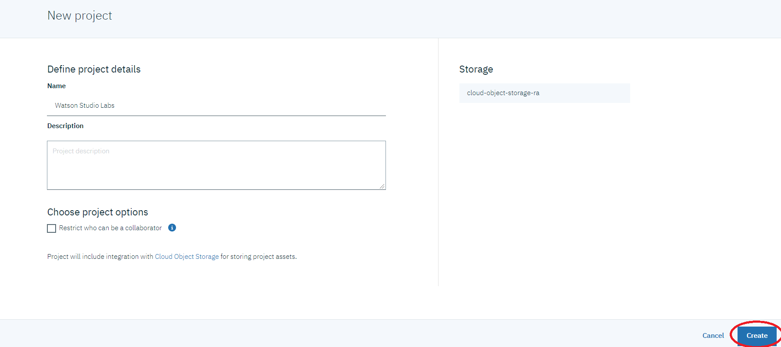

1. The Project **Overview** page is shown. This page provides summarized information about the project. In addition to the Overview page, are six other pages described below.
   1. **Assets Page –** Analytics and Data assets can be added to the project from this page.
   2. **Environments Page -** Provides information on the current notebook environments that are defined, lists the active notebook environments currently running, and enables users to create custom notebook environments.
   3. **Jobs Page –** Provides the interface to the job subsystem. This replaces the separate UIs to set up and run jobs for Notebooks and the Data Refinery. This is a new feature in Watson Studio Cloud version.
   4. **Bookmarks Page -** Lists artifacts from the Community that are bookmarked in this project.
   5. **Deployments Page –** Lists the deployed models
   6. **Access Control –** Lists the project collaborators and enables users to add/remove collaborators.
   7. **Settings –** Enables users to view and set project attributes.

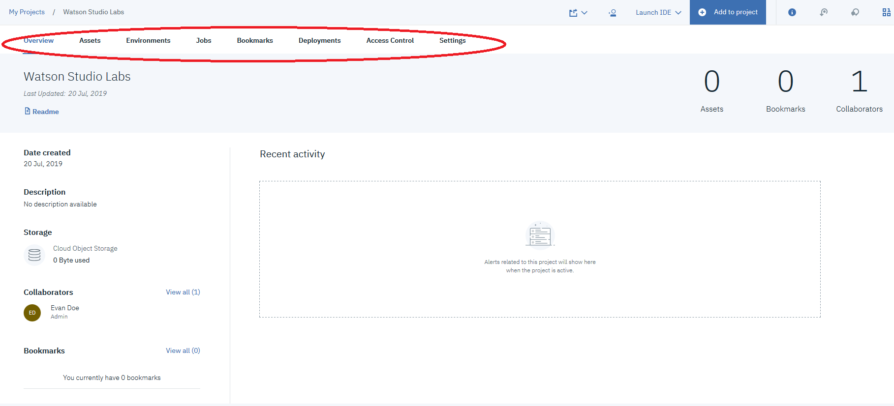

# Associate a Watson Machine Learning Service to the Project

To save and deploy machine learning models, a Watson Machine Learning service must be created (if one doesn’t exist) and added to our project.

1. Click on **Settings** to navigate to the Project **Settings** page.

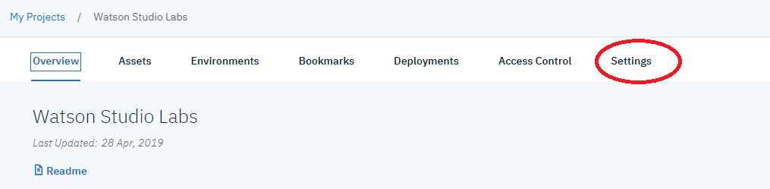

1. Scroll down to **Associated Services,** click on **Add service,** click on **Watson**.

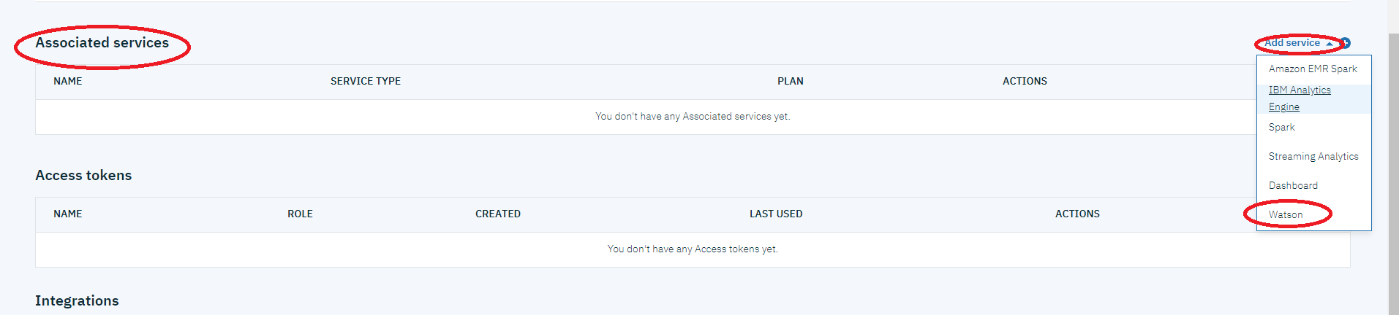

1. Click on **Add** in the **Machine Learning** tile.

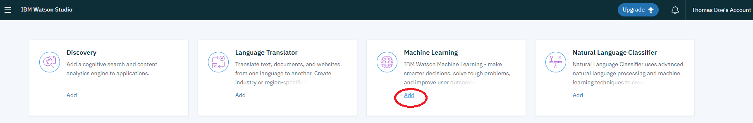

1. Newer Watson Studio accounts come with the WatsonMachineLearning instance already created. Select **Existing**, select **WatsonMachineLearning** for the **Existing Service Instance**, and click on **Select**. If you don’t have an existing service, click on New and follow the instructions to create a **Lite** Watson Machine Learning service.

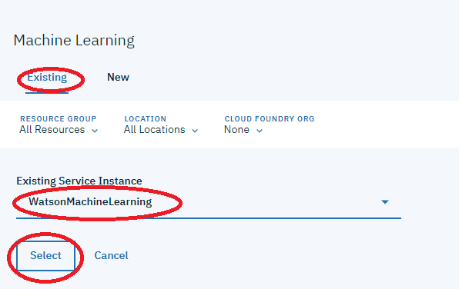

1. The **WatsonMachineLearning** service is associated with the project.

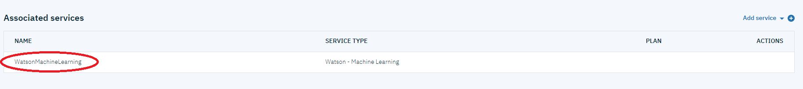

# Add a Project Collaborator

Colleagues can gain access to a project’s data and analytic assets by being made a collaborator. Permissions are based on the assigned role. The roles are administrator, editor, and viewer.

We will add a collaborator with a role of **Editor.**

1. Click on the **Access Control** tab.



1. Click on **Add collaborators**.

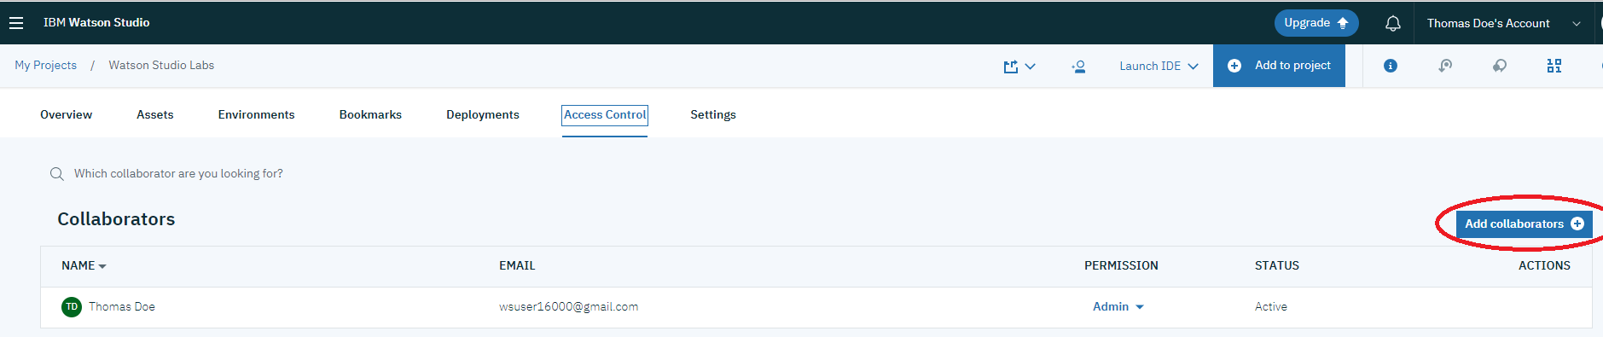

1. For **Invite**, enter [**beekmanb@us.ibm.com**](mailto:beekmanb@us.ibm.com), press the <Enter> key, select Editor from the **Access Level** dropdown, and click on **Add**.

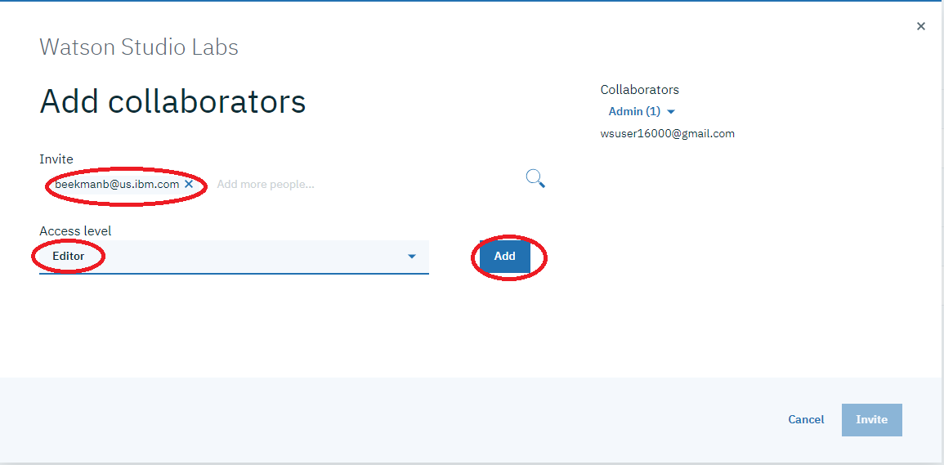

1. The collaborator is added to the list of Collaborators on the right-hand side. Click on **Invite**.

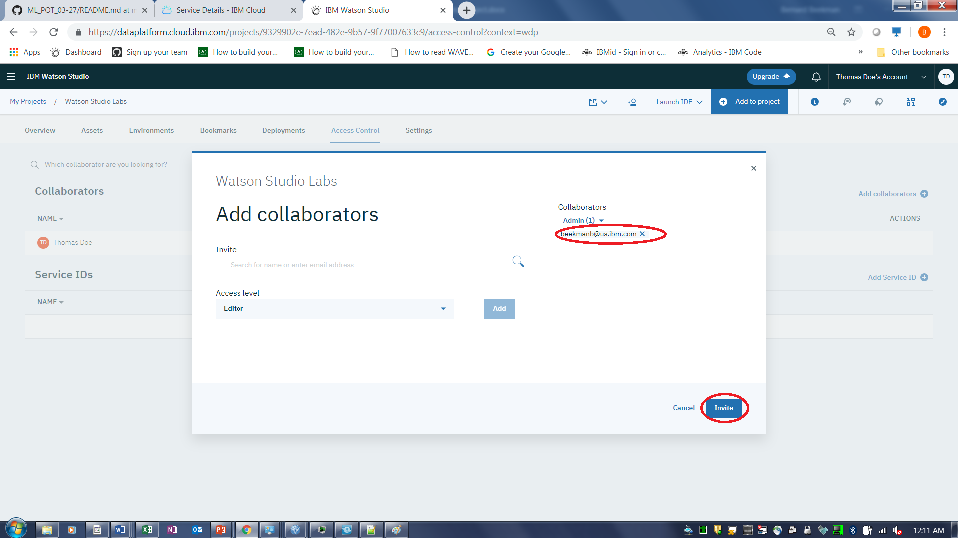

1. The collaborator is added.

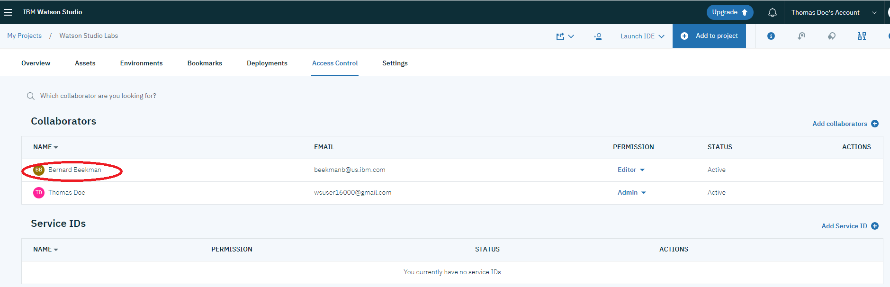

**You have completed Lab-1!**

* Created a project
* Created an object storage instance and associated it with the project
* Associated an existing Watson Machine Learning service instance with the project or created a new service instance and associated it with the project.
* Added a collaborator to the project