# Screenshots - How to install Add-In inside SCVMM 2012 R2 console

Start SCVMM console as user who has admin rights.

Go to Setings -> Console Add-ins.

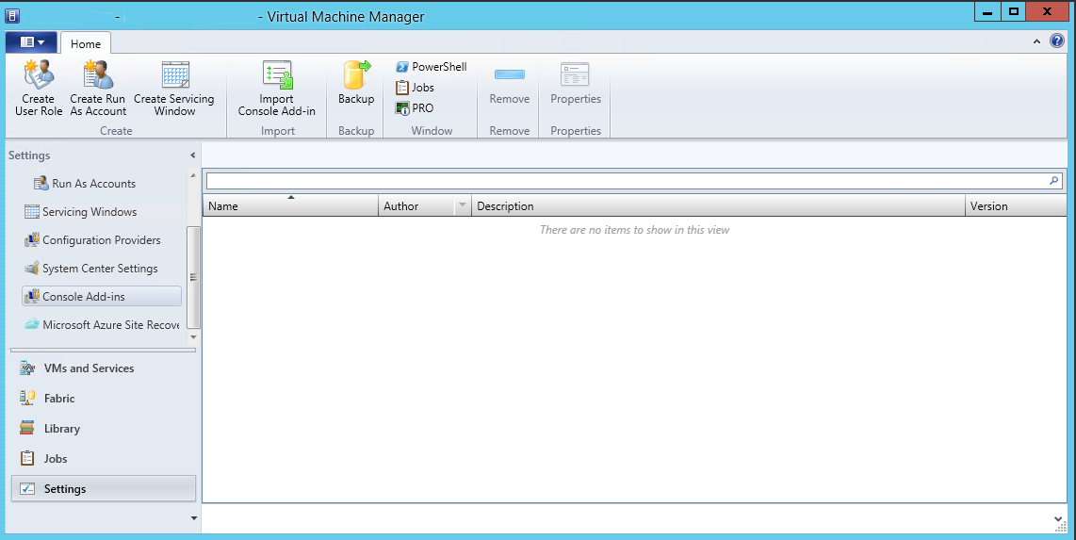

Click on button „Import Console Add-in“ inside toolbar.

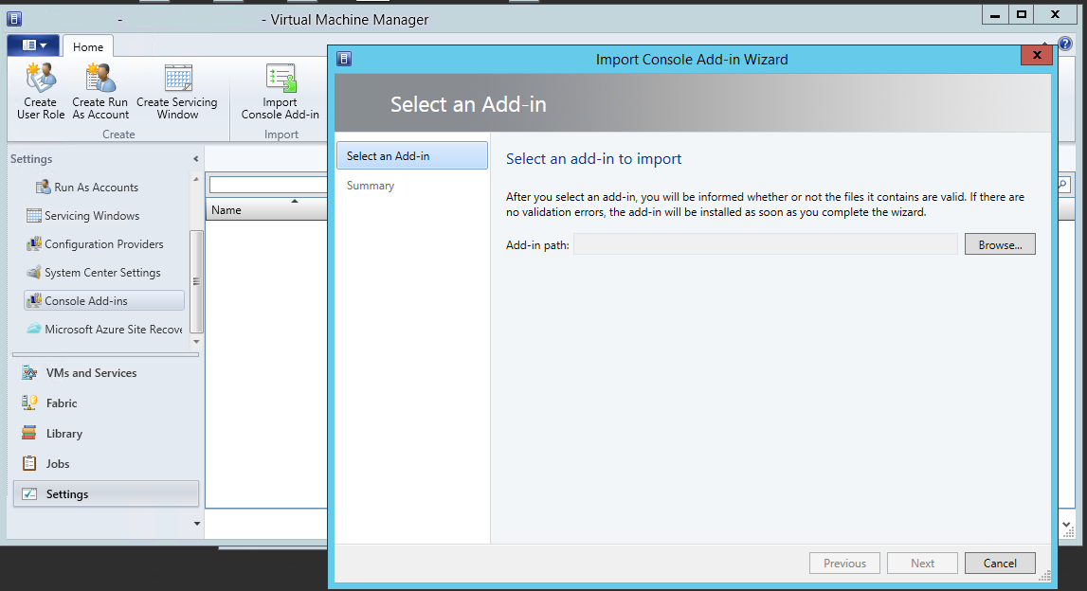

Click Browse button and navigate to folder where you previously copied SCVMM Add-in file SCVMMAddin.zip.

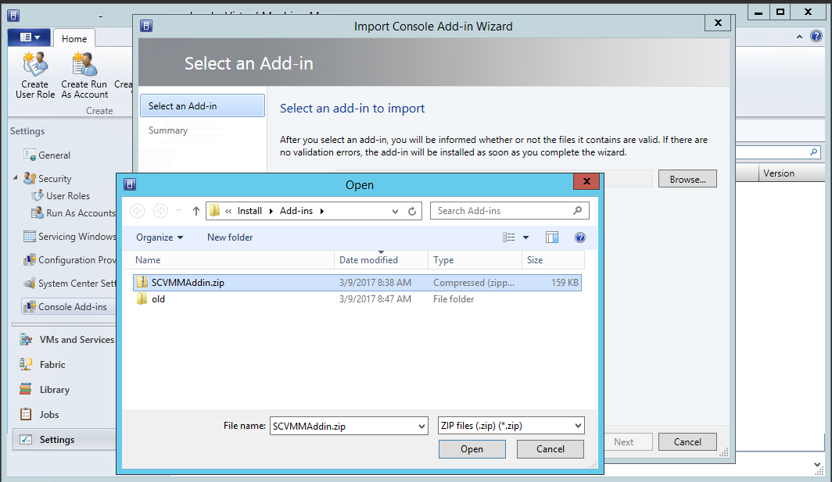

Then select that file and click Open.

You will get next picture screen.

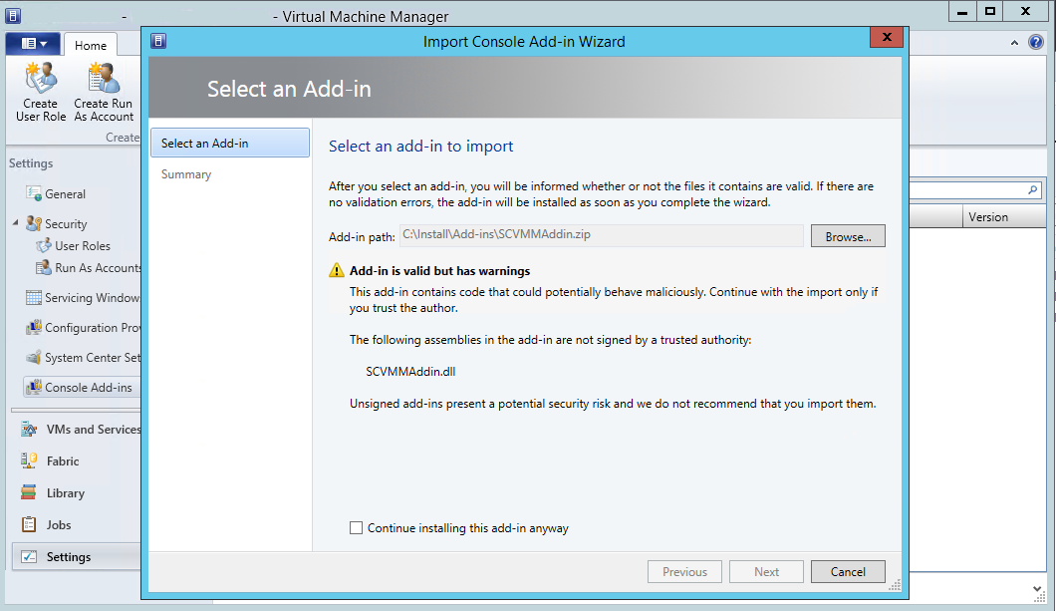

Click on checkbox at the bootom of shown application dialog.

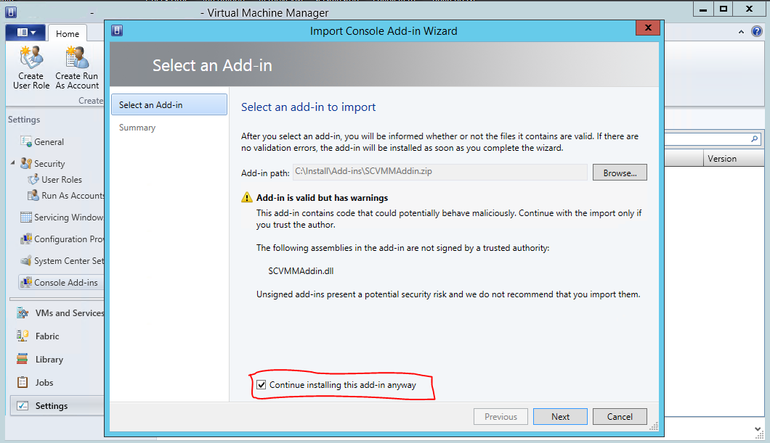

Click Next button.

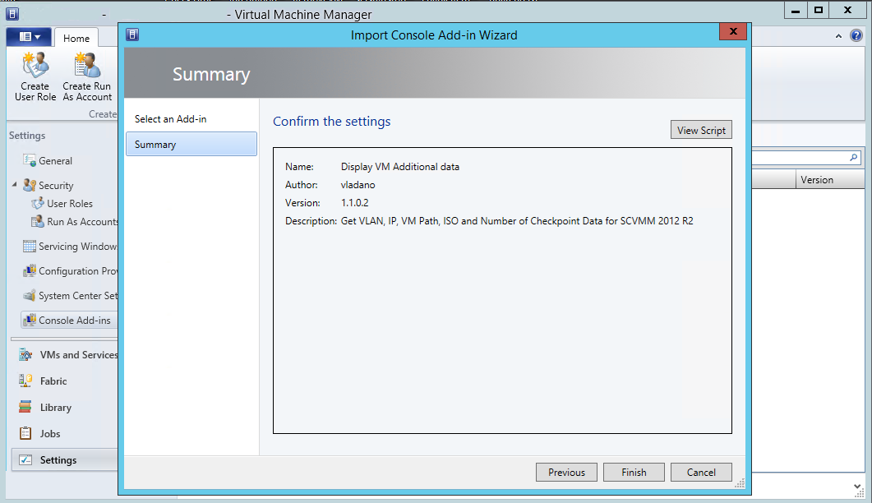

Click Finish button.

After Add-in sucessfuly imported inside SCVMM console, you will see picture below.

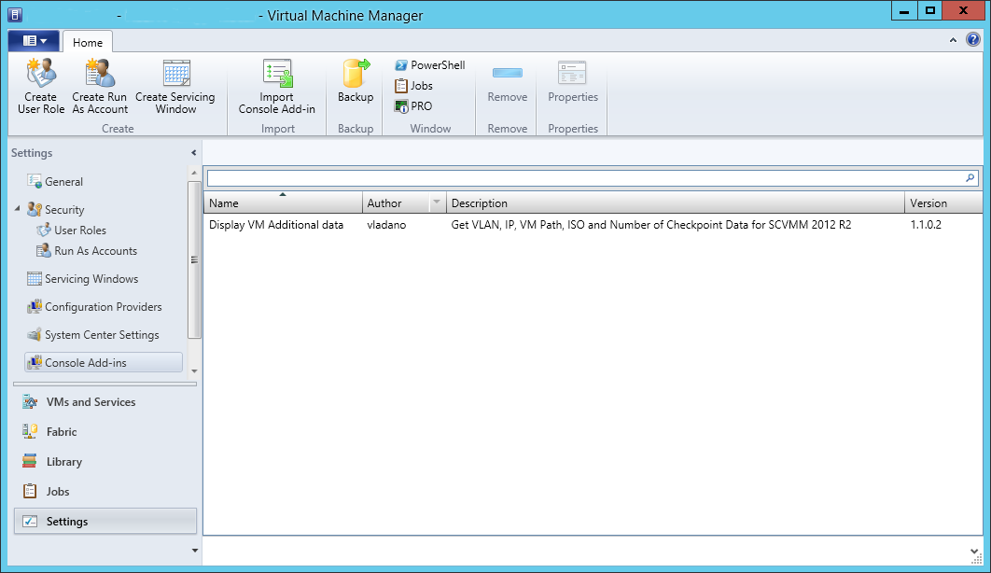

# SCVMM 2012 R2 console with installed Add-In

Select „VMs and Services“. When you select VM inside SCVMM console, you will see additional icons of imported Add-in inside toolbar, section „Add-in Actions“.

Screenshoot after creating VMs and before execute Add-In „Get VM Data“

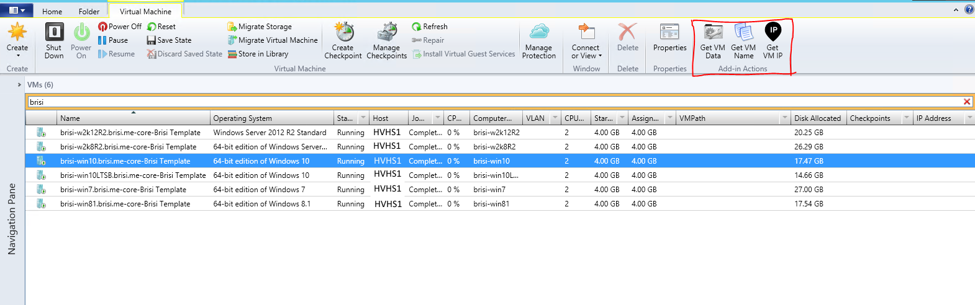

Screenshoot Add-In commad added to context menu

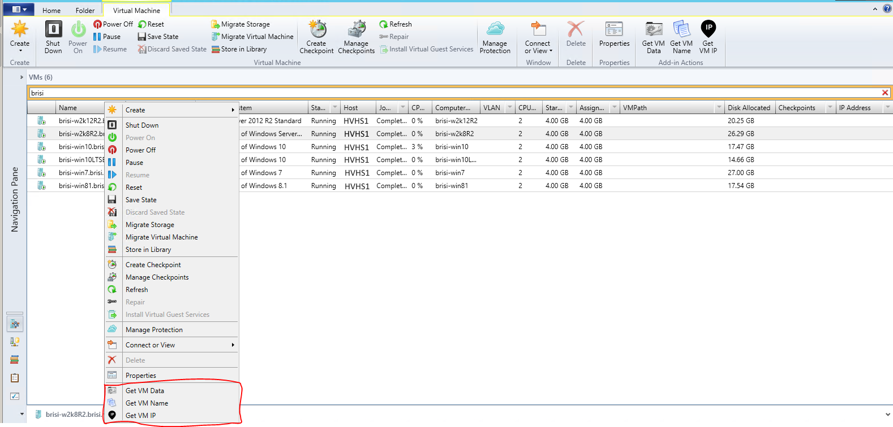

Screenshoot after creating VMs and after execute Add-In action „Get VM Data“

