Kohl Kennedy

Professor Flann

CS5050

01/13/2020

Assignment One: Nim

1. The win(int N) function works for the simple recursion algorithm
2. It works.
3. The maximum size on my Hexacore laptop is 78. After that, it goes beyond 1.5 hours and is thus impractical
4. 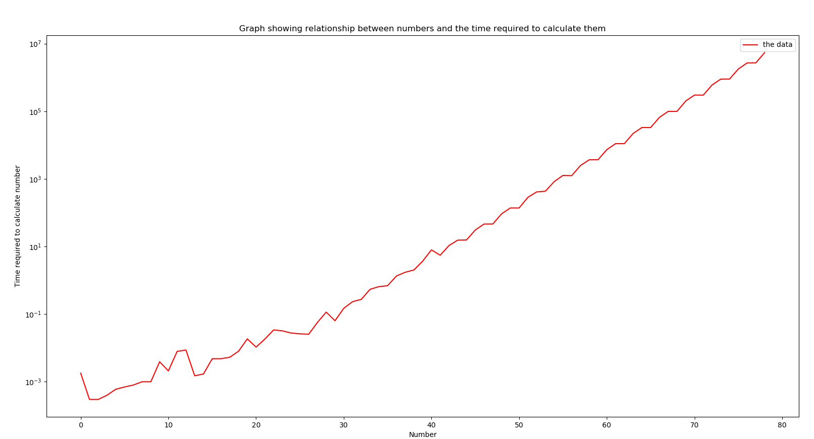
   1. The slope of the line is 9.58
5. It computes the same answers as the recursive algorithm