1. Open the Program Number Conversion.

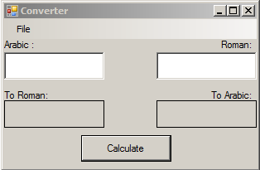

2. Now with the program open if you type a Number in the Arabic side.

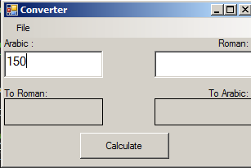

3. Then hit Calculate. It should calculate the Arabic number and put it into Roman numerals under the Arabic number box.

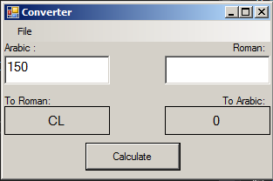

4. This will automatically put a 0 for the other Arabic side due to there being nothing in the Roman box. But if you put a roman numeral in that box then Calculate it will process that numeral and make it into a number.

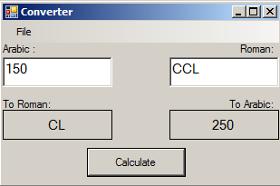

That is the program until more features are added.