**Does True or False = Boolean?**

What do the following six statements have in common?

* If the average is greater than or equal to 90, then the grade is an A.
* If the hours worked are greater than 40, then the rate of pay is time-and-a-half.
* If the Fahrenheit temperature equals 32, then the Centigrade temperature equals 0.
* If the balance is less than 0, then the insufficient funds fee is 24.00.
* If the age is less than or equal to 10, then the child’s admission fee is 4.50.
* If the length of side 1 does not equal side 2, the rectangle is not a square.

Each statement contains if and then, all six compare the relationship between two values, and each requires a Boolean decision (i.e., true or false).

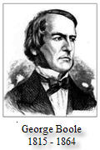Public Domain

Using the simple rules of algebra, George Boole developed a unique system of thought that expressed the principles of symbolic logic. This eventually gained him an appointment as the first professor of mathematics at Queens College in Ireland in 1849. Although he died well before the invention of even the most rudimentary computer, Boolean algebra is the foundation upon which every digital circuit used today is designed.

Statements involving binary decisions are **conditionals** (a statement involving a binary decision) because *if* some condition is true, *then* some consequence or action occurs. Condition statements give programmers the ability to make decisions based on evaluation of relationships using Java’s reserved word **if** in combination with six **relational operators** (an operator used to compare two values, variables, or expressions) as follows.

if(average >= 90)  
   System.out.println ("Grade = A")

if(age <= 10)  
   admissionFee = 4.50;

if(hours > 40)  
   overtimePay = (hours - 40) * rate * 1.5;

if(balance < 0)  
   fee = 24;

if(side1 != side2)  
   System.out.println("Not a square.");

if(tempF == 32)  
   tempC = 0;

Four (>, <, >=, and <=) of the six relational operator symbols should look very familiar to you from your study of inequalities in algebra, but the other two (== and !=) are unique to several programming languages. Can you determine which operations these symbols represent? The double equal sign means "equals," and the exclamation point with the equal sign represents "not equal."

Notice the following:

* **if** statements are written on more than one line.
* The condition is on the first line, and the action or consequence is on the second.
* The condition is written inside a pair of parentheses.
* There is no semicolon on the first line.

Conditional statements always involve a branch in a program's **flow of control** (the order in which statements are executed (e.g. sequential, looping, branching). This is most clearly illustrated by several flowchart segments shown below:

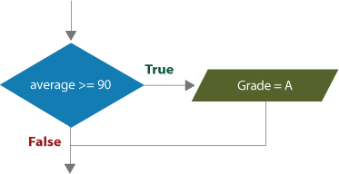

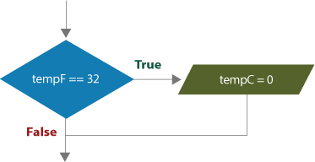

Simple **if** statements always exhibit this pattern; the flow of control branches if a binary condition is true, otherwise the branch is skipped.