**Do You Agree With My Decision?**

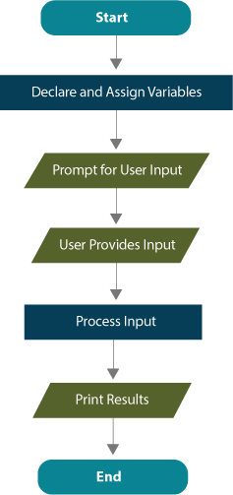

Programs that only ask the user for input, perform calculations, and print output are structured sequentially. Every line of code is executed in order from the start of the main() method to the end. These programs tend to be very simple.

One of the most powerful features of a computer is its ability to make decisions and control which parts of a program to execute. This capability allows a computer to work sequentially through a program or even skip around. Because of this, you have the ability to use **branching** (the flow of control that permits different blocks of code to be executed based on a condition) in the structure of programs so that, based on a specific condition, a program may execute one set of instructions and not another.

In addition to crunching numbers, computers are designed to easily evaluate and execute binary decisions. Consequently, branching structures are simple to write.

A generic flowchart with a simple branching structure is shown below. There is one new symbol that immediately indicates that this flowchart is not sequential. Can you spot how the branching and sequential design structures are different?

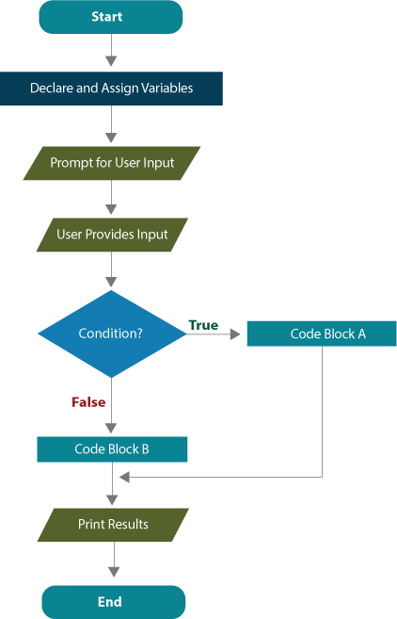

A diamond is the flowchart symbol for an **if** statement, the point in a program where a decision must be evaluated.

* If the condition is evaluated as **true**, control branches off to the right to execute a specific segment of code.
* If the condition is evaluated as **false,** control completely bypasses the branch to the right.

Since there are only two possibilities, conditions are always **boolean** expressions.