**Recursion in our World**

The purpose of art is washing the dust of daily life off our souls.

Pablo Picasso

**Recursion in Abstract Art**

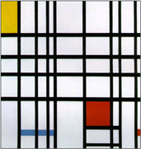

In 1917, during World War I, a group of Dutch artists developed a new style of abstract art known as Neoplasticism. This group advocated a purification of art through abstraction and simplicity. They believed that art should not reproduce real objects, but express absolutes. They defined these absolutes as horizontal and vertical lines, the primary colors (i.e., red, blue, and yellow), and the primary values of black, white, and gray. Piet Mondrian (1872–1944) was the most famous of the Neoplastic artists.

What does this have to do with computer science? Because Mondrian’s art can be represented as horizontal and vertical geometric patterns and simple primary colors, this style was an early favorite of many computer scientists trying to generate “computer art.”

**Recursion in Artful Toys**

A matryoshka doll (or Russian stacking doll) is a set of wooden dolls of decreasing size placed one inside of another. Open one matryoshka and another smaller doll is revealed until you arrive at the last doll, which cannot be opened. From the base of this sequence, the set of dolls can then be re-assembled. This is a concrete example of recursion: dolls within dolls.

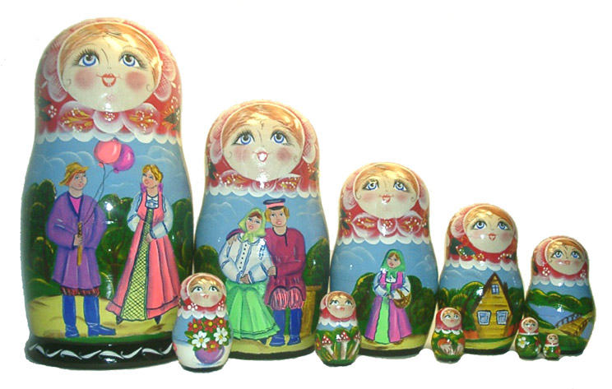Public Domain

Even Russian stacking dolls follow the three rules of recursion:

1. Know when to stop. This is the destination (the base case).
2. Decide how to take one step in the direction of the destination (the recursive call).
3. Break the journey down into one step plus the rest of the journey.

### Part 1

Some of the earliest attempts to create computer art involved modeling Neoplasticism, and today a number of Mondrian Art generators are available on the Internet. Try your hand at creating a masterpiece with the [Mondrimat](https://l.flvsgl.com/GSL04df5e7727d3ef95ff09feafdec0d252a/) (https://www.stephen.com/mondrimat/).

Did you notice the pattern for the algorithm? Could you list the steps to follow?

Mondrian-like art is not difficult to imitate. The following instructions describe a step-by-step process that uses the principle of recursion to create an image that resembles the Neoplastic art style. There is an infinite variety of rectangles and color patterns that could be chosen, although not all would be aesthetically pleasing. As you examine this sequence, try to understand how recursion has been applied.

1. Start with a blank, rectangular canvas.

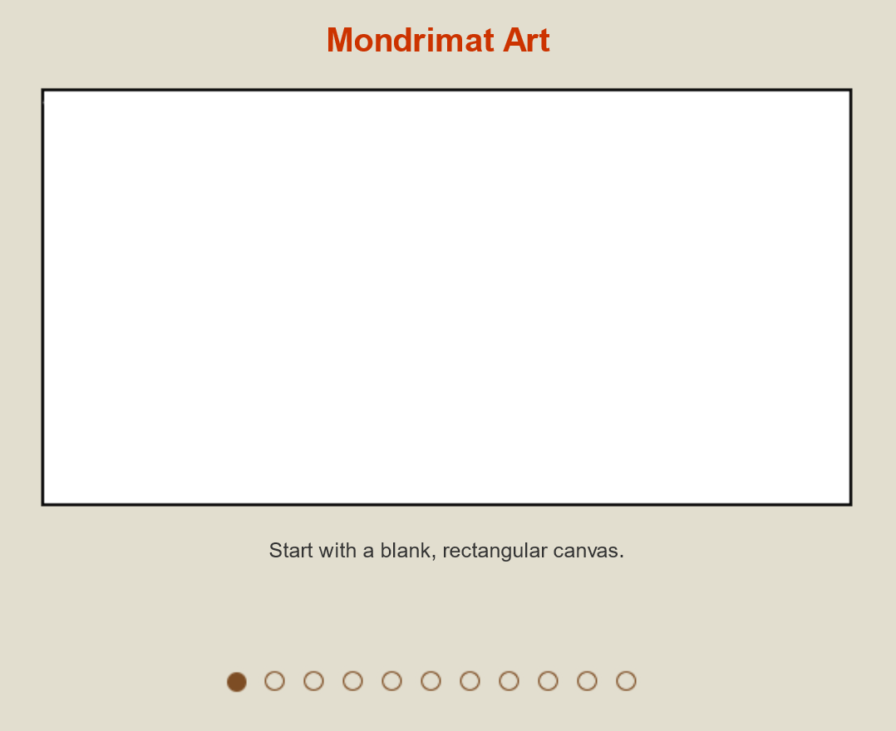

1. Divide the canvas into two smaller rectangles, with either a vertical or a horizontal line. The size of either rectangle is up to you but they cannot be the same. In this example, we start with a vertical line. Adapt the instructions if you choose to start with a horizontal line.

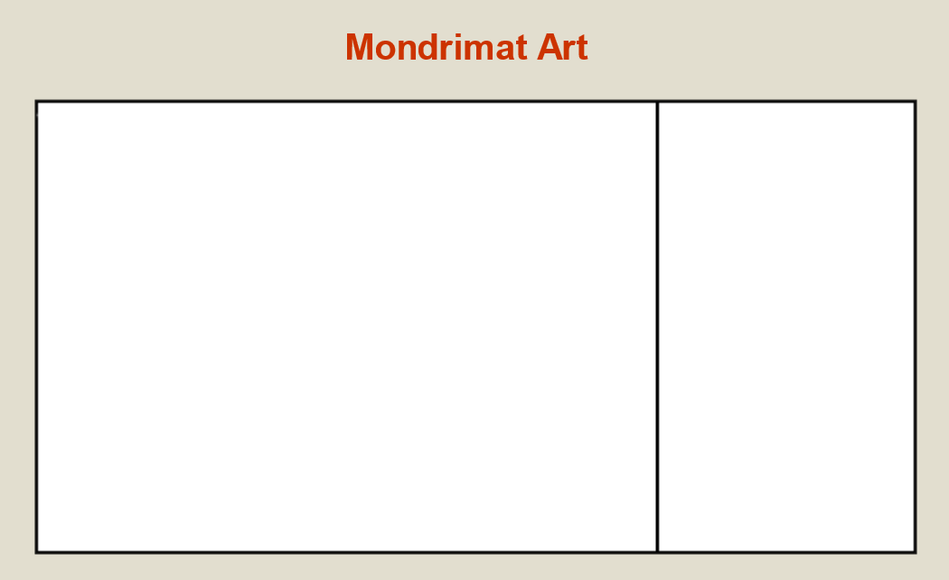

1. Using the example, start with the smaller of the two rectangles and divide it with a horizontal line into two even smaller rectangles.

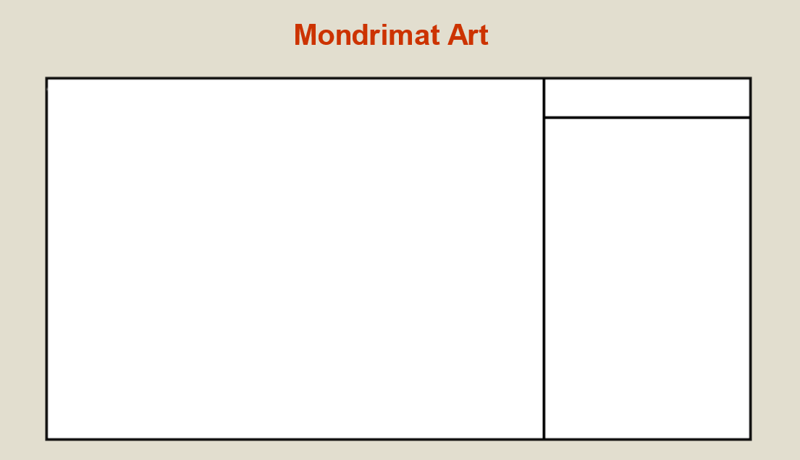

1. Divide the very small horizontal rectangle at the top of the rectangle on the right side with a vertical line. You can continue dividing until your artistic muse is satisfied.

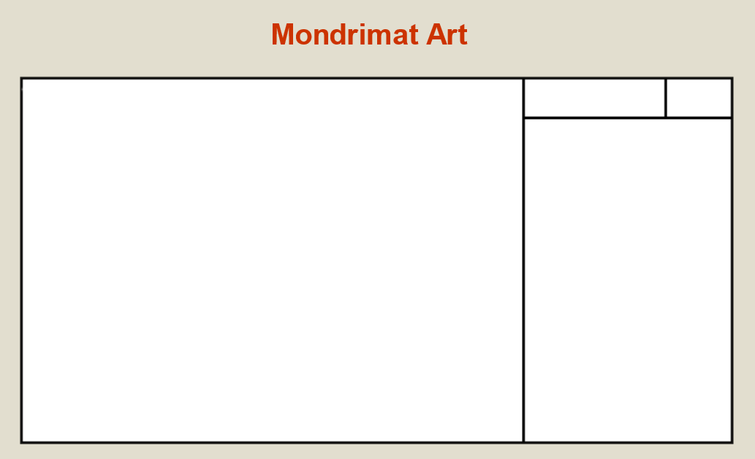

1. Next, turn your attention to the rectangle in the bottom of the original rectangle on the right. Draw a vertical line.

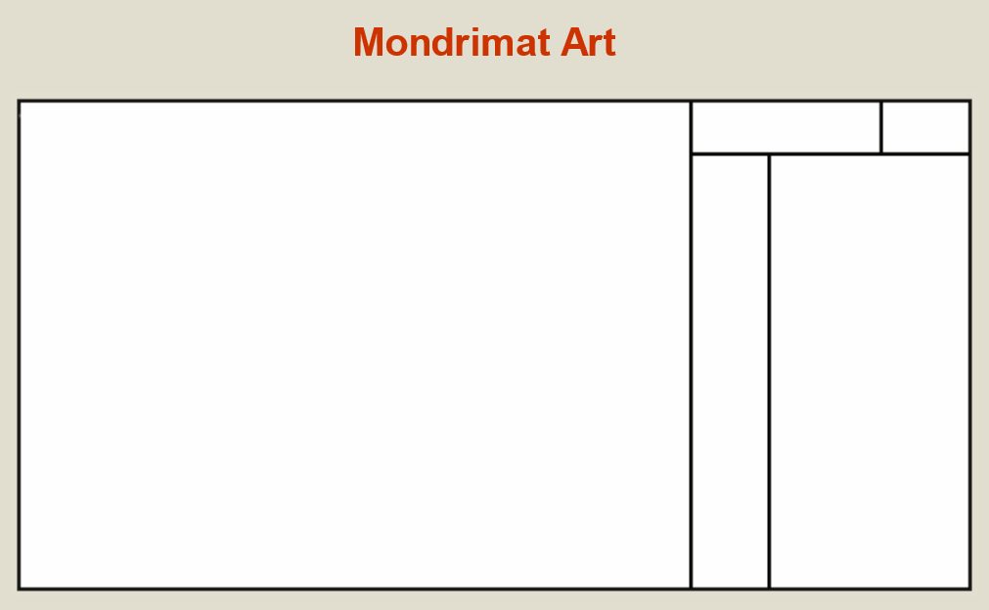

1. Continue working on this rectangle until you are satisfied with the design. Can you follow the sequence of divisions through to the bottom of this series?

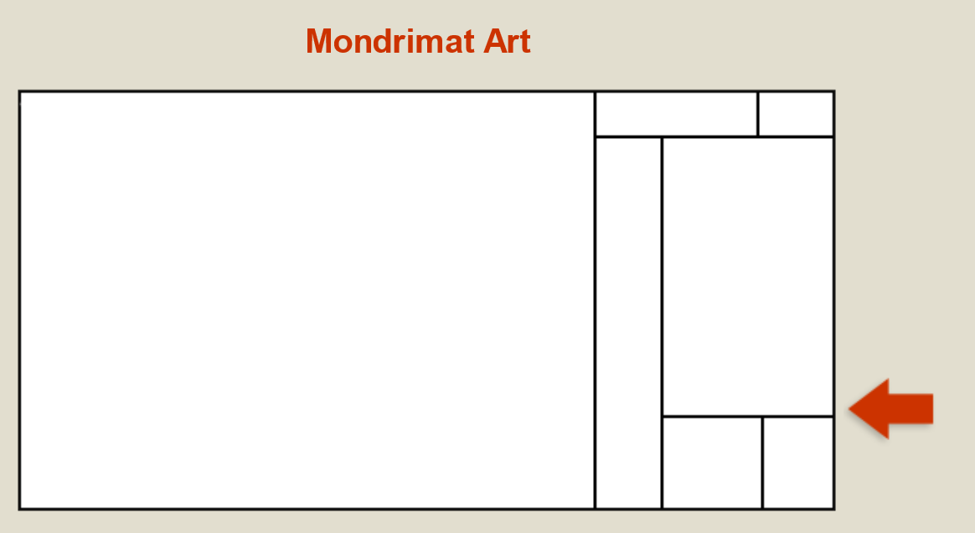

1. Once you finish with the original rectangle on the right, it is time to turn your attention to the bigger rectangle on the left. Divide the rectangle on the left with a horizontal line.

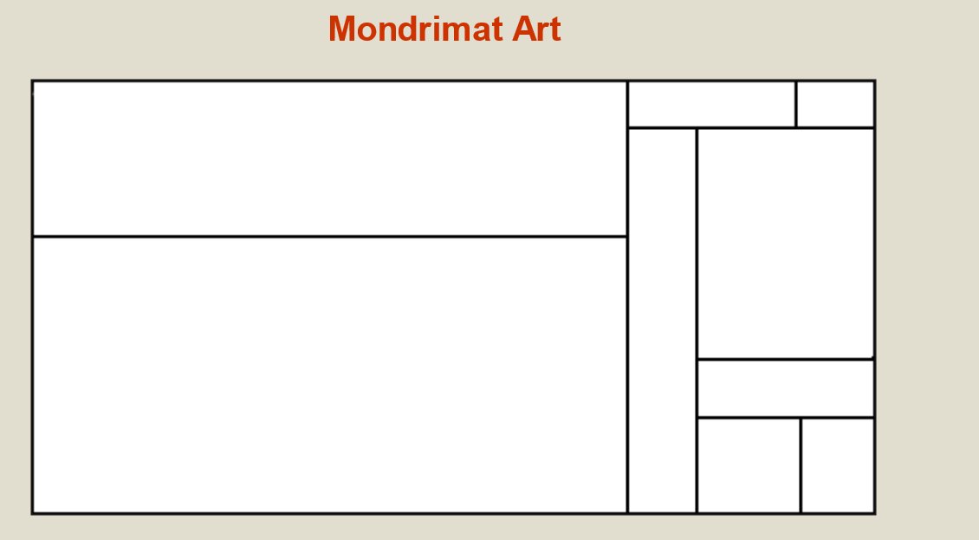

1. Divide the smaller top rectangle on the left with a vertical line.

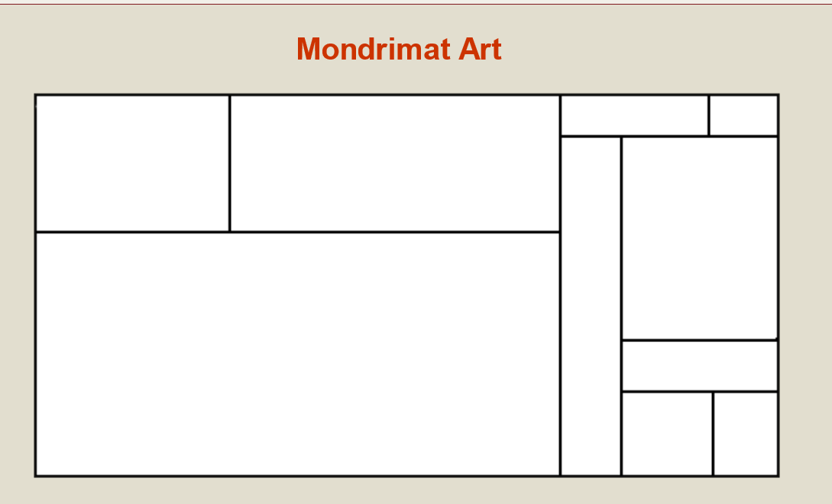

1. Continue dividing rectangles until you create a design you are satisfied with.

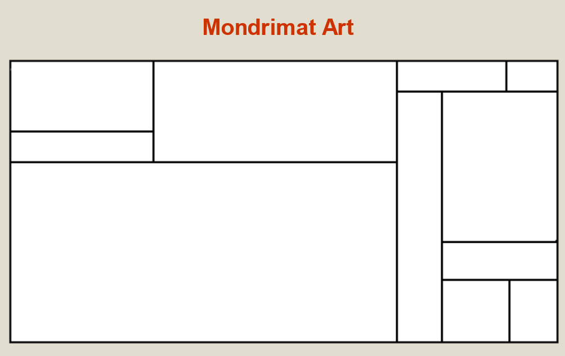

1. Follow the sequence of divisions through to the last canvas and see if you can detect a pattern.

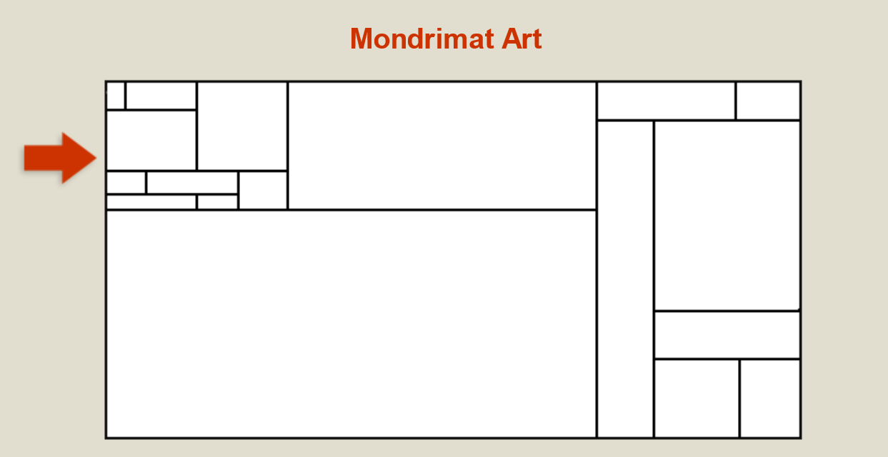

1. As a final step, primary colors can be applied to express your concept.

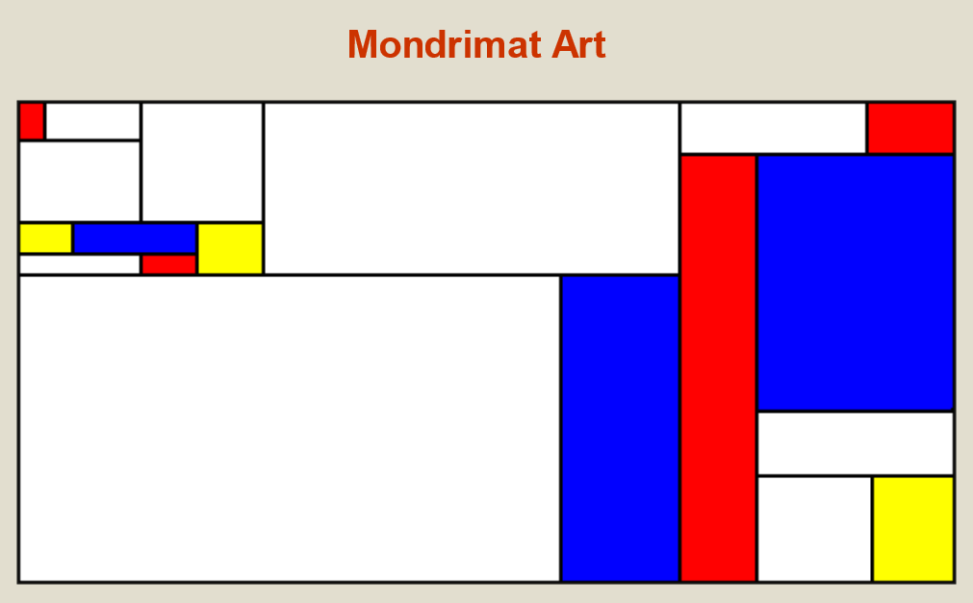

### Part 2

Here's something to think about. What is the purpose of art? Maybe we should ask, instead, what artists do. One might say artists express ideas to stimulate responses in others. A painting may be an artist's expression of a concept, an instance that portrays an idea or object in a specific medium. To a certain extent, isn't that also what programmers do? A program is a model of an abstract or concrete object. Computer scientists are often fascinated by art and its attributes (e.g., structure, form, composition, etc.) and have programmed computers to create computer art.

Do you think a computer could analyze the characteristics of all the different styles of art and devise a completely new style never before seen? Would that be a sign of Artificial Intelligence? Who would the copyright belong to, the CPU, the software, or the programmer? These are serious questions because as computers increasingly program themselves, they may exceed the abilities of carbon-based life forms.