Name: Cole Woodyard
Date: 5/10/2021
08.07 Picture Lab Worksheet
Directions: Make note of your responses to the following questions as you work through the activities and exercise in the lesson.
Activity 5 Questions
Question | Yes | No
- Is the method getPixels2D in the Picture.java class? |  | X
- Is the method getPixels2D in the SimplePicture.java class? | X
- Will the following code compile?  DigitalPicture p = new DigitalPicture(); |  | X
- Assuming a no-argument constructor exists for SimplePicture, will the following code compile?  DigitalPicture p = new SimplePicture(); | X
- Assuming a no-argument constructor exists for Picture, will the following code compile?  DigitalPicture p = new Picture(); |  | X
- Assuming a no-argument constructor exists for Picture, will the following code compile?  SimplePicture p = new Picture(); | X
- Assuming a no-argument constructor exists for SimplePicture, will the following code compile?  Picture p = new SimplePicture(); |  | X

Activity 5 Exercise Results

- Describe your method for keepOnly red, blue, or green.
Travel through each array row and set the blue and green values to 0 until we hit the end of our picture.

- For the negate method, paste your code related to calculating and setting the values for red, blue, and green.
public void negate() {
Pixel[][] pixels = this.getPixels2D();
for (Pixel[] rowArray : pixels) {
for (Pixel pixelObj : rowArray) {
pixelObj.setRed(255 - pixelObj.getRed());
pixelObj.setGreen(255 - pixelObj.getGreen());
pixelObj.setBlue(255 - pixelObj.getBlue());
}
}
}
- Paste a copy of the image that is the result of calling the grayscale.
public void grayscale() {
Pixel[][] pixels = this.getPixels2D();
for (Pixel[] rowArray : pixels) {
for (Pixel pixelObj : rowArray) {
int average = (pixelObj.getRed() + pixelObj.getGreen() + pixelObj.getBlue()) / 3;

pixelObj.setRed(average);
pixelObj.setGreen(average);
pixelObj.setBlue(average);
}
}
}

- For the method fixUnderwater, describe the algorithm you'd propose to accomplish the task.
To help see the fish we can see there is a heavy blue filter applied to the image to mask them. As a result, we can safely assume that negating the blue filter can reverse the image to a respectable degree to make out the fish.
Activity 6 Exercise Results
- Paste the image that is the result of calling the method mirrorVerticalRightToLeft.
USED BEACH FOR EASIER EXAMPLE 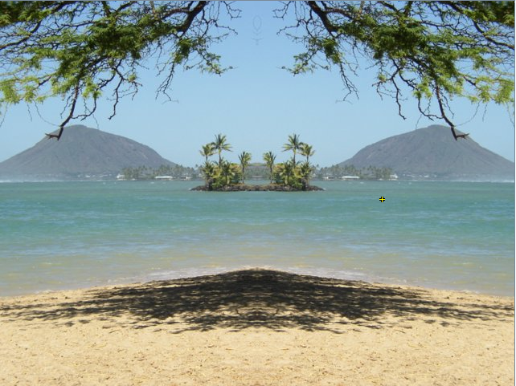

- Describe the algorithm for the method mirrorHorizontal works.
it will do the same thing as mirror vertical but instead will reverse the column and rows portion of the code as if the image was turned 90 degrees. (layman’s terms)
- Paste the image that is the result of calling the method mirrorHorizontalBotToTop.
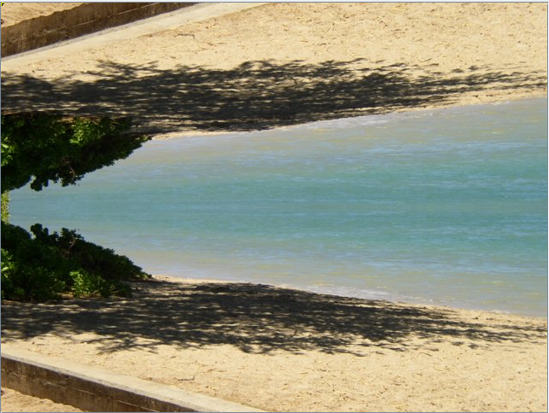

Activity 7 Questions
  - How many times would the body of this nested for loop execute? 90
for(int row = 7; row < 17; row++)
for(int col = 6; col < 15; col++)
  - How many times would the body of this nested for loop execute? 112
for(int row = 5; row <= 11; row++)
for(int col = 3; col <= 18; col++)

Activity 7 Exercise Results

- What value is displayed for count after the nested loop ends in the mirrorTemple method? 0
- Paste the image that is the result of calling the method mirrorArms.
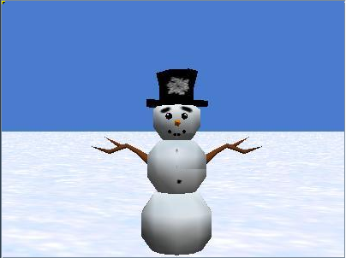
- Paste the image that is the result of calling the method mirrorGull.
