Overview of BlueJ’s Features

A program written with BlueJ is referred to as a Project. As you might guess from the following screen, the first two options (New Project … and Open Project …) will be used frequently.
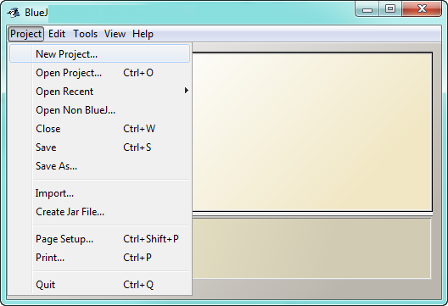

You will use the Save and Save As menu options to store your assignments in the Java Files subfolders. Very few of the options on the remaining menus will be used, but familiarize yourself with each menu when you explore on your own.
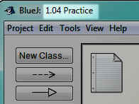
Launch the BlueJ application and create a new project. Save it in the Lessons folder. When you name a new project, use the specific lesson number followed by a meaningful project name, as shown in this example. This project is obviously associated with Lesson 01.04 and is named Practice.
When a new project is created, a document icon will appear, in which you can write notes about the program.

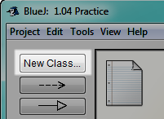
A BlueJ project always consists of one or more classes.
The New Class … button is used to create each new class.

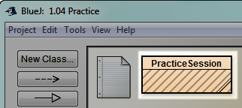
Once a new class is named, its icon appears in the projects window.
The diagonal lines indicate that the class needs to be compiled before it can be run.

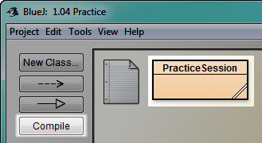
The Compile button is used to check for syntax errors. If no syntax errors are detected by the compiler, all except two of the diagonal lines will disappear from the class icon.

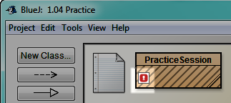
However, if the compiler detects an error, you will hear an annoying sound, and the class icon will appear as follows.
You should get used to this because your programs will contain many errors that need to be fixed.

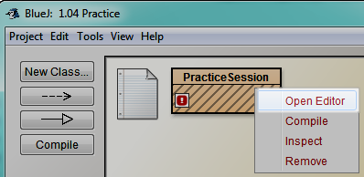
When a program does not compile, right click once on the class icon and choose the Open Editor option from the pop up menu. The source code will appear in the project window so that you can find the error, fix it, and recompile. As an alternative, you can simply double left click on the class icon to display the source code.
The source code will appear in the project window so that you can find the error, fix it, and recompile. If you want, you can make yours look like the image below. Most will already appear. Delete the extra lines of code BlueJ provided by default and type the portion in yellow.
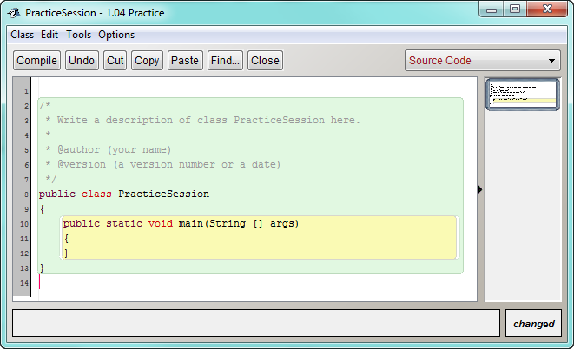

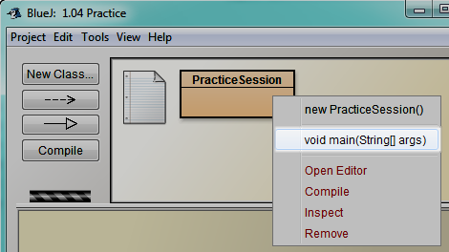
And, last but not least, once the program compiles correctly, it is time to run it. Right click on the class icon and choose the highlighted option shown in the popup menu below (void main(String[] args), then select OK.
If there are no additional runtime errors, the program should execute and produce the desired output. The PracticeSession program doesn't do anything. Soon you'll write programs to do all sorts of things.
These are the highpoints of the BlueJ IDE. The BlueJ Tutorial goes into much greater detail, so consult it if you have questions. The tutorial can be found by selecting the Help menu.

