Quick Start Guide

- To create a new project:
- Select New Project … from the Project menu.
- Navigate to the folder to place the new project folder.
- Following Folder Name:, type the project name.
- Select Create.
- To open a project:
- Select Open Project … from the Project menu.
- Select the project name.
- Select Open.
- To create a class:
- Left click the New Class … button
- Enter a valid class name.
- Select OK.

- To edit the source code of a class:
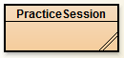
- Double left click on the class icon.

- To compile a class:
- Left click the Compile button in the editor view.
or
- Right click the class icon in the project window view.
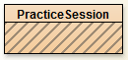
- Left click the Compile menu option.

- To compile a project:
- Left click the Compile button in the project window view.

- To run a program:
- Left click the class icon.
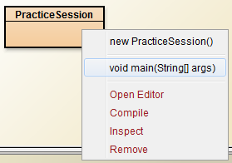
- Select the void main(String[] args) option in the pop up menu.
- Select OK.

- To get help for a compiler error message:
- Left click the question mark next to the error message.

- To remove a class:
- Right click on the class icon in the project window.
- Select the Remove option from the popup menu.

- To view the Java standard class API:
- Select Java Class Libraries from the Help menu.

- To view the BlueJ Tutorial:
- Select BlueJ Tutorial from the Help menu.

