# Strabismus

Strabismus is lazy eye. We detect this by detecting the differing ratios of sclera(the white of the eye) area in eyes that are looking not in the same direction

## Algorithm

1. Detect face
2. Detect eyes
3. Obtain area of left and right sclera for each eye
4. Compare area of left sclera on left eye to area of left sclera on right eye
5. Compare area of right sclera on left eye to area of right sclera on right eye
6. If the comparisons are significantly[1] off then it is likely the patient has astigmatism

## Examples

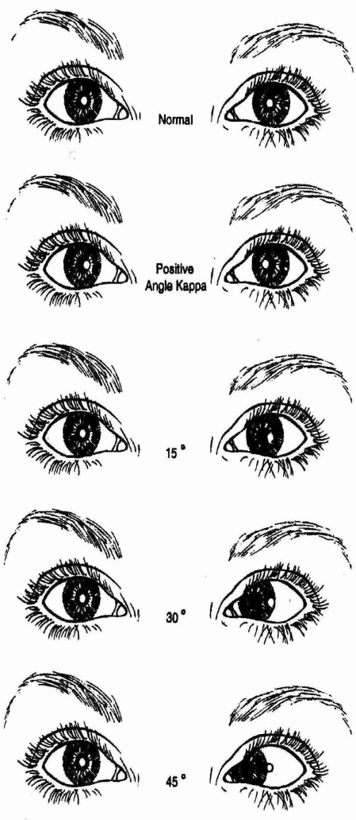

***Figure 1:*** *As the angle between the eyes increases the ratio of the left eye’s sclera to the right eye’s sclera becomes diverges*

*(continued below)*

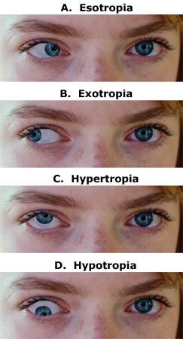

***Figure 2:*** *As pictures C and D show an eye can also be misaligned in along it’s vertical axis.*

# Astigmatism

Astigmatism is a malformation of the eye. This can be detected by looking at the crescent shaped reflection in the eye that appears because of the red eye effect. An unhealthy eye will have a crescent to pupil ratio that is significantly[2] different from that of a normal eye. Both a horizontal and a vertical picture are taken so that we can normalize the crescent size in that patient’s eye and detect horizontal or vertical malformations.

## Algorithm

1. For the horizontal and the vertical photo:
   1. Detect the face
   2. Detect the eyes
   3. Detect the pupil
   4. Measure the area of the pupil
   5. Detect the crescent
   6. Measure the area of crescent to pupil
2. If the crescent:pupil ratio is unhealthy in either photo the patient may have astigmatism

## Examples

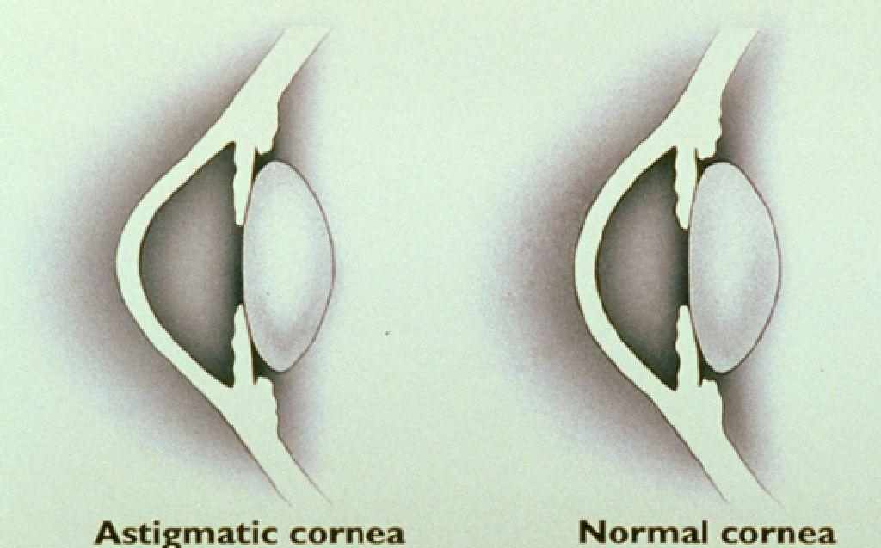

***Figure 3:*** *Difference between astigmatic and normal cornea*



***Figure 4:*** *An example of the crescent detection process*

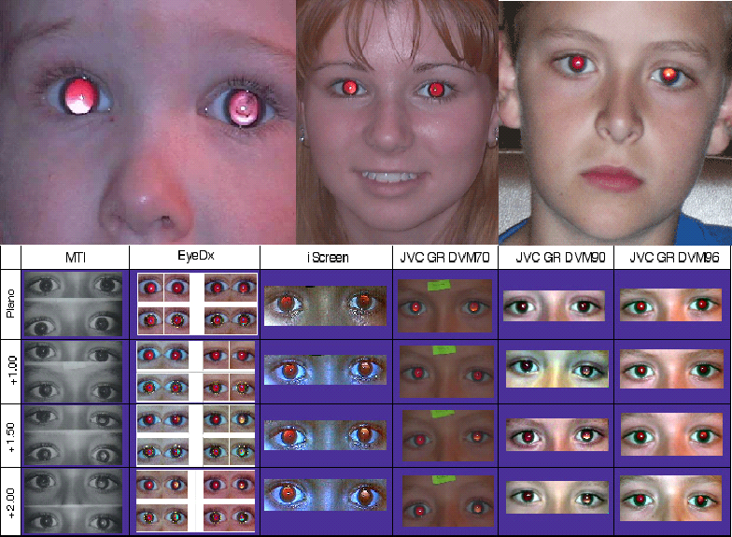

***Figure 5:*** *Examples of the images we’ll be working with*

# Cataracts

Cataracts is characterized by cloudiness in the eyes.

# Algorithm

1. Detect face
2. Detect eyes
3. Detect pupils
4. Detect cloudiness[3]

# Examples

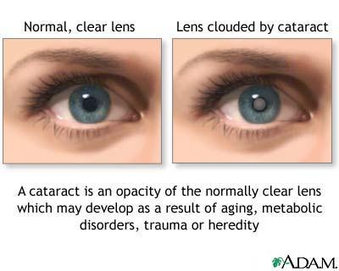

***Figure 6:*** *Overview of Cataracts*

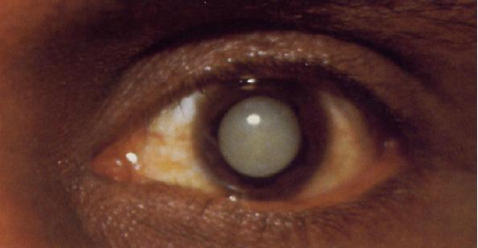

***Figure 7:*** *Eye fully occluded by cataracts*

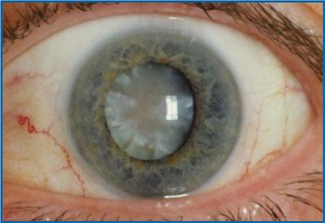

***Figure 8:***  *Another cataracts eye*

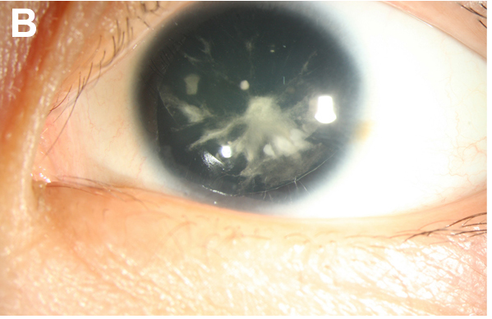

***Figure 9:*** *Eye partially occluded by cataracts*

1. significance is trained through machine learning
2. significance is trained through machine learning
3. We currently do not have a more fine grain algorithm than this.