**Báo cáo thiết kế và xây dựng phần mềm**

1. **Bài tập 1**

1. **Bài tập 2**

1. **Bài tập 3**

1. **GIT actions**

* **Add file**

* **Remove file**

* **Modify file**

* **Commit & push**

* **Pull & resolve merge conflict**

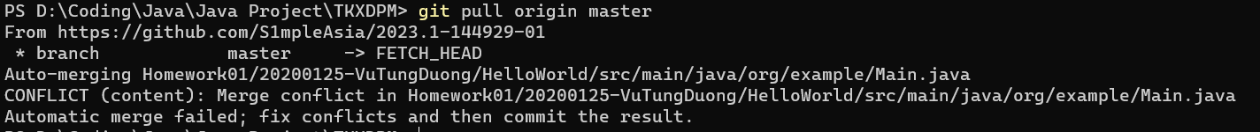

* **Create branch**

* **Merge branch**

