## Forward-Facing Steps Induced Transition in a Subsonic Boundary Layer

Forward-facing steps (FFS) are common configurations in engineering applications. For example, minor errors in installation of tile-shaped surfaces and wind turbines located on hills can both be categorized into forward-facing step flows. Despite its simple two-dimensional geometry, the flow over a forward-facing step can be quite complicated. In this paper, forward-facing steps immersed in a subsonic boundary layer are surveyed through a high-order Computational Fluid Dynamics (CFD) method, in order to investigate the flow transition phenomenon induced by the forward-facing step.

## Introduction

The flow phenomenon of transition from laminar to turbulent flow has long attracted the attention of researchers. On one hand, it is one of the problems that is not totally solved in classic Newtonian mechanics, while on the other hand, it is commonly observed in the engineering field as well. However, the intrinsic nonlinearity of the Navier-Stokes equation adds to the difficulty of understanding the transition phenomena.

The nonlinearity property also gives rise to some complicated flow physics. For example, for two-dimensional geometries such as Forward-Facing Steps (FFS) and Backward-Facing Steps (BFS), an inflow condition with disturbance may induce three-dimensional flow structures, which is a key step in transition from laminar to turbulent flows.

Although similar in geometry configuration, BFS has accumulated much more detailed research results than FFS. For instance, Brederode and Bradshaw [1] studied the separation region of BFS experimentally, and Eaton and Johnston [2] reviewed the reattachment in the downstream of BFS. Nevertheless, there is much less research on FFS. Chiba et. al.[3] made experiments on flow through a forward-facing step channel of both Newtonian and non-Newtonian fluid. Largeau and Moriniere [4] measured wall pressure fluctuations and flow fields in separated flows over a forward facing step. Camussi et. al. [5] analyzed statistical properties of wall pressure fluctuations over a forward facing step. Stuer, Gyr and Kinzelbach [6] and Zukoski [7] studied low speed laminar separation flow and supersonic turbulent separation flow over a forward facing step respectively.

The papers referred above mainly falls into two Reynolds number ranges. One is the low-Reynolds-number case, such that the inlet flow is laminar, and the evolution of small disturbances is analyzed. The other is the high-Reynolds-number case, where the upstream flow is fully turbulent, and the basic focus is pressure distributions and flow regime. However, few research has been published for the Reynolds number in between, which is called the mid-Reynolds-number case here. In this range, the inlet flow is laminar, yet the FFS may induce flow transition. Moreover, most of the papers referred above pay their attention to forward-facing steps in channel flows, while the FFS in the boundary layer flow is more or less neglected.

The thesis of Edelmann [8] focused on the transitional effects of the FFS in boundary layers. A blowing-suction pulse disturbance is set on the wall upstream of the FFS, and the evolution of this wave package is studied. Numerous different flow cases are considered, including a Mach number range from 0.15 to 1.06, Reynolds number based on the step height from 400 to 4440, and zero-or-favorable streamwise pressure condition. Results were obtained by linearized flow instability analysis, and direct numerical simulation of the disturbance Navier-Stokes equation.

It is well known that there are two types of transition in boundary layer flows, that is, natural transition and bypass transition. In a natural transition, the inflow disturbances, typically the Tollmien-Schlichting waves, experience an exponential growth in the first stage, then the nonlinearity brings up disturbance in different wavelengths, and finally the vortices break down, where the flow becomes fully turbulent. By contrast, the linear stage does not exist in the bypass transition. Due to the larger amplitude of inflow disturbance, or other kinds of disturbances such as obstacles on walls and fluctuations from outside of the boundary layer, the transitional flow skipped the linear growth stage, and non-linear instability is triggered directly.

Previous studies have demonstrated that three-dimensional obstacles in boundary layers could trigger flow transition for flows at a certain Reynolds number range. For example, diamond-shaped or cylinder-shaped obstacles in boundary layers can bring up three-dimensional horse-shoe vortices, and lead the boundary layer to become fully turbulent.[9] However, how a two-dimensional obstacle, such as the FFS, could affect the transitional boundary layer is not so clear yet. The key difference here is that, three-dimensional horse-shoe vortices which plays a key role in obstacles flows does not exist in the FFS flow, therefore the mechanism in boundary-layer transition should be distinct.

This paper presents a numerical study of the influence of FFS on the transition of boundary-layer flows, based on the high-order Flux Reconstruction (FR) method with the Implicit Large Eddy Simulation approach (ILES). In Section 2, a brief introduction of the numerical methods is given. Then in Section 3, the cases are described, and the flow physics are studied in detail. Finally the conclusions are drawn in Section 4.

## Numerical Methods

Transitional flows are governed by compressible Navier-Stokes equations. In Cartesian coordinates, the Navier-Stokes equations can be written as:



where

，，，

Here, U is the conservative variables, F and Fv are convective and viscous fluxes respectively, and ρ, p and u are density, pressure and velocity components. For perfect gas, E is specific total energy, , and e is specific internal energy, . H is specific total enthalpy, , where R is the gas constant, and γ is the specific heat ratio. σij and qi are components of viscous stress tensor and heat conduction vector respectively.

Transitional flows are dominated by waves and vortices of different sizes. Thus, a numerical method that can resolve a wide range of length scales is required. Among traditional CFD methods, the Finite Difference Method (FDM) is usually applied to such flows, due to its high resolution ability. However, boundary conditions are not easy to treat in FDM, since the scheme is not compact.

On the other hand, the resolution ability of high-order Finite Element Methods (FEM), such as Flux Reconstruction (FR) and Discontinuous Galerkin (DG), is similar to that of FDM, meanwhile the numerical scheme involves one layer of neighboring cells. Therefore, it is much easier to apply boundary conditions in high-order FEM. In transitional flows, both solid wall and outflow boundaries could play important roles in numerical simulations, and the advantages of high-order FEM are not trivial.

In this paper, an in-house CFD solver called MUltiphysics SImulation Code (MUSIC) is adopted to calculate the transitional flows induced by forward-facing steps. MUSIC is a high-order Flux Reconstruction solver on unstructured meshes. Here a brief introduction of the numerical method is demonstrated.

### Basic Ideas of the Flux Reconstruction method

The Flux Reconstruction method was first introduced by Huynh in hexahedral cells [], and later Wang [10] developed this method to other kinds of cells including simplexes. The FR method can be categorized into discontinuous finite element methods. It involves multiple degrees of freedom (DOFs) in one computation cell, just like standard FEM, and uses Riemann solvers to calculate fluxes on cell interfaces, which resembles Finite Volume Method (FVM).

The DOFs in cells are variables at certain points called Solution Points (SP), and flux between cells are evaluated at points on cell interfaces called Flux Points (FP). In order to achieve the best numerical accuracy, Gauss quadrature points are chosen as SPs and FPs.

The first step of the FR method is to reconstruct a polynomial of flux in a cell based on variables at SPs. This polynomial is discontinuous at cell interfaces, thus not applicable directly. Nevertheless, a Riemann solver can be employed to get a common flux at FPs, and a correction to the flux polynomial is added. Then, the derivative of the corrected polynomial is used to propagate the solution to the next time step.

These two steps are known as the reconstruction step and the correction step respectively. Therefore, the Flux Reconstruction method is called Correction Procedure via Reconstruction (CPR) as well.

### Calculation of the Viscous Term

The procedure described above is only available for the first-order convection term, and the second-order viscous term should be calculated in a different way. Here, an additional set of equations is introduced to evaluate the gradient of conservative variables:



This augmented equation is also a first-order partial differential equation (PDE), and can also be solved by the FR method, although the cost may be high. Bassi and Rebay [11] developed a simple algebraic scheme called BR2 to achieve the solution approximately, and Huynh [12] introduced this scheme to the FR method. The BR2 scheme is a compact one involving only the immediate neighboring cell, and also purely symmetric, which mimics the elliptic property of the viscous term.

### Time Integration

Since an Implicit Large Eddy Simulation (ILES) approach is to be used, the calculation has to take the unsteady effect into account. For the high-order Flux Reconstruction method, explicit Runge-Kutta time integration could be an appropriate choice, because it finds a balance between precision and efficiency. Here, a Strong Stability Preserving (SSP) third-order Runge-Kutta [13] scheme is adopted. The coefficients in the SSP Runge-Kutta scheme are carefully tuned to improve the numerical stability, and the maximum CFL number could reach 1.0. The scheme is as follows:



### Characteristic Outflow Boundary Condition

The outflow boundary condition plays an important role in the calculation. If treated improperly, spurious flow structures may come up in the vicinity of the outflow boundary, thus deteriorate the results.

The Flux Reconstruction method applies the boundary condition at boundary Flux Points, using Riemann solver for inviscid flux and Bassi-Rebay 2 scheme mentioned in 2.2 for viscous flux respectively. Comparing to the Finite Volume Method, virtual mesh is not necessary herein.

In this paper, the flows are all at low Mach number, so that the outflow condition is always subsonic. Only one outflow parameter should be fixed, according to the one-dimensional Riemann invariant theory. Here the back pressure is given, while all other values are extrapolated from the flow.

The outflow boundary condition applied are as follows:

1. Extrapolate conservative variables to the boundary,
2. Compute the corresponding characteristic variables at the boundary,
3. Use fixed back pressure to compute given boundary characteristic values,
4. Compute the given boundary conservative variables.

This procedure is able to minimize the fake disturbance caused by the outflow condition.

### Implicit Large Eddy Simulation

There has been a heated discussion on whether Large Eddy Simulations (LES) can be applied to transitional flows. Some researchers infer that the resolving ability of LES helps to capture the waves in the transitional phase, while others insist that the sub-grid scale is incorrectly modelled by the standard Smagorinsky model. Both sides have their points, whereas the resolving part should play a more important role, since structures in large scale dominates the flow until late transitional phase, and the sub-grid scale (SGS) model should not interfere the flow too much.

In this paper, an implicit Large Eddy Simulation approach based on the high-order Flux Reconstruction method is adopted. The high-order FR method can well capture flow structures on a relatively coarse mesh, and the implicit LES approach minimizes the SGS effect. This method finds a balance between the two viewpoints mentioned here.

## Results and Discussion

### Case Description

The transitional flow over an FFS inside a subsonic flat plate boundary layer is simulated. Due to limited computer resources, the streamwise length computed is only 100 times of the height of the FFS (h). The step is set at the streamwise location of x=0. The inlet plane is set at 50 times of h upstream of the FFS, while the outflow plane is located at 50 times of h downstream of the step. The upper boundary is set as farfield boundary condition at 50 times of h, thus minimizes its effect on the boundary layer. The characteristic outflow boundary described in Section 2.4 is applied at the outflow boundary.

The Reynolds number based on the height of FFS is 720, and the streamwise Reynolds number is 330624, which stays in the middle of transition stage from laminar to turbulent flows, according to the classic boundary layer theory. The height of FFS is one-third of the thickness of boundary layer at inlet plane, and the spanwise range is 30 times of h. At the inlet plane, the Reynolds number based on the streamwise location from the leading edge of the flate plate is 186624, meaning that the transition procedure is beyond the linear growth phase. Therefore, a disturbance with finite amplitude is superimposed to the Blasius velocity profile. The final inlet velocity profile is as follows:



whereand  is the amplitude of the disturbance, which is both set as 0.05 here, and  are the thickness of boundary layer and the spanwise width respectively. The disturbance is periodic in time with a frequency of , in order to better simulate real inlet flow.

The inlet velocity profile is illustrated in Figure X. Due to the property of sine and cosine functions, the mean profile is identical to the Blasius solution, and the maximum and minimum curves are perturbed velocity profiles with the maximum magnitude.

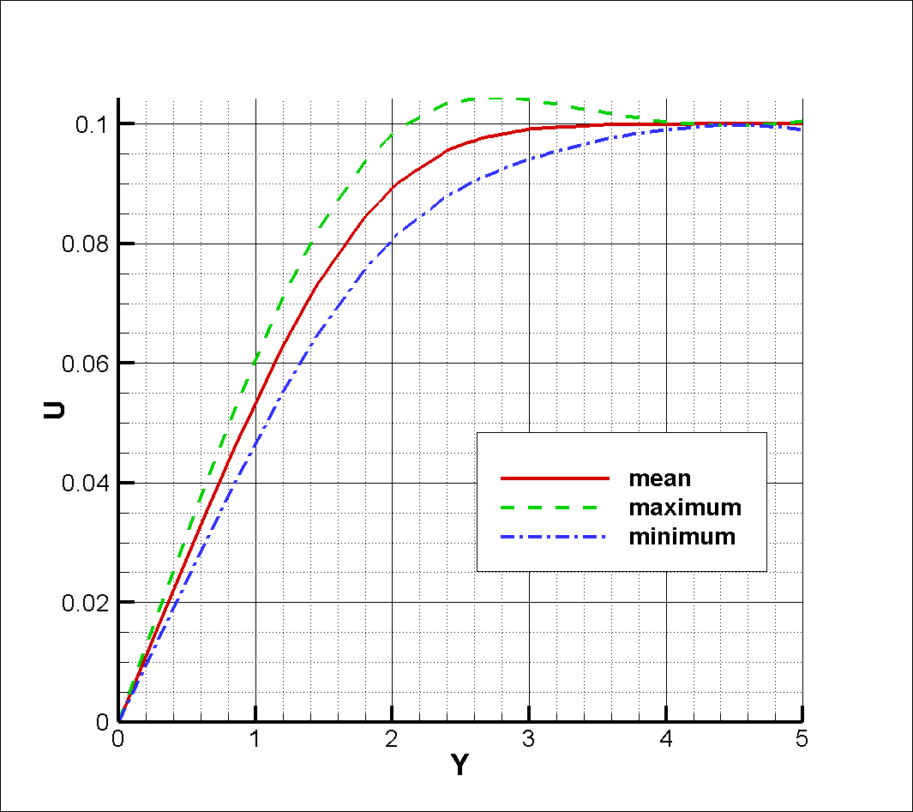

### Mean Flow Analysis

Flat plate boundary layer flows serve as a basis for the study of transitional flows. Here, a flat plate with the same inlet flow condition and other configurations is calculated, in order to find whether such disturbance will trigger the flow transition itself.

Figure X shows the averaged streamwise velocity profile at different streamwise locations of the flat plate boundary layer flow calculated. The flowfield is both averaged both in time series and in spanwise direction, with more than 60 million samples altogether. It is found that at all the streamwise planes shown in the figure, the velocity profiles resemble each other, with almost identical slope at the wall. This supports the viewpoint that the flow stays laminar in this case.

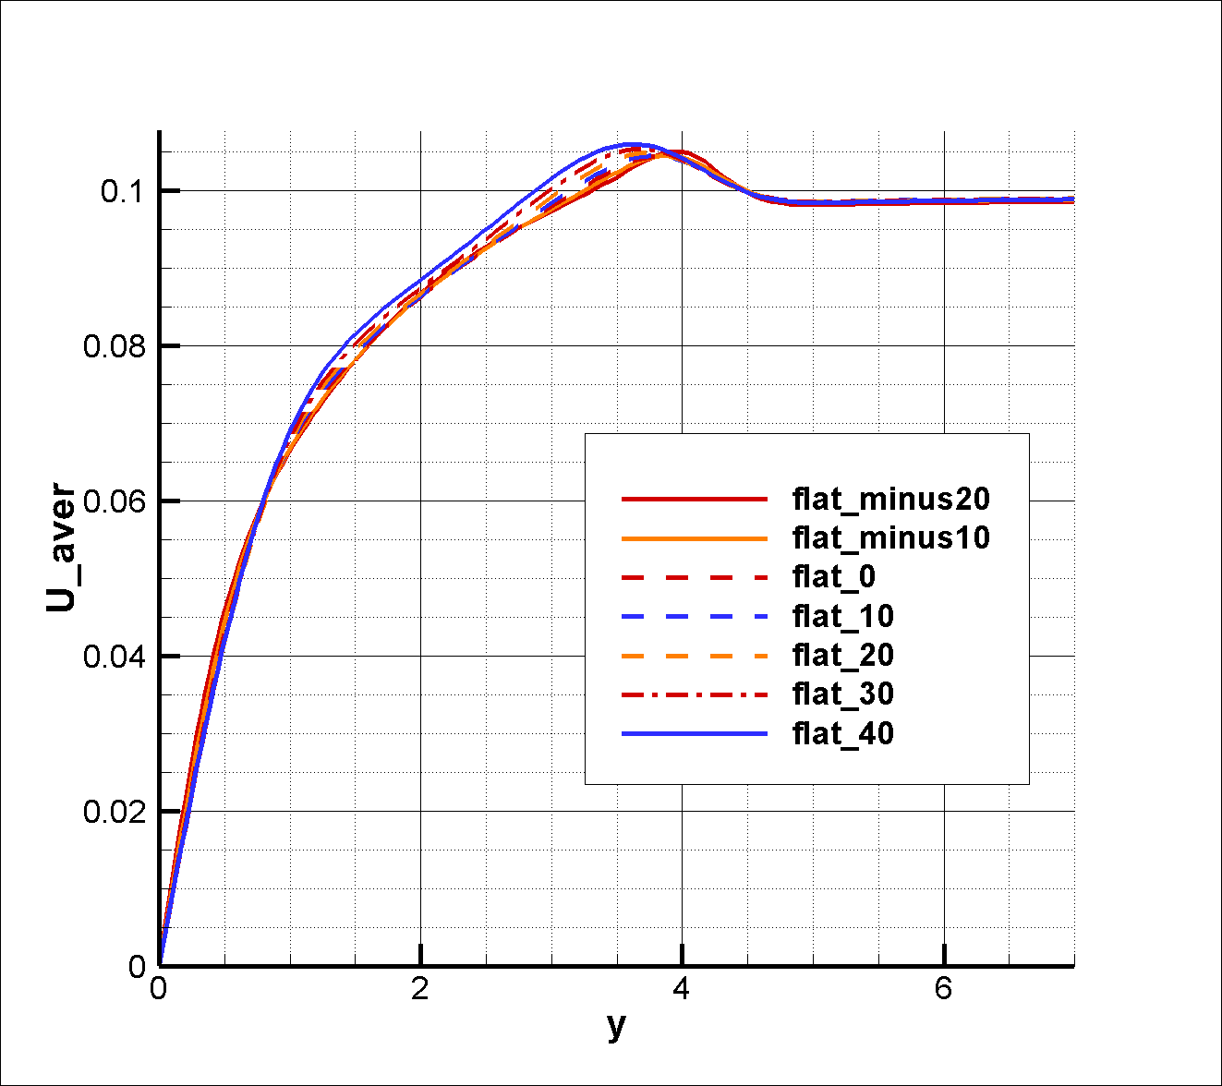

Non-dimensional turbulent intensity of the flat plate flow is shown in Figure X. Here k is the turbulent kinetic energy, and U is the magnitude of local velocity. This variable takes both averaged local velocity and turbulent effect into effect, eliminating the sharp velocity changing effect in the boundary layer. For the flat plate flow, the value of non-dimensional turbulent intensity is no larger than 0.04 in the whole boundary layer, also indicating that the flow is not experiencing a transition. These figures above demonstrate that the disturbance added at the inlet plane could not trigger the boundary layer transition by itself.

On the other hand, with respect to the forward-facing step, the case is quite different. Figure X presents the time-averaged streamline and non-dimensional turbulent intensity in the vicinity of the step. Two separation regions can be observed: one at the upstream of the FFS, the other at the top of the step. In both regions, streamlines bears complicated topology, including multiple vortices and saddle points. It is noteworthy that the first reattachment point locates at the vertical wall of the step instead of the corner, which means that the two separation regions are isolated. Meanwhile, high non-dimensional turbulent intensity coincides in these two regions, indicating that these separations are possibly amplifying the inflow disturbance and triggering transition. On the other hand, the streamlines outside the separation regions become concave, which may be a source of flow instability according to classic theory as well.

The time-averaged streamwise velocity profile is given in Figure X. At the upstream of the step, due to the separation effect, slopes at the wall are significantly small, while at the downstream side, the velocity profiles are developing rapidly, with growing slope at the wall. This is also an evidence of transitioning boundary layer.

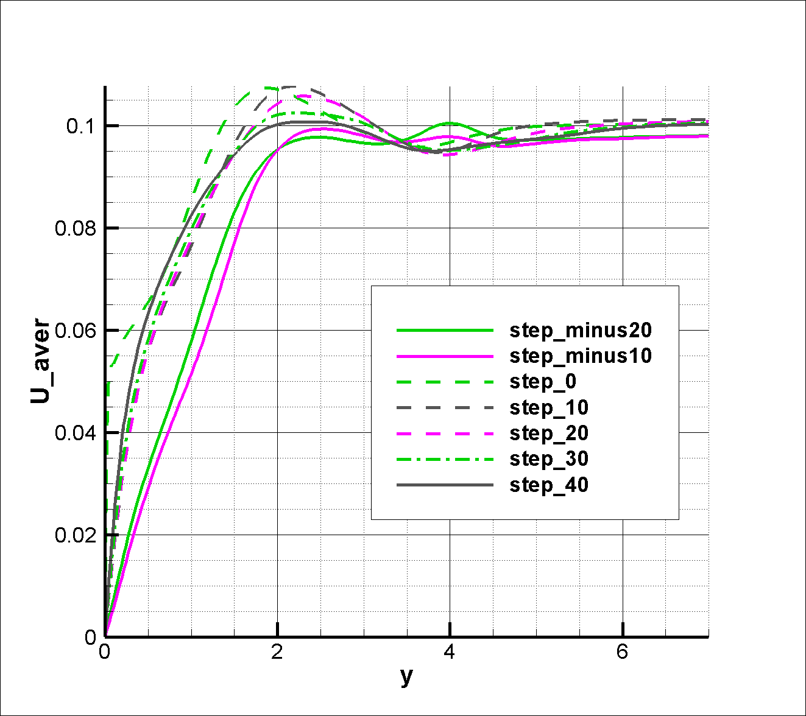

The eddy viscosity is a common variable for modelling fully turbulent flows and transitional flows. In fact, almost all popular transition models, such as Menter’s transitional SST model [13] and the Fu-Wang transition model [14] are based on the eddy viscosity hypothesis. Here, the eddy viscosity is estimated by the averaged flowfield. According to the eddy viscosity hypothesis, the Reynolds shear stress is proportional to the averaged shear rate:



where U and V stands for the velocity components in x and y directions respectively,  stands for the eddy viscosity, and  is the Reynolds shear stress. Classic boundary layer theory assumes that the y-velocity is negligible compared to the x- velocity, and the gradients in the streamwise direction is small. Therefore, the eddy viscosity can be estimated by the following equation:



The estimated non-dimensional eddy viscosity, defined as eddy viscosity divided by fluid viscosity, is shown in Figure X. It can be found that in the separation region at the upstream of the step, the eddy viscosity begins to grow. At the corner of the step, the eddy viscosity reaches its first local maxima, and continues to ascend after the second re-attachment point, to a value greater than 10. The eddy viscosity growth just outside of the first separation region is also significant, which can be related to streamwise vortices there, as is discussed later.

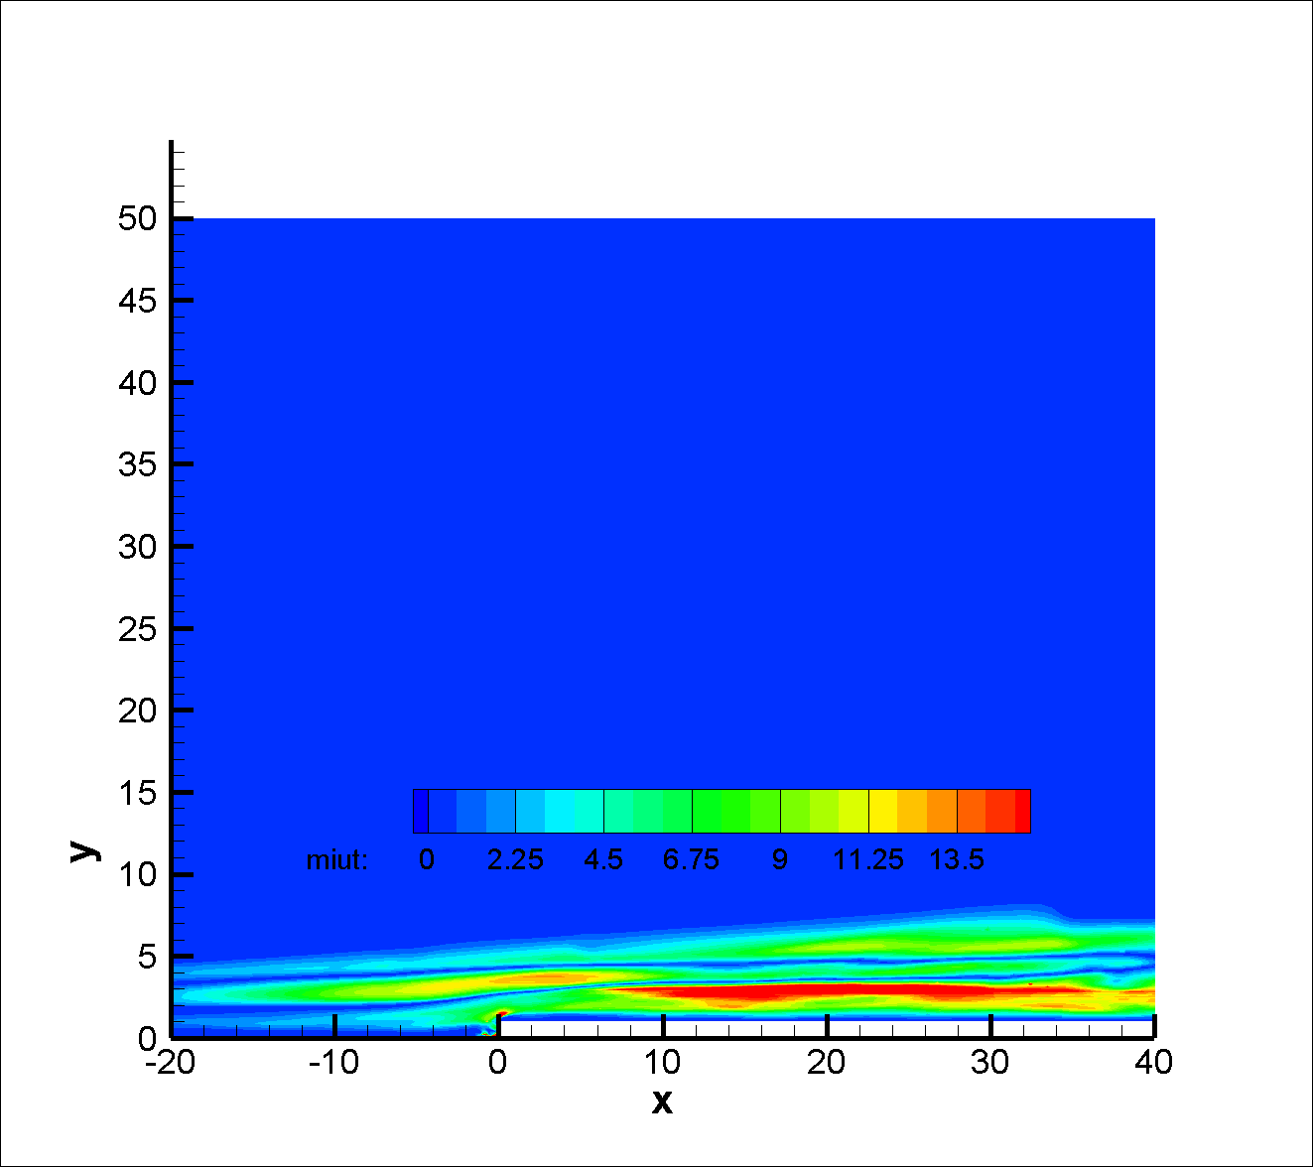

The Reynolds shear stress is shown in Fig. X. Negative values of Reynolds shear stress <u’v’> can be observed in the downstream of the step, meaning that the high-speed fluid particles are sweeping downwards to the wall, while the low-speed fluid particles are going away from the wall. This exchanges the momentum in the wall normal direction of the boundary layer, which accelerates the flow transition. The Reynolds shear stress shows positive values outside of the first separation region as mentioned before, confirming that streamwise vortices exist there.

### Frequency Analysis

Fourier analysis of pressure history at certain sample points can be helpful in understanding the transitional flows. In this section, sample points at different locations are studied, as shown in Table X and Fig. X. The pressure history analyzed at each point is recorded from non-dimensional time 2000 to 3000, with 500000 time steps at all.

It can be observed that the pressure history bears a wide frequency range at all points. Point 1 and 2 are located at the upstream of the step. The amplitude of pressure fluctuation is relatively low at these points, with an isolated main frequency at 0.01 Hz and a set of energy-containing frequencies around 0.1 Hz. Point 3 and 4 are set in the first separation region in the upstream of the step, and another low main frequency can be found next to the 0.01 Hz one, with the energy at all frequencies goes higher. At point 5, 6 and 7, whose location is along the edge of the step, the pressure fluctuations are similar, meaning that the flow shows little difference in frequency in the spanwise direction . Point 8, 9, 10 and 11 are along the center line downstream of the step. As it goes downstream, the amplitude gets higher as well. Comparing point 1 and 12, the magnitude of pressure fluctuation has a growth of around 10 times.

Table 1

|  |  |
| --- | --- |
| Sample point | Coordinate |
| 1 | (-10,0,15) |
| 2 | (-5,0,15) |
| 3 | (-1,0,15) |
| 4 | (0,0,15) |
| 5 | (0,1,15) |
| 6 | (0,1,10) |
| 7 | (0,1,20) |
| 8 | (1,1,15) |
| 9 | (5,1,15) |
| 10 | (10,1,15) |
| 11 | (20,1,15) |
| 12 | (40,1,15) |

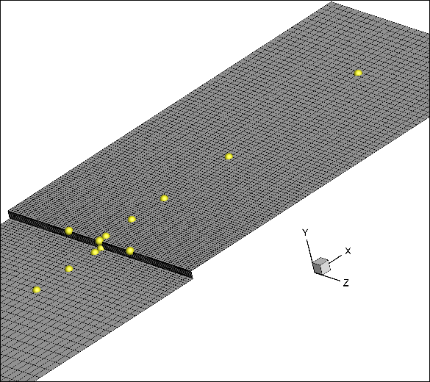

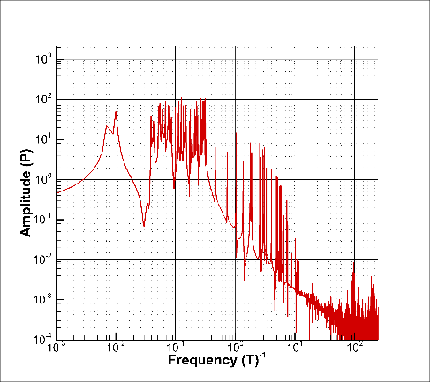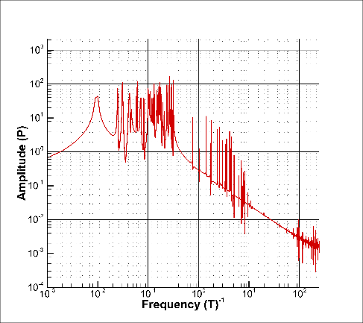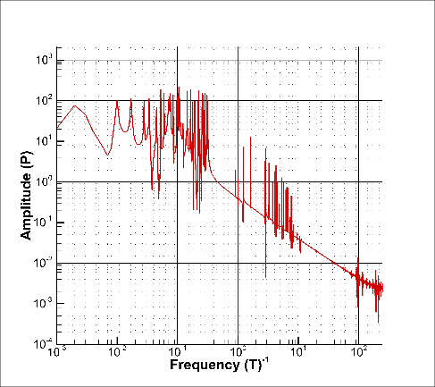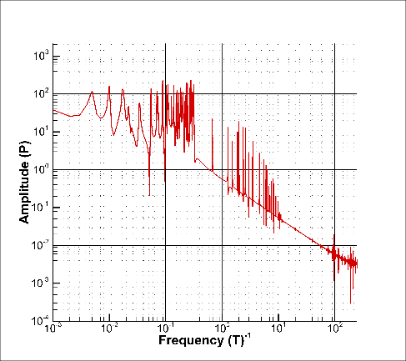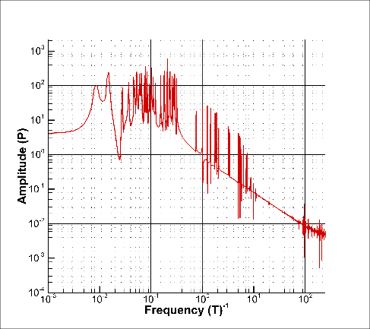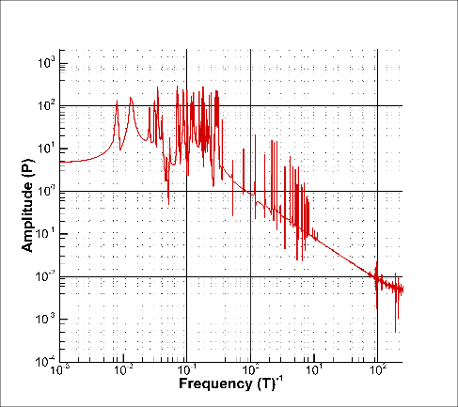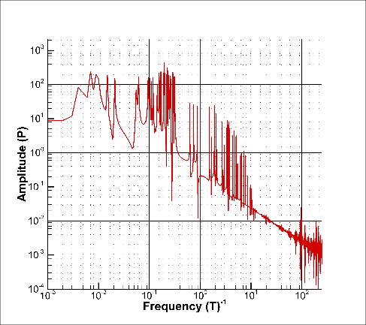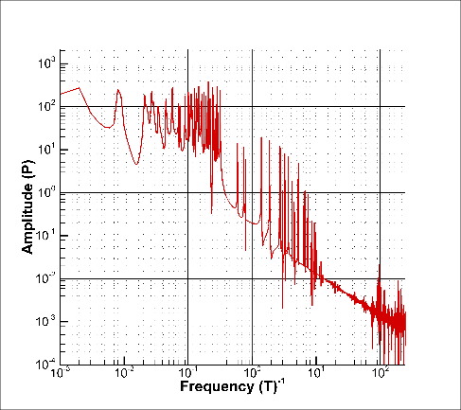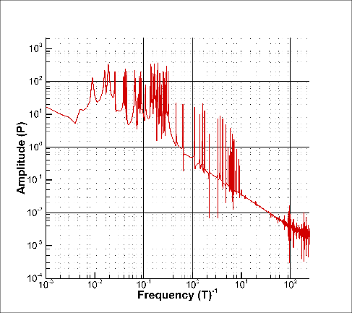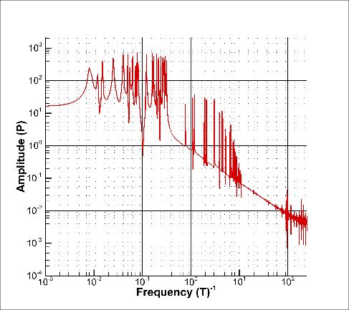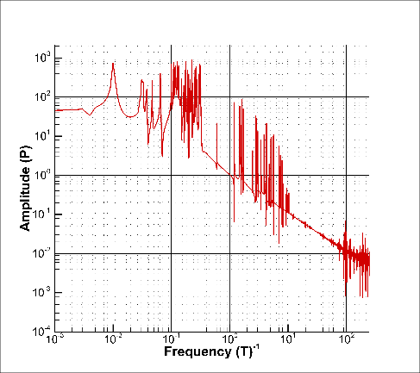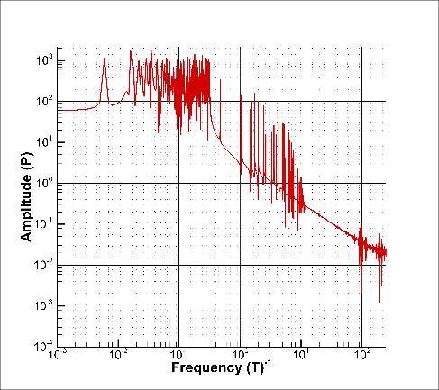

### Instantaneous Flow Analysis

The instantaneous isosurface of vorticity in the upstream of the FFS is shown in Fig. X. The inlet disturbance invokes unsteady weak vortices in the upstream of the step. These vortices later interacts with the step and break down into small scale structures.

On the other hand, the instantaneous isosurface of vorticity over the flat plate is shown in Fig. X. The snapshot time is at non-dimensional time t = 3000. Weak streamwise vortices are formed as well, thus the averaged velocity profiles deviate from the Blasius solution at different streamwise locations, as is discussed before. However, these weak vortices do not deform or breakdown as it goes downstream. This confirmed the observation before that the inlet disturbance itself cannot trigger flow transition.

Streamwise slices of instantaneous vorticities in the vicinity of the step is shown in Figure X to X. The snapshot time is at non-dimensional time t = 2700. The incoming disturbance behaves as weak vortices in the boundary layer. When it reaches x = -10, small scale secondary structures begin to emerge on the edge of these weak vortices, and continues to grow and move upwards in the first separation region. At x = -0.5, the main vortices become much stronger and gets lower, and the secondary vortices go further upwards and deform into pairs of vortices. Then at the corner plane where x = 0, the lower main vortices are blocked by the step, while the secondary vortices climb over the step and continue to grow stronger. At x = 5, these secondary vortices are still significant. It can be found that these secondary vortices lies in the streamwise direction, and continuous become stronger as it goes downstream. Meanwhile, the vertical location of these vortices is going upwards in the upstream of the step, but stays stationary later in the downstream of the step. This indicates that the structures observed here is actually a set of streamwise vortices, which resembles the experimental results of Stuer[15].

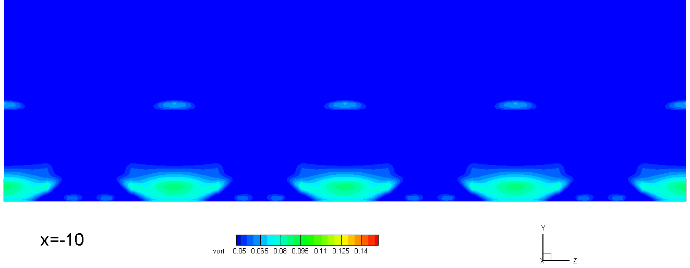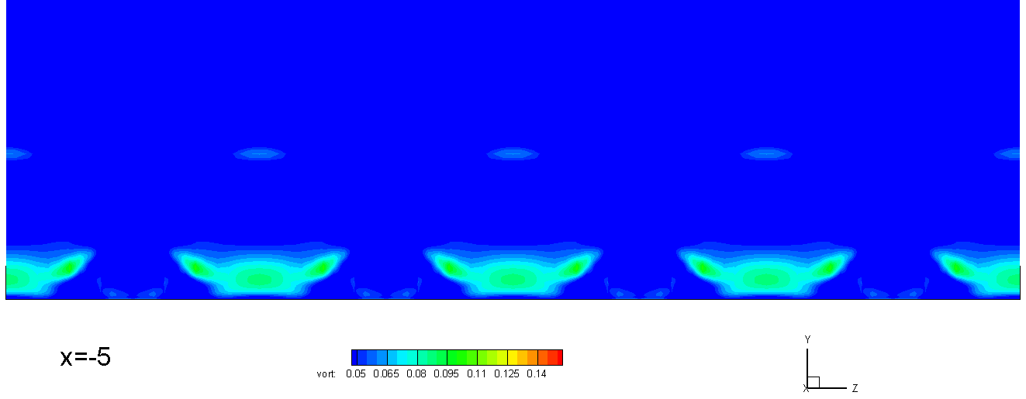

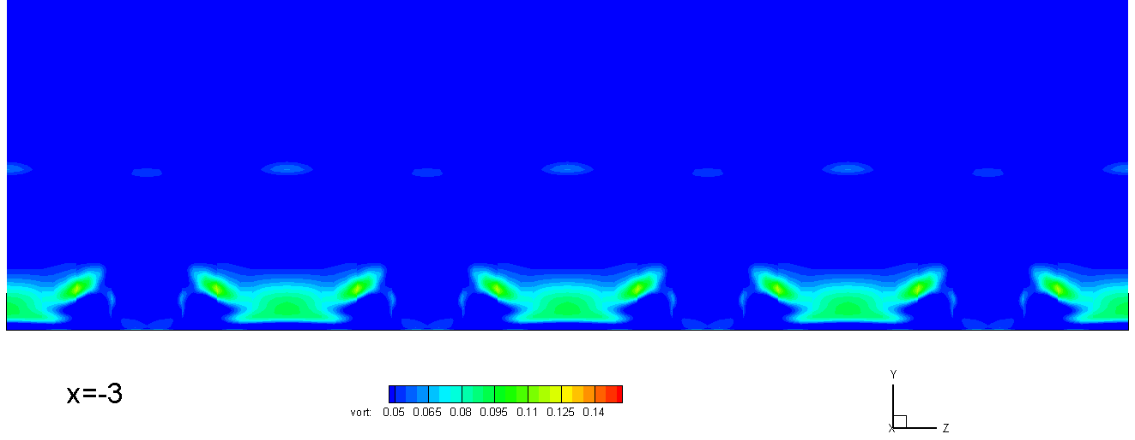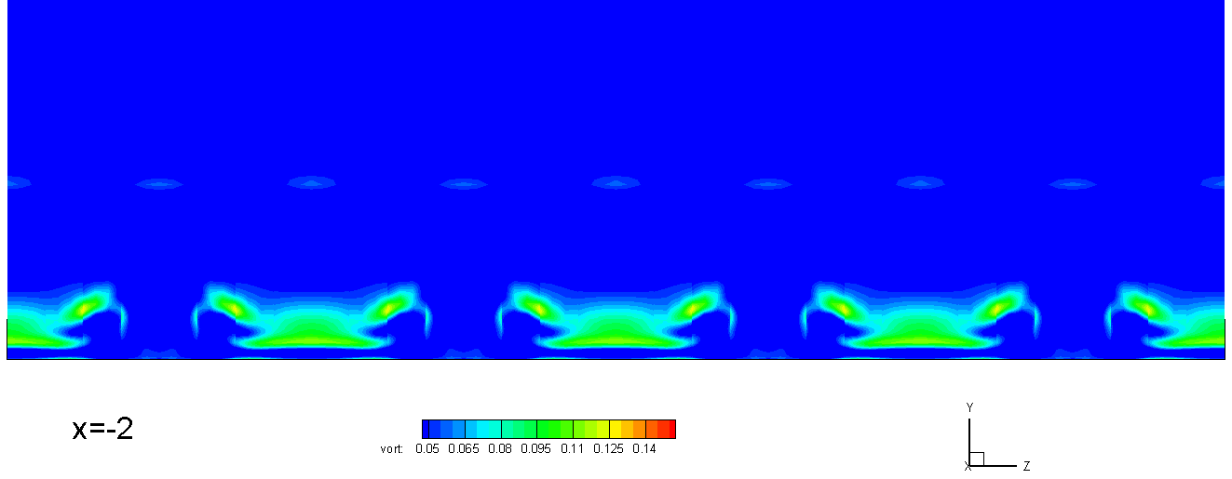

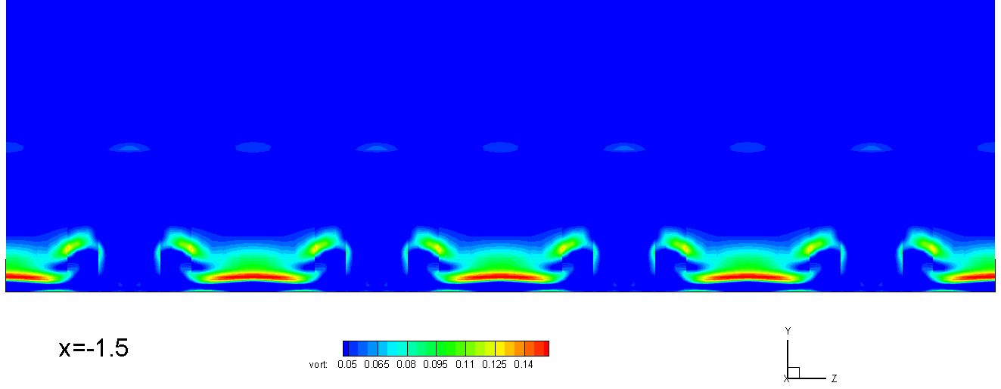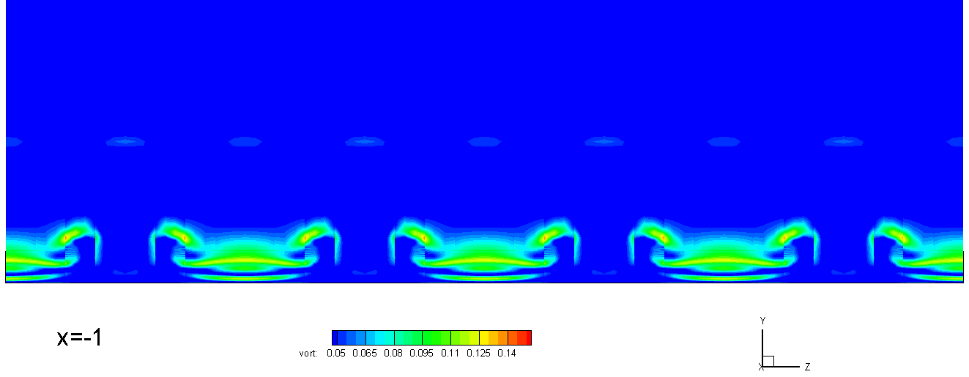

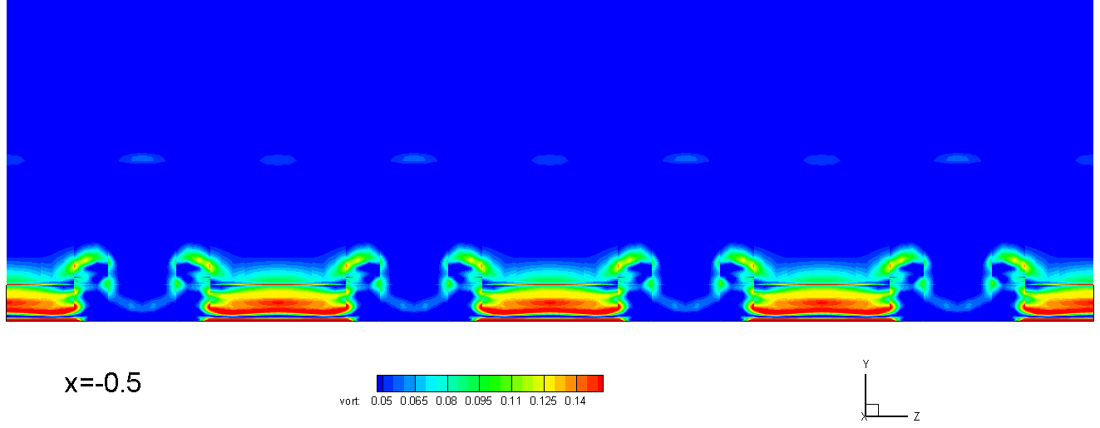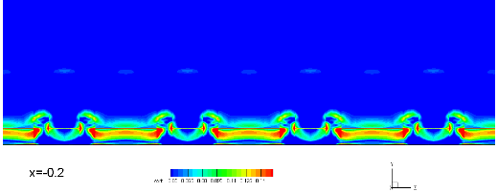

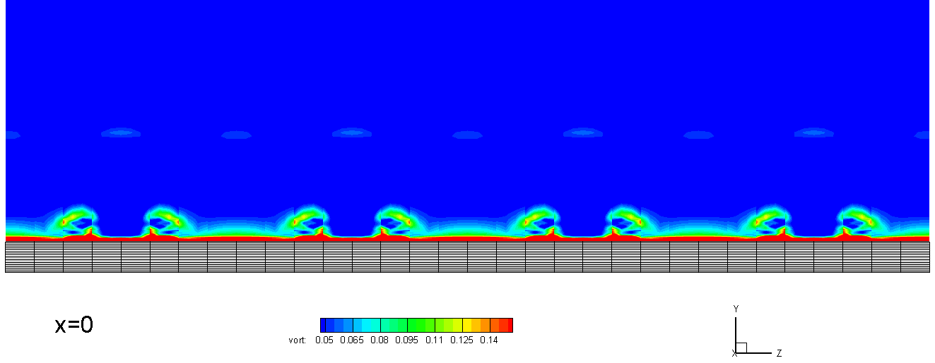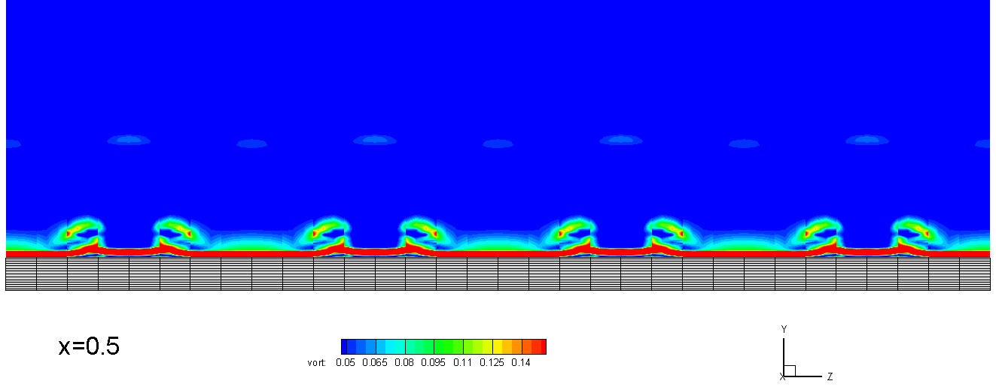

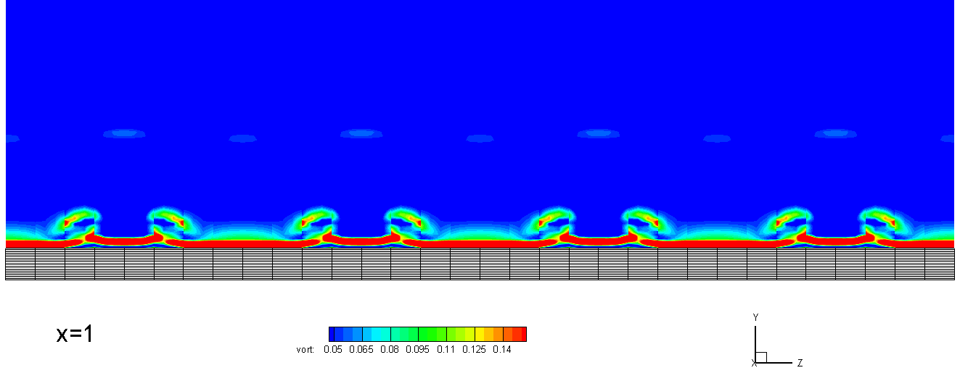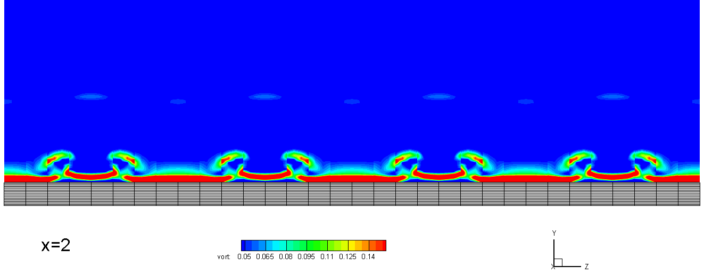

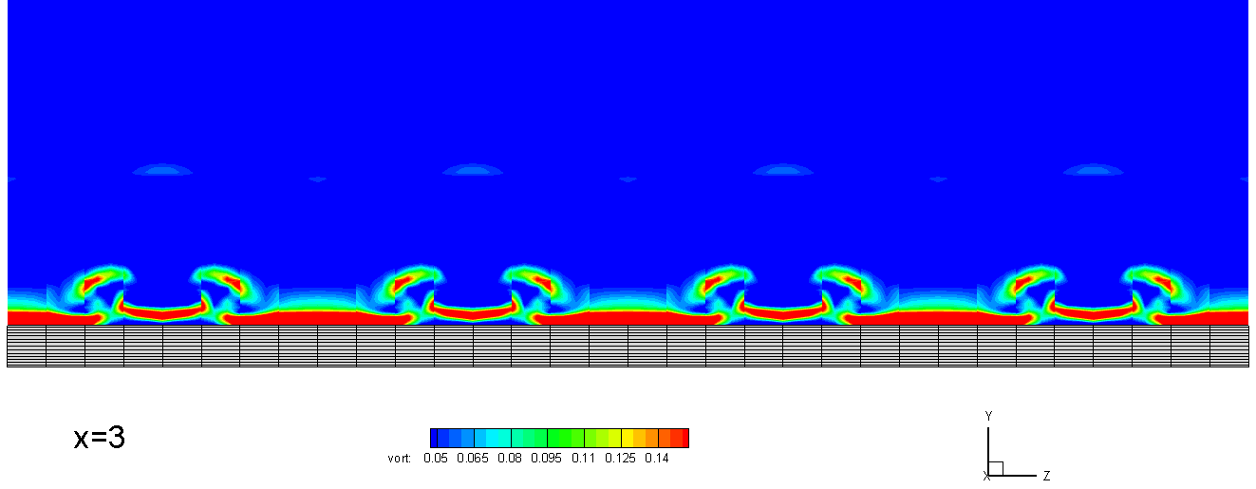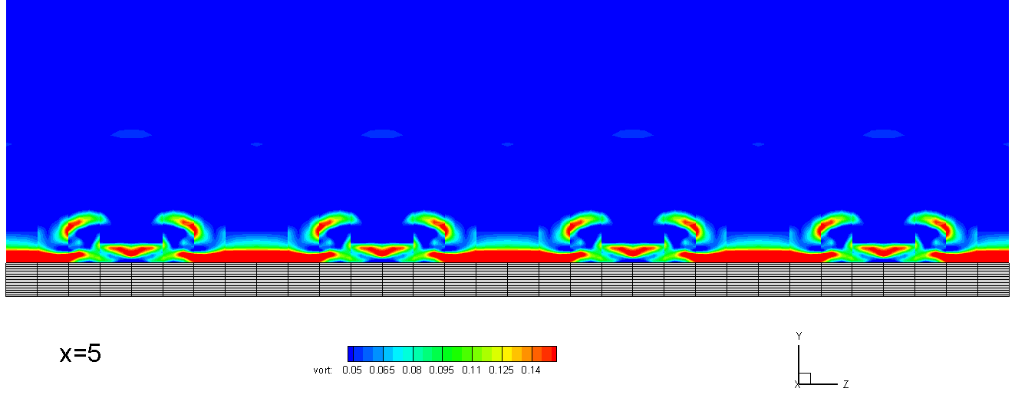

To further investigate the effect of the forward-facing steps on boundary layer transition, instantaneous flow fields are demonstrated in Figure X to X. Q-criterions colored by the streamwise velocity are used to show the vortex structures. Due to the blockage effect of the FFS, stationary vortices stays in two separation regions around the step, corresponding to that in the averaged field results. Streamwise vortices form in the concave-streamline regions outside separation regions, and break down into smaller scale structures afterwards. These small structures introduce a new set of spanwise vortices. Due to their small-scale sources, the spanwise vortices are high in frequency, which trigger secondary instabilities in the boundary layer. Further downstream, these vortices are raised and deform into classic hairpin vortices that is the key to later transition. It is observed that although all the structures mentioned above locates in the near-wall scope of the boundary layer, another set of hairpin vortices are induced as well, which locates in the outer region of the boundary layer. All the flow phenomenon mentioned above resembles the Klebanoff modes in the boundary layer instability problem.

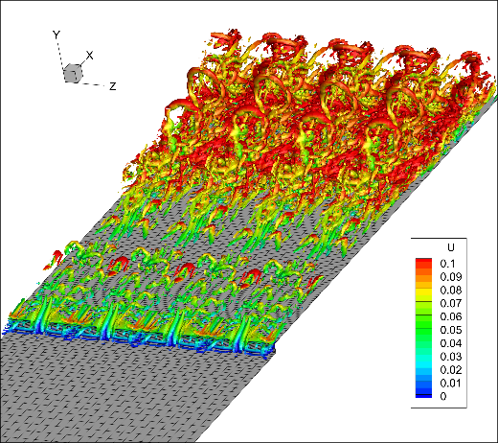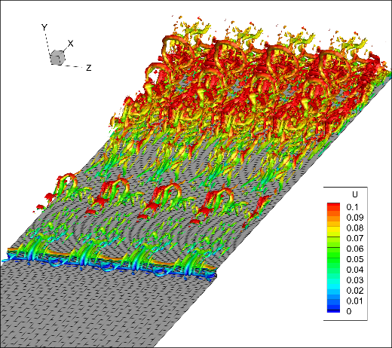

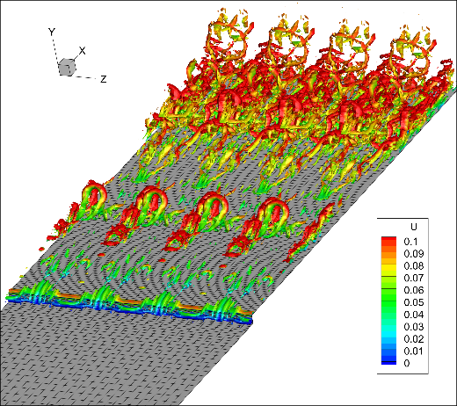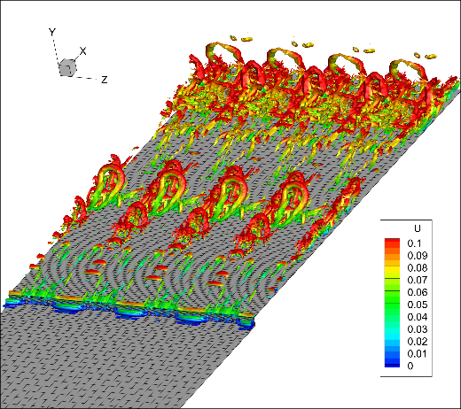

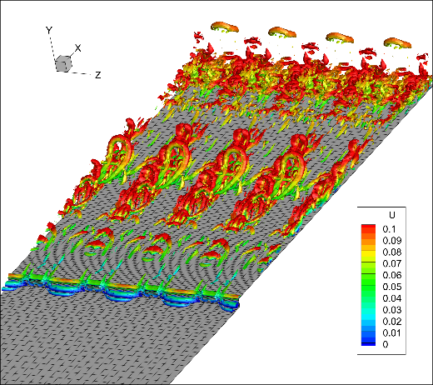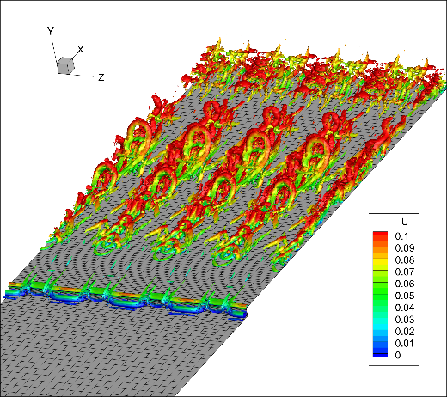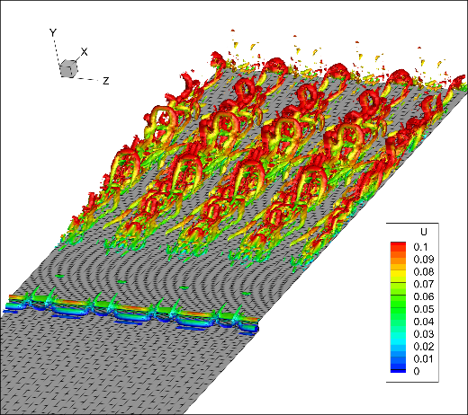

## Conclusion

An Implicit Large Eddy Simulation based on the high-order Flux Reconstruction method is performed on transitional flows over a forward-facing step immersed in a low-speed boundary layer. The inlet flow with finite disturbance forms weak streamwise vortices, but will not trigger flow transition itself, according to the flat plate flow simulation. The separation region in front of the forward-facing step causes the streamlines outside to curve into concave shapes, and introduce strong streamwise voritices due to the Taylor-Gortler instability. As these vortices goes downstream over the step, they introduce secondary spanwise structures, which becomes hairpin vortices further downstream.

[1] Brederode V, Bradshaw P (1972) Three-dimensional flow in nominally two-dimensional separation bubbles. I. Flow behind a rearward-facing step. Imp Coll Aero Rep 72–19

[2] Eaton JK, Johnston JP (1981) A review of research on subsonic turbulent flow reattachment. AIAA J 19:1093–1100