## Czech Technical University in Prague

Faculty of Electrical Engineering

[A4M35KO] Happy Delivery company

Contents

Czech Technical University in Prague 1

Task description 3

Problem categorization and summary 3

Categorization 3

Summary 4

Related work and proposed solution 5

Related works 5

Proposed solution 6

General model 6

What about those contaminated planets? 6

Are there other conditions? ... Yes! 6

Formulating the problem 6

An algorithm to solve the problem 7

# Task description

The “Happy Delivery Company” does deliveries to planets orbiting a local group of stars. The company has a permit to deliver goods to 20 of the planets. They have 2 spaceships. As it is a small family business, the company does not have much money to spend on new technology. As a result only one spaceship has a special shield against radioactivity which is required to visit some of the planets. On the other hand, the other ship has more efficient engines. The special shield lasts 3 visits to a planet in contaminated zones. In order to recharge the shield, the ship must return to base. The price of one traveled LY (light year) is 25 units in case of the first ship and 15 units for the second one with more efficient propulsion systems. Both ships have a range of 2500 LYs. The aim of the optimization task is to minimize the cost of visiting all of the planets.

|  |  |  |  |  |  |  |  |  |  |  |  |  |  |  |  |  |  |  |  |  |
| --- | --- | --- | --- | --- | --- | --- | --- | --- | --- | --- | --- | --- | --- | --- | --- | --- | --- | --- | --- | --- |
|  | 0 | 1 | 2 | 3 | 4 | 5 | 6 | 7 | 8 | 9 | 10 | 11 | 12 | 13 | 14 | 15 | 16 | 17 | 18 | 19 |
| 0 | 0 | 40 | 185 | 110 | 55 | 228 | 233 | 259 | 256 | 150 | 198 | 195 | 263 | 245 | 166 | 191 | 200 | 228 | 301 | 379 |
| 1 | 40 | 0 | 154 | 102 | 92 | 212 | 210 | 238 | 240 | 177 | 200 | 210 | 280 | 265 | 206 | 231 | 241 | 258 | 339 | 367 |
| 2 | 185 | 154 | 0 | 114 | 212 | 105 | 80 | 107 | 128 | 241 | 169 | 224 | 282 | 283 | 331 | 349 | 368 | 319 | 436 | 255 |
| 3 | 110 | 102 | 114 | 0 | 111 | 120 | 131 | 155 | 147 | 128 | 98 | 126 | 194 | 186 | 223 | 237 | 260 | 208 | 322 | 269 |
| 4 | 55 | 92 | 212 | 111 | 0 | 230 | 243 | 266 | 256 | 100 | 177 | 156 | 221 | 200 | 120 | 142 | 157 | 173 | 247 | 368 |
| 5 | 228 | 212 | 105 | 120 | 230 | 0 | 36 | 41 | 28 | 212 | 97 | 165 | 205 | 215 | 332 | 342 | 369 | 273 | 405 | 158 |
| 6 | 233 | 210 | 80 | 131 | 243 | 36 | 0 | 28 | 50 | 237 | 130 | 197 | 240 | 249 | 352 | 363 | 389 | 304 | 433 | 174 |
| 7 | 259 | 238 | 107 | 155 | 266 | 41 | 28 | 0 | 36 | 253 | 137 | 206 | 242 | 253 | 372 | 382 | 409 | 314 | 446 | 148 |
| 8 | 256 | 240 | 128 | 147 | 256 | 28 | 50 | 36 | 0 | 230 | 109 | 177 | 208 | 221 | 354 | 362 | 391 | 286 | 419 | 130 |
| 9 | 150 | 177 | 241 | 128 | 100 | 212 | 237 | 253 | 230 | 0 | 125 | 72 | 125 | 101 | 133 | 134 | 166 | 83 | 196 | 316 |
| 10 | 198 | 200 | 169 | 98 | 177 | 97 | 130 | 137 | 109 | 125 | 0 | 68 | 113 | 119 | 256 | 259 | 290 | 177 | 310 | 195 |
| 11 | 195 | 210 | 224 | 126 | 156 | 165 | 197 | 206 | 177 | 72 | 68 | 0 | 70 | 60 | 205 | 203 | 236 | 109 | 243 | 247 |
| 12 | 263 | 280 | 282 | 194 | 221 | 205 | 240 | 242 | 208 | 125 | 113 | 70 | 0 | 29 | 245 | 235 | 271 | 112 | 241 | 240 |
| 13 | 245 | 265 | 283 | 186 | 200 | 215 | 249 | 253 | 221 | 101 | 119 | 60 | 29 | 0 | 217 | 206 | 242 | 83 | 215 | 265 |
| 14 | 166 | 206 | 331 | 223 | 120 | 332 | 352 | 372 | 354 | 133 | 256 | 205 | 245 | 217 | 0 | 29 | 37 | 146 | 146 | 449 |
| 15 | 191 | 231 | 349 | 237 | 142 | 342 | 363 | 382 | 362 | 134 | 259 | 203 | 235 | 206 | 29 | 0 | 35 | 130 | 117 | 450 |
| 16 | 200 | 241 | 368 | 260 | 157 | 369 | 389 | 409 | 391 | 166 | 290 | 236 | 271 | 242 | 37 | 35 | 0 | 165 | 131 | 482 |
| 17 | 228 | 258 | 319 | 208 | 173 | 273 | 304 | 314 | 286 | 83 | 177 | 109 | 112 | 83 | 146 | 130 | 165 | 0 | 135 | 346 |
| 18 | 301 | 339 | 436 | 322 | 247 | 405 | 433 | 446 | 419 | 196 | 310 | 243 | 241 | 215 | 146 | 117 | 131 | 135 | 0 | 480 |
| 19 | 379 | 367 | 255 | 269 | 368 | 158 | 174 | 148 | 130 | 316 | 195 | 247 | 240 | 265 | 449 | 450 | 482 | 346 | 480 | 0 |

Table 1 Planetary distances in LY

# Problem categorization and summary

## Categorization

This problem can be expressed as a “Vehicle routing problem (VRP). We have a couple of vehicles, their possible trajectories and constraints and we need to find optimal routings. Solving this problem via ILP makes it NP-hard.

## Summary

Vehicles: 2

* + 1.Vehicle:
    - Sole that is able to visit contaminated zones
    - 25 units per LY
    - Range: 2500 AU
  + 2.vehicle:
    - 15 units per LY
    - Range: 2500 AU
* Constraints:
  + Range
  + Able to visit 3 planets without recharging. Recharges by visiting the base.

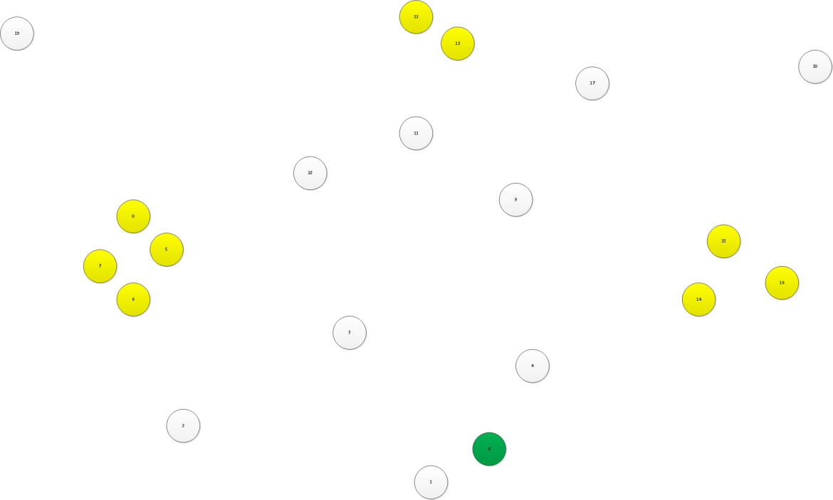

Figure 1 Illuistrated planet constellations

Colors: yellow – contaminated planets, green – base

# Related work and proposed solution

## Related works

This problem belongs, as stated before, to a problem group called „Vehicle routing problems“. This problem is often encountered in real life situations where companies need to optimize routes. In a world where gas prices are constantly rising, optimal goods distribution is becoming crucial in keeping prices and service at an acceptable level.

All related works differ in constraints that are laid on them and the definition of „what is optimal“. Most typically the constraints concern the capacity of the vehicles, their range, traffic regulations, traffic situations, time constraints etc. Interestingly, often the only constraints are capacities and the range of a vehicle is often neglected. This is probably because the problem is often solved within cities, where one tank is enough for the whole delivery to be made. Interestingly, my problem, which is a heterogeneous vehicle routing problem, has received little attention and it was quite hard to look for research papers concerning this subject.

Some examples of real life applications of this method include works like

* Strategic Planning and Vehicle Routing Algorithm for Newspaper Delivery Problem: Case study of Morning Newspaper,Bangkok, Thailand
  + A classic VRP, with constraints on time of delivery (180 minutes) and 7 available vehicles.
  + A solution was found using ILP with a modified sweep method. Ironically the solution was less optimal than the state before.
* On the Miller-Tucker-Zemlin Based Formulations for the Distance Constrained.
  + This paper deals with VRP when the vehicles are distance constrained and in the end it sketches how it would be it the if we were to minimize the distance traveled.
* THE TRUCK DISPATCHING PROBLEM by G. B. DANTZIG' AND J. H. RAMSER
  + One of the first papers dealing with VRP. (Nov 1958)
  + Deals only with capacity issues has a homogenous fleet and no range constraints.
  + Solves it by LP, as ILP was not known yet.
* A parallel evolutionary algorithm for the vehicle routing problem with heterogeneous fleet by Eunjeong Choi and Dong-Wan Tcha
  + Deals with a heterogeneous fleet which is my problem.
* Formulations and Valid Inequalities for the Heterogeneous

Vehicle Routing Problem by Hande Yaman

## Proposed solution

### General model

The VRP is a generalized form of the traveling salesman problem. In VRP, we have a constraint on the range, capacity and the fact that each tour is starts and ends in one node. To model this situation, I consider a graph G (N,E), N = {0…19}, where N0=0, represents the base and E = {(i,j);I,j∈{0..19} }. To represent this graph and edges we have a matrix of distances C. As this is a real world(we don’t take Stargates or similar devices in account), the triangle inequality property is satisfied.

### What about those contaminated planets?

Although I don’t address the problem of cargo capacity, I will introduce it to the model as it will serve to simulate the contaminated problem restrictions. The problem will be simulated as the case where the spaceship with no shield has 0 capacity, and the other spaceship, the one with a shield, will have a capacity equal to 3. In other words D0 = 0, D2 =3. Each planet has a weight di associated. The weight represents if the planet is contaminated or not di={0,1}, i ∈ {0..19}.

### Are there other conditions? ... Yes!

* Every planet has to be visited exactly once by any one of the two vehicles.
* The spaceship starts and ends its journey at the depot, the distance traveled in one journey must not exceed the range of the vehicle, which is in this case 2500 LY.
* The objective is to minimize the cost of the journeys keeping in mind the conditions we need to respect.

### Formulating the problem

In this paragraph I will try to formulate the problem as a linear programming problem. I based my formulation on a paper written by PING JI and KEJIA CHEN with the title “**The Vehicle Routing Problem: The Case of the Hong Kong Postal Service**”.

I introduce a set X, which is a 2 dimensional array. This array will be my variable with which I will optimize the solution. It will indicate which path is taken by which vehicle. Ex: xi,j,0 =1 , would mean that the edge between I and j was selected and the first vehicle is going to serve that path. Next I introduce a set of variables Y that indicate whether a particular edge is served by a vehicle, it does not matter which.

$$\min{\sum_{i∈N}{\sum_{j∈N}{25C_{i,j }x_{i,j,0}+15}C_{i,j}}x_{i,j,1}} \left(1\right)$$

Subject to: $$x_{i,j,k} ϵ \left\{0,1\right\} ∀ i,jϵN,kϵ\left\{0…n\right\} \left(2\right)$$

$$y_{i,j} ϵ \left\{0,1\right\} ∀ i,jϵN (3)$$

$$\sum_{m=0..n}{x_{i,j,m}}=y_{i,j} ∀ i,jϵN (4)$$

$$\sum_{j=1⋯19}{y_{i,j}=1 \left(i=1…19\right) (5) }$$

$$\sum_{i=1⋯19}{y_{i,j}=1 \left(j=1…19\right) (6) }$$

$$\sum_{m=0..\left\lfloor \frac{n}{2}\right\rfloor }{\sum_{i=1}^{n}{\sum_{j=0}^{n}{d_{i}x_{i,j,m }}}} ≤3 (7)$$

$$\sum_{m=\left\lfloor \frac{n}{2}\right\rfloor +1..n}{\sum_{i=1}^{n}{\sum_{j=0}^{n}{d_{i}x_{i,j,m }}}} ≤0 (8)$$

$$\sum_{m=0..n}{\sum_{i=1}^{n}{\sum_{j=0}^{n}{c_{i}x_{i,j,m }}}} ≤2500 (9)$$

Let us now look closely on the above model for linear programming. First things first, I have decided to model the two spaceships I have with and equal number of spaceships I I have specified (1) as an objective to reach the minimum possible cost for the routes. The cost is subject to a number of constraints. (2) and (3) basically say that the decision variables are binary, that is ones and zeroes. Then I have (4) which says that an arc is taken by at most one single vehicle. Constraint (5) is in place so that from every planet, apart from the base, a ship arrives exactly once. (6) is here to say that for every planet, apart from the base, a ship departs exactly once. (7) and (8) are here to represent the contaminated planet problem. As the ship with no shield is simulated by having zero capacity and planets that are contaminated have a need to deliver 1 unit of something, the equation prevents the non-shielded ship from arriving to a contaminated planet whilst simultaneously enabling the shielded ship co continue on its journey to non-contaminated planets even when it has depleted shields. (9) limits the length of a journey.

### An algorithm to solve the problem

There are numerous ways to solve an ILP problem. There is the branch and bound algorithm, the branch and cut algorithm, or the cutting plane method.

#### Brute force

Well, the first thing that comes to mind is a brute force solution. This would be trivial to implement but experience tells us that this solution is infeasible on a problem event as small as this. This is owing to the $O(n!)$ nature of the problem.

#### Can we do better? … yes!

The formulation in the beginning if the chapter was not only to cover space. Better than a brute force method, I will use a linear programming approach. Algorithms for linear programming are well defined and it would be pointless to explain them in detail in this work. I will however, make an outline of how I imagine my algorithm will be. For this problem I will try to implement the branch and bound algorithm, which is a well-known algorithm for solving ILP problems.

Basically the algorithm goes like this:



As There are also numerous ILP solvers readily available. For the solving of the ILP I will also try to use IBM ILOG CPLEX Optimizer, which is offered with a 90 day trial and use a java wrapper as I am confident in Java.