**Team Members**:Alexander Nguyen Laura Yip Renz Ian Negrana Cyril Efren Fabro

**Title**: *RISKY ROADS*

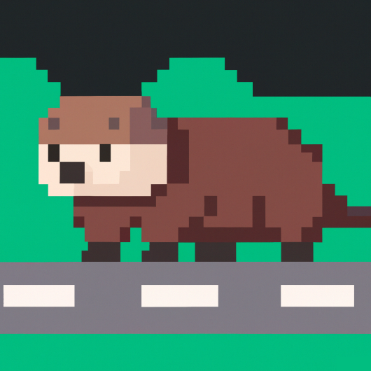

**Tag line** “Cross the road without getting hit!”

**Genre** Platformer, Action-adventure

**Target**  Everyone

**Goal Reach the final level and return home.**

*Draft of Box Art*

**Plays like** __Crossy Road but with different worlds and more random buffs/debuffs.

*Popular Game A Popular Game B or twist*

**Core Mechanics**

1. Tile based movement with arrow keys.
2. Moving world tiles downwards as the game progresses.
3. Obstacles such as cars.
4. Portals to progress and random buffs/debuffs.

**Related Games**

1. Crossy Road Hipster Whale Platformer, Action-adventure 2014

2. Frogger Hasbro Interactive Arcade Action Game 1981

**Game Project Summary**

*Supporting Screenshot / Drawings / Collage for Worlds / Levels / Characters / Game Items*

This is a game where the player is supposed to cross roads and reach the other side with various obstacles with different mystery enhancements along the way. These “enhancements” will either hinder or improve the player’s ability to cross the roads to make the game more interesting. As the game progresses, the world levels increase in difficulty. Obstacles such as cars and others will attempt to collide with the player to make them lose.

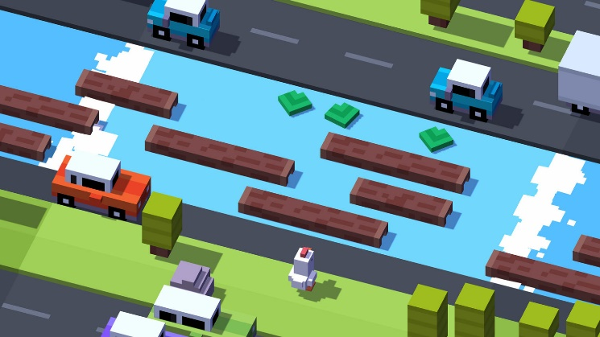

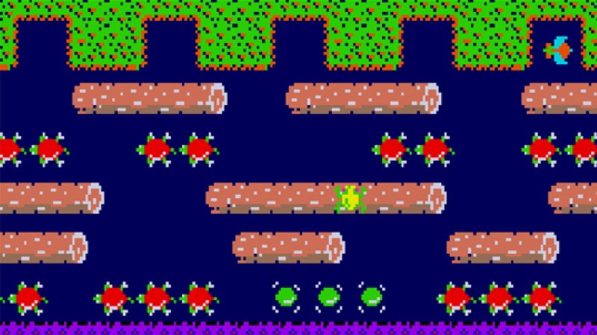

*Supporting Screenshot / Drawings / Collage for Worlds / Levels / Characters / Game Items*