Installed Terraform

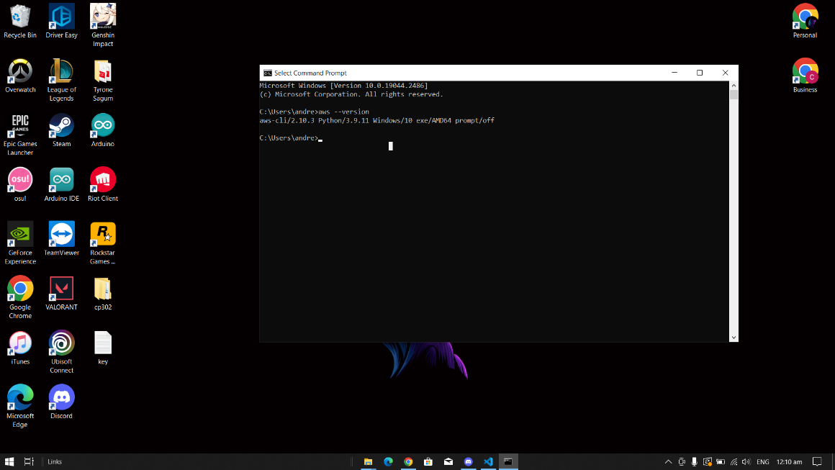Installed AWS CLU

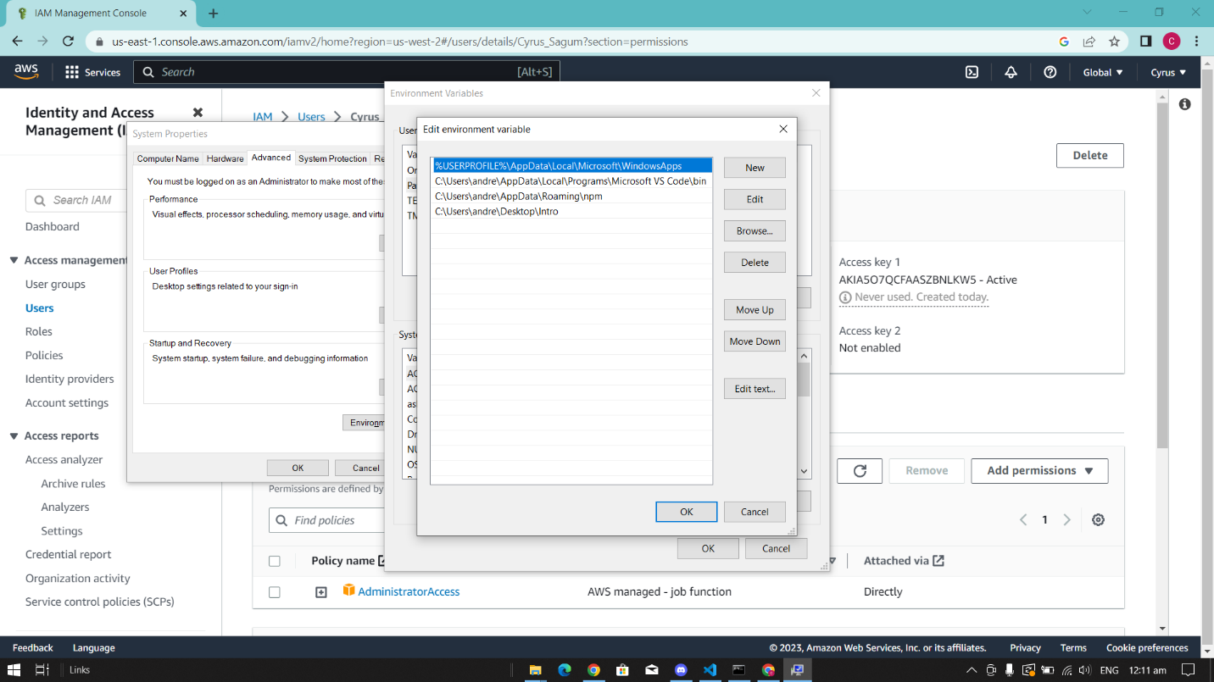Edited path of environment variables

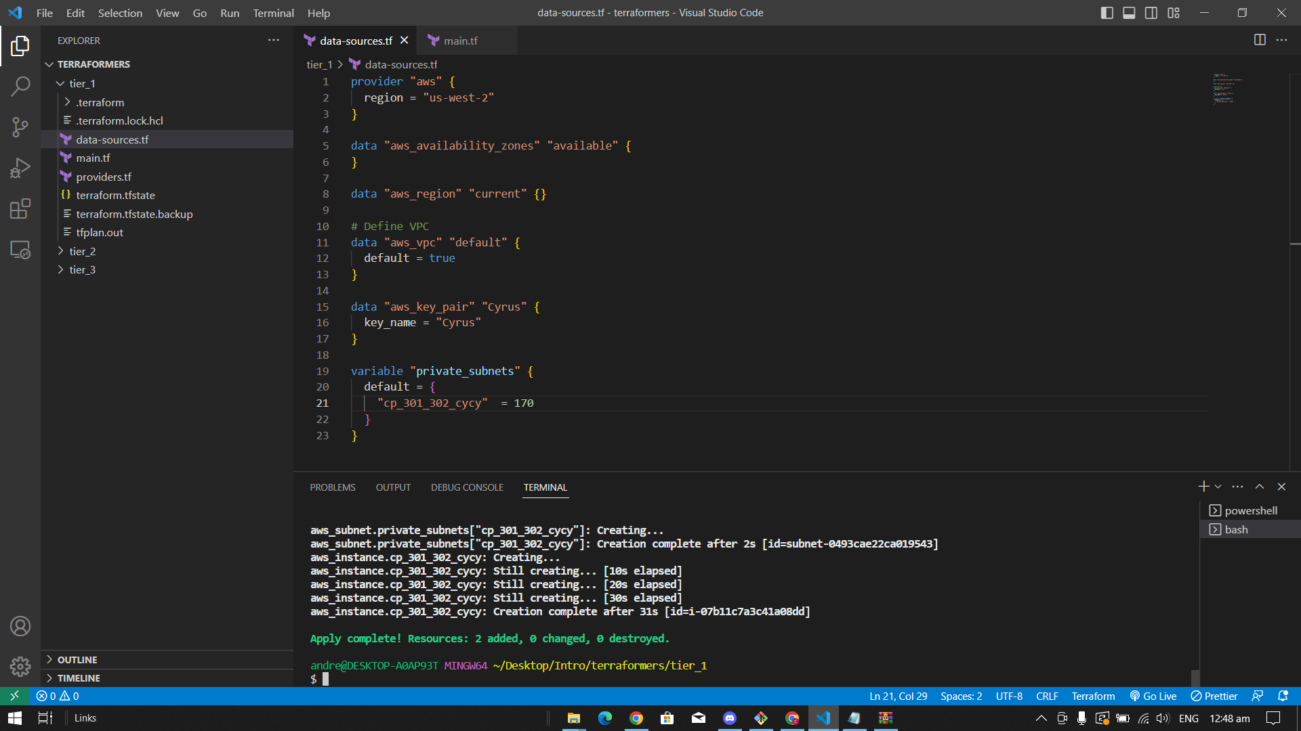Changed the key name for my created key pair and changed the private subnets to avoid conflicts, then used “terraform apply” to launch the instance.

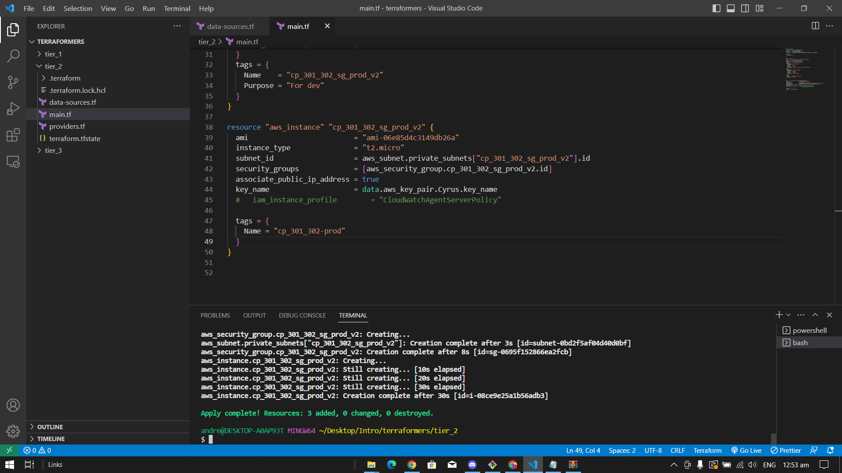Repeated the process in tier 1 to tier 2, but changed the private subnets to avoid conflicts with tier 1.

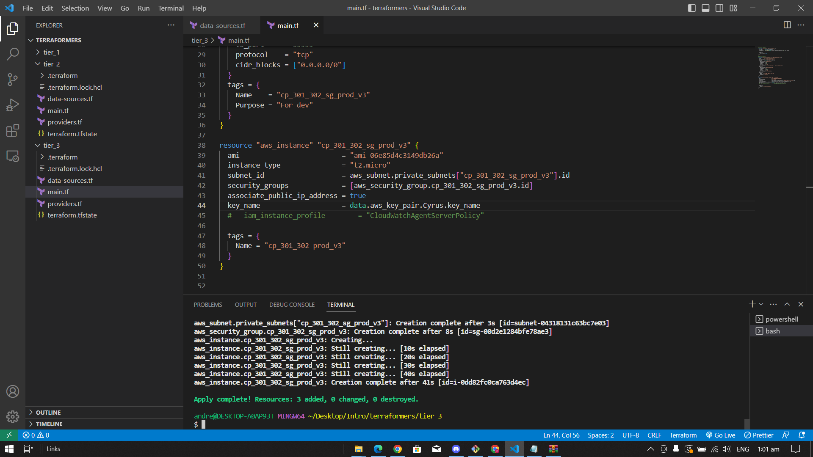Repeated the process for tier 3 but, changed the private subnets to avoid conflict with tier 1 and tier 2

Final output all tiers are up and running 😊

