**Introduction**

Real-time Quote Board is a dynamic web application designed to provide users with a continuous stream of inspirational quotes and humorous jokes, updated in real time. This project leverages modern web technologies to create an engaging user experience that combines wisdom and humor. The application consists of a frontend built with HTML, CSS, and JavaScript, and a backend powered by a Node.js WebSocket server to handle real-time updates.

**Main Objectives**

The primary objective of this project is to create an interactive WebSocket-based application that provides users with motivational content, including quotes and jokes. The application aims to enhance user engagement by allowing real-time updates and interaction between the client and server. The key functionalities include:

1. **Real-Time Content Delivery**:
   * Deliver a "Quote of the Day" to all connected clients as soon as they connect to the server.
   * Update the "Quote of the Day" daily and broadcast it to all clients.
2. **User-Requested Quotes and Jokes**:
   * Allow users to fetch and display random quotes by a specific author.
   * Provide users with the ability to request and display random jokes.
   * Ensure all user-requested content is broadcast to all connected clients in real-time.
3. **Interactive User Interface**:
   * Create an engaging UI that dynamically updates with the latest quotes and jokes.
   * Utilize WebSocket technology to facilitate instant content updates without the need for page refreshes.

**Core Functionalities**

This WebSocket-based project provides users with motivational quotes and humor through the following core functionalities:

1. **Real-Time WebSocket Connection**:
   * Establishes a real-time connection between clients and the server.
   * Broadcasts messages from one client to all connected clients.
2. **Quote of the Day**:
   * Fetches a daily motivational quote from the Quotable API.
   * Sends the "Quote of the Day" to all clients upon connection and updates it every 24 hours.
3. **User-Requested Quotes by Author**:
   * Allows users to request random quotes by a specific author.
   * Fetches, sends, and displays these quotes in real-time to all connected clients.
4. **User-Requested Random Jokes**:
   * Allows users to request random jokes.
   * Fetches, sends, and displays these jokes in real-time to all connected clients.
5. **UI Updates**:
   * Dynamically updates the client UI with new quotes and jokes.
   * Displays the "Quote of the Day" in a dedicated section of the UI.

**Specific Features**

• **Real-Time WebSocket Connection**:

* **WebSocket Server Initialization**:
  + **Feature**: The server is initialized to listen for WebSocket connections on port 8080.
  + **Support**: This setup enables real-time communication between the server and clients.
* **Client Connection**:
  + **Feature**: Clients connect to the WebSocket server.
  + **Support**: This connection allows clients to send and receive messages instantly.
* **Message Broadcasting**:
  + **Feature**: The server broadcasts messages received from one client to all connected clients.
  + **Support**: Ensures that all clients receive updates in real-time, maintaining synchronization.

• **Quote of the Day**:

* **Daily Quote Fetching**:
  + **Feature**: The server fetches a new random quote from the Quotable API every 24 hours.
  + **Support**: Keeps the "Quote of the Day" fresh and updated daily for all clients.
* **Initial Quote Distribution**:
  + **Feature**: When a new client connects, the server sends the current "Quote of the Day" to the client.
  + **Support**: Ensures new clients receive the latest motivational quote immediately upon connection.

• **User-Requested Quotes by Author**:

* **Author Input**:
  + **Feature**: An input field for users to enter an author's name.
  + **Support**: Allows users to specify the author from whom they want to receive a quote.
* **API Request for Quotes**:
  + **Feature**: Fetches quotes from the Quotable API based on the entered author’s name.
  + **Support**: Provides relevant quotes by the specified author.
* **Random Quote Selection**:
  + **Feature**: Selects a random quote from the fetched results.
  + **Support**: Adds variety and randomness to the quotes displayed.
* **Quote Broadcasting**:
  + **Feature**: Sends the selected quote to the server, which then broadcasts it to all clients.
  + **Support**: Shares the quote with all connected users in real-time.

• **User-Requested Random Jokes**:

* **Joke Fetching**:
  + **Feature**: Fetches a random joke from the Chuck Norris Jokes API.
  + **Support**: Provides humorous content to the users.
* **Joke Broadcasting**:
  + **Feature**: Sends the fetched joke to the server, which then broadcasts it to all clients.
  + **Support**: Shares the joke with all connected users in real-time.

• **UI Updates**:

* **Quote Display**:
  + **Feature**: Dynamically creates and appends a new quote card in the UI.
  + **Support**: Visually displays the new quote to the user.
* **Joke Display**:
  + **Feature**: Dynamically creates and appends a new joke card in the UI.
  + **Support**: Visually displays the new joke to the user.
* **Quote of the Day Display**:
  + **Feature**: Updates the "Quote of the Day" section in the UI.
  + **Support**: Ensures the latest "Quote of the Day" is prominently displayed for all users.

This HTML file is the face of our real-time quote board app. It's like a digital bulletin board where you can explore different sections like the home, about us, quotes, jokes, and author list. You can easily navigate using the top menu. If you're in the mood for some inspiration, you can fetch random quotes by author, or if you need a good laugh, there's an option to fetch random jokes. Everything's neatly organized with clear labels, making it easy to use. And of course, we've got a footer with copyright info, just to keep things official.

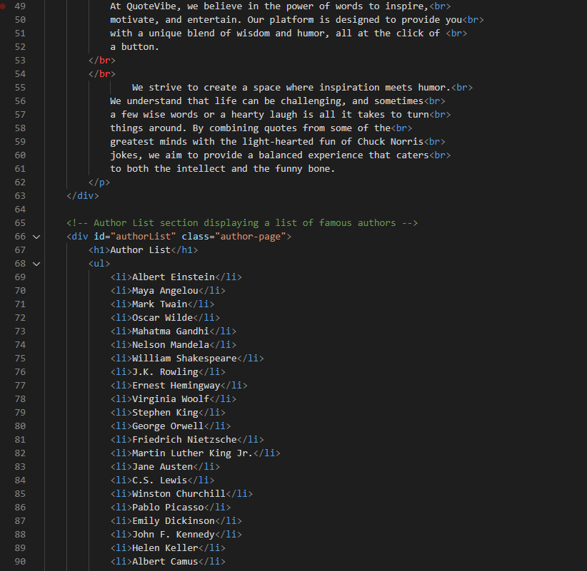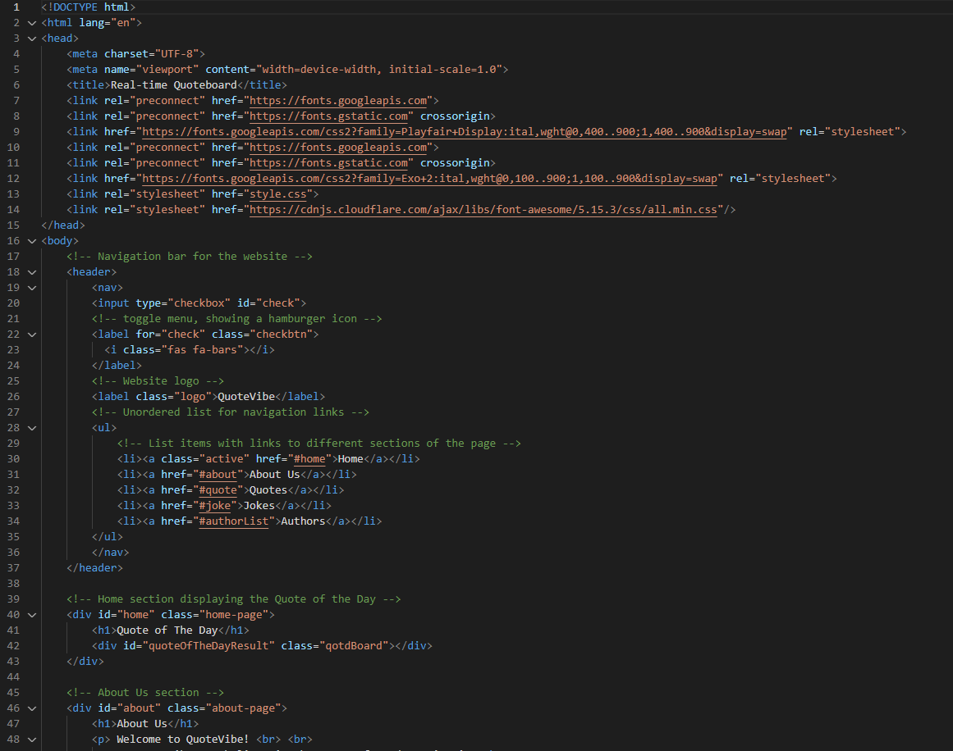

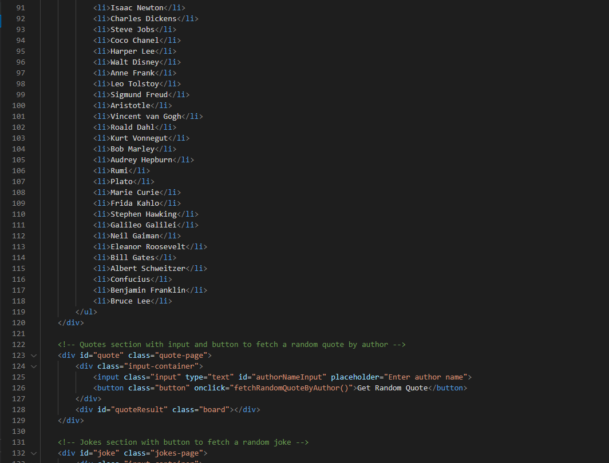

The JavaScript code establishes a WebSocket connection with a server at localhost:8080, logs confirmation upon connection, and updates the UI with received messages. It includes functions to fetch quotes and jokes from external APIs, handle user input, and update the UI dynamically. This enables real-time interaction between clients and the server, facilitating the display of quotes and jokes seamlessly.

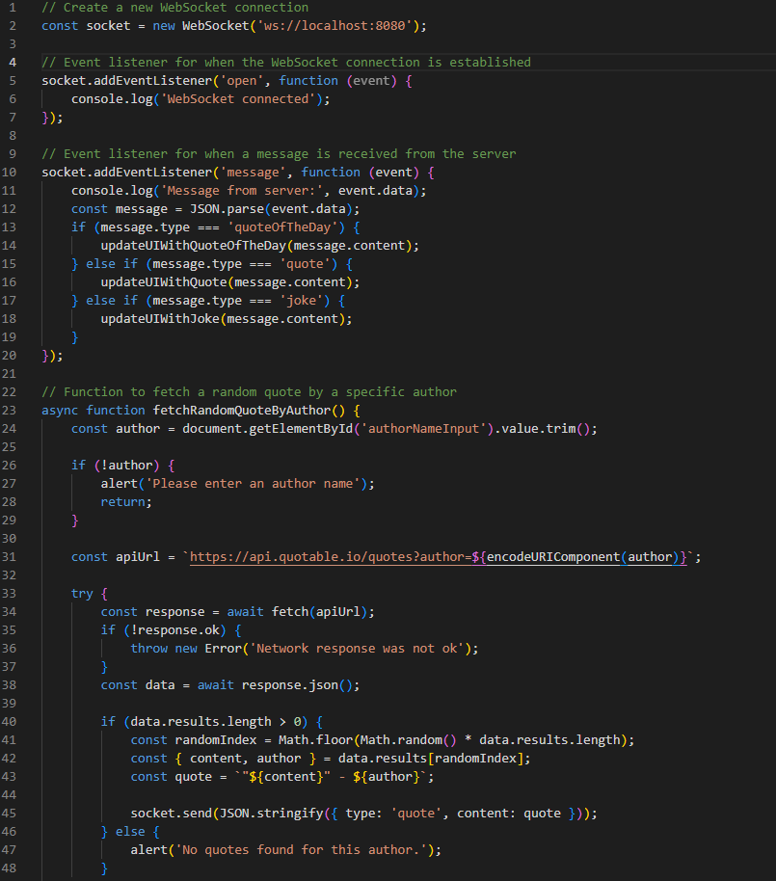

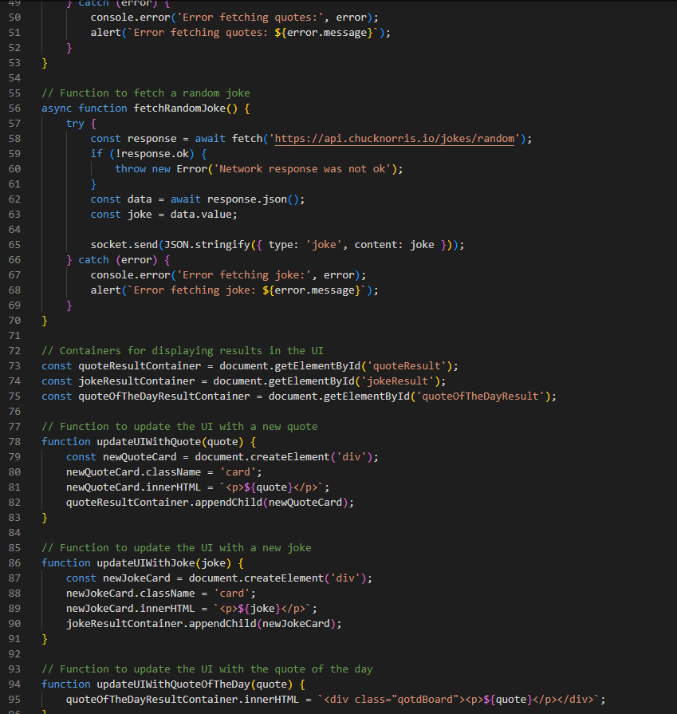

This JavaScript code sets up a WebSocket server on port 8080, allowing clients to connect and communicate with it. When a client connects, it sends any existing "quote of the day" if available and broadcasts messages from one client to all others. It also handles client disconnections. Additionally, there's a function to fetch a random quote from an external API and update the quote of the day. This function runs immediately upon server startup and at regular intervals to keep the quote of the day up to date. Overall, the code creates a real-time messaging system with a dynamic quote feature.

