Project 4: Open Cv Image Processing

# Introduction

The purpose of this assignment is to experiment with open cv and compare the results from previous image processing projects to this project. The filters that were tested were: opencvhistogramequalization, opencvycrcbhistogramequalization, opencvsobeledgedetection, and opencvcannyedgedetection. The comparison is to: grayhistogramequalization, hsihistogramequalization, and sobeledgedetection.

# Gray Histogram

In the previous project for histogram equalization the following histogram and image was used:

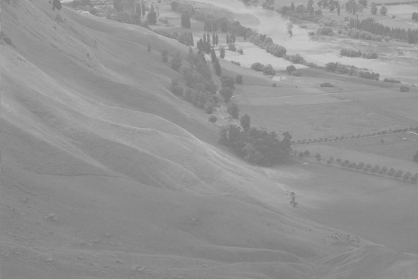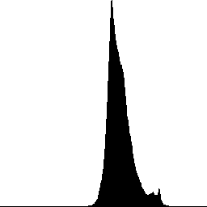

The results of that project is on the left and the results of using open cv is on the right:

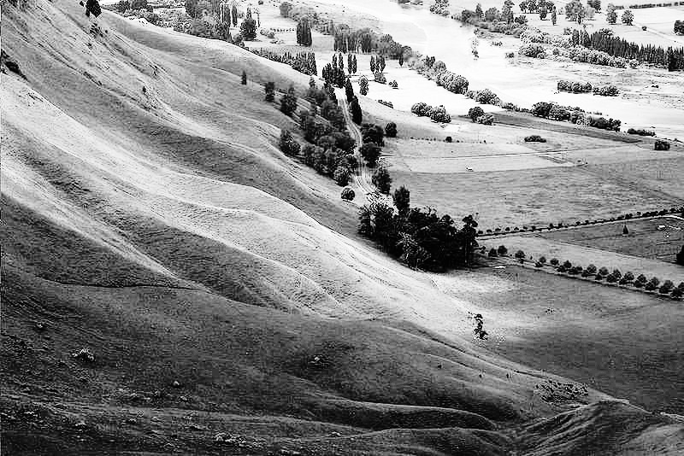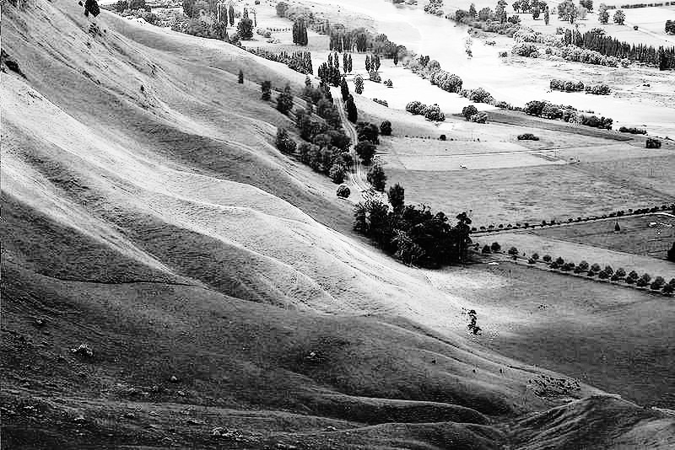

The after histogram for both are:

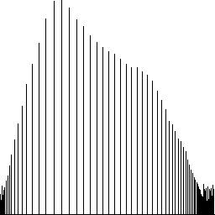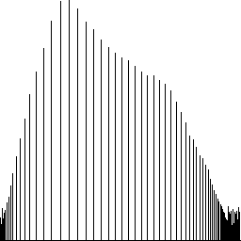

As expected the results are the same. However, the open cv did most of the hard work. Open cv has a simple function that transforms the image instead of the developer rolling out the algorithm for implementing it.

overall performance of the algorithm is .

# Histogram Equalization in HSI compared to YCrCb

Open cv does not support the HSI color space. The closes it does support is YCrCb. YCrCb has an intensity channel just like HSI; however, how it creates colors is different. YCrCb uses to 8 bit channels to represent all colors. Just like with HSI histogram equalization, doing the equalization on the intensity channel does the best effect. Doing it on any other channel distorts the colors. Below is the histogram equalization for HSI (on the right) and YCrCb (on the left) for the intensity channel only:



As you can tell the difference in how the color space works changes the output of the image.

# Edge Detection

In the previous project edge detection was done by using the Sobel edge detector. Open cv does support that feature but it also supports another edge detector called Canny. Below you can see examples: on the left is Sobel in project 3, in the middle is Sobel using open cv, and on the right is canny using open cv.

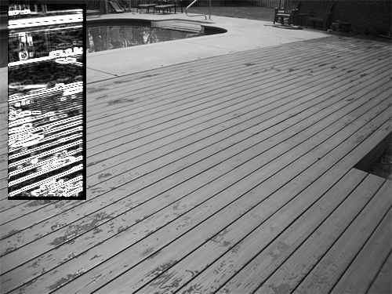

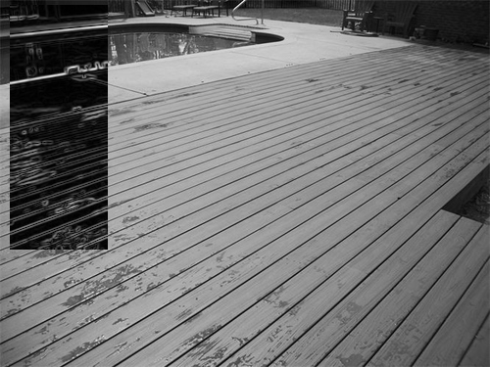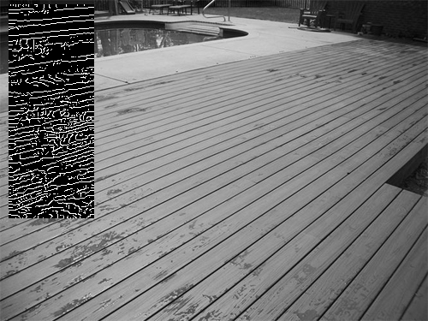

Open cv seems to using a better mask for Sobel operations than the one that was used for project 3. Furthermore, the canny operation does produce better results. With canny the edges are exact and not in gradient form.

# Conclusion

Open cv makes image manipulation very easy and treats all images are matrices. As such, its APIs make doing operations on images a lot like doing math operations on matrices. In addition, its support for filters is almost endless.