Facial Recognition Using Hybrid Technologies Based on Independence Testing
Kyle Yuan L. Uy*, Andrew P. Eroyla*, John Roland L. Octavio*, Jim Jonathan C. Decripito*, Loreto B. Damasco*, and Weon Geon Oh*+
*Computer Science Department, College of Computing Studies, University of St. La Salle - Bacolod, Bacolod City, Philippines
+THINKforBL, Korea
Abstract. A facial recognition system is a technology capable of identifying or verifying a person from a digital image by comparing facial features with a database and has many applications such as home security and access control, finance, public safety and marketing, etc. Among these, the field of Home Security is particularly important for protecting family safety, preventing property loss, and ensuring psychological stability in daily life. Home security consists of a complex combination of various technologies, among which facial recognition technology requires high accuracy, a low false positive rate, and fast processing speeds as essential requirements. Furthermore, recent advancements in artificial intelligence have significantly improved the performance of facial recognition technology, establishing it as an indispensable core function. However, the reality is that applying face recognition technology in real-world environments is difficult because recognition results vary significantly depending on the diversity of facial images due to environmental changes, differences in facial structures between the East and West, and changes in facial expressions and gaze. Meanwhile, various methods to address these issues have recently been proposed. Representative examples include a hybrid approach combining computer vision and deep neural networks, and independence testing techniques that analyze statistical associations between visual variables, features, or data distributions of face images. In this paper, we proposed a methodology that organically links a hybrid approach combining computer vision and deep neural networks with independence testing and validated its effectiveness using the Labeled Faces in the Wild (LFW) dataset.
Keywords: Home Security, Facial Recognition, Hybrid Technology, Combination of Computer Vision and Deep Learning, Independence Testing
- Introduction
Based on the advancement of artificial intelligence (AI) and deep learning, the latest facial recognition technology is maximizing accuracy and convenience through features such as remote detection, real-time processing, and contactless authentication. It is rapidly expanding into various industries, including security, financial digital identity verification, and smart access control.
Facial recognition technology used in home security identifies individuals using bio-metric(face) data. It captures photo images in real time to extract unique facial features into a digital facial fingerprint, which is then compared to a trusted database. The primary purpose is to automate access control, reduce false alarms, and immediately notify the homeowner in the presence of unfamiliar visitors or potential intruders.
In home security, facial recognition technology is being utilized as a key means to accurately identify residents and outsiders without the risk of losing keys or passwords, thereby blocking unauthorized intrusions in real time. It is producing significant ripple effects, such as improved ease of use, enhanced security accuracy, and increased connectivity with smart homes.
However, facial recognition technology in home security still has many factors that limit stable recognition results. These can be broadly divided into two categories: 1) bio-mechanical diversity of facial images and 2) physical changes due to environmental changes.
Examples of the first factor include structural differences in facial features between Eastern and Western people, diversity in facial expressions and behaviors, and diversity in style and adornment.
Furthermore, examples of the second factor include changes in lighting and light sources, changes in camera angles and poses, and changes in background and context.
Various technologies have been developed to solve these problems from the early stages of research to the present, the representative of which is Hybrid technology that combines traditional Computer Vision technology with Deep Learning technology, an application of Neural Network technology, and independence testing techniques that analyze statistical associations between visual variables, features, or data distributions of face images.
The purpose of this study is to develop stable and robust facial recognition technology by resolving the aforementioned problems in face recognition, and to this end, we proposed a methodology that organically links a hybrid approach combining computer vision and deep neural networks with independence testing and validated its effectiveness using the Labeled Faces in the Wild (LFW) dataset.
- Related Work

Classical recognition. Eigenfaces [1] projects faces onto PCA components; Fisherfaces [2] adds LDA to separate classes; LBPH [3] compares local binary-pattern histograms per region. All three ship in OpenCV [10], need no GPU, and produce models from kilobytes to a few megabytes.
Deep recognition. FaceNet [6] mapped faces to an embedding space with triplet loss. SFace [4] uses a sigmoid-constrained hypersphere loss and is small enough to run on edge hardware, so we use it as the hybrid's DL engine.
Detection. Viola-Jones Haar cascades [5] remain the classical baseline; YuNet [7] is a millisecond-scale CNN detector that also returns the five landmarks DL recognizers use for alignment.
Evaluation. Biometric practice separates TAR, FAR, and FRR [9]. LFW [8] tests verification on fixed pair lists; independence testing instead yields the whole impostor distribution, so a threshold ties to an exact error count. For claims that two recognizers complement each other we adopt the standard yardsticks rather than invent our own: pairwise diversity measures (Yule's Q, double-fault [11]) and McNemar's paired test [12].
- Method
  - System overview
LS-Face processes one camera frame as follows. A shared YuNet front-end returns one face box, a confidence, and five landmarks. The frame first takes the cheap path: LBPH (grayscale 100×100 crop, Tan-Triggs illumination normalization) predicts an identity and a distance d. A gate then decides whether that answer can be trusted. If yes, LBPH's decision stands and the DL model never runs. If not, the frame escalates: SFace aligns the face to 112×112 with the landmarks, extracts a 128-D (512-byte) embedding, and matches it against per-identity mean embeddings by cosine similarity. A no-accelerator fallback (LBPH alone) engages automatically if the DL gallery is absent.
  - Offline Candidate Screening and Component Selection
Component selection is an offline development stage, distinct from the frame-level escalation gate. Classical candidates are selected on La Salle DB1 only: a deterministic subset of its training images fits each model, a disjoint La Salle calibration subset sets that model's native-score operating point, and the held-out La Salle test split and its 41-modification probes remain untouched until evaluation. We considered the classical recognizers LBPH, Eigenfaces, and Fisherfaces, and the learned embedding models SFace, FaceNet, and ArcFace. Since their score scales are not comparable, raw distances were never compared across families. Instead, each candidate was assessed on its native score using cross-identity impostor comparisons, held-out genuine recognition, robustness under the 41 image modifications, runtime, and per-identity representation size. This offline selection protocol is separate from later LFW-based calibration that freezes deployed LBPH--SFace cascade thresholds.
For the classical pool, a scripted constrained selector requires acceptable true-acceptance performance at a fixed false-acceptance operating point and sufficient runtime, then ranks eligible models by modification robustness, with true-acceptance rate and model size as tie-breakers. Its strict recorded rule has no candidate that meets every project constraint: LBPH supplies the needed verification and robustness but its 64-kB histogram exceeds the nominal 1-kB representation budget, while Eigenfaces and Fisherfaces fail the genuine-acceptance requirement. LBPH is therefore described as the selected fast-path recognizer, not as the winner of an unconstrained six-model optimization; the deep gallery supplies the compact enrollment representation.
The learned-model screening used a common YuNet alignment and brightness-normalization front end. The available artifacts establish a 128-dimensional, 512-byte SFace embedding, compared with 512-dimensional, 2,048-byte FaceNet and ArcFace representations. SFace was retained as the deployment-compatible escalation model. This is a resource-constrained engineering choice, not a demonstrated accuracy win over FaceNet and ArcFace: archived learned-model results use model-specific thresholds, and their reported true-positive values allow self-matching. After component selection, subsequent cascade experiments evaluate the frozen LBPH--SFace configuration rather than retuning it on reported test outcomes.
  - Independence testing and threshold rule
Take N identities with one image each. Comparing every unique pair gives
C = N(N − 1) / 2 unique comparisons (1)
all impostor pairs by construction. Sort the C distances ascending. To operate at a target rate FAR*, choose the rank
k = ⌈ FAR* · C ⌉ (1)
and set θ to the k-th smallest impostor distance. The rank sets the target false-accept count; after thresholding, we recompute the realized FAR from all pairs that satisfy the deployed comparison rule, including ties. The deployed LBPH acceptance threshold is derived on LFW DB1: N=5,749 gives C=16,522,626 unique impostor pairs; rank 165 produces 9.986 ppm FAR. A La Salle DB1 sweep (N=28) is too small to resolve a 10-ppm operating point. The full formalism is in docs/archive/report_docs/independence_test/MATHEMATICAL_FOUNDATION.md in the repository.
  - The escalation gate
Let d₁ and d₂ be the best and second-best LBPH distances. Let τ_a be the frozen LBPH acceptance threshold and τ_r > τ_a the frozen escalation/reject threshold.
(i) a quality flag fires (blur, low light, sensor noise, off-pose, or too-small face, measured on the crop LBPH already holds); (ii) the score is ambiguous: τ_a < d₁ < τ_r; (iii) the top-two margin is thin:
(d₂ − d₁)/d₁ < m_min (2)
The margin is relative because LBPH training distances are near zero by memorization; an absolute margin fitted on training data escalates every held-out frame. A quality flag deliberately overrides a confident LBPH score: the corrupted regimes are exactly where LBPH confidence is least trustworthy. If nothing fires, d₁ ≤ τ_a accepts on LBPH and d₁ ≥ τ_r rejects.
  - Robustness: the 41-modification accuracy ratio
Every original image receives 41 deterministic (modification, level) variants across 12 types: brightness up/down, contrast up/down, gamma up/down, Gaussian noise, Gaussian blur, motion blur, rotation, zoom, occlusion. A modified probe matches when the recognizer outputs the correct identity within the deployed threshold. With M probes and K matches,
AR = K / M (3)
averaged per modification over its levels, then over modifications. The suite is seeded per (image, modification, level), so CV, DL, and hybrid score bit-identical probes.
  - Testing complementarity directly
Complementarity is three claims, each with its own instrument.
Robustness and complementarity are separate quantities. Robustness measures whether a recognizer retains genuine-probe acceptance performance under deterministic artificial modifications; in pairwise verification this is TAR, whereas this 1-to-N suite reports the analogous fixed-operating-point accuracy ratio (AR). Per modification, compare this result with the clean condition; its decline is the robustness loss. The paired per-probe outcomes separately assess complementarity: the recovery rate, P(SFace correct | LBPH wrong); the both-wrong rate, the accuracy ceiling no fusion of the two can beat; and McNemar's exact test [12] on the discordant cells, certifying the gap is not sampling noise.
Gate competence: can the cascade route? Escalation helps only if LBPH's own signal predicts LBPH's failures. We score the gate signal (distance d₁ and relative margin) against the label "LBPH got this probe wrong" and report ROC AUC; 0.5 would mean escalation is blind.
Error independence on impostors. On the same sweep, flag each pair a CV false accept (d ≤ τ_a) and/or a DL false accept (cosine ≥ 0.363 and L2 ≤ 1.0313). At the deployed L2 boundary, the cosine condition is non-binding. Independent errors would give
E[both] = C · P(FP_CV) · P(FP_DL) (4)
We report observed against expected, Fisher's exact test in both directions, and the literature-standard [11]
Q = (ad − bc) / (ad + bc), DF = a / C (5)
where a = both engines err, b/c = exactly one, d = neither. Two honesty rules govern the reading. First, Q pins to −1 whenever a = 0 regardless of base rates, and at La Salle's error rates a zero cell is the expected outcome under independence, so a lone "Q = −1" is a floor artifact; the base-rate-aware quantities and the cascade's own false-accept count carry the claim. Second, the direction is empirical: a significant excess of joint errors refutes independence, . DF stays useful either way as the impostor-side floor of any fusion. Every rate carries a 95% Wilson interval; 756 comparisons cannot support bare point estimates.
Frozen cascade configuration across databases
Separately tuned values across four databases would show tunability, not transfer. We freeze one configuration before cross-database evaluation: τ_a = 67.03325520645528 from LFW DB1's unique-pair LBPH sweep (rank 165; 9.986 ppm); τ_r = 140.13 from the LFW escalation trade-off; m_min = 0.05 is policy-set; and SFace uses its deployed L2 rule, 1.0313. The harness records the threshold-file SHA-256, and the same configuration is applied unchanged across database legs. Enrollment is always clean originals; only probes are modified. Each database answers one question (Table 1):
Table 1. Evidence matrix
Database | Evaluation | Purpose
LSDB1 (28; clean) | 10-seed independence | in-domain frozen-FAR check
LSDB-DL41 (held-out) | complementarity / gate | target-domain recovery; not headline robustness
LFW1 (5,749; clean) | independence sweep | out-of-domain calibration / power
LFW2-DL41 (disjoint) | 1:N AR robustness | main out-of-domain robustness

All identification and verification numbers on LS-DB1/LS-DB2 use closed-set enrollment: gallery and probes share the same 28 identities and are image-disjoint (10 gallery / 2 probe images per identity), mirroring a gate that admits only enrolled subjects. Robustness to unseen identities is measured as impostor rejection against the LFW legs; open-set identification is out of scope.
- Experiments and Results
  - Algorithm Selection on La Salle DB1
Classical candidates were fitted on 224 images, calibrated on 56 disjoint images, and evaluated once on 56 untouched LSDB test images. The calibration set supplied 1,512 cross-identity scores; the 15th error score yielded realized FAR 0.992%. LBPH achieved the highest test TAR (96.43%) and Rank-1 accuracy (100.00%) and was selected as the classical fast path. Its 64 KB representation remains an explicit engineering exception.
Table 2. LSDB classical candidate selection. TAR is thresholded at each model's calibration-only LSDB operating point.
Recognizer | TAR (%) | Rank-1 (%) | Feature size
LBPH | 96.43% | 100.00% | 64 KB
Eigenfaces | 41.07% | 75.00% | 896 B
Fisherfaces | 51.79% | 58.93% | 108 B

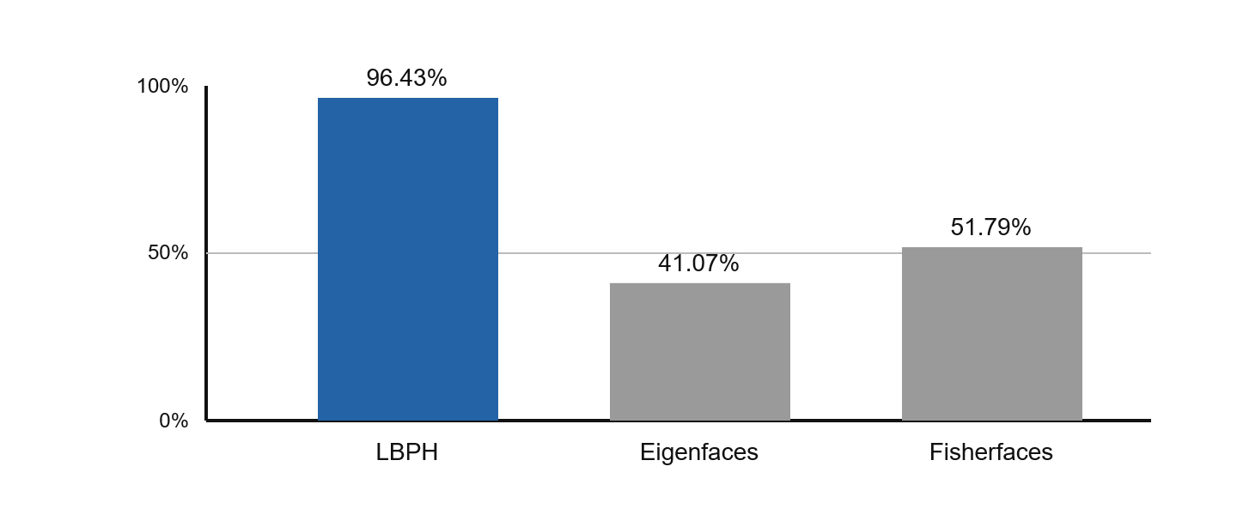
Fig. 1. LSDB held-out thresholded TAR for classical candidate selection.
External LSDB artifacts use a 128-D (512-byte) SFace embedding, whereas ArcFace and FaceNet use 512-D (2,048-byte) embeddings. SFace is retained as the deployment-compatible escalation model; these external, model-specific thresholds are not a same-harness accuracy ranking.
  - Independence Test: Frozen Operating Points
LFW DB1 fixes the operating points before LSDB evaluation (Table 3). Figure 2 places those fixed boundaries against fresh LSDB clean-impostor pairs; it is not a re-calibration.
Table 3. Frozen operating points: native scales and LFW calibration.
Boundary | Frozen / native scale | LFW calibration / FAR
LBPH accept | d <= 67.0333 predict_collect | rank 165 / 16.52M; 9.986 ppm FAR
SFace accept | L2 <= 1.0313 FR_NORM_L2 | joint LFW; about 10 ppm FAR
LBPH reject | d >= 140.13 predict_collect | FRR/escalation; no FAR target


Fig. 2. Histograms and KDE curves for fresh LSDB clean impostor pairs. Long-dotted lines mark frozen LFW operating points.
  - LFW2 Robustness Evaluation
Table 4 summarizes gallery/probe-disjoint LFW2 1-to-N identification robustness at the frozen deployment thresholds. Across all 41 modifications, SFace and the cascade retain 80.65% AR, whereas LBPH alone retains 1.41%. The cascade escalates 97.51% of probes to SFace; isolated latency is reported from a 575-identity subset.
Table 4. LFW2 1-to-N identification robustness at frozen deployment thresholds.
Mode | AR  (%) | Latency  (ms) | FAR  (%) | Escalation  (%)
Classical CV (LBPH) | 1.41 | 72.49 | 0.0010 | N/A
Deep Learning (SFace) | 80.65 | 84.36 | ~0.0010 | N/A
Hybrid Cascade | 80.65 | 82.54 | ≤0.0020 | 97.51
Overall AR and escalation are means across 41 modifications (5,749 enrolled identities; 1,680 probes; strict no-face policy). Latencies are isolated means from a 575-identity/172-probe subset. Standalone FAR values are LFW1 9.986-ppm calibrations; SFace is approximate at the deployed boundary. Cascade ≤0.0020% is a conservative union bound, not a measured joint FAR.
  - Complementarity on Held-Out LSDB-DL41 Probes
The complementarity battery used 2,296 DL41-transformed probes from the 56-image held-out LSDB split, with the frozen LFW-derived gate and strict detector-failure handling. This is a paired transform-sensitivity analysis, not a new operating-point calibration or an LFW result. At the thresholded correct-identity decision, LBPH was correct on 707 probes, SFace alone recovered 1,296 LBPH failures, and both engines failed on 293 probes.
Table 5. Paired thresholded correct-identity outcomes on held-out LSDB-DL41 probes (n = 2,296).
LBPH outcome | SFace correct | SFace wrong
LBPH correct | 707 | 0
LBPH wrong | 1,296 | 293
SFace recovered 1,296 of 1,589 LBPH errors: 81.56% (Wilson 95% CI, 79.58â€“83.39%). Exact two-sided McNemar testing of the discordant cells (LBPH-only right = 0; SFace-only right = 1,296) gave p < 10^-300. These counts establish asymmetric error recovery in this LSDB stress setting; they do not establish error independence on a population-level impostor distribution.
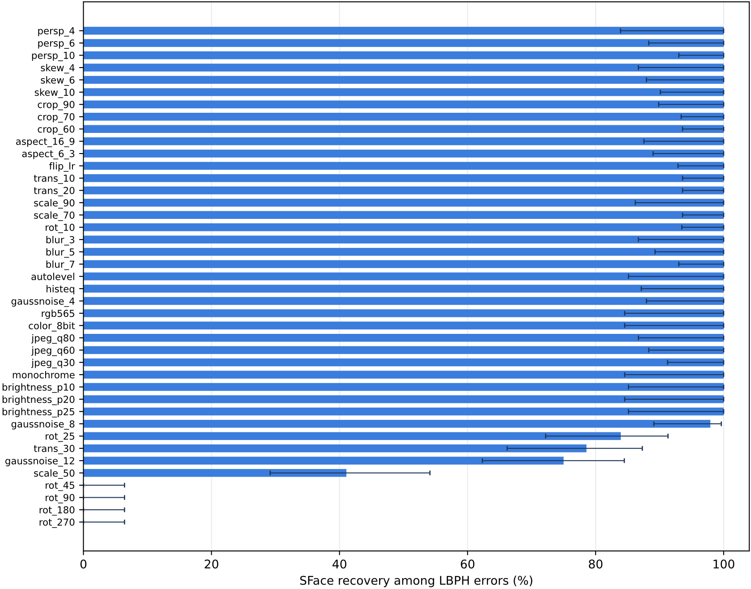
Fig. 3. SFace recovery of LBPH thresholded errors by DL41 transformation on the LSDB held-out split.
Whiskers show 95% Wilson intervals; all claims are restricted to this transform-sensitivity stress test.
The gate signal separated threshold-free LBPH Rank-1 failures strongly among the 2,060 probes for which a gate signal was available: the LBPH distance yielded ROC AUC 0.95019 and negative relative margin yielded AUC 0.95319, against 444 Rank-1 errors. At the deployed routing rule, the gate recalled all thresholded LBPH system failures, while its false-positive routing rate among thresholded LBPH-correct scored probes was 40.88% and routing precision was 82.40%. The gate therefore captures the relevant failure regime, but deliberately routes many correct LBPH cases to the DL tier.
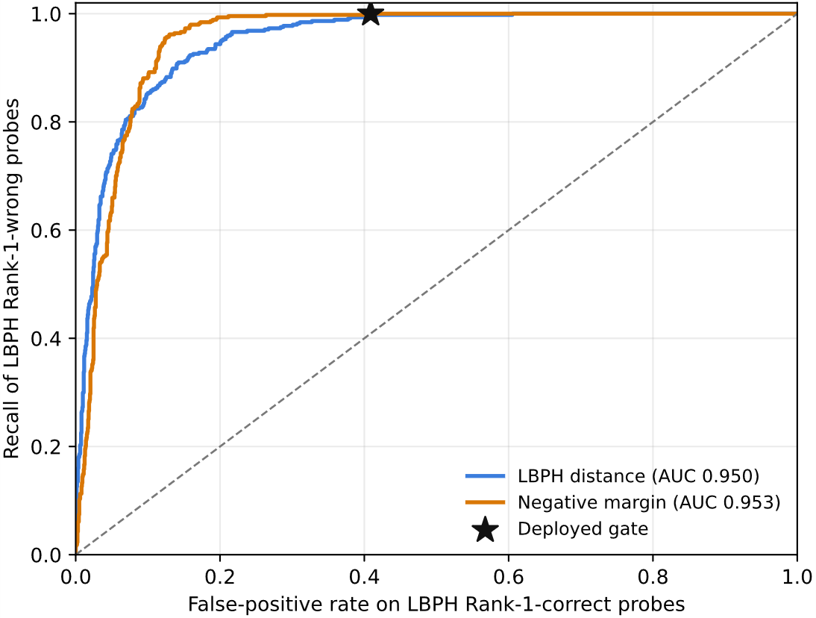
Fig. 4. Gate competence for threshold-free LBPH Rank-1 errors on scored LSDB-DL41 probes (n = 2,060; 444 errors).
Curves evaluate failure discrimination, separate from the thresholded routing outcomes reported in text.
The route sweep shows the cost of that recovery under the recorded recognition-stage timing protocol. The deployed cascade matched SFace at 87.24% thresholded correct-identity acceptance, but used 11.96 ms per probe versus 8.33 ms for SFace-only; it escalated 71.52% of probes. LBPH-only ran at 5.25 ms but reached 30.79%. Thus this run supports recovery and routing evidence, not a selective speed-gain claim.
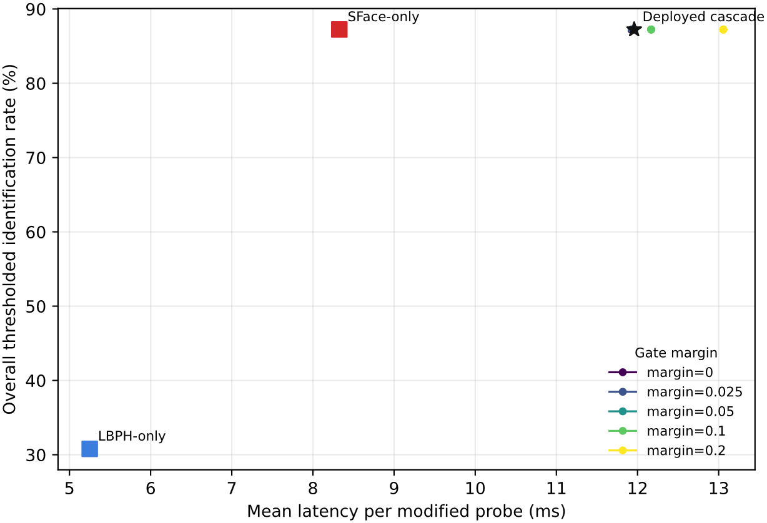
Fig. 5. Recognition-stage timing versus thresholded correct-identity acceptance for held-out LSDB-DL41 probes.
Timing is single-pass, model-initialized measurement and is not end-to-end deployment latency.
- Discussion
Results support a division of labor rather than a claim that the cascade universally improves a stronger learned recognizer. LSDB selection identifies LBPH as the strongest tested classical fast path under its local calibration-only protocol, while SFace is retained as the compact learned tier. The held-out DL41 stress test then shows why the two tiers are operationally useful together: SFace recovers most thresholded LBPH failures and the LBPH distance/margin signals predict rank failures well enough to route them.
The evaluation also exposes an important boundary. On the LSDB-DL41 sweep, the deployed cascade equals SFace-only acceptance but is slower under recorded recognition-stage timing because most probes escalate. On the LFW2 identification evaluation, the cascade likewise closely follows SFace because the frozen LFW gate escalates 97.51% of degraded probes. The practical benefit is therefore a policy-controlled fallback and a transparent failure-routing mechanism, not a demonstrated latency reduction in every domain.
Several limits remain. LSDB candidate selection, LFW threshold calibration, LFW2 robustness, and LSDB-DL41 complementarity answer different protocol questions and must not be merged into one accuracy claim. The LSDB complementarity results use deterministic transformations of a small held-out split; they do not measure open-set recognition, end-to-end device latency, or population-level error independence. Future work should repeat the paired battery with independently captured probes, full end-to-end hardware timing, and a larger open-set impostor corpus.
- Conclusion
This paper presented LS-Face, a gated hybrid face-recognition system that couples an LBPH fast path with SFace escalation. A provenance-separated evaluation selected LBPH on LSDB, froze the deployment gate from LFW impostor evidence, and evaluated robustness and paired recovery without silently retuning thresholds on test outcomes. On held-out LSDB-DL41 probes, SFace recovered 81.56% of thresholded LBPH errors, while the gate signals discriminated LBPH Rank-1 failures with AUCs near 0.95.
The evidence supports the hybrid as an interpretable routing design: LBPH can provide a low-cost first decision, and SFace supplies a robust fallback when the gate identifies a risky case. It does not support a general claim of lower latency than SFace-only or a universal accuracy gain. Larger independently captured open-set trials and end-to-end embedded measurements are needed before deployment-level performance claims.
- Acknowledgments
The authors thank the external deep-learning team for providing the candidate-model artifacts used in the offline screening stage.
- Disclosure of Interests
The authors have no competing interests to declare.
References
- M. Turk and A. Pentland, "Eigenfaces for recognition," J. Cogn. Neurosci., vol. 3, no. 1, pp. 71-86, 1991.
- P. N. Belhumeur, J. P. Hespanha, and D. J. Kriegman, "Eigenfaces vs. Fisherfaces: recognition using class specific linear projection," IEEE Trans. Pattern Anal. Mach. Intell., vol. 19, no. 7, pp. 711-720, Jul. 1997.
- T. Ahonen, A. Hadid, and M. Pietikäinen, "Face description with local binary patterns: application to face recognition," IEEE Trans. Pattern Anal. Mach. Intell., vol. 28, no. 12, pp. 2037-2041, Dec. 2006.
- Y. Zhong, W. Deng, J. Hu, D. Zhao, X. Li, and D. Wen, "SFace: sigmoid-constrained hypersphere loss for robust face recognition," IEEE Trans. Image Process., vol. 30, pp. 2587-2598, 2021.
- P. Viola and M. Jones, "Rapid object detection using a boosted cascade of simple features," in Proc. IEEE CVPR, 2001, vol. 1, pp. I-511-I-518.
- F. Schroff, D. Kalenichenko, and J. Philbin, "FaceNet: a unified embedding for face recognition and clustering," in Proc. IEEE CVPR, 2015, pp. 815-823.
- W. Wu, H. Peng, and S. Yu, "YuNet: a tiny millisecond-level face detector," Mach. Intell. Res., vol. 20, no. 5, pp. 656-665, 2023.
- G. B. Huang, M. Ramesh, T. Berg, and E. Learned-Miller, "Labeled faces in the wild: a database for studying face recognition in unconstrained environments," Univ. Massachusetts, Amherst, Tech. Rep. 07-49, Oct. 2007.
- ISO/IEC 19795-1:2006, Information Technology, Biometric Performance Testing and Reporting, Part 1: Principles and Framework, ISO, Geneva, 2006.
- G. Bradski, "The OpenCV library," Dr. Dobb's J. Softw. Tools, vol. 25, no. 11, pp. 120-125, Nov. 2000.
- L. I. Kuncheva and C. J. Whitaker, "Measures of diversity in classifier ensembles and their relationship with the ensemble accuracy," Mach. Learn., vol. 51, no. 2, pp. 181-207, 2003.
- Q. McNemar, "Note on the sampling error of the difference between correlated proportions or percentages," Psychometrika, vol. 12, no. 2, pp. 153-157, 1947.

