Facial Recognition Using Hybrid Technologies Based on Independence Testing
Kyle Yuan L. Uy*, Andrew P. Eroyla*, John Roland L. Octavio*, Jim Jonathan C. Decripito*, Loreto B. Damasco Jr.*, and Weon Geon Oh*+
*Computer Science Department, College of Computing Studies, University of St. La Salle - Bacolod, Bacolod City, Philippines
+THINKforBL, Korea
Abstract. Face recognition for access-control systems must remain reliable under changing image conditions without using more computation than necessary. This study presents LS-Face, a two-stage recognizer that uses LBPH first and sends uncertain or poor-quality cases to SFace. The experiments were divided into four parts: recognizer selection, threshold setting, controlled robustness testing, and held-out cascade testing. LBPH and SFace were chosen from three classical and three deep-learning candidates using La Salle DB1. The acceptance thresholds were then set using cross-identity comparisons on LFW. For LBPH, 16,522,626 impostor comparisons produced a calibration false-accept rate of 9.986 ppm at the selected threshold. In the controlled self-match robustness test, transformed versions of the enrolled images were matched back to their source identities. Across 41 transformations, LBPH, SFace, and the cascade achieved retention rates of 77.02%, 88.90%, and 88.91%, respectively, with 92.45% of modified conditions escalated to SFace. In a separate held-out La Salle DB1-DL41 test using different enrollment and probe photographs, SFace recovered 81.56% of thresholded LBPH failures. LBPH distance and the separation between its top two matches were also strong indicators of LBPH failure, with AUCs of 0.950 and 0.953. A post-hoc replay on the same evaluation data reduced escalation from 71.52% to 59.23% while preserving the same 87.24% thresholded correct-identity acceptance. However, the cascade still required 10.81 ms on average compared with 8.33 ms for direct SFace. These results show that SFace provides an effective fallback for difficult LBPH cases and that LBPH scores can help decide when fallback is needed, but the current cascade does not provide a runtime advantage over direct SFace under the tested stress conditions. Open-set identification and end-to-end target-device performance were not evaluated.
Keywords: Face Recognition, Home Security, Hybrid Recognition, Selective Computation, Independence Testing
- Introduction
Face recognition is a biometric technology that identifies or verifies an individual by comparing facial characteristics obtained from a digital image with previously enrolled biometric references [17]. It has various applications, including home security and access control, financial identity verification, and public safety.
Among these applications, home security is particularly important because reliable recognition can support household safety and convenient access control. This application is also relevant in countries such as the Philippines, where rapid urbanization continues to increase the concentration of people and activities in urban areas [18]. These conditions provide practical motivation for investigating reliable face-recognition technologies for residential environments.
However, applying face recognition in real-world environments remains difficult because recognition performance can vary with image and capture conditions. Changes in illumination, camera angle, head pose, facial expression, gaze, blur, scale, occlusion, and other image-quality factors can alter the appearance of the same person [8, 14, 15]. Recognition must also distinguish natural differences in facial appearance and structure among individuals. These variations create a need for recognition methods that remain reliable under changing conditions.
Various approaches have been proposed to address these challenges, including lightweight recognition methods and selective systems that use stronger models only when necessary [12–14]. In this study, a hybrid approach combines classical computer vision and deep learning, while an empirical independence-testing procedure examines cross-identity score separation and establishes recognition operating thresholds [9, 16].
Based on these concepts, this paper presents LS-Face, a two-stage face-recognition methodology that uses LBPH as the first-stage recognizer and escalates uncertain or degraded cases to SFace. The methodology is evaluated through recognizer selection on La Salle DB1, cross-identity threshold calibration on LFW [8], controlled self-match robustness testing under 41 image transformations, and held-out evaluation of fallback and routing behavior on La Salle DB1-DL41. These experiments examine the robustness provided by SFace fallback and the recognition-performance and computational-cost trade-offs of selective escalation.
- Related Work
  - Face Recognition Models
Classical face recognition methods provide computationally simple baselines for identity representation. Eigenfaces [1] projects facial appearance into a PCA subspace, Fisherfaces [2] combines dimensionality reduction with LDA for class separation, and LBPH [3] represents local texture through spatial histograms of binary patterns. These methods serve as the classical candidates evaluated in this study.
Deep face recognition instead learns discriminative embedding spaces. FaceNet [6] introduced triplet-loss training, ArcFace [11] improved angular class separation, and SFace [4] uses a sigmoid-constrained hypersphere loss. These embedding-based approaches form the learned-model candidates considered for the deep stage.
  - Face Detection and Alignment
Recognition also depends on reliable localization and alignment. Viola-Jones [5] established the classical boosted-cascade detector, while YuNet [7] provides lightweight CNN-based detection together with five facial landmarks. In this study, YuNet supplies both face localization and the landmarks used for SFace alignment.
  - Selective and Edge Recognition
Efficient face recognition can be addressed through compact learned models or selective computation. Lightweight architectures such as EdgeFace [12] demonstrate deep recognition under edge constraints, while SelectiveNet [13] formalizes the trade-off between prediction risk and coverage. Face-quality approaches such as SER-FIQ [14] similarly estimate when a recognition input may be unreliable.
LS-Face follows this selective-computation principle. LBPH handles first-stage recognition, while its score, candidate separation, and image-quality indicators determine whether SFace is invoked. The resulting accuracy-cost trade-off is therefore compared with always-LBPH and always-SFace operation.
  - Evaluation and Robustness
Biometric evaluation requires the recognition task and error unit to be stated explicitly. ISO/IEC 19795-1 [9] defines general biometric performance-testing principles. LFW [8] is primarily a pairwise verification benchmark, whereas IJB-A [15] extends evaluation to unconstrained 1:1 verification and open-set 1:N identification. NIST 1:N evaluation [16] further distinguishes identification measures such as FPIR and FNIR from pairwise verification errors.
Accordingly, this study treats exhaustive cross-identity impostor-score enumeration as an empirical threshold-calibration procedure rather than evidence of statistical independence. The held-out La Salle DB1-DL41 experiment evaluates complementarity and routing behavior through paired recognizer outcomes, recovery of LBPH failures, routing discrimination, escalation, and timing. Because multiple transformations originate from the same source images, they are treated as correlated conditions rather than independent trials.
- Method
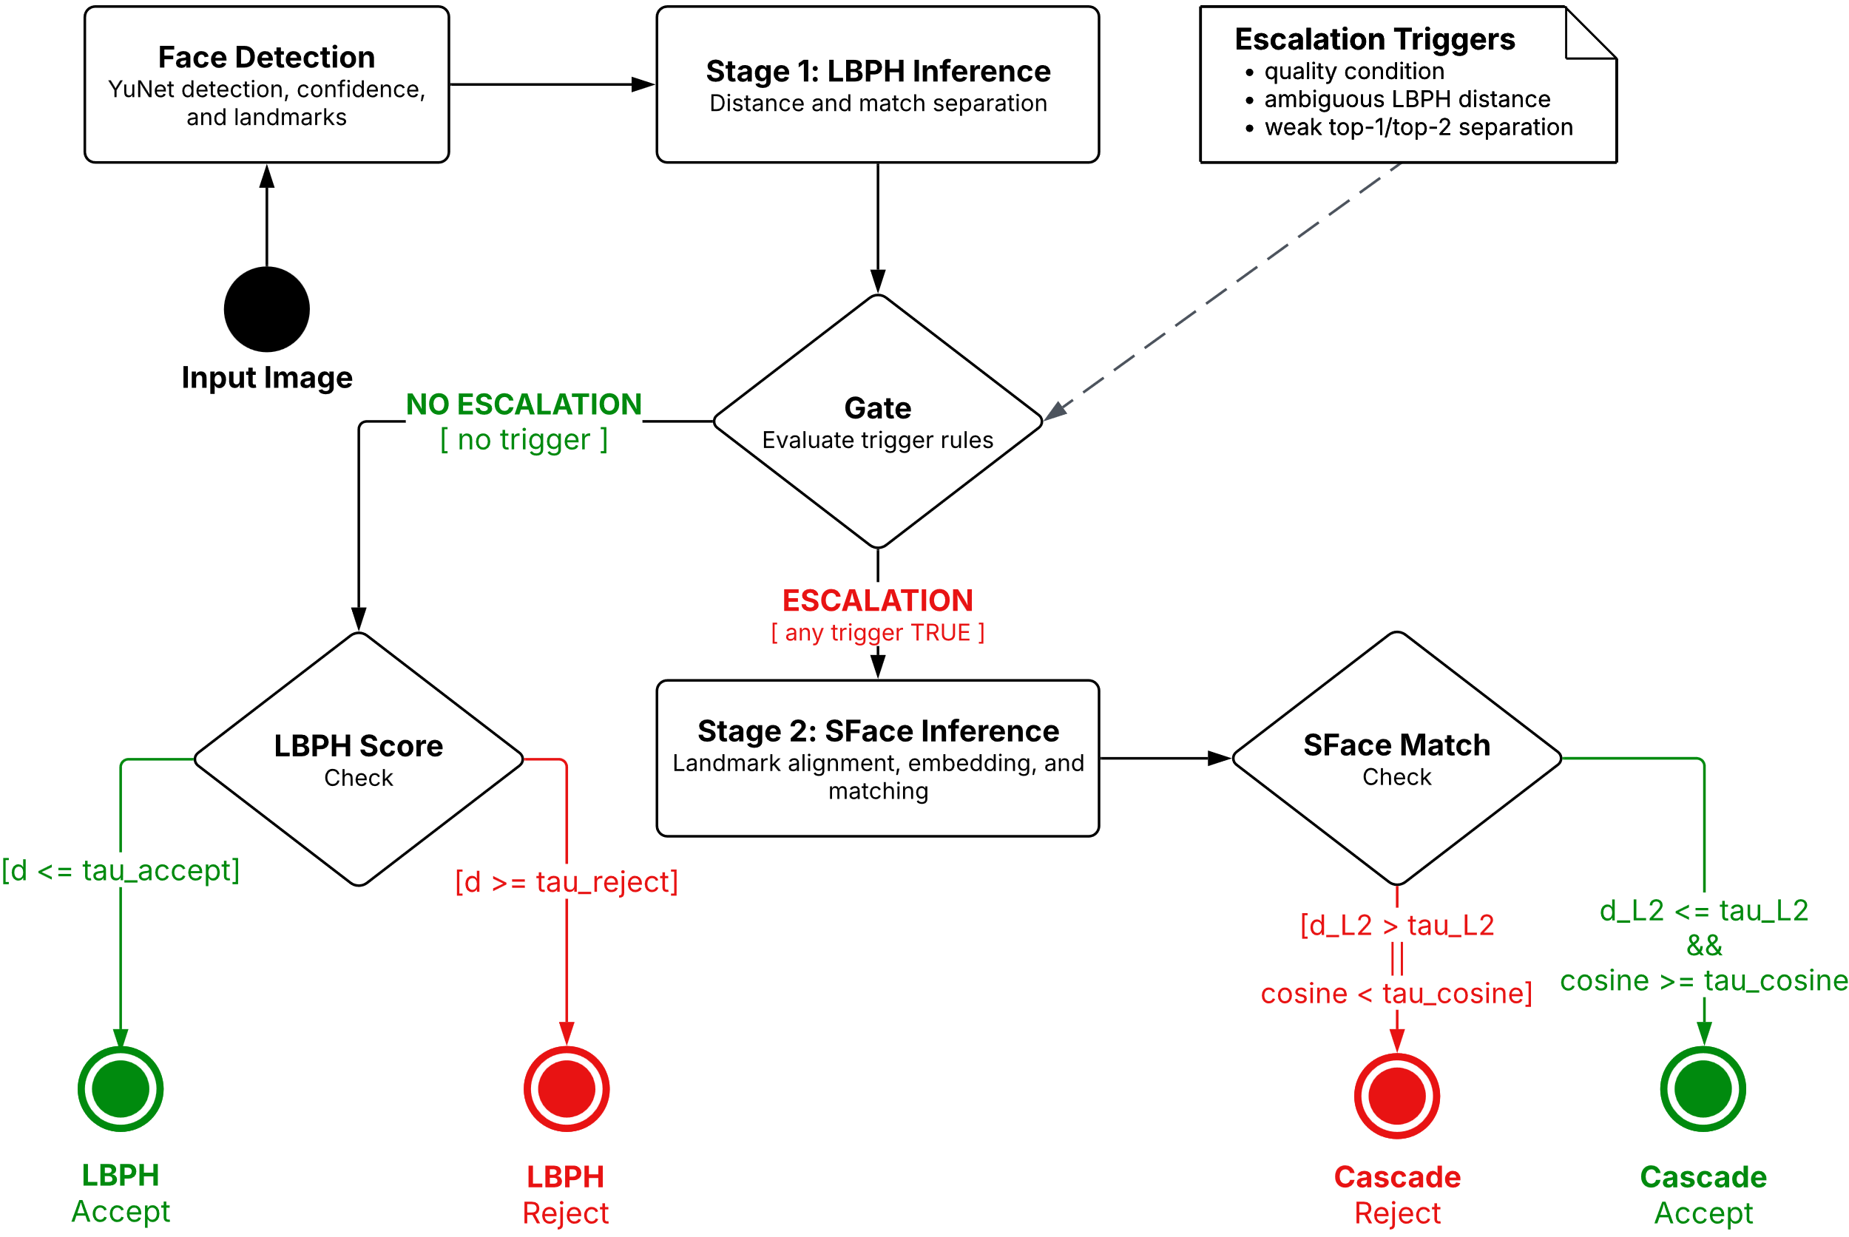
  - System Overview and Escalation Logic
Fig. 1. Overview of the LS-Face recognition and escalation pipeline
LS-Face processes each input image through the two-stage recognition pipeline shown in Fig. 1. The YuNet detector [7] implemented in OpenCV [10] first detects the face and provides detection confidence and facial landmarks. If no valid face is detected, recognition stops and the sample is treated as a detection failure.
Stage 1 recognition. For a detected face, LBPH ranks the enrolled identities according to their matching distances. Let d₁ and d₂ denote the best and second-best LBPH distances, respectively, where a smaller distance indicates a closer match. These scores, together with image-quality indicators computed from the detected face crop, are evaluated by the escalation rule.
Escalation logic. Let τ_{accept} denote the frozen LBPH acceptance threshold, τ_{reject} the frozen rejection threshold, where τ_{reject} > τ_{accept}, and m_{min} the minimum permitted relative separation between the two highest-ranked identity candidates. An input is escalated to Stage 2 when at least one of the following conditions is satisfied:
(i) an image-quality flag is raised because of blur, illumination outside the calibrated range, sensor noise, off-pose presentation, or insufficient face size;
(ii) the best LBPH distance lies within the ambiguous region, τ_{accept} < d₁ < τ_{reject};
(iii) the relative top-two margin is below m_{min}:
$\frac{(d2-d1)}{d1} < m_{min}$ (1)
Table 1. Deployed quality-check and candidate-separation parameters for Stage 1 escalation.
Signal | Measurement / condition | Selection rule | Deployed value
Blur | Variance of Laplacian below threshold | 5th percentile of clean values | 587.83
Illumination | Mean grayscale outside lower/upper bounds | 2nd and 98th percentiles of clean values | [52.88, 137.71]
Noise | Immerkaer noise estimate above threshold | 95th percentile of clean values | 8.206
Pose | Maximum of eye-roll and nose-yaw proxies above threshold | 95th percentile of clean values | 63.74°
Face size | Detected box side below minimum | ⌊0.9 × p₅⌋ of clean box sizes | 61 px
Relative top-two margin | (d₂ − d₁) / d₁ < m_{min} | Fixed engineering policy value | m_{min} = 0.05
The quality thresholds in Table 1 were defined from the empirical distribution edges of 279 clean facial crops detected across a 280-image reference collection (10 clean frontal and pose images per identity across 28 identities, with one detector miss excluded), rather than optimized on the 41-transformation evaluation set or fitted to a measured LBPH-to-SFace performance crossover. The relative top-two margin expresses the separation between the two highest-ranked candidates relative to the best-match distance; m_{min} = 0.05 was chosen as a fixed engineering policy value rather than statistically optimized. The quality condition is evaluated independently of the LBPH score, allowing quality-flagged inputs to be escalated even when the first-stage distance appears confident.
If no escalation condition is triggered, the result is resolved by LBPH. The best-ranked identity is accepted when d₁ ≤ τ_{accept} and rejected when d₁ ≥ τ_{reject}. Scores between the two thresholds cannot terminate at Stage 1 because they satisfy the ambiguous-score condition and are therefore escalated.
Stage 2 recognition and final decision. For an escalated input, SFace uses the facial landmarks returned by YuNet to align the detected face, extracts its embedding, and compares it with the enrolled identity representations. The predicted identity is accepted only when it satisfies the frozen SFace acceptance criterion; otherwise, the prediction is rejected. Thus, each successfully detected input terminates either with an LBPH decision at Stage 1 or, when escalation is triggered, with an SFace decision at Stage 2.
The deployed thresholds and escalation parameters were fixed before the held-out La Salle DB1-DL41 cascade evaluation and were not adjusted using individual test outcomes.
  - Offline Recognizer Selection
Recognizer selection was conducted offline and independently of the frame-level escalation process summarized in Section 3.1. As shown in Fig. 2, La Salle DB1 was divided into fixed training, calibration, and held-out evaluation subsets. Three classical recognizers (LBPH, Eigenfaces, and Fisherfaces) and three learned models (SFace, FaceNet, and ArcFace) were evaluated as separate candidate groups.
Classical candidates were fitted and calibrated using the designated development subsets, while the learned candidates were evaluated using a common YuNet alignment and brightness-normalization front end. Because the candidate models produce different score types and scales, each was evaluated using its native scoring method. Evaluation considered cross-identity impostor scores, held-out genuine recognition, robustness under the 41 image transformations, runtime, and representation size. Selection was performed separately for the classical first stage and learned second stage using these evaluation criteria and deployment considerations. The resulting two-stage configuration was then frozen before subsequent threshold calibration and cascade evaluation.


Fig. 2. Offline recognizer selection procedure for the LS-Face cascade
  - Independence Testing and Threshold Freezing
Independence-test construction. In this study, the independence test examines cross-identity separation by comparing facial representations belonging to different identities. Given (N) identities represented by one designated image each, every unordered pair of different identities is compared once, yielding
C = N(N − 1) / 2 (2)
unique comparisons. Because every pair contains two different identities, all (C) comparisons are impostor comparisons by construction.
For each recognizer, the resulting native scores are ordered from the most likely to be accepted to the least likely. For distance-based scores such as LBPH and SFace L2, this corresponds to sorting the distances in ascending order. For a target false-accept rate (FAR^*), the maximum permitted number of accepted impostor comparisons is
k = ⌊FAR* · C⌋ (3)
The operating threshold is selected at the corresponding lower tail of the impostor-score distribution. Because the deployed acceptance rule includes scores equal to the threshold, the realized FAR is recomputed after threshold selection, including any ties at the boundary.
LFW is used for the primary low-FAR independence test because its 5,749 identities yield 16,522,626 unique cross-identity comparisons, enabling resolution on the order of 10 ppm (rank 165 yields 9.986 ppm). Applying the rank-165 operating rule separately to the LBPH and SFace impostor-score distributions yielded their respective acceptance boundaries: τ_accept = 67.0333 for LBPH and L₂ ≤ 1.0313 for SFace. The cosine threshold of 0.363 was retained from the existing SFace decision policy rather than independently fitted at this operating point; because normalized embeddings satisfy L₂ = √(2 − 2 cos θ), L₂ ≤ 1.0313 already implies cos θ ≥ 0.4682, rendering the 0.363 cosine constraint non-binding at the deployed L2 boundary.
Unlike the acceptance threshold, the LBPH rejection boundary τ_reject = 140.13 was not derived from rank-based low-FAR impostor calibration. Instead, a trade-off sweep across candidate values from 70 to 170 was conducted using 70,560 genuine and 70,560 designated-impostor rows from the image-disjoint LFW verification run (where the designated-impostor count serves as a 1:1 proxy rather than a 1:N FPIR measurement). Because no clear separation-favorable knee emerged on unconstrained LFW, 140.13 was selected as a deliberately permissive engineering boundary corresponding to the 99th percentile of genuine LBPH distances under heavy image degradations, limiting irreversible genuine rejections before SFace fallback.
Threshold freezing. The final cascade configuration, comprising the LFW-calibrated LBPH acceptance threshold, the permissive LBPH rejection boundary, the fixed relative top-two margin rule, the clean-distribution quality thresholds, and the deployed SFace acceptance policy, was frozen before conducting the held-out La Salle DB1-DL41 cascade evaluation. The evaluation harness records the configuration SHA-256, and no parameters were retuned using the held-out evaluation outcomes. The final numerical operating points are summarized in Section 4.2.
  - Complementarity Evaluation
The frozen held-out La Salle DB1-DL41 evaluation set supports three parallel analyses of fallback value, routability, and selective utility. The evaluation set contains 56 image-disjoint test images, two for each of 28 identities, with 41 deterministic transformations per image, yielding 2,296 correlated test conditions. Thresholds and routing rules were frozen before scoring, and detector failures were retained as failures.

Fallback value. Thresholded LBPH and SFace outcomes are paired as both correct, LBPH-only correct, SFace-only correct, or neither correct. A recognizer is correct only when it returns the target identity and satisfies its deployed acceptance criterion. SFace recovery of LBPH failures is measured as
$Recovery=\frac{N\left(SFace correct∩LBPH failure\right)}{N\left(LBPH failure\right)}$ (4)

Routability. LBPH distance $d_{1}$ and negative relative top-two margin are evaluated using ROC AUC to separate threshold-free LBPH Rank-1 errors. The deployed rule is then measured using failure-routing recall and unnecessary escalation. Signal-based metrics use only conditions with the required LBPH signals; detector failures remain retained elsewhere.

Measured utility. The cascade is compared with always-LBPH and always-SFace using thresholded acceptance, escalation rate, and recognition-stage time. The post-hoc accept-protection replay treats quality flags as telemetry for already accepted LBPH decisions, without recalibrating scores or thresholds. It is therefore a descriptive ablation, not independent validation. Timing excludes face detection and external I/O and does not represent end-to-end latency.
- Experiments and Results
The experimental program consists of four evidence legs summarized in Table 2. Each leg has a distinct role in the study: recognizer selection, independence testing and operating-point determination, controlled self-match robustness analysis, or held-out cascade evaluation. Results from one leg are not interpreted as measurements of outcomes that its protocol does not directly evaluate.
Table 2. Experiments and their roles in the study.
Experiment | Role in the Study
La Salle DB1 recognizer selection | Select the classical and learned recognizers using fixed La Salle DB1 subsets.
LFW independence test (Sec. 4.2) | Determine low-tail impostor operating points and freeze the deployed thresholds.
Controlled self-match robustness test (Sec. 4.3) | Measure within-image degradation retention under controlled transformations; no cross-photo or FAR claim.
La Salle DB1-DL41 held-out evaluation (Sec. 4.4) | Evaluate SFace recovery, routability, escalation, and recognition-stage cost.

The La Salle DB1 held-out evaluation uses clean enrollment images and image-disjoint probes from the same 28 enrolled identities, but each probe is transformed across 41 deterministic conditions. It evaluates the complementary rescue provided by SFace on LBPH failures, the discriminative capacity of the first-stage routing signals, and the overall accuracy and computational trade-offs of selective escalation.
  - Algorithm Selection on La Salle DB1
Classical candidates were fitted on 224 images, calibrated on 56 disjoint images, and evaluated once on 56 untouched La Salle DB1 probes. The calibration set supplied 1,512 cross-identity scores; the rank-15 impostor score yielded a realized FAR of 0.992%. LBPH achieved the highest test TAR (96.43%) and Rank-1 accuracy (100.00%) and was selected as the classical fast path.
Table 3. Classical candidate selection on La Salle DB1.
Recognizer | TAR (%) | Rank-1 (%) | Feature size
LBPH | 96.43% | 100.00% | 64 KB
Eigenfaces | 41.07% | 75.00% | 896 B
Fisherfaces | 51.79% | 58.93% | 108 B
The learned candidates were evaluated on the same deterministic 224/56/56 La Salle DB1 split. Each model's rank-15 acceptance edge was derived from the 1,512 calibration cross-identity scores, yielding a realized FAR of 0.992%.
Table 4. DL candidate selection on La Salle DB1.
Candidate | TAR (%) | Rank-1 (%) | Feature size
SFace | 100.00% | 100.00% | 512 B
ArcFace | 96.43% | 100.00% | 2,048 B
FaceNet | 100.00% | 100.00% | 2,048 B
SFace and FaceNet tied at 100.00% held-out TAR and Rank-1; SFace was selected using feature size as the deployment tie-break (512 B versus 2,048 B). ArcFace retained 100.00% Rank-1 but reached 96.43% TAR. Thus, SFace was selected as the learned tier, while LBPH remained the separately selected classical fast path.
  - Independence Test: Frozen Operating Points
The LFW independence test produced the frozen operating points summarized in Table 5. Applying the rank-165 operating rule separately to each recognizer's 16,522,626-comparison impostor-score distribution yielded an empirical LBPH acceptance boundary of 67.0333 (realized FAR of 9.986 ppm) and an SFace L2 threshold of 1.0313. The SFace cosine condition (cosine ≥ 0.363) is inherited from the existing SFace decision policy and is non-binding at the deployed L2 boundary.
Table 5. Final frozen operating points.
Boundary | Frozen value | Role
LBPH accept | 67.0333 | Accept
SFace accept | L2 ≤ 1.0313; cosine ≥ 0.363 | Escalated accept
LBPH reject | 140.13 | Reject
Fig. 3 places these frozen operating points against the separately computed La Salle DB1 clean-impostor score distributions. The La Salle DB1 scores are shown only to visualize cross-database transfer and were not used to recalibrate the thresholds.
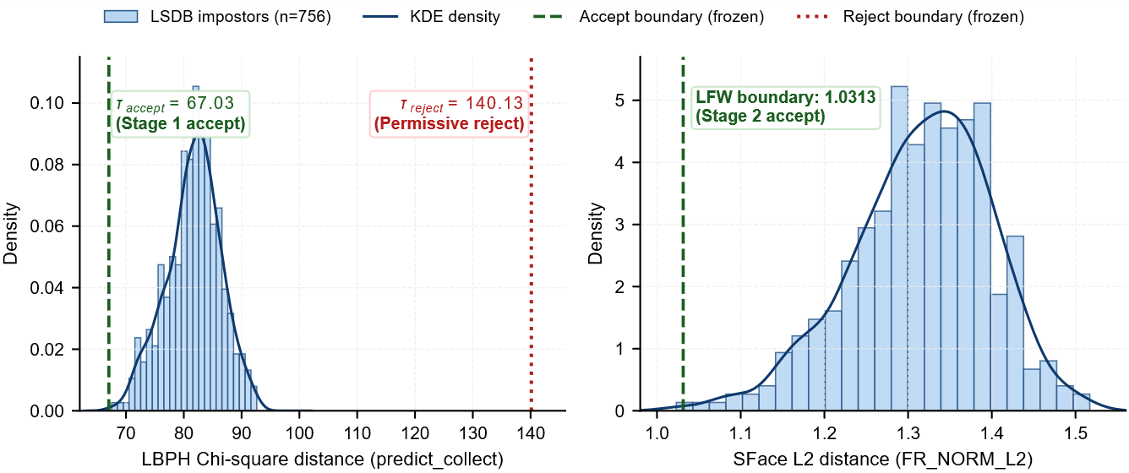
Fig. 3. Histograms and KDE curves of La Salle DB1 clean-impostor scores with frozen LFW operating points overlaid.
  - Controlled Self-Match Robustness Test
Table 6 reports the controlled self-match robustness test under the same frozen operating configuration summarized in Table 5. One selected source image for each of 5,749 LFW identities was enrolled, and the clean and transformed test images were derived from that same source. The experiment therefore measures within-image transformation retention rather than image-disjoint identification, and no FAR is measured because no impostor comparisons are performed. Across the 235,709 modified conditions (41 transformations × 5,749 source images), LBPH, SFace, and the hybrid cascade achieved retention rates of 77.02%, 88.90%, and 88.91%, respectively. The cascade escalated 217,917 of the 235,709 modified conditions (92.45% pooled escalation), essentially matching SFace retention (88.91% versus 88.90%). Under the strict detector-failure policy, 15,083 modified conditions (6.40%) failed face detection—concentrated in 90°, 180°, and 270° rotations and horizontal flipping—and were retained as failures. No modified condition terminated through the LBPH hard-reject branch at τ_{reject} = 140.13, consistent with the boundary's deliberately permissive role on this workload.
Table 6. Controlled self-match robustness test on LFW.
Mode | Clean self-match (%) | 41-transformation retention (%) | 41-transformation escalation (%)
Classical CV (LBPH) | 99.22 | 77.02 | N/A
Deep Learning (SFace) | 99.53 | 88.90 | N/A
Hybrid Cascade | 99.53 | 88.91 | 92.45
The experiment uses the frozen operating configuration summarized in Table 5; detector failures are retained as failures.
  - Complementarity on Held-Out La Salle DB1-DL41 Probes
The evaluation follows the three-link argument described above. It uses 56 image-disjoint held-out La Salle DB1 source test images, two for each of 28 enrolled identities, and 41 deterministic transformations per source, yielding 2,296 correlated test conditions. The LFW-derived thresholds and routing rule were frozen before scoring, and detector failures were handled strictly. Figures 4 and 5 summarize the two main complementarity findings: whether SFace can recover LBPH failures and whether the routing rule can distinguish cases that should be escalated.

Fig. 4. SFace Recovery of Thresholded LBPH Failures in the Hybrid Cascade
First, the fallback outcomes were strongly asymmetric. As shown in Fig. 4, SFace recovered 1,296 of the 1,589 thresholded LBPH failures, corresponding to a recovery rate of 81.56%. The remaining 293 cases (18.44%) were not recovered by either final decision. Conversely, LBPH supplied no thresholded success that SFace lacked. The observed complementarity is therefore one-way: SFace provides substantial rescue for LBPH failures, rather than the two recognizers mutually recovering each other's errors. Because the 41 transformations are repeated conditions derived from the same source images, these counts are interpreted descriptively rather than as 2,296 independent observations.
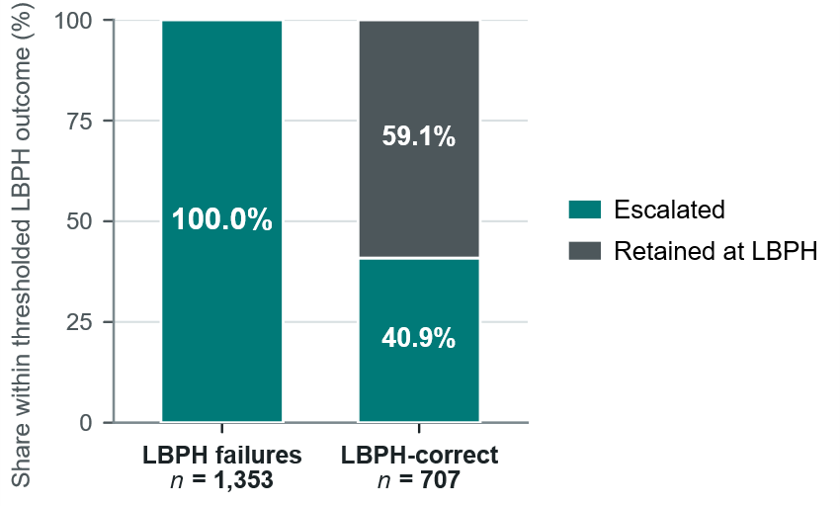
Fig. 5. Escalation behavior by LBPH outcome

Second, LBPH distance and relative top-two margin provided strong discrimination of LBPH Rank-1 errors. Of the 1,589 thresholded LBPH failures, 1,353 had the LBPH signals required for routing analysis; the remaining 236 conditions were excluded from signal-based routing metrics. Among the 2,060 test conditions with available routing signals, LBPH distance and negative relative top-two margin separated 444 threshold-free LBPH Rank-1 errors with AUCs of 0.95019 and 0.95319, respectively. As shown in Fig. 5, the deployed rule escalated all 1,353 thresholded LBPH failures, giving 100.0% failure-routing recall. However, it also escalated 289 of the 707 LBPH-correct cases (40.88%), while the remaining 418 cases (59.12%) were correctly retained at the LBPH stage. Thus, the rule captured all signal-available thresholded LBPH failures but also escalated 40.88% of LBPH-correct cases.
A post-hoc accept-protection replay examined whether this redundant routing could be reduced. The replay preserved the deployed low-margin trigger and all conditions above τ_{accept}, while treating accept-side quality flags as telemetry rather than escalation triggers. Under this replay, unnecessary escalations among LBPH-correct cases fell from 289 to 7 of 707. Because the same transformed probes motivated and evaluated this candidate policy, however, the result is treated only as a descriptive ablation and not as independent validation of an improved routing rule.

Third, reducing redundant escalation improves the deployed route without establishing a speed advantage over direct SFace. The candidate replay preserved the same 87.24% thresholded correct-identity acceptance while reducing escalation from 71.52% to 59.23% and lowering mean recognition-stage time from 11.96 ms to 10.81 ms. Direct SFace nevertheless achieved the same 87.24% acceptance at 8.33 ms, while LBPH-only reached 30.79% at 5.25 ms. These timings represent single-pass stored recognition-stage measurements and exclude detection and I/O. The result therefore suggests that simplifying the routing logic could reduce redundant escalation, but it does not demonstrate a Pareto or runtime advantage over direct SFace.
- Discussion
  - Controlled Robustness
The controlled LFW self-match experiment isolates sensitivity to known image transformations by deriving each test image from its enrolled source. Under this constrained protocol, LBPH, SFace, and the cascade achieved 77.02%, 88.90%, and 88.91% retention across 235,709 modified conditions, with 15,083 strict detector failures (6.40%) retained as failures. The cascade essentially matched SFace retention under the tested transformations, but its 92.45% pooled escalation rate shows that the current routing policy provided little selectivity on this stress workload. Therefore, this self-match workload provides evidence of SFace robustness rather than substantial selective-computation savings. Because transformed test images derive from their enrolled source, the experiment remains a controlled transformation-sensitivity test rather than image-disjoint identification or FAR measurement.
  - Fallback and Routing Behavior
The held-out La Salle DB1-DL41 experiment provides separate image-disjoint evidence. SFace recovered 81.56% of thresholded LBPH failures, while LBPH produced no thresholded success that SFace lacked, showing strongly one-way fallback value. LBPH distance and relative top-two margin also discriminated failure risk well, with AUCs near 0.95. However, useful risk signals did not automatically produce an efficient cascade: among conditions with routing signals, the deployed rule captured all 1,353 thresholded LBPH failures but also escalated 40.88% of LBPH-correct cases.
  - Efficiency Trade-off and Scope
A post-hoc replay on the same evaluation data reduced escalation from 71.52% to 59.23% while preserving 87.24% thresholded correct-identity acceptance, lowering mean recognition-stage time from 11.96 ms to 10.81 ms. Direct SFace nevertheless achieved the same acceptance at 8.33 ms. The replay therefore identifies a possible simplification of the routing policy, but it is descriptive rather than independently validated and does not establish a runtime advantage over direct SFace.
These findings remain bounded by the experimental protocols. The La Salle DB1-DL41 conditions are correlated transformations of 56 source probes, 236 conditions lacked the signals required for routing-score analysis, and timing excludes detection and external I/O. The study therefore does not claim open-set identification performance or end-to-end target-device efficiency.
- Conclusion
  - Main Findings
LS-Face combines an LBPH first stage with SFace fallback and was evaluated through separate selection, calibration, controlled-robustness, and held-out cascade experiments. The controlled self-match run showed that SFace showed higher retention than LBPH under the tested transformations, while the cascade essentially matched SFace retention with high escalation. The held-out La Salle DB1-DL41 experiment separately showed substantial SFace recovery of LBPH failures and useful first-stage risk signals.
  - Overall Implication
Under the held-out La Salle DB1-DL41 stress workload, however, the cascade did not outperform direct SFace in the recognition-performance/runtime trade-off. The study therefore supports SFace as an effective fallback and LBPH scores as informative routing signals, while defining a clear efficiency limit of the current architecture. Open-set identification and end-to-end target-device evaluation remain outside the present scope.

Acknowledgments. The authors gratefully acknowledge the Department of Computer Science, University of St. La Salle–Bacolod, for its institutional support throughout this research. The authors also thank the 10 additional group members who contributed to the study and the 28 student volunteers whose participation made the construction of the La Salle DB1 dataset possible.

Disclosure of Interests. The authors have no competing interests to declare.

- References
- M. Turk and A. Pentland, “Eigenfaces for recognition,” J. Cogn. Neurosci., vol. 3, no. 1, pp. 71–86, 1991.
- P. N. Belhumeur, J. P. Hespanha, and D. J. Kriegman, “Eigenfaces vs. Fisherfaces: Recognition using class specific linear projection,” IEEE Trans. Pattern Anal. Mach. Intell., vol. 19, no. 7, pp. 711–720, Jul. 1997.
- T. Ahonen, A. Hadid, and M. Pietikäinen, “Face description with local binary patterns: Application to face recognition,” IEEE Trans. Pattern Anal. Mach. Intell., vol. 28, no. 12, pp. 2037–2041, Dec. 2006.
- Y. Zhong, W. Deng, J. Hu, D. Zhao, X. Li, and D. Wen, “SFace: Sigmoid-constrained hypersphere loss for robust face recognition,” IEEE Trans. Image Process., vol. 30, pp. 2587–2598, 2021.
- P. Viola and M. Jones, “Rapid object detection using a boosted cascade of simple features,” in Proc. IEEE Conf. Comput. Vis. Pattern Recognit. (CVPR), 2001, vol. 1, pp. I-511–I-518.
- F. Schroff, D. Kalenichenko, and J. Philbin, “FaceNet: A unified embedding for face recognition and clustering,” in Proc. IEEE Conf. Comput. Vis. Pattern Recognit. (CVPR), 2015, pp. 815–823.
- W. Wu, H. Peng, and S. Yu, “YuNet: A tiny millisecond-level face detector,” Mach. Intell. Res., vol. 20, no. 5, pp. 656–665, 2023.
- G. B. Huang, M. Ramesh, T. Berg, and E. Learned-Miller, “Labeled Faces in the Wild: A database for studying face recognition in unconstrained environments,” Univ. Massachusetts, Amherst, Tech. Rep. 07-49, Oct. 2007.
- ISO/IEC 19795-1:2021, Information Technology—Biometric Performance Testing and Reporting—Part 1: Principles and Framework. Geneva, Switzerland: ISO, 2021.
- G. Bradski, “The OpenCV library,” Dr. Dobb’s J. Softw. Tools, vol. 25, no. 11, pp. 120–125, Nov. 2000.
- J. Deng, J. Guo, N. Xue, and S. Zafeiriou, “ArcFace: Additive angular margin loss for deep face recognition,” in Proc. IEEE/CVF Conf. Comput. Vis. Pattern Recognit. (CVPR), 2019, pp. 4690–4699.
- A. George, C. Ecabert, H. O. Shahreza, K. Kotwal, and S. Marcel, “EdgeFace: Efficient face recognition model for edge devices,” IEEE Trans. Biometrics, Behav., Identity Sci., vol. 6, no. 2, pp. 158–168, Apr. 2024.
- Y. Geifman and R. El-Yaniv, “SelectiveNet: A deep neural network with an integrated reject option,” in Proc. 36th Int. Conf. Mach. Learn. (ICML), vol. 97, 2019, pp. 2151–2159.
- P. Terhörst, J. N. Kolf, N. Damer, F. Kirchbuchner, and A. Kuijper, “SER-FIQ: Unsupervised estimation of face image quality based on stochastic embedding robustness,” in Proc. IEEE/CVF Conf. Comput. Vis. Pattern Recognit. (CVPR), 2020, pp. 5651–5660.
- B. F. Klare et al., “Pushing the frontiers of unconstrained face detection and recognition: IARPA Janus Benchmark A,” in Proc. IEEE Conf. Comput. Vis. Pattern Recognit. (CVPR), 2015, pp. 1931–1939.
- P. Grother, M. Ngan, and K. Hanaoka, Face Recognition Vendor Test (FRVT) Part 2: Identification, NIST Interagency/Internal Rep. 8271, National Institute of Standards and Technology, Gaithersburg, MD, USA, 2019.
- ISO/IEC 2382-37:2022, Information Technology—Vocabulary—Part 37: Biometrics. Geneva, Switzerland: ISO, 2022.
- World Bank, Philippines Urbanization Review: Fostering Competitive, Sustainable, and Inclusive Cities. Washington, DC, USA: World Bank Group, 2017.

