MiniShell
A Shell, CPU Scheduling Simulator, and Deadlock Simulator in C
CmpSc 123 Operating Systems · Group Final Project · November 2026
Queypo, Ckhiel Joshua · Viloria, Julian Shaun
Repository: github.com/CyJul17/Micro_Shell

1. Design Overview
MiniShell is a command-line shell written in C that also simulates two core parts of an operating system: CPU scheduling and deadlock handling. It runs as a loop that shows a minishell> prompt, reads a line, runs it, and repeats until the user types exit. Real commands are run with the same system calls a real shell uses (fork, execvp, pipe, dup2, waitpid), so the shell is not a simulation; only the scheduler and the deadlock module are simulators. The two simulators are built-in commands, sched and deadlock, that read plain text input files.

Modules
Source file | Responsibility
main.c | Entry point and REPL loop; interactive, -c "command", and script-file modes
parser.c | Splits ; && ||, tokenizes words, quotes, $VAR and operators, builds pipeline stages, and executes them
builtin.c | File and directory built-ins, chmod, ls -l, grep, env, echo, exit, help
scheduler.c | Process loader, PCB table, six scheduling algorithms, Gantt chart, state log, averages
deadlock.c | Matrix loader, deadlock detection, Banker's safety check, resource requests, recovery
utils.c | Memory, string, and path helpers; recursive copy and remove

How a command line is executed
- Read. The REPL reads one line (shell_getline).
- Split. The line is split on ;, &&, and || outside quotes. && runs the next part only if the last status was 0; || only if it was not.
- Tokenize. Each part becomes tokens. Quotes and backslashes are removed, $NAME, ${NAME}, $?, and ~ are expanded, and operators (|, >, >>, <, 2>, 2>&1, >&2) are marked as operators so a quoted "|" stays a normal word.
- Parse. Tokens are cut at | into pipeline stages. Each stage gets its argument list and its redirections.
- Execute. cd and exit run inside the shell because they change its state. Every other command, built-in or external, runs in a child created with fork; the child applies redirections with dup2 and then runs the built-in or calls execvp. A pipeline creates one child per stage connected by pipes.
- Wait. The shell waits for the children and stores the exit status in $?. Errors print a message and the loop continues, so the shell never crashes.

2. Modules

2.1 Module 1: Shell Core
Requirement | Implementation
File and directory built-ins | pwd cd ls mkdir [-p] rmdir touch cp [-r] mv rm [-r -f] cat
Permissions | chmod 755 file (numeric modes); ls -l prints -rwxr-xr-x, links, owner, size, and date
Redirection | > >> < 2> 2>> 2>&1 >&2, applied left to right as in Bash
Pipes | Any number of stages, e.g. ls -l | grep txt | cat
Variables | NAME=value, $NAME, ${NAME}, $?, env; NAME=value cmd sets it for that command only
Conditionals | cmd1 && cmd2, cmd1 || cmd2, cmd1 ; cmd2
Text search | grep [-i] [-n] pattern [file...] for plain text; grep -E adds regular expressions (. [a-z] * + ? escaping, groups) using the POSIX regex library
Error handling | Clear messages for unknown commands (status 127), missing files, bad options and syntax errors; Ctrl+C stops the running command, not the shell

2.2 Module 2: Process Scheduling Simulator
sched <algorithm> [--quantum N] <file> loads processes (one per line: PID arrival burst priority; - reads from standard input). Each process has a PCB with its PID, arrival, burst, priority, remaining time, completion, waiting, turnaround, queue level, and state. The simulator advances a clock, records every CPU slice in a Gantt chart, and computes Turnaround = Completion − Arrival and Waiting = Turnaround − Burst with their averages.
Algorithm | Selection rule | Preemption
FCFS | Earliest arrival (ties by PID) | Non-preemptive
SJN | Shortest burst among ready processes | Non-preemptive
Priority | Smallest priority number | Non-preemptive
Round-Robin | FIFO ready queue | Quantum 4 (--quantum N)
MLQ | Q0: priority 0-2, Q1: 3-5, Q2: 6+ | Q0 q=2, Q1 q=4, Q2 FCFS
MLFQ | All start in Q0; demoted after a full quantum | q = 2, 4, 8

Each run prints the initial PCB table (all New), the Gantt chart, a timed log of PCB state changes, the final PCB table (all Terminated), and the per-process results. The state log shows New → Ready on arrival, Ready → Running on dispatch, Running → Ready on preemption, and Running → Terminated on completion. There are no I/O events, so no process enters Waiting. Round-Robin on basic.txt begins:
t=0 P1 New -> Ready (arrived)
t=0 P1 Ready -> Running (dispatched)
t=1 P2 New -> Ready (arrived)
t=4 P1 Running -> Ready (preempted)
t=4 P2 Ready -> Running (dispatched)
t=8 P2 Running -> Terminated (burst complete)

2.3 Module 3: Deadlock Simulator
deadlock detect|banker <file> reads the number of processes and resources, the Allocation and Max matrices, and the Available vector, and computes Need = Max − Allocation. Both algorithms use the same reduction: start with Work = Available, repeatedly find an unfinished process whose demand fits in Work, let it finish, and add its allocation back to Work.
- Detection uses each process's current request (an optional requests matrix; without one it assumes each process requests its full Need). Processes that can never finish are reported as deadlocked, followed by a recovery suggestion (terminate a process or preempt its resources).
- Banker's algorithm uses Need. If every process can finish, the state is SAFE and the order found is printed as the safe sequence; otherwise it is UNSAFE.
- Resource request (--request PID r1 r2 ... or a request line in the file) is granted only if it is ≤ the process's Need, ≤ Available, and the state after pretending to grant it is still safe. Otherwise it is denied with the reason, and the state is rolled back.

3. Module 4: Comparison

3.1 Scheduling algorithms
The same two input files were run through all six algorithms (Round-Robin with quantum 4). Every value below comes from the simulator's own output, collected by tests/compare.sh.
Algorithm | mixed.txt avg waiting | mixed.txt avg turnaround | basic.txt avg waiting | basic.txt avg turnaround
FCFS | 5.20 | 9.20 | 8.75 | 15.25
SJN | 3.80 | 7.80 | 7.75 | 14.25
Priority | 5.40 | 9.40 | 7.75 | 14.25
Round-Robin (q=4) | 5.60 | 9.60 | 11.75 | 18.25
MLQ | 4.80 | 8.80 | 9.50 | 16.00
MLFQ | 7.40 | 11.40 | 13.00 | 19.50
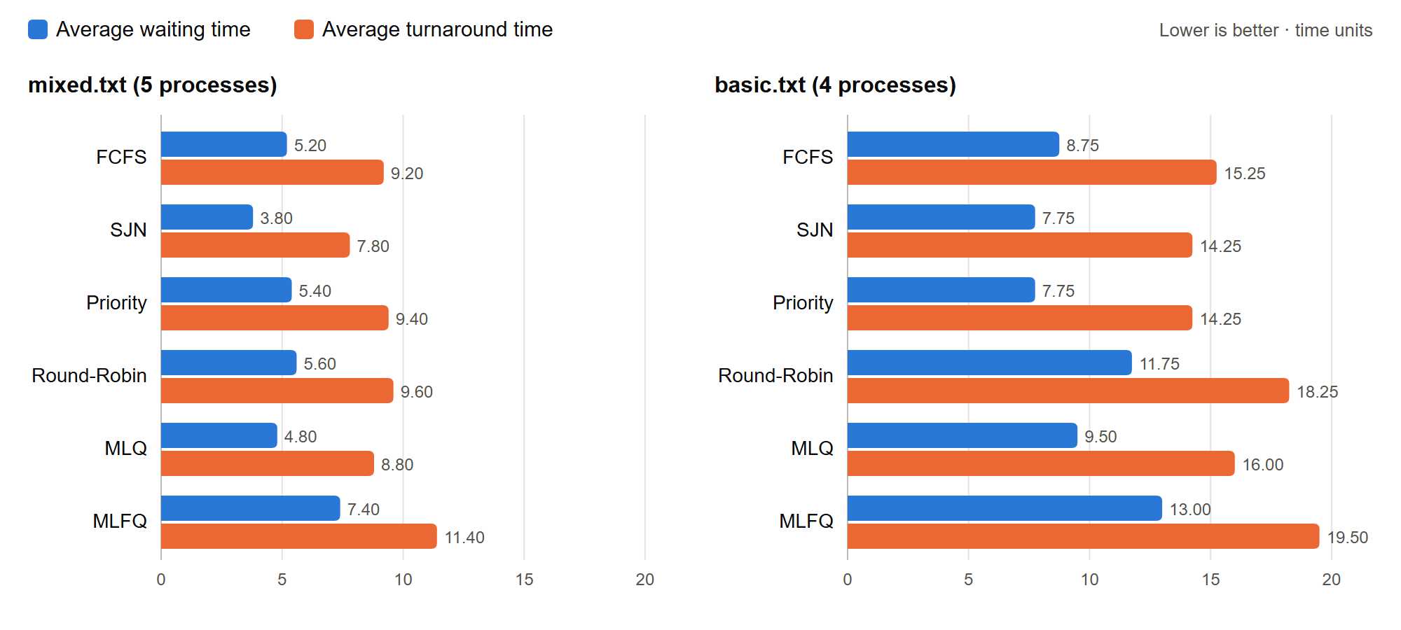
Figure 1. Average waiting and turnaround time per algorithm (lower is better).
Gantt charts for mixed.txt:
FCFS [0-3] P1 | [3-9] P2 | [9-13] P3 | [13-15] P4 | [15-20] P5
SJN [0-3] P1 | [3-7] P3 | [7-9] P4 | [9-14] P5 | [14-20] P2
Priority [0-6] P2 | [6-8] P4 | [8-11] P1 | [11-16] P5 | [16-20] P3
RR (q=4) [0-3] P1 | [3-7] P2 | [7-11] P3 | [11-13] P4 | [13-15] P2 | [15-20] P5
Best algorithm: SJN. It had the lowest average waiting and turnaround time on both workloads (3.80 / 7.80 on mixed.txt). Running the shortest ready job first means the most processes finish early, so less total time is spent waiting. In mixed.txt it moves the short jobs P3 and P4 ahead of the long job P2, while FCFS makes them wait behind P2 (the convoy effect). The trade-off is that SJN needs to know burst times in advance and can starve long jobs: P2 finishes last.
- Priority tied SJN on basic.txt because there the priorities happened to pick the same short jobs first; on mixed.txt the high-priority P2 is also the longest job, so it did worse.
- MLQ came second on mixed.txt by giving high-priority short jobs a fast queue.
- Round-Robin gives the fairest response time, but splitting jobs into slices delays their completion, which raises the averages.
- MLFQ had the highest averages: every job starts in Q0 and is demoted after each full quantum, so long jobs are split many times and wait behind newer ones.

3.2 Deadlock: safe and unsafe examples
Safe (safe.txt, 5 processes, 3 resources, Available = 3 3 2): P1's Need (1 2 2) fits in Available, so P1 can finish and release its resources, which then lets P3, P0, P2, and P4 finish. Output: State is SAFE. Safe sequence: P1 → P3 → P0 → P2 → P4. A request of (1, 0, 2) by P1 is GRANTED; a request of (7, 4, 3) by P0 is DENIED because only 3 units of resource A are free.
Unsafe (unsafe.txt, 3 processes, 2 resources, Available = 0 0):
Process | Allocation | Max | Need
P0 | 1 0 | 2 1 | 1 1
P1 | 0 1 | 1 2 | 1 1
P2 | 1 1 | 2 2 | 1 1

Every process still needs one more unit of each resource and none are free, so no process can finish. Output: State is UNSAFE. No safe sequence exists. Unfinished processes: P0 P1 P2. Unsafe does not yet mean deadlocked; it means the system can no longer guarantee that all processes finish, which is exactly what the Banker's algorithm prevents by denying requests that lead there. With a requests matrix, detection on requests_deadlock.txt finds P1, P2, P3, and P4 deadlocked while P0 can finish.

4. Testing
make test runs 126 automated checks (tests/run_tests.sh) covering every built-in, redirection, pipes, variables, conditionals, grep, error cases, all six schedulers, and every deadlock input. The simulators have 5 process files and 8 resource files, including edge cases: an empty process list, a single process, an idle CPU before the first arrival, and a single-process deadlock system. Each input, its purpose, and its verified result are listed in docs/TEST_CASES.md.

5. Member Contributions
Member | Work
Queypo, Ckhiel Joshua | Shell core: parser, executor, built-ins, redirection, pipes, variables, error handling, integration of all commands; bug fixes and PCB state transitions; test runner and test-case catalog
Viloria, Julian Shaun | Scheduler (six algorithms, PCB table, Gantt chart), deadlock detection and Banker's algorithm, test input files, comparison data, README and documentation

Both members tested and reviewed each other's modules and the combined program.

