Data Dictionary
This data dictionary describes every table in the RAPID MySQL schema. Import database/rapid-datamodeler.sql into Oracle SQL Developer Data Modeler (File > Import > DDL File) or MySQL Workbench (File > Import > Reverse Engineer MySQL Create Script) to generate the logical ERD with the same relationships.
Entity Relationship Diagram
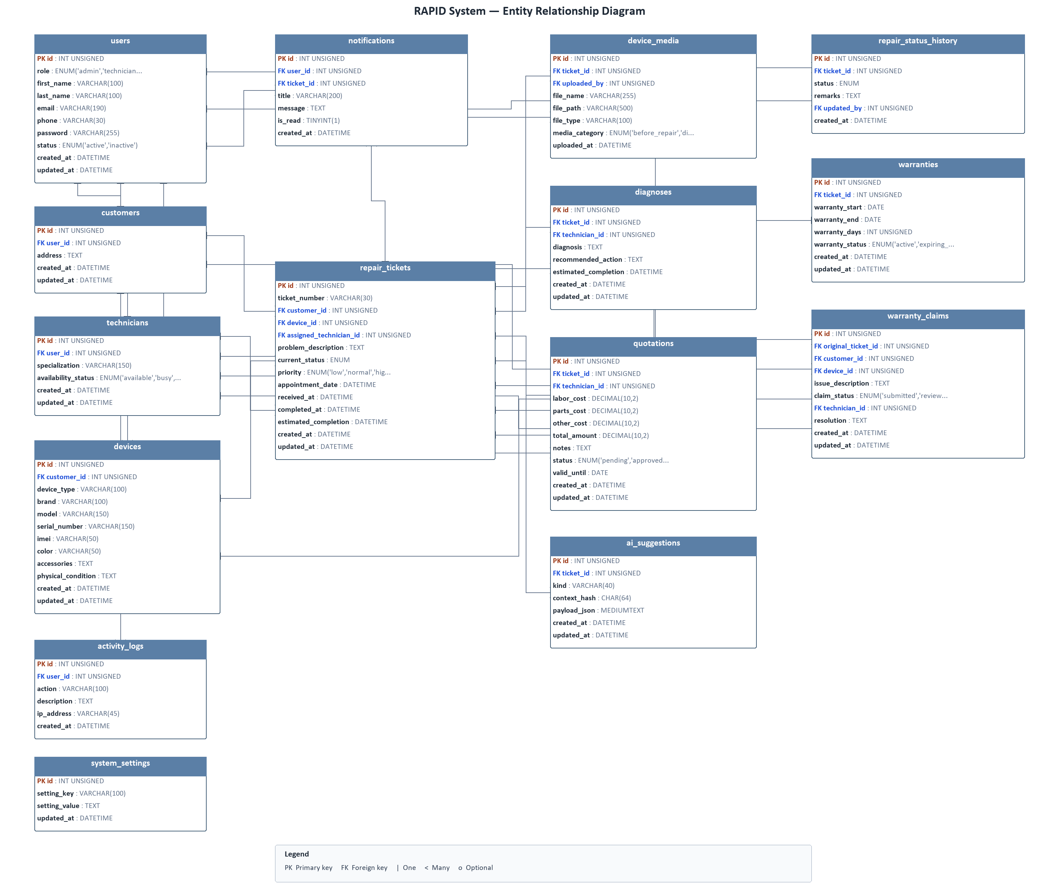
Figure 3.1: Entity Relationship Diagram of RAPID System.

Data Dictionary
Users Table
users | rapid
Attribute | Type | Null | Default | Description
id | INT UNSIGNED | NO | PK | Unique ID of the user.
role | ENUM('admin','technician','customer') | NO |  | Role of the user in the RAPID system.
first_name | VARCHAR(100) | NO |  | First name of the user.
last_name | VARCHAR(100) | NO |  | Last name of the user.
email | VARCHAR(190) | NO | UNIQUE | Email address used to log in.
phone | VARCHAR(30) | YES | NULL | Contact number of the user.
password | VARCHAR(255) | NO |  | Hashed password of the user.
status | ENUM('active','inactive') | NO | active | Account status of the user.
created_at | DATETIME | NO | CURRENT_TIMESTAMP | Date and time the user was created.
updated_at | DATETIME | NO | CURRENT_TIMESTAMP | Date and time the user was last updated.
Table 3.1: Users Table of RAPID System.
Client/Customer Table
customers | rapid
Attribute | Type | Null | Default | Description
id | INT UNSIGNED | NO | PK | Unique ID of the customer.
user_id | INT UNSIGNED | NO | FK, UNIQUE | Linked user account of the customer.
address | TEXT | YES | NULL | Address of the customer.
created_at | DATETIME | NO | CURRENT_TIMESTAMP | Date and time the customer was created.
updated_at | DATETIME | NO | CURRENT_TIMESTAMP | Date and time the customer was last updated.
Table 3.2: Client/Customer Table of RAPID System.
Technicians Table
technicians | rapid
Attribute | Type | Null | Default | Description
id | INT UNSIGNED | NO | PK | Unique ID of the technician.
user_id | INT UNSIGNED | NO | FK, UNIQUE | Linked user account of the technician.
specialization | VARCHAR(150) | YES | NULL | Repair specialization of the technician.
availability_status | ENUM('available','busy','unavailable') | NO | available | Current availability of the technician.
created_at | DATETIME | NO | CURRENT_TIMESTAMP | Date and time the technician was created.
updated_at | DATETIME | NO | CURRENT_TIMESTAMP | Date and time the technician was last updated.
Table 3.3: Technicians Table of RAPID System.
Devices Table
devices | rapid
Attribute | Type | Null | Default | Description
id | INT UNSIGNED | NO | PK | Unique ID of the device.
customer_id | INT UNSIGNED | NO | FK | Owner of the device.
device_type | VARCHAR(100) | NO |  | Type of the device.
brand | VARCHAR(100) | NO |  | Brand of the device.
model | VARCHAR(150) | NO |  | Model of the device.
serial_number | VARCHAR(150) | YES | NULL | Serial number of the device.
imei | VARCHAR(50) | YES | NULL | IMEI of the device.
color | VARCHAR(50) | YES | NULL | Color of the device.
accessories | TEXT | YES | NULL | Accessories received with the device.
physical_condition | TEXT | YES | NULL | Physical condition of the device.
created_at | DATETIME | NO | CURRENT_TIMESTAMP | Date and time the device was created.
updated_at | DATETIME | NO | CURRENT_TIMESTAMP | Date and time the device was last updated.
Table 3.4: Devices Table of RAPID System.
Repair Tickets Table
repair_tickets | rapid
Attribute | Type | Null | Default | Description
id | INT UNSIGNED | NO | PK | Unique ID of the repair ticket.
ticket_number | VARCHAR(30) | NO | UNIQUE | Public tracking number of the ticket.
customer_id | INT UNSIGNED | NO | FK | Customer who requested the repair.
device_id | INT UNSIGNED | NO | FK | Device attached to the ticket.
assigned_technician_id | INT UNSIGNED | YES | FK, NULL | Technician assigned to the ticket.
problem_description | TEXT | NO |  | Reported problem of the device.
current_status | ENUM | NO | booking_submitted | Current repair status of the ticket (booking_submitted, received, diagnosing, quotation_pending, awaiting_approval, approved, repairing, ready_for_pickup, completed, declined, cancelled).
priority | ENUM('low','normal','high','urgent') | NO | normal | Priority level of the ticket.
appointment_date | DATETIME | YES | NULL | Scheduled appointment date of the ticket.
received_at | DATETIME | YES | NULL | Date and time the device was received.
completed_at | DATETIME | YES | NULL | Date and time the repair was completed.
estimated_completion | DATETIME | YES | NULL | Estimated completion date of the repair.
created_at | DATETIME | NO | CURRENT_TIMESTAMP | Date and time the ticket was created.
updated_at | DATETIME | NO | CURRENT_TIMESTAMP | Date and time the ticket was last updated.
Table 3.5: Repair Tickets Table of RAPID System.
Device Media Table
device_media | rapid
Attribute | Type | Null | Default | Description
id | INT UNSIGNED | NO | PK | Unique ID of the media file.
ticket_id | INT UNSIGNED | NO | FK | Repair ticket of the media file.
uploaded_by | INT UNSIGNED | NO | FK | User who uploaded the media file.
file_name | VARCHAR(255) | NO |  | Original file name of the media.
file_path | VARCHAR(500) | NO |  | Stored path of the media file.
file_type | VARCHAR(100) | NO |  | MIME type of the media file.
media_category | ENUM('before_repair','diagnosis','during_repair','after_repair') | NO | before_repair | Stage of the repair when the media was taken.
uploaded_at | DATETIME | NO | CURRENT_TIMESTAMP | Date and time the media was uploaded.
Table 3.6: Device Media Table of RAPID System.
Diagnoses Table
diagnoses | rapid
Attribute | Type | Null | Default | Description
id | INT UNSIGNED | NO | PK | Unique ID of the diagnosis.
ticket_id | INT UNSIGNED | NO | FK | Repair ticket of the diagnosis.
technician_id | INT UNSIGNED | NO | FK | Technician who recorded the diagnosis.
diagnosis | TEXT | NO |  | Diagnosis findings of the device.
recommended_action | TEXT | YES | NULL | Recommended repair action.
estimated_completion | DATETIME | YES | NULL | Estimated completion after diagnosis.
created_at | DATETIME | NO | CURRENT_TIMESTAMP | Date and time the diagnosis was created.
updated_at | DATETIME | NO | CURRENT_TIMESTAMP | Date and time the diagnosis was last updated.
Table 3.7: Diagnoses Table of RAPID System.
AI Suggestions Table
ai_suggestions | rapid
Attribute | Type | Null | Default | Description
id | INT UNSIGNED | NO | PK | Unique ID of the AI suggestion.
ticket_id | INT UNSIGNED | NO | FK | Repair ticket of the AI suggestion.
kind | VARCHAR(40) | NO | technician_repair | Type of AI suggestion stored.
context_hash | CHAR(64) | NO |  | Hash of the ticket context used for cache.
payload_json | MEDIUMTEXT | NO |  | JSON payload of the AI suggestion.
created_at | DATETIME | NO | CURRENT_TIMESTAMP | Date and time the suggestion was created.
updated_at | DATETIME | NO | CURRENT_TIMESTAMP | Date and time the suggestion was last updated.
Table 3.8: AI Suggestions Table of RAPID System.
Quotations Table
quotations | rapid
Attribute | Type | Null | Default | Description
id | INT UNSIGNED | NO | PK | Unique ID of the quotation.
ticket_id | INT UNSIGNED | NO | FK | Repair ticket of the quotation.
technician_id | INT UNSIGNED | NO | FK | Technician who prepared the quotation.
labor_cost | DECIMAL(10,2) | NO | 0.00 | Labor cost of the repair.
parts_cost | DECIMAL(10,2) | NO | 0.00 | Parts cost of the repair.
other_cost | DECIMAL(10,2) | NO | 0.00 | Other cost of the repair.
total_amount | DECIMAL(10,2) | NO | 0.00 | Total amount of the quotation.
notes | TEXT | YES | NULL | Additional notes of the quotation.
status | ENUM('pending','approved','declined','expired') | NO | pending | Approval status of the quotation.
valid_until | DATE | YES | NULL | Expiry date of the quotation.
created_at | DATETIME | NO | CURRENT_TIMESTAMP | Date and time the quotation was created.
updated_at | DATETIME | NO | CURRENT_TIMESTAMP | Date and time the quotation was last updated.
Table 3.9: Quotations Table of RAPID System.
Repair Status History Table
repair_status_history | rapid
Attribute | Type | Null | Default | Description
id | INT UNSIGNED | NO | PK | Unique ID of the status history record.
ticket_id | INT UNSIGNED | NO | FK | Repair ticket of the status change.
status | ENUM | NO |  | Status value recorded in the timeline (same values as repair_tickets.current_status).
remarks | TEXT | YES | NULL | Remarks of the status change.
updated_by | INT UNSIGNED | YES | FK, NULL | User who recorded the status change.
created_at | DATETIME | NO | CURRENT_TIMESTAMP | Date and time the status was recorded.
Table 3.10: Repair Status History Table of RAPID System.
Warranties Table
warranties | rapid
Attribute | Type | Null | Default | Description
id | INT UNSIGNED | NO | PK | Unique ID of the warranty.
ticket_id | INT UNSIGNED | NO | FK, UNIQUE | Completed repair ticket of the warranty.
warranty_start | DATE | NO |  | Start date of the warranty.
warranty_end | DATE | NO |  | End date of the warranty.
warranty_days | INT UNSIGNED | NO | 30 | Coverage length of the warranty in days.
warranty_status | ENUM('active','expiring_soon','expired') | NO | active | Current status of the warranty.
created_at | DATETIME | NO | CURRENT_TIMESTAMP | Date and time the warranty was created.
updated_at | DATETIME | NO | CURRENT_TIMESTAMP | Date and time the warranty was last updated.
Table 3.11: Warranties Table of RAPID System.
Warranty Claims Table
warranty_claims | rapid
Attribute | Type | Null | Default | Description
id | INT UNSIGNED | NO | PK | Unique ID of the warranty claim.
original_ticket_id | INT UNSIGNED | NO | FK | Original repair ticket of the claim.
customer_id | INT UNSIGNED | NO | FK | Customer who filed the claim.
device_id | INT UNSIGNED | NO | FK | Device covered by the claim.
issue_description | TEXT | NO |  | Reported issue of the warranty claim.
claim_status | ENUM('submitted','reviewing','approved','rejected','repairing','resolved') | NO | submitted | Current status of the warranty claim.
technician_id | INT UNSIGNED | YES | FK, NULL | Technician assigned to the claim.
resolution | TEXT | YES | NULL | Resolution notes of the claim.
created_at | DATETIME | NO | CURRENT_TIMESTAMP | Date and time the claim was created.
updated_at | DATETIME | NO | CURRENT_TIMESTAMP | Date and time the claim was last updated.
Table 3.12: Warranty Claims Table of RAPID System.
Notifications Table
notifications | rapid
Attribute | Type | Null | Default | Description
id | INT UNSIGNED | NO | PK | Unique ID of the notification.
user_id | INT UNSIGNED | NO | FK | User who receives the notification.
ticket_id | INT UNSIGNED | YES | FK, NULL | Related repair ticket of the notification.
title | VARCHAR(200) | NO |  | Title of the notification.
message | TEXT | NO |  | Message of the notification.
is_read | TINYINT(1) | NO | 0 | Read flag of the notification.
created_at | DATETIME | NO | CURRENT_TIMESTAMP | Date and time the notification was created.
Table 3.13: Notifications Table of RAPID System.
Activity Logs Table
activity_logs | rapid
Attribute | Type | Null | Default | Description
id | INT UNSIGNED | NO | PK | Unique ID of the activity log.
user_id | INT UNSIGNED | YES | FK, NULL | User who performed the action.
action | VARCHAR(100) | NO |  | Action name of the log.
description | TEXT | YES | NULL | Details of the activity.
ip_address | VARCHAR(45) | YES | NULL | IP address of the activity.
created_at | DATETIME | NO | CURRENT_TIMESTAMP | Date and time the activity was recorded.
Table 3.14: Activity Logs Table of RAPID System.
System Settings Table
system_settings | rapid
Attribute | Type | Null | Default | Description
id | INT UNSIGNED | NO | PK | Unique ID of the setting.
setting_key | VARCHAR(100) | NO | UNIQUE | Key name of the setting.
setting_value | TEXT | YES | NULL | Value of the setting.
updated_at | DATETIME | NO | CURRENT_TIMESTAMP | Date and time the setting was last updated.
Table 3.15: System Settings Table of RAPID System.
Relationship Dictionary
Parent Table | Child Table | Parent | Child | Foreign Key
users | customers | 1 | 0..1 | user_id
users | technicians | 1 | 0..1 | user_id
customers | devices | 1 | 0..* | customer_id
customers | repair_tickets | 1 | 0..* | customer_id
devices | repair_tickets | 1 | 0..* | device_id
technicians | repair_tickets | 0..1 | 0..* | assigned_technician_id
repair_tickets | device_media | 1 | 0..* | ticket_id
users | device_media | 1 | 0..* | uploaded_by
repair_tickets | diagnoses | 1 | 0..* | ticket_id
technicians | diagnoses | 1 | 0..* | technician_id
repair_tickets | ai_suggestions | 1 | 0..* | ticket_id
repair_tickets | quotations | 1 | 0..* | ticket_id
technicians | quotations | 1 | 0..* | technician_id
repair_tickets | repair_status_history | 1 | 1..* | ticket_id
users | repair_status_history | 0..1 | 0..* | updated_by
repair_tickets | warranties | 1 | 0..1 | ticket_id
repair_tickets | warranty_claims | 1 | 0..* | original_ticket_id
customers | warranty_claims | 1 | 0..* | customer_id
devices | warranty_claims | 1 | 0..* | device_id
technicians | warranty_claims | 0..1 | 0..* | technician_id
users | notifications | 1 | 0..* | user_id
repair_tickets | notifications | 0..1 | 0..* | ticket_id
users | activity_logs | 0..1 | 0..* | user_id
Table 3.16: Relationship Dictionary of RAPID System.

