Guidance
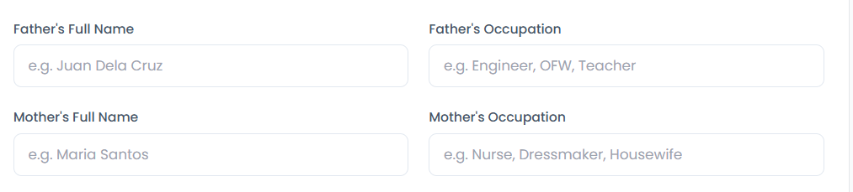
-Remove the parent field due to it is not necessary to recommend strand/course

-use random forest algorithm to recommend strand/course. How it computes the strand/course recommendation based on specific factors. What are the basis for coming up with that recommendation.
-Academic Competency scores
-Work Immersion Performance(for incoming 1st year college)
-Skills assessment
-Student Interest
-Technical Skill Level
Random Forest recommends courses by:
- Collecting student data (grades, skills, interests)
- Creating multiple decision trees from historical student records
- Each tree predicts a possible course
- The system uses majority voting to determine the final recommended course.

-what analytics is needed to decide on the recommendations for a particular student.
-input,process, output for recommending strands/course
-inputs should be as follows:
-Academic Grades
-Skills Assessment
-Interest
-Score during Entrance Exam
-Career Preference

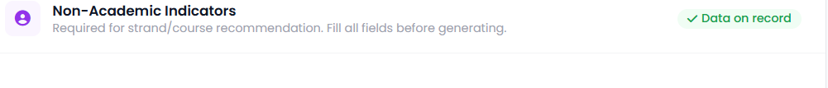
-add 1st choice of strand/course then it will be the indicator for guidance that the recommendation has mismatch with what the students want.

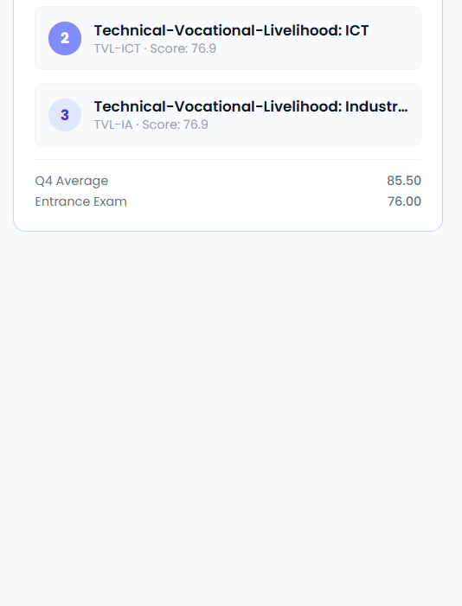
Add information on the lower part
- Just to tell that there is mismatch. “When the guidance counselor sees the first choice is a mismatch based on the following recommendations”. If did not match the top 3 recommendation the system will show to the guidance counselor that there is a mismatch.
-Provide explanation in the lower part why does this 3 is the recommended strand/course

-Employability readiness should be seen only by the guidance counselor, wherein the factor that affect it is the work immersion
“how will the system assist the guidance counselor about the employability readiness of student for senior high school.”

Teacher
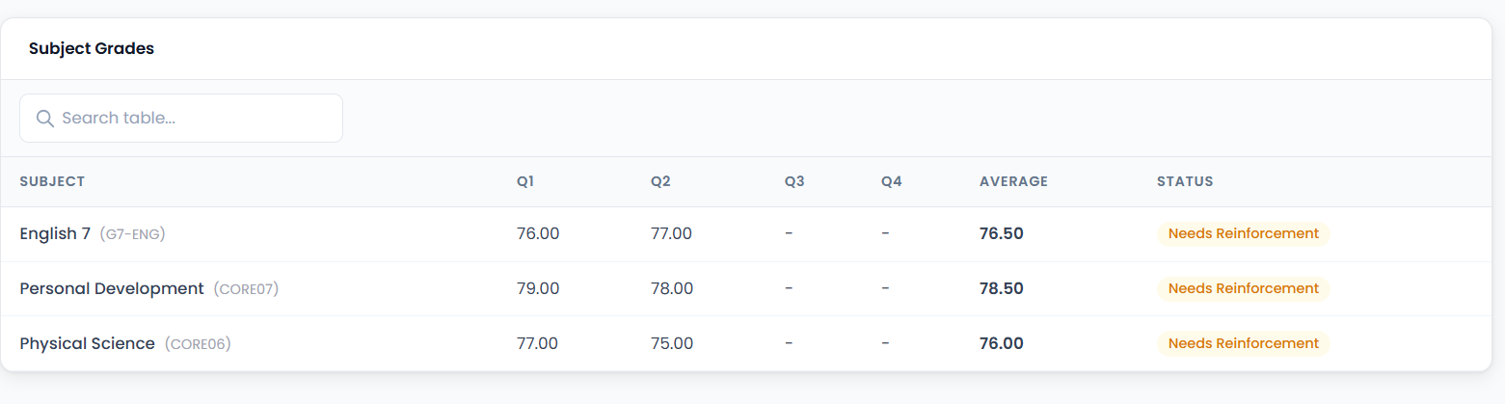
-provide remarks “what are the learning gaps” “why is it the status needs reinforcement”

