**Project Title: Incident Response Lab**

This is a text file, essay, on the Lazysysadmin Virtual Box

**Description**

This essay details the tactics used to attack the Lazysysadmin Virtual Box by VulnHub, provided as coursework at Coding Dojo Cyber Security. This walkthrough demonstrates possibilities for attack vectors from a threat actor point of view, as well as detections of Indicators of Compromise from the Security Responder point of view.

**Getting Started**

**Dependencies**

* Oracle VirtualBox
* Linuz or Windows Distro
* Kali Linux Virtual Box
* Lazysysadmin Virtual Box
* SluethKit / Autopsy

**Installing**

* Enter:

curl -O https://github.com/CySJM/-Lazysysadmin.git

* Or download text file from github

**Executing**

* Open file in text editor

**Help**

No issues reported at this time

**Authors**

Jon Murray

**Version History**

* 0.1
  + Initial Release

**License**

This project is licensed under the MIT License – see the LICENSE.md file for details.

**Acknowledgements**

* Inspiration – Several YouTube videos and written walkthroughs

**Photos**

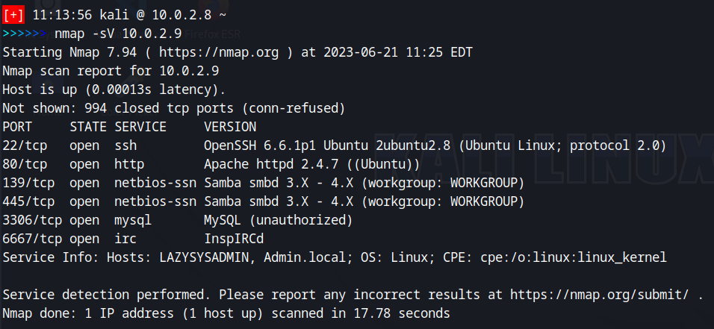

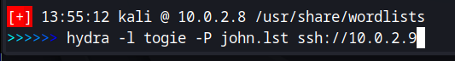

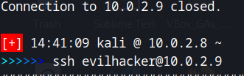

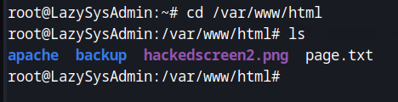

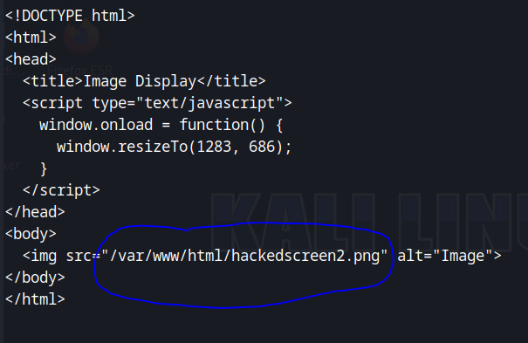

**Photos - Additional**

