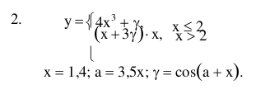

def main():

x = int(input(«x = »)) # 1.4 # arg 1

a = int(input(«a = »)) # 3.5 # arg 2

a = a \* x

Y = cos(a + x)

if x <= 2:

y = x \* (x \*\* 3) + Y

elif x > 2:

y = (x + 3 \* Y) \* x

return y

ds

