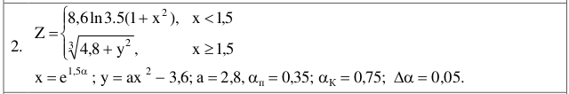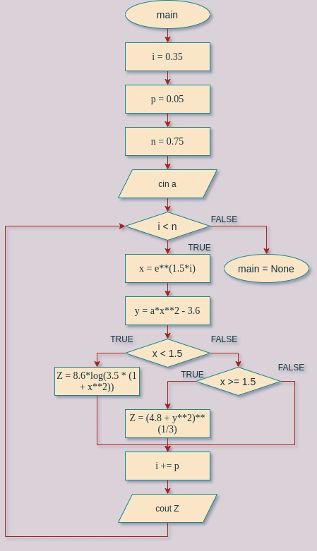

import math

i = 0.35

p = 0.05

n = 0.75

a = int(input(«a = »))

while (i < n):

x = e\*\*(1.5\*i)

y = a\*x\*\*2 — 3.6

if x < 1.5:

Z = 8.6\*log(3.5 \* (1 + x\*\*2))

elif x >= 1.5:

Z = (4.8 + y\*\*2)\*\*(1/3)

i += p

print(Z)