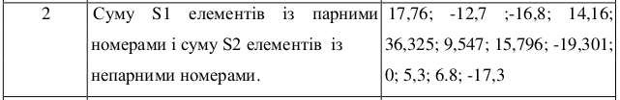
S = [
[17.76, -12.7, -16.8, 14.16],
[36.325, 9.567, 15.796, -19.301],
[0, 5.3, 6.8, -17.3]]
S1 = 0
S2 = 0
def search(mod):
tmp = 0
mod %=2
i = 0
while (i < len(S)):
j = 0
while(j < len(S[i])):
tmp += S[i+mod][j+mod]
j += 2
i += 2
S2 = search(2)
S1 = searh(1)
print(S1, S2)

