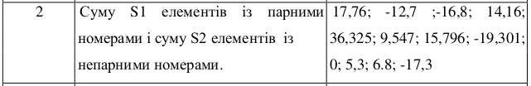  
S = [

[17.76, -12.7, -16.8, 14.16],

[36.325, 9.567, 15.796, -19.301],

[0, 5.3, 6.8, -17.3]]  
S1 = 0

S2 = 0

def foo(mod):

tmp = 0

mod %=2

i = 0

while (i < len(S)):

j = 0

while(j < len(S[i])):

tmp += S[i+mod][j+mod]

j += 2

i += 2

return tmp

S2 = foo(2)

S1 = foo(1)

print(S1, S2)