SPRUCE PRO · EXTERIOR CLEANING

Google Ads  Ready to Run | 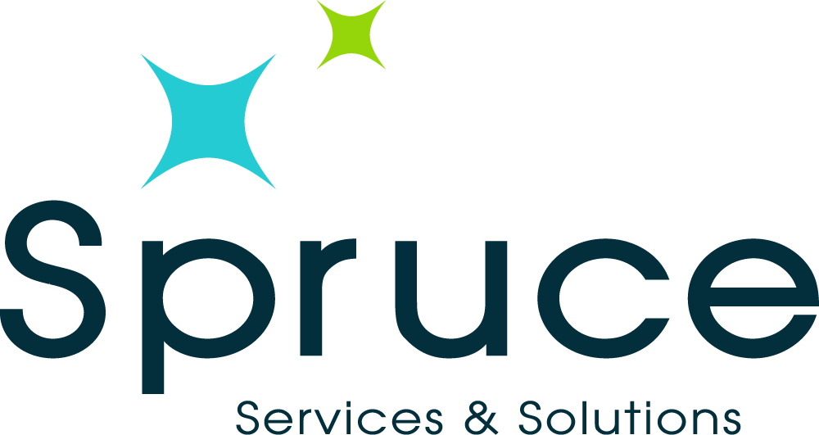
4 Local Services Ads · 4 Business Profile Ads · November 2026
How the two formats differ
Local Services Ads sit above everything with the Google Guaranteed badge, and you pay per lead, not per click. Google builds the ad from the inputs on the next four pages: the business description, services and seasonal focus. Speed wins there, answer a new lead within five minutes or it usually goes cold.
Business Profile ads are the copy and campaigns attached to your Google listing. The Post text is free to publish on the profile the same day. The headlines and descriptions drop straight into a Smart campaign when you want to pay for reach. Every campaign carries the UTM tag printed on its page so the analytics fix can attribute what it earns.
Spruce Pro · (864) 483-4300 · sprucepro.com · @spruce_pro

LOCAL SERVICES AD 1 OF 4 · FALL RESET

RUN WINDOW Run Nov 3 - Nov 30 · pays per lead · Google Guaranteed badge

Business description (paste into LSA)
"Local, licensed and insured crew washing houses, driveways and gutters across Greenville since 2006. Free quotes, fast scheduling, and a team that answers the phone. Book the fall reset before the first freeze."
CHARACTER CHECK 210/300 characters — fits the LSA description field

Services to attach
• House washing (soft wash)
• Driveway & concrete cleaning
• Gutter cleaning (full flush)

Starting prices: LSA lets you show a from-price per service. Suggested market anchors: gutter cleaning from $149, house wash from $199, window cleaning from $129. Confirm your own numbers before enabling.
TARGET SEARCHES house washing near me · pressure washing greenville sc · driveway cleaning

WHY THIS VARIANT Your baseline LSA. Broad exterior-cleaning intent, priced to carry the season.

LOCAL SERVICES AD 2 OF 4 · GUTTER SEASON

RUN WINDOW Run Nov 3 - Dec 15 (leaf fall) · pays per lead · Google Guaranteed badge

Business description (paste into LSA)
"Gutter cleaning done right: troughs cleared, downspouts flushed, debris hauled away. Gutter guards installed too, with a clog free guarantee. Licensed and insured, serving Greenville since 2006."
CHARACTER CHECK 194/300 characters — fits the LSA description field

Services to attach
• Gutter cleaning (clean + flush)
• Downspout check
• Gutter guard install

Starting prices: LSA lets you show a from-price per service. Suggested market anchors: gutter cleaning from $149, house wash from $199, window cleaning from $129. Confirm your own numbers before enabling.
TARGET SEARCHES gutter cleaning near me · gutter cleaning greenville · gutter guards cost

WHY THIS VARIANT Highest winter-urgency lead type. Clogs become claims in December.

LOCAL SERVICES AD 3 OF 4 · GUEST-READY HOLIDAYS

RUN WINDOW Run Nov 17 - Dec 20 · pays per lead · Google Guaranteed badge

Business description (paste into LSA)
"Get guest ready before the holidays: house washing, window cleaning, driveways and gutters. One crew handles the whole exterior. Locally owned since 2006, free quotes within 24 hours."
CHARACTER CHECK 183/300 characters — fits the LSA description field

Services to attach
• House wash + windows bundle
• Window cleaning (sills & tracks)
• Concrete & entry walkways

Starting prices: LSA lets you show a from-price per service. Suggested market anchors: gutter cleaning from $149, house wash from $199, window cleaning from $129. Confirm your own numbers before enabling.
TARGET SEARCHES window cleaning near me · holiday cleaning services · pressure washing before holidays

WHY THIS VARIANT Premium-angle variant for the hosting crowd; pairs with SP_11 social post.

LOCAL SERVICES AD 4 OF 4 · NO-LADDER / TWO STORY+

RUN WINDOW Run year-round, weight to spring · pays per lead · Google Guaranteed badge

Business description (paste into LSA)
"Pressure washing and window cleaning for homes up to five stories: by ladder, by pole, or by drone where it is safer. No ladders leaning on your home. Licensed and insured, Greenville's own crew since 2006."
CHARACTER CHECK 206/300 characters — fits the LSA description field

Services to attach
• Multi-story house washing
• Drone gutter & roofline cleaning
• High window cleaning

Starting prices: LSA lets you show a from-price per service. Suggested market anchors: gutter cleaning from $149, house wash from $199, window cleaning from $129. Confirm your own numbers before enabling.
TARGET SEARCHES drone pressure washing · 3 story house washing · roof cleaning no ladders

WHY THIS VARIANT Differentiator nobody local can match; video-inspection offer is the lead hook.

BUSINESS PROFILE AD 1 OF 4 · NOVEMBER SLOTS OPEN

Google Post (publish free on the profile today)
"Fall slots are filling fast. House washing, gutters and windows, done by one crew with one invoice, before the holidays take over. Free quotes within 24 hours, licensed and insured, serving the Upstate since 2006. Call or message and we will hold your slot."
CTA BUTTON Call now

Smart campaign headlines (max 30 characters)
• Greenville Exterior Cleaning (28/30)
• Free Quotes, Fast Scheduling (28/30)
• Licensed & Insured Crews (24/30)

Descriptions (max 90 characters)
• House washing, gutters and windows in Greenville. Free quotes within 24 hours. (78/90)
• Licensed and insured since 2006. Fall slots open now. Call or book online today. (80/90)

TRACKING TAG Attach to every final URL: utm_source=google&utm_medium=cpc&utm_campaign=sp_gmb_nov26&utm_content=slots

BUSINESS PROFILE AD 2 OF 4 · GUTTER CLEANING SPECIAL

Google Post (publish free on the profile today)
"The leaves are down and the gutters are full. We clear the trough, flush every downspout until it runs clean, and haul the debris away. Ask about gutter guards while we are up there and retire the ladder for good. Free quotes, clog free guarantee."
CTA BUTTON Get quote

Smart campaign headlines (max 30 characters)
• Gutters Cleaned & Flushed (25/30)
• Never Scoop Again (17/30)
• Book Before The Storms (22/30)

Descriptions (max 90 characters)
• Gutter cleaning with a full downspout flush. Debris hauled away. Free quote. (76/90)
• Guards installed with a clog free guarantee. Licensed and insured, since 2006. (78/90)

TRACKING TAG Attach to every final URL: utm_source=google&utm_medium=cpc&utm_campaign=sp_gmb_nov26&utm_content=gutters

BUSINESS PROFILE AD 3 OF 4 · GUEST-READY OUTSIDE

Google Post (publish free on the profile today)
"The guests are coming and the outside of the house gets one chance at a first impression. House wash, windows, entry walkways: one visit, whole exterior. We schedule around your cooking, not the other way around. Message us for a free quote."
CTA BUTTON Book

Smart campaign headlines (max 30 characters)
• Get Guest-Ready Outside (23/30)
• One Visit, Whole Exterior (25/30)
• Windows, Wash & Walkways (24/30)

Descriptions (max 90 characters)
• Guest ready outside before the guests arrive. One visit, whole exterior. (72/90)
• House wash, windows and entry walkways before the holidays. Free quote. (71/90)

TRACKING TAG Attach to every final URL: utm_source=google&utm_medium=cpc&utm_campaign=sp_gmb_nov26&utm_content=guestready

BUSINESS PROFILE AD 4 OF 4 · TOP-RATED LOCAL CREW

Google Post (publish free on the profile today)
"Maria watched our crew work through a full window job and wrote about it: a thorough, excellent job, start to finish. That is the standard on every home we visit, big or small. Read the reviews, check the photos, then give us a call. Free quotes, always."
CTA BUTTON Learn more

Smart campaign headlines (max 30 characters)
• A Crew Neighbors Recommend (26/30)
• Streak-Free Window Cleaning (27/30)
• Trusted Since 2006 (18/30)

Descriptions (max 90 characters)
• Real reviews from real Greenville neighbors. Free quotes within 24 hours. (73/90)
• Windows, washing and gutters by the crew your neighbors keep rebooking. (71/90)

TRACKING TAG Attach to every final URL: utm_source=google&utm_medium=cpc&utm_campaign=sp_gmb_nov26&utm_content=reviews

