SPRUCE HOLIDAY LIGHTING & EVENTS
October 2026 Content Pack
Captions, hashtags and a visual posting calendar for all 30 posts
Prepared by your social media team · October 8, 2026
Three posts a week, Monday Wednesday Friday, with the Halloween moments locked to their exact days. The calendar now runs the full season, closing with five real customer installs we shot on site.
A quick hello
Hi Spruce team! In this pack you'll find everything needed to run the season without writing a single caption yourself: a calendar showing exactly which graphic goes up on which day (with a little preview of each one so you always know what you're posting), a ready to paste caption and hashtag set for every post, and a few habits that make the whole thing perform.
The graphics already show your phone, website and handle, so captions stay conversational instead of repeating them. Tweak any line that doesn't sound like you. That's allowed and encouraged.

The calendar at a glance
Three posts a week. The one exception is Halloween week, which gets two bonus posts because the moment only comes once a year. Each row shows the actual graphic so there's no guessing which is which.
Preview | Date | Post and angle
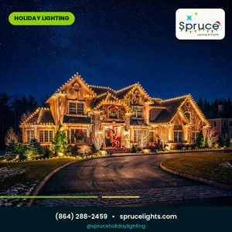 | Fri Oct 9 | SL_01 Campaign launch, the mansion hero
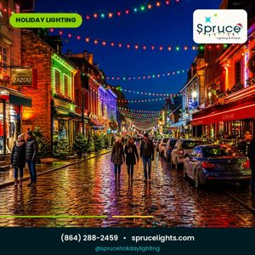 | Mon Oct 12 | SL_06 Homes, businesses and towns
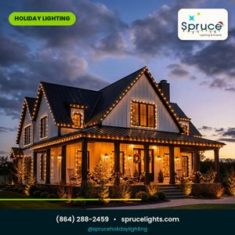 | Wed Oct 14 | SL_14 Why book in October
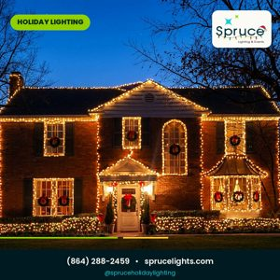 | Fri Oct 16 | SL_02 Michelle review
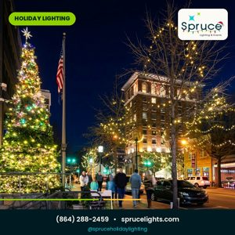 | Mon Oct 19 | SL_04 Free service calls
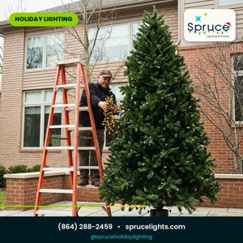 | Wed Oct 21 | SL_05 The process
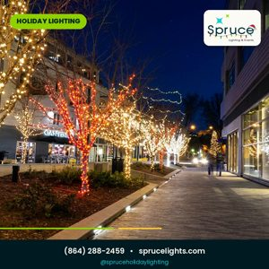 | Fri Oct 23 | SL_07 Poll, which look wins
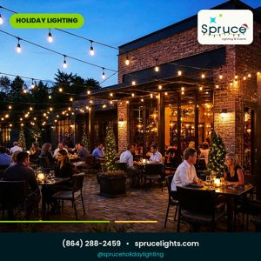 | Mon Oct 26 | SL_24 Year round, cafe patio
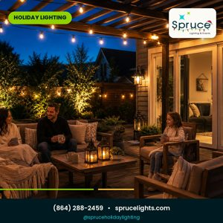 | Wed Oct 28 | SL_25 Year round, backyard pergola
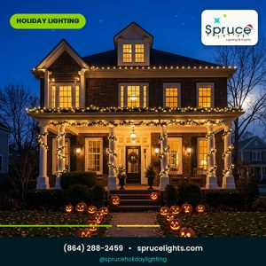 | Fri Oct 30 | SL_08 Halloween crossover, day before
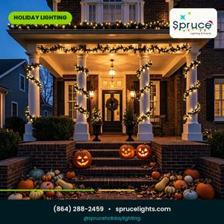 | Sat Oct 31, morning | SL_30 Halloween porch
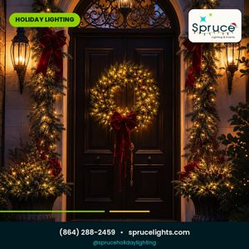 | Sat Oct 31, evening | SL_20 Happy Halloween Greenville
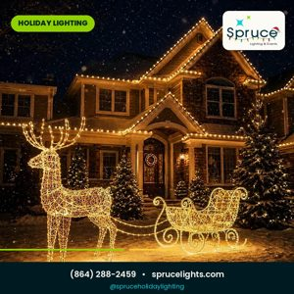 | Mon Nov 2 | SL_29 Christmas begins, reindeer and sleigh
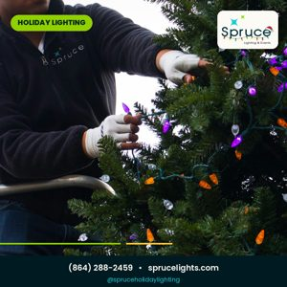 | Wed Nov 4 | SL_12 Countdown to install season
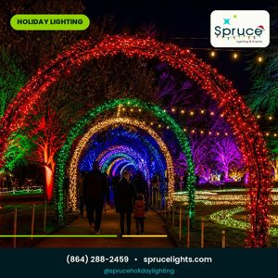 | Fri Nov 6 | SL_09 Why professional installs
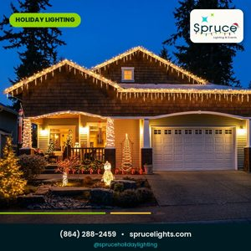 | Mon Nov 9 | SL_10 Randy review
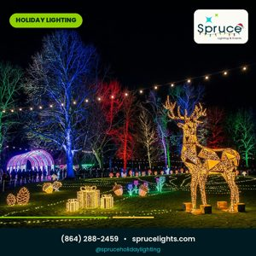 | Wed Nov 11 | SL_16 Stag light trail, showstopper
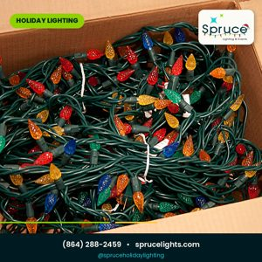 | Fri Nov 13 | SL_17 Jan review
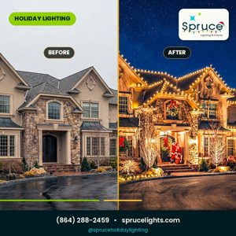 | Mon Nov 16 | SL_21 Before and after, mansion
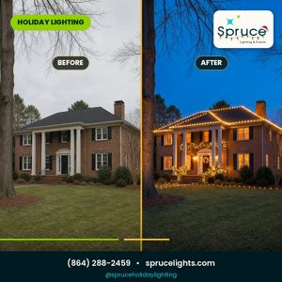 | Wed Nov 18 | SL_03 Before and after, classic
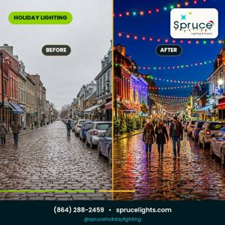 | Fri Nov 20 | SL_22 Overnight street transformation
 | Mon Nov 23 | SL_13 HOA and municipal programs
 | Wed Nov 25 | SL_18 Slots almost gone
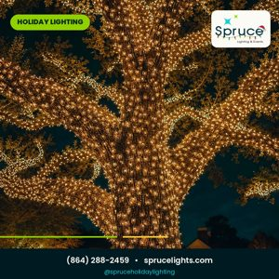 | Fri Nov 27 | SL_27 Showstopper tree wrap
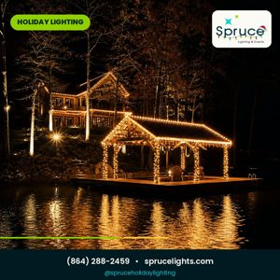 | Mon Nov 30 | SL_28 Lake life
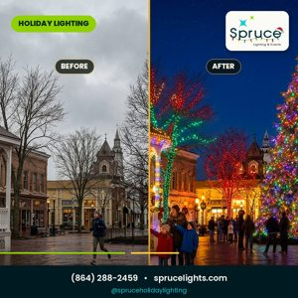 | Wed Dec 2 | SL_23 Your town aglow
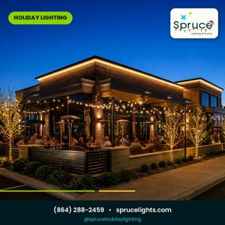 | Fri Dec 4 | SL_26 Year round, bistro
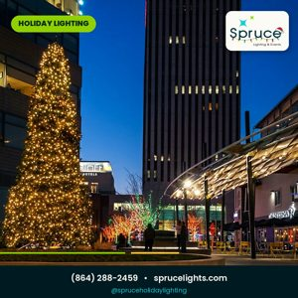 | Mon Dec 7 | SL_15 Poll, ladder or cocoa
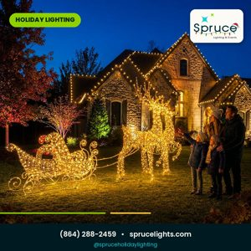 | Wed Dec 9 | SL_11 Be the favorite house
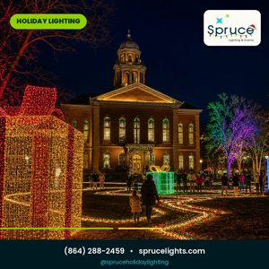 | Fri Dec 11 | SL_19 Direct call to action
The green highlighted rows are your Halloween day posts. Post SL_30 with your morning coffee and SL_20 right around trick or treat time.

Captions and hashtags, post by post
Copy the caption into the post, drop the hashtags in as the first comment to keep everything looking clean. Feed and story versions of a graphic share the same caption.
SL_01 · Booking launch (mansion)
You know that one house in your neighborhood that everyone slows down for? That could be yours this year. We design every roofline, install every bulb, and you never climb a single ladder. October install weeks are open right now and the good ones go fast.
#SpruceLights #ChristmasLightInstallation #HolidayLighting #GreenvilleSC #YeahThatGreenville #UpstateSC #ChristmasIsComing #LightUpTheHolidays #OctoberBooking #HouseGoals

SL_06 · Homes, businesses, towns
One porch or one whole street, we do both. If you run a business or you're on an HOA board, ask about our commercial and municipal programs. Bulk pricing, unified designs, one crew that shows up on time.
#SpruceLights #CommercialLighting #MunicipalLighting #HOALighting #GreenvilleSC #UpstateSC #HolidayLighting #MainStreetMagic #LightItUp #AllInclusive

SL_14 · Why October (golden farmhouse)
Simple math really. Book in October and you get first pick of install weeks, nicer weather for the crew, and lights that are ready before the first cold snap. Same price as always. Just a better spot in line.
#SpruceLights #ProTip #BookInOctober #GreenvilleSC #UpstateSC #HolidayLighting #FallInGreenville #SmartHomeowner #GoldenHour #BetterSlot

SL_02 · Review from Michelle
"Made our house look magical." That's Michelle B. from right here in Greenville, and her five star review means the world to us. We've got over 55 of them on Google now, and every single job gets that same treatment.
#SpruceLights #GoogleReview #FiveStars #GreenvilleSC #UpstateSC #HolidayLighting #ChristmasLights #CustomerLove #ShopLocal #MagicalHomes

SL_04 · Free service calls
Here's something nobody else does: if a bulb goes out or a strand acts up anytime this season, we come fix it. Free. You literally call, we show up, done. That's the Spruce promise and it comes with every single install.
#SpruceLights #FreeServiceCalls #NoWorries #HolidayLighting #GreenvilleSC #UpstateSC #ChristmasLights #StressFreeSeason #LocalAndTrusted #TheSprucePromise

SL_05 · The process
People ask what "full service" actually means. It means we design the display with you, install every strand, take it all down after the holidays, and store the lights in our warehouse until next year. You never touch a ladder. You just come home to a glowing house.
#SpruceLights #FullService #DesignInstallStore #ZeroLadders #GreenvilleSC #YeahThatGreenville #UpstateSC #ChristmasLightInstallation #EasySeason #DoneForYou

SL_07 · Poll: which look wins?
Rooflines, trees, or walkways? Everyone has a favorite and people get weirdly passionate about this. Drop yours in the comments. Bonus points if you tag a neighbor who desperately needs the walkway treatment.
#SpruceLights #ThisOrThat #ChristmasPoll #CommentBelow #GreenvilleSC #UpstateSC #HolidayLighting #ChristmasDecor #NeighborhoodGoals #LightDesign

SL_24 · Year round lighting (cafe patio)
These lights stay up all year and honestly that's the point. Warm string lights over a patio keep tables full in October and April alike. Restaurant owners, this is the cheapest seat upgrade you'll ever make.
#SpruceLights #YearRoundLighting #CafeLights #PatioSeason #GreenvilleSC #UpstateSC #OutdoorDining #RestaurantLife #Ambiance #HospitalityDesign

SL_25 · Year round lighting (pergola)
Tuesday night dinner hits different under string lights. Pergola weaves, fence lines, lantern glow. Your backyard becomes the place everyone wants to be, twelve months a year.
#SpruceLights #YearRoundLighting #PergolaLights #BackyardGoals #GreenvilleSC #UpstateSC #OutdoorLiving #HomeUpgrade #CozyVibes #TuesdayNights

SL_08 · Halloween crossover
The pumpkins are still on the porch but guess what, December is coming whether we like it or not. Book your Christmas install now while there's still room on the calendar. Future you will be very grateful.
#SpruceLights #HalloweenToChristmas #BookEarly #GreenvilleSC #UpstateSC #HolidayLighting #PumpkinSeason #PlanAhead #FallInGreenville #ChristmasIsComing

SL_30 · Halloween porch, Christmas next
This porch does both seasons right. Garland on the columns for October, warm twinkle for December, pumpkins optional but encouraged. Book now and yours is the porch everyone photographs next year.
#SpruceLights #HalloweenToChristmas #PorchGoals #GarlandAndLights #GreenvilleSC #YeahThatGreenville #UpstateSC #HolidayLighting #MostPinned #BookForChristmas

SL_20 · Happy Halloween Greenville
Candy tonight, twinkle soon. While you're out walking the neighborhood tonight, keep an eye on the rooflines. A few of them already sparkle, and those are our folks. Yours can join them next year.
#SpruceLights #HappyHalloween #GreenvilleSC #YeahThatGreenville #UpstateSC #TrickOrTreat #CandyTonight #TwinkleSoon #FallFun #ChristmasNext

SL_29 · Classic reindeer and sleigh
The classic lawn tableau, done properly. Reindeer out front, sleigh behind, and a roofline dressed in warm white to tie it together. Front yard fame starts with one phone call.
#SpruceLights #ClassicChristmas #ReindeerAndSleigh #FavoriteHouse #GreenvilleSC #UpstateSC #HolidayLighting #FrontYardFame #ChristmasTradition #YardEnvy

SL_12 · Countdown to install season
The calendar is the real Grinch here. Every November we get calls from folks who want the first week and by then it's gone. Lock your week now and skip the panic entirely.
#SpruceLights #BookNow #InstallSeason #GreenvilleSC #YeahThatGreenville #UpstateSC #HolidayLighting #DontWait #ChristmasCountdown #PlanAhead

SL_09 · Why professional installs (light arch trail)
This is what commercial grade looks like. Real hardware, real strands built for winter weather, and a crew that knows what they're doing on a ladder. It holds up through storms and it looks like this every single night.
#SpruceLights #CommercialGrade #ProInstalled #HolidayLighting #LightTrail #GreenvilleSC #UpstateSC #EventLighting #DoItRight #BuiltToLast

SL_10 · Review from Randy
"Great team. Excellent work." Randy kept it short and sweet and honestly that's all we need. On time, uniformed crews, and when we leave you'd never know we were there. Except after dark of course.
#SpruceLights #FiveStarReview #GreatTeam #GreenvilleSC #UpstateSC #HolidayLighting #CustomerFirst #ChristmasLights #TrustedLocal #ShopSmall

SL_16 · Trees that stop traffic (stag light trail)
Some displays make people pull over. That's the bar we set for tree wraps and event style lighting, and this one's our favorite so far this year. Imagine this on your property.
#SpruceLights #TreeWraps #LightTrail #Showstopper #GreenvilleSC #UpstateSC #HolidayLighting #YardOfTheYear #ChristmasDestination #SignatureService

SL_17 · Review from Jan
"My wrapped trees look amazing!!" Jan gets it. Tree wraps are the upgrade everyone asks about once they see one in person. If you've got a big oak or a row of crepe myrtles, we can make them the stars of the street.
#SpruceLights #FiveStarReview #TreeWraps #CustomerLove #GreenvilleSC #UpstateSC #HolidayLighting #WrappedTrees #LocalFavorite #AmazingResults

SL_21 · Before and after (mansion)
On the left, a perfectly nice stone house on a Tuesday in November. On the right, the same house making the whole street better. Design matters. Warm white on stone with glowing ridge lines never misses.
#SpruceLights #BeforeAndAfter #LuxuryLighting #CurbAppeal #GreenvilleSC #UpstateSC #HolidayLighting #EstateLighting #GlowUp #DreamHome

SL_03 · Before and after (classic)
Same house. Same evening. The only difference is what happened at 2pm while you were at work. Professional design and install really does change everything, and honestly the photos don't even do it justice.
#SpruceLights #BeforeAndAfter #GlowUp #ChristmasLightInstallation #GreenvilleSC #UpstateSC #HolidayLighting #ChristmasMagic #InstalledRight #Transformation

SL_22 · Overnight transformation (street)
Here's how it works for business districts. Plain street at closing time. Glowing boulevard by the next morning. Your customers show up and the whole block feels like a Hallmark set. Ask about commercial installs.
#SpruceLights #CommercialLighting #MainStreet #BeforeAndAfter #GreenvilleSC #UpstateSC #HolidayLighting #ShopLocal #DistrictGlow #OvernightMagic

SL_13 · HOAs, businesses and towns
Want the whole street glowing? We handle full neighborhood and HOA displays with unified designs and bulk rates. One point of contact, one invoice, zero headaches for your board. 2026 proposals are open.
#SpruceLights #HOALighting #CommunityChristmas #MunicipalLighting #GreenvilleSC #UpstateSC #HolidayLighting #LightUpTheNeighborhood #TownSquare #ProposalSeason

SL_18 · Slots almost gone
Real talk: the first two weeks of November are almost full. If you want your lights up before Thanksgiving, this is the week to call. After that we're into December dates and nobody wants that.
#SpruceLights #LastCall #SlotsFillingFast #BookNow #GreenvilleSC #YeahThatGreenville #UpstateSC #HolidayLighting #ThanksgivingReady #TimeSensitive

SL_27 · The showstopper tree wrap
One oak tree. Hundreds of strands, thousands of bulbs. Every year the first wrapped tree on the block becomes the one everyone photographs. Pricing is by tree size, message us for a same week quote.
#SpruceLights #TreeWrap #Showstopper #GreenvilleSC #UpstateSC #HolidayLighting #BiggerIsBrighter #YardGoals #QuoteToday #SignatureService

SL_28 · Lake life, lit up
Docks, boathouses, lakeside porches. If your home faces the water, the reflection does half the work for you. Lake installs book earliest every year so grab your week while they're open.
#SpruceLights #LakeLife #DockLighting #LakesideLiving #GreenvilleSC #UpstateSC #HolidayLighting #WaterViewGlow #LakeHome #BookEarly

SL_23 · Your town aglow
Small towns do Christmas better and we love being part of it. Municipal programs come with unified designs, bulk rates, and zero extra work for your public works crew. Get your town on the 2026 schedule.
#SpruceLights #MunicipalLighting #TownSquare #SmallTownChristmas #GreenvilleSC #UpstateSC #HolidayLighting #CommunityFirst #TreeLighting #PublicSpaces

SL_26 · Year round lighting (bistro)
Restaurants ask us if permanent lighting is worth it. Then they watch their evening covers climb and stop asking. Roofline plus patio string lights, and suddenly every guest is taking photos of your venue. Free marketing.
#SpruceLights #YearRoundLighting #PermanentLighting #RestaurantOwners #ROI #GreenvilleSC #UpstateSC #VenueLighting #BistroVibes #BusinessUpgrade

SL_15 · Poll: ladder this weekend or cocoa?
Be honest with us. Is that ladder actually happening this weekend, or are you staying in your pajamas with cocoa like a responsible adult? There's a third option by the way. It involves us doing the whole thing for you.
#SpruceLights #HonestPoll #TeamCocoa #NeverTouchALadder #GreenvilleSC #UpstateSC #HolidayLighting #CommentBelow #FridayFunny #ChristmasPrep

SL_11 · Be the favorite house (reindeer and sleigh)
There's always one house. The one kids beg to walk past, the one that ends up in seventeen family Christmas photos. Might as well make it yours this year. The reindeer and sleigh setup is available and yes, it's as good as it looks.
#SpruceLights #FavoriteHouse #SleighSeason #ReindeerLights #GreenvilleSC #UpstateSC #HolidayLighting #FrontYardGoals #ChristmasEnvy #TangleFree

SL_19 · Closing call to action
One call and the whole season handles itself. Design, install, maintenance all season, takedown in January, storage until next year. Give us a ring at (864) 288-2459. A real person picks up.
#SpruceLights #NowBooking #HolidayLighting #GreenvilleSC #UpstateSC #OneCallDoesItAll #ChristmasLights #StressFreeHolidays #CallToday #LocalBusiness

The hashtag bank
Every caption already has its ten tags picked. If you want to swap any out, pull from here. One rule we stick to: always keep three to five Greenville area tags so Instagram and Facebook keep showing you to local homeowners.
Brand: #SpruceLights #SpruceHolidayLighting #LightUpTheHolidays
Services: #ChristmasLightInstallation #HolidayLighting #OutdoorLighting #TreeWraps #PermanentLighting #FullService #DesignInstallStore
Local: #GreenvilleSC #YeahThatGreenville #UpstateSC #GreerSC #MauldinSC #TaylorsSC #PowdersvilleSC #PiedmontSC #GrandStrand #WesternNC
Seasonal: #ChristmasIsComing #FallInGreenville #HalloweenToChristmas #BookEarly #TisTheSeason #DecemberReady
Engagement: #CommentBelow #ThisOrThat #BeforeAndAfter #NeighborGoals #YardEnvy
Five habits that make these posts work harder
1. Stick to the Monday Wednesday Friday rhythm. Consistency trains the algorithm and your audience.
2. Halloween day is the one exception: SL_30 goes up in the morning, SL_20 in the evening, and together they own the whole day.
3. The review posts (02, 10 and 17) do best Tuesday to Thursday mornings when people are having coffee. On this calendar they already land on Mondays and Fridays, so just aim for the morning window.
4. The polls (07 and 15) do best Friday afternoons when everyone is winding down. Reply to every comment within the hour, even with just an emoji and a question.
5. Repost the story version of each graphic on the same day as the feed post. It warms up the algorithm for the feed version.

That's the whole pack. If a caption doesn't sound quite like you, change that one line and keep the rest. Consistency beats perfection every time. Here's to your biggest season yet!
Spruce Holiday Lighting & Events · (864) 288-2459 · sprucelights.com · @spruceholidaylighting

