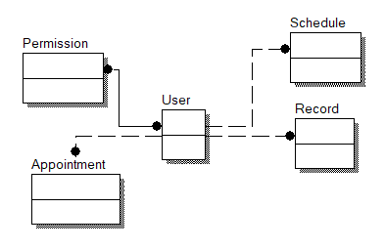

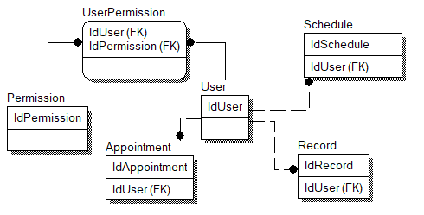

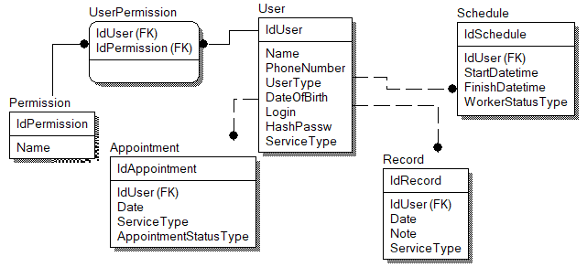

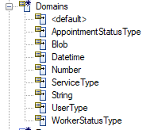

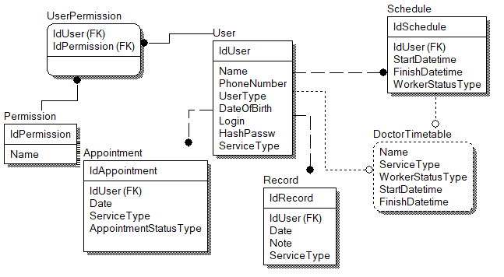

CREATE TABLE Appointment

(

IdAppointment INTEGER NOT NULL,

IdUser INTEGER NOT NULL,

Date DATE NOT NULL,

ServiceType ENUM NOT NULL,

AppointmentStatusType ENUM NOT NULL

);

CREATE UNIQUE INDEX XPKAppointment ON Appointment

(

IdAppointment

);

ALTER TABLE Appointment

ADD PRIMARY KEY (IdAppointment);

CREATE INDEX XIF1Appointment ON Appointment

(

IdUser

);

CREATE TABLE Permission

(

IdPermission INTEGER NOT NULL,

Name VARCHAR(20) NOT NULL

);

CREATE UNIQUE INDEX XPKPermission ON Permission

(

IdPermission

);

ALTER TABLE Permission

ADD PRIMARY KEY (IdPermission);

CREATE TABLE Record

(

IdRecord INTEGER NOT NULL,

IdUser INTEGER NOT NULL,

Date DATE NOT NULL,

Note BLOB NOT NULL,

ServiceType ENUM NOT NULL

);

CREATE UNIQUE INDEX XPKRecord ON Record

(

IdRecord

);

ALTER TABLE Record

ADD PRIMARY KEY (IdRecord);

CREATE INDEX XIF1Record ON Record

(

IdUser

);

CREATE TABLE Schedule

(

IdSchedule INTEGER NOT NULL,

IdUser INTEGER NOT NULL,

StartDatetime DATE NOT NULL,

FinishDatetime DATE NOT NULL,

WorkerStatusType ENUM NOT NULL

);

CREATE UNIQUE INDEX XPKSchedule ON Schedule

(

IdSchedule

);

ALTER TABLE Schedule

ADD PRIMARY KEY (IdSchedule);

CREATE INDEX XIF1Schedule ON Schedule

(

IdUser

);

CREATE TABLE User

(

IdUser INTEGER NOT NULL,

Name VARCHAR(20) NOT NULL,

PhoneNumber INTEGER NOT NULL,

UserType ENUM NOT NULL,

DateOfBirth DATE NOT NULL,

Login VARCHAR(20) NOT NULL,

HashPassw VARCHAR(20) NOT NULL,

ServiceType ENUM NOT NULL

);

CREATE UNIQUE INDEX XPKUser ON User

(

IdUser

);

ALTER TABLE User

ADD PRIMARY KEY (IdUser);

CREATE TABLE UserPermission

(

IdUser INTEGER NOT NULL,

IdPermission INTEGER NOT NULL

);

CREATE UNIQUE INDEX PKUserPermission ON UserPermission

(

IdUser,

IdPermission

);

ALTER TABLE UserPermission

ADD PRIMARY KEY (IdUser,IdPermission);

CREATE INDEX XIF1UserPermission ON UserPermission

(

IdUser

);

CREATE INDEX XIF2UserPermission ON UserPermission

(

IdPermission

);

CREATE VIEW DoctorTimetable AS

SELECT User.Name,User.ServiceType,Schedule.WorkerStatusType,Schedule.StartDatetime,Schedule.FinishDatetime

FROM Schedule,User;

ALTER TABLE Appointment

ADD FOREIGN KEY R_3 (IdUser) REFERENCES User(IdUser);

ALTER TABLE Record

ADD FOREIGN KEY R_4 (IdUser) REFERENCES User(IdUser);

ALTER TABLE Schedule

ADD FOREIGN KEY R_2 (IdUser) REFERENCES User(IdUser);

ALTER TABLE UserPermission

ADD FOREIGN KEY R_6 (IdUser) REFERENCES User(IdUser);

ALTER TABLE UserPermission

ADD FOREIGN KEY R_5 (IdPermission) REFERENCES Permission(IdPermission);

