**WK08 READING**

*Complete the following tasks and submit your answers in a single Word file named “student number + name”, e.g. “1120180000LIMING.*

***Task 1: Summarize the main idea of each paragraph in Unit 4 Text II using your own words.***

Para 1: Importance of the development of an effective and cost-efficient freight transport system.

Para 2: Issues and factors tipping the balance from uni-modal to inter-modal transport system.

Para 3: The definition of inter-modal transport.

Para 4: The purpose of this study is to develop an inter-modal transport system.

Para 5: The structure of the rest of the paper

Para 6: Introduction of the section literature review

Para 7: Review of the spatio-temporal short term traffic flow prediction methods and models

Para 8: Review of incident detection algorithms

Para 9: Review of inter-modal transport network optimization methods

Para 10: Review of more inter-modal transport network optimization methods

***Task 2: Identify the types of information based on paragraphs 6-10 of Text II.***

1. The purpose of reviewing literature according to the authors:

The main purpose and the overt purpose is to establish the context of the intended research.

1. Topics that the literature review focuses on:

The spatio-temporal short term traffic flow prediction methods and models; intermodal transport optimization.

1. Types and examples of models for spatio-temporal short-term traffic flow prediction mainly in chronological order:

univariate time series models

Box–Jenkins autoregressive integrated moving average (ARIMA) models

ARIMA and exponential smoothing (ES) models Holt‘s–Winter‘s approach

1. Major advantage of support vector regression (SVR):

The major advantage of SVR is that it avoids over-fitting and allows for a faster process of multi-dimensional data than other algorithms.

1. Examples of incident detection algorithms and their disadvantages:

California Algorithm This algorithm is based on the logical assumption that a traffic incident increases the traffic occupancy at the upstream portions of the incident and significantly decreases the traffic occupancy downstream of the incident.

The Minnesota Algorithm attempts to minimize false alarms and missed incidents

1. Exemplary models for intermodal transport network optimization and their limitations:

Service network design models proposed by Gorman.

GIS model based intermodal freight network modeling.

A dynamic modeling approach presented by Yano and Newman.

A train routing model proposed by Newman and Yano.

A linear mixed integer programming (MIP) model by Gorman and Wong et al.

A bi-level programming detailed by Yamada et al.

A column generation methodology developed by Caprara et al.

1. Purpose of this paper derived from the contributions and most importantly limitations of reviewed literature:

This paper aims to develop an integrated modeling structure by which a travel manager will be able to decide whether to consider a unimodal or intermodal strategy based on cost-time tradeoff for a complex distributions network.

***Task 3: The following demos highlight the citation forms and sentence patterns of summarizing or reporting previous research. Likewise, extract all the other sentence patterns in*** ***paragraphs 7 & 9 of Text II and discuss the primary usage of past tense and present perfect tense.***

**DEMO (1):**

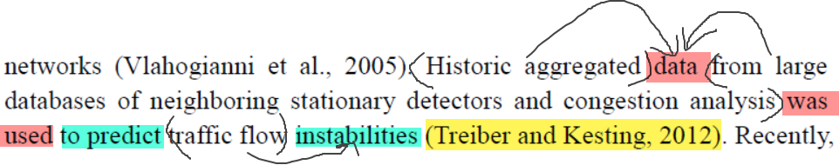

**Sentence pattern:** data was used to predict (AUTHORS, YEAR)

**Verb + noun (phrase) collocation:** use () data from (); predict () instability

**DEMO (2):**

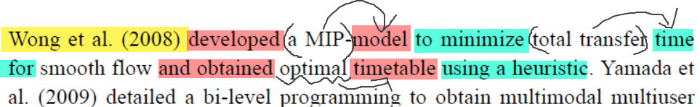

**Sentence pattern:** XXX (YEAR) developed a model and obtained optimal timetable

**Verb + noun (phrase) collocation:** develop a () model; minimize () time for; obtain () timetable using ()

***Paragraph 7***

Since XXX (YEAR), models have been widely used for prediction, especially XXX (EXAMPLE) (AUTHORS, YEAR)

Subsequently, models, such as XXX (EXAMPLE), have been used for purposes.

Over the past decade, models have been extensively used in the field of XXX (FIELD).

In addition to… other parameters including XXX (AUTHOR, YEAR) and XXX (AUTHOR, YEAR) have been predicted by models.

Several other techniques have been applied to predict. Some of these include XXX (AUTHOR, YEAR).

XXX (AUTHOR, YEAR) proposed a model based on XXX to perform XXX using data.

This (FORMER STUDIES) largely removes the issue of XXX.

Better results have been observed for XXX (AUTHOR, YEAR).

Recently, XXX is being widely applied to predict XXX such as XXX (AUTHOR, YEAR). The major advantage of XXX is that….

***Paragraph 9***

Several contributions exist on XXX. XXX (AUTHOR, YEAR) focus on models. XXX (AUTHOR, YEAR) shed light on XXX, based…

XXX (AUTHOR, YEAR) presented/proposeed/developed/detailed an approach/a model/a methodology to…