**Unit 2 Technical Reports**

***Task 1:*** *Identify the general similarities and differences between proposals and reports.*

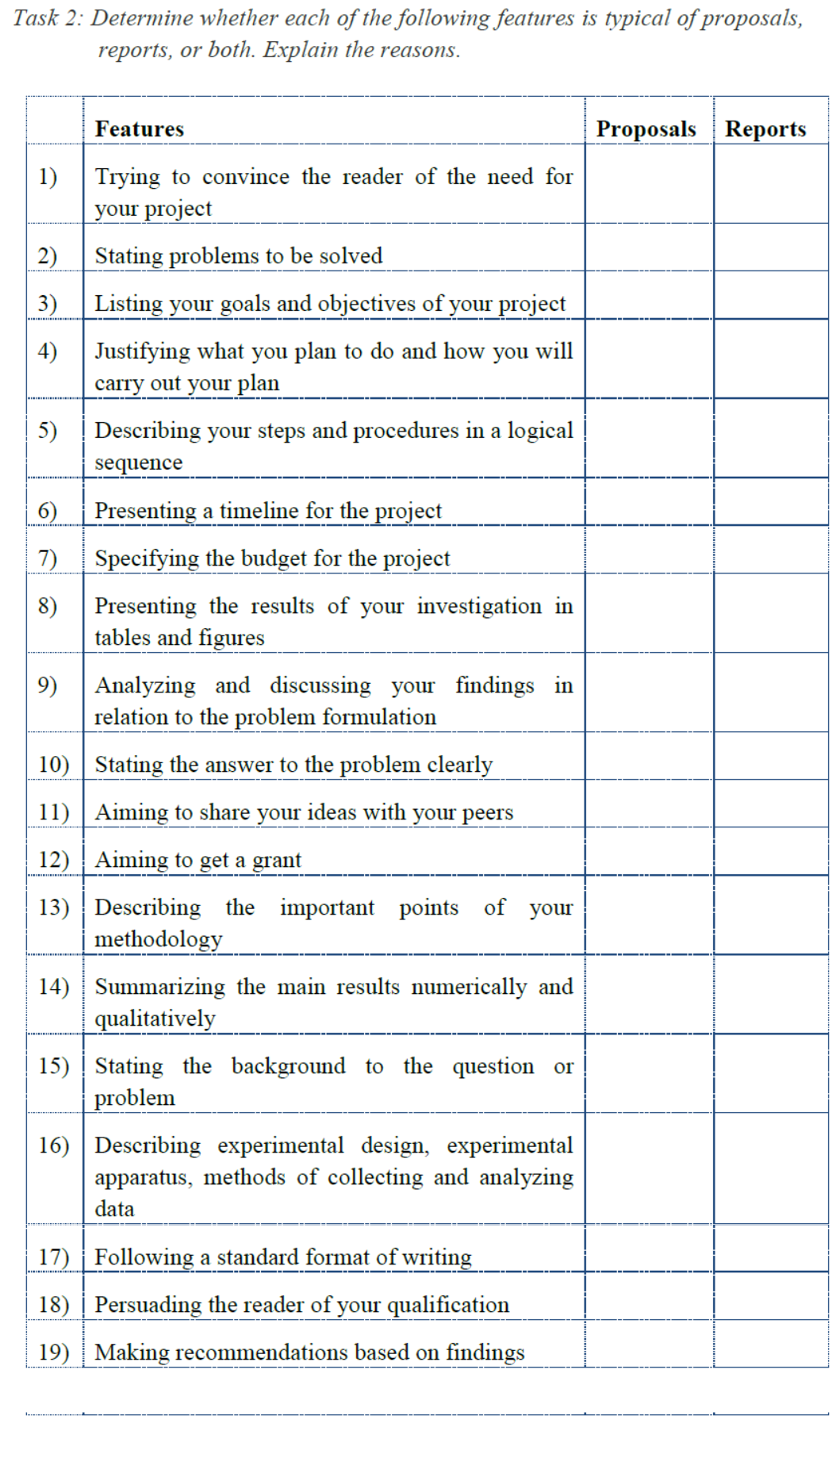

***Task 2:*** *Identify and summarize the following types of information in Text I using your own words.*

1. Background of the testing: A newly-developed aluminum alloy production method
2. Problem(s) to be solved: unable to find due to an inadequate number of fracture specimens.
3. Goals/objectives of testing: to test the material supplied to them is whether or not 7075-T651 aluminum alloy.
4. Materials and apparatus:a cylindrical tensile bar in tensile testing and four ASTM 399 standard single-edge-notch beam specimens of varying thickness for fracture toughness testing.
5. Variables (or material properties) measured in the testing: gauge length, diameter, the dimensions of four fracture samples and the crack length.
6. Quantitative and qualitative results: (taking density and Poisson’ ratio as examples)

Density: 2863 ± 82 kg/m3

Poisson’ ratio: 0.314 ± 0.023

7) Discussion of the results, or in other words, the answer to the problems stated above: the values of yield strength and ultimate tensile strength do not agree . These results the conclusion that the material supplied with is not 7075-T651 aluminum alloy;

8) Recommendation: inspect the method of heat treatment of the alloy to determine the true identity of your alloy and re-test the fracture toughness with more samples to further investigate and understand the properties of the alloy you have produced.

***Task 3:*** *List the “verb + noun” collocations expressing test procedures in paragraphs 2-5 of Text I by following the examples below.*

* machine the specimens
* use calipers
* measure the gauge length and diameter of the specimen
* attach the specimen

…

***Task 4:*** *The following excerpt is the structural analysis of paragraph 7 of Text I, underling the quantitative (in red) and qualitative result (in green) highlighted at the very beginning, and then the data calculation (in yellow) and primary data involved (in purple). Select at least one part from the rest “Poisson’ ratio”, “Ultimate tensile strength”, and “Young’s modulus of elasticity and yield strength”, analyze its organization and determine whether it is arranged in a similar way.*

