**WK08 WRITING**

*Submit your writing in a single Word file named “student number + name”, e.g. “1120180000LIMING.*

***Example 1 in the following shows the organization of information in a typical citation, while Example 2 compares another citation and its source, both indicating that generally purpose, method and results of a study would be reported or summarized primarily in past tense. Based on this, analyze the structural pattern of the abstract in the exercise and write citations in different formats.***

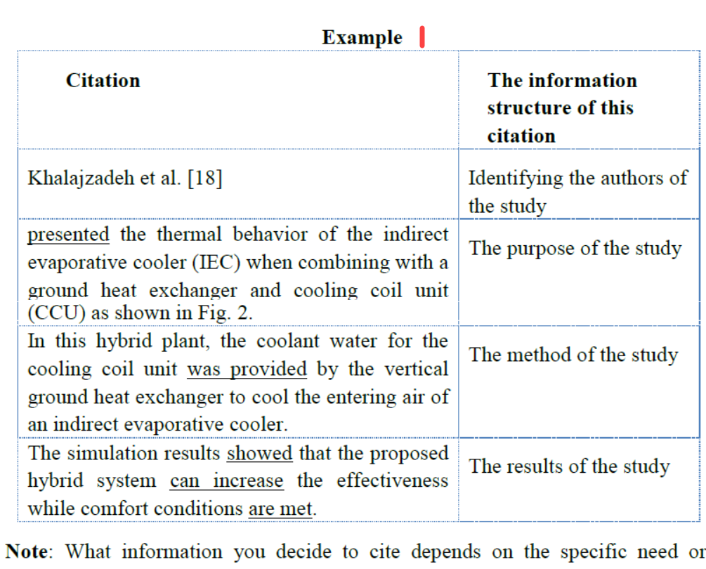

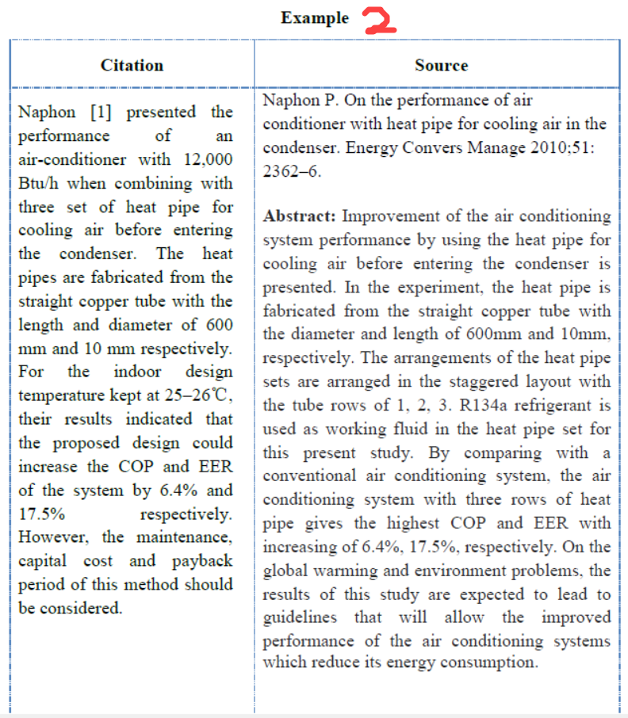

**Exercise:**

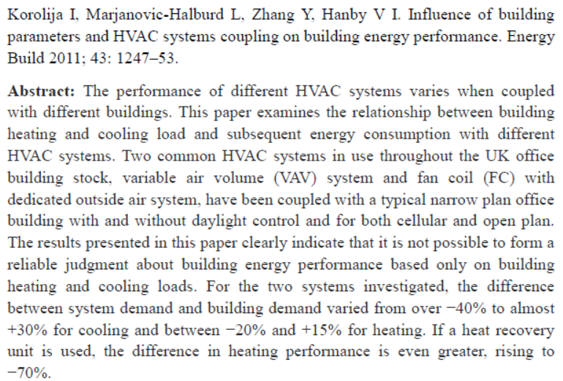

1. **Structural pattern:**

* purpose: To examine the relationship between building heating and cooling load and subsequent energy consumption with different HVAC systems.
* method: Tow common HVAC systems have been coupled with a typical narrow plan office building with and without daylight control and for both cellular and open plan.
* results (and discussion): It’s impossible to form a reliable judgment about building energy performance based only on building heating and cooling loads.

1. **Citation format 1: Korolija et al. (2011) …**

* Korolija et al examine the relationship between building heating and cooling load and subsequent energy consumption with different HVAC systems. This experiments coupled tow common HVAC systems have been coupled with a typical narrow plan office building with and without daylight control and for both cellular and open plan. The result indicates that it’s impossible to form a reliable judgment about building energy performance based only on building heating and cooling loads.

1. **Citation format 2: … (Korolija et al., 2011). …**

* Korolija et al coupled tow common HVAC systems with a typical narrow plan office building with and without daylight control and for both cellular and open plan. For the two systems investigated. The difference between system demand and building demand varied from over -40% to almost +30% for cooling and between -20% and +15% for heating, which indicates that it’s impossible to form a reliable judgment about building energy performance based only on building heating and cooling loads.

1. **Citation format 3: … [1]. …**

* Korolija et al examine the relationship between building heating and cooling load and subsequent energy consumption with different HVAC systems, which indicates that it’s impossible to form a reliable judgment about building energy performance based only on building heating and cooling loads. In this experiment, the difference between system demand and building demand varied from over -40% to almost +30% for cooling and between -20% and +15% for heating