**WK08 READING**

*Complete the following tasks and submit your answers in a single Word file named “student number + name”, e.g. “1120180000LIMING.*

***Task 1: Summarize the main idea of each paragraph in Unit 4 Text II using your own words.***

Para 1: Importance of the development of an effective and cost-efficient freight transport system.

Para 2: Issues and factors tipping the balance from unimodal to intermodal transport system.

Para 3:

Para 4:

Para 5:

Para 6:

Para 7:

Para 8:

Para 9:

Para 10:

***Task 2: Identify the types of information based on paragraphs 6-10 of Text II.***

1. The purpose of reviewing literature according to the authors:

_____________________________________________________

1. Topics that the literature review focuses on:

_____________________________________________________

1. Types and examples of models for spatio-temporal short-term traffic flow prediction mainly in chronological order:

_____________________________________________________

1. Major advantage of support vector regression (SVR):

_____________________________________________________

1. Examples of incident detection algorithms and their disadvantages:

_____________________________________________________

1. Exemplary models for intermodal transport network optimization and their limitations:

_____________________________________________________

1. Purpose of this paper derived from the contributions and most importantly limitations of reviewed literature:

_____________________________________________________

***Task 3: The following demos highlight the citation forms and sentence patterns of summarizing or reporting previous research. Likewise, extract all the other sentence patterns in paragraphs 7 & 9 of Text II and discuss the primary usage of past tense and present perfect tense.***

**DEMO (1):**

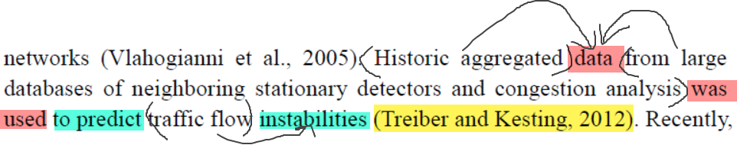

**Sentence pattern:** data was used to predict (AUTHORS, YEAR)

**Verb + noun (phrase) collocation:** use () data from (); predict () instability

**DEMO (2):**

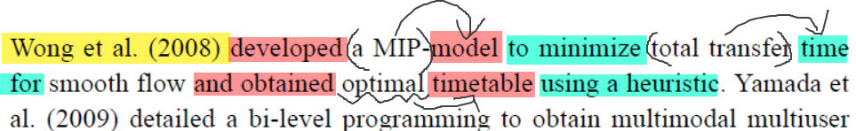

**Sentence pattern:** XXX (YEAR) developed a model and obtained optimal timetable

**Verb + noun (phrase) collocation:** develop a () model; minimize () time for; obtain () timetable using ()