**WK04 READING TASKS**

Read Text II & Text III of Unit 2 and finish the following tasks.

**Text II**

***Task 1: Identify the types of information each sentence provides in the Summary part, and then identify the corresponding paragraph(s) in the main part of the text providing each type of information.***

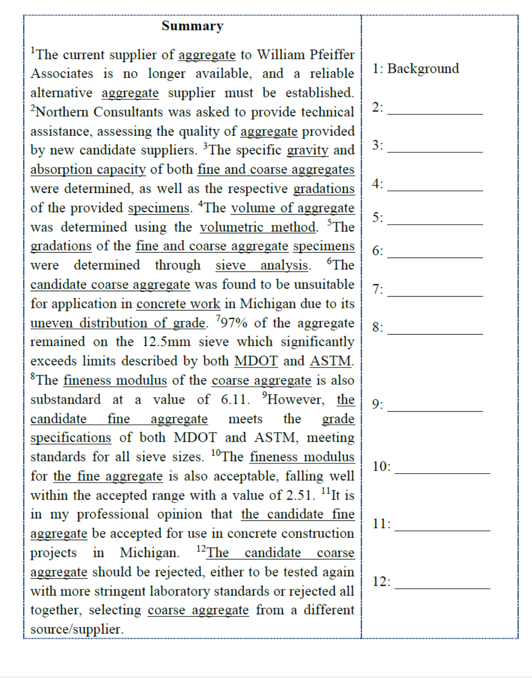

Conclusion P10

Conclusion P10

Result1 P7,8,9

Result2 P7,8,9

Result2 P7,8,9

Result1 P7,8,9

Result1 P7,8,9

Methods P4,6

Methods P2,6

Objectives P1

Purpose P1

***Task 2: Read the main part of Text II and identify the details of the following types of information.***

1. Purpose of the report

The purpose of this document is to provide the methods of laboratory analysis of the candidate supplier aggregate and their findings from the analysis regarding the specific gravity, absorption capacity, grade and fineness, as well as their conclusions and recommendations for usage of the coarse and fine aggregate.

1. Problem(s) to be solved

Northern Consultants was asked to provide technical assistance, assessing the quality of aggregate provided by new candidate suppliers.

1. Goals and objectives of the test

The coarse and fine aggregate samples were tested to determine their respective specific gravity and absorption capacity.

1. Variables measured and test procedures

The ASTM C127 and C128 procedures were followed to determine the density, specific gravity, and absorption capacity of the fine and coarse aggregate. To determine the gradation of the candidate Michigan aggregate, dried fine and coarse samples were analyzed using the ASTM C136 method. To determine the unit weight of the candidate Michigan coarse aggregate sample, the ASTM C29 procedure was followed.

1. Major findings/Answer to the problem(s)

The coarse aggregate sample is not adequate for use in high quality, durableconcrete as desired by your firm. The gradation of the coarse aggregate is not adequately distributed to provide even strength across a slab. The fineness modulus confirms the evidence, which is shown to be lower than accepted values.

***Task 3: Analyze the structural pattern of paragraphs 8 & 9 based on the following demo of paragraph 7, and discuss the significant overuse of present tense (现在时) as opposed to the dominant past tense (过去时) in Methodology part.***

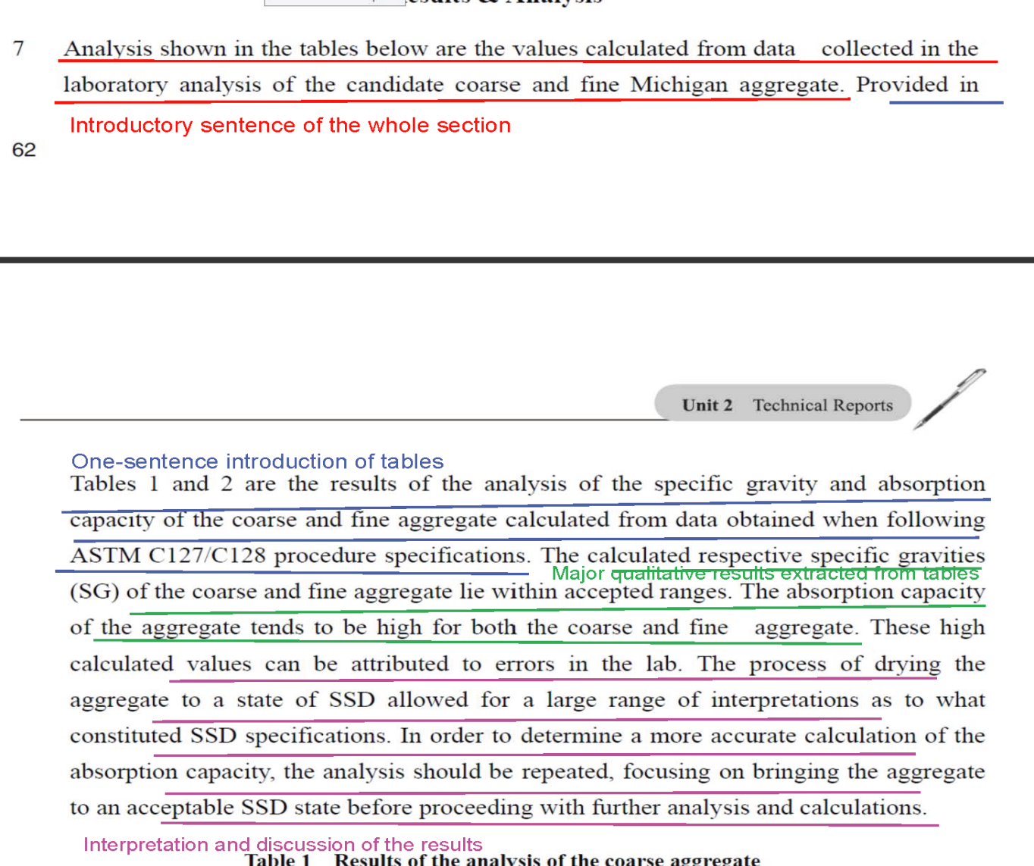

Tables 3 and 4 are the sieve analysis of the candidate Michigan aggregate. The coarse aggregate fails to meet MDOT and ASTM specifications for gradation due to its high yield value in the 12.5 mm sieve.

The value of aggregate remaining on the 12.5 mm sieve is much higher than the acceptable range. Also, due to the uneven distribution of grade in the coarse aggregate, the fineness modulus is slightly below the standard acceptable range.

A more appropriate FM coarse would be 7.0. The fine aggregate meets standards described by both MDOT and ASTM. The cumulative percent of aggregate by weight that is passing through each sieve falls within the acceptable ranges at all values. Also, the fineness modulus for the candidate fine aggregate is within accepted standards, where 2.3< 2.51< 3.1.

The results of the unit weight analysis of the coarse aggregate are shown in Table 5. The weights of the rodded aggregate along with the respective unit weight are greater than those of the loose aggregate as expected.

**Text III**

***Task 4: Analyze the function of each sentence in the Abstract and work out a structural pattern for the Abstract.***

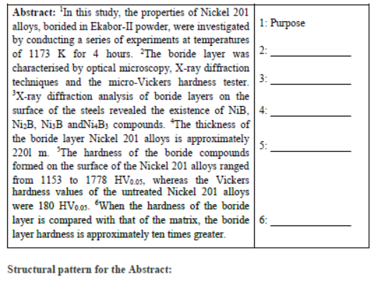

1. Purpose: Introduction/Paragraph 1.

2. Method: Experimental Procedures/Paragraphs 2-4.

3. Result 1: Results and Discussion/Paragraph 8.

4. Result 2: Results and Discussion/Paragraph 9

5. Result 3: Results and Discussion/Paragraph 11

6. Discussion: Results and Discussion/Paragraph 13/Conclusion

***Task 5: Identify the details of the following types of information in the Introduction part.***

1. Aim of the study

The aim of this study was to improve the low surface hardness and low wear performance of Ni alloys through boriding.

1. Importance of Ni alloys

Ni alloys are used in various industrial plants and equipment for their high resistance to corrosion. Problem existing in Ni alloys utilization. Despite this superior property, the fields of their utilisation are limited because they have low hardness and poor wear performance

1. Problem existing in Ni alloys utilization

Coatings are normally used to improve the corrosion and wear properties of metals.

1. Typical solution to the problem

Boriding is a thermo-chemical diffusion process in which boron is diffused onto steel under high temperature. The borided reaction layer maintains its hardness at high temperatures (550–600℃) and has a very low friction coefficient and corrosion resistance against acid and high temperature oxidations.

1. Definition of boriding and its advantages

Boriding is a thermo-chemical diffusion process in which boron is diffused onto steel under high temperature. It offers superior properties such as a surface hardness of 1400–3000 HV. The borided reaction layer maintains its hardness at high temperatures (550–600℃) and has a very low friction coefficient and corrosion resistance against acid and high temperature oxidations.

***Task 6: The following is boriding treatment description (paragraph 2) with certain clauses blurred to highlight the test steps. Discuss what functions the blurred parts might perform and whether they could be deleted. Then extract the major experimental procedures in paragraphs 3 & 4 in a similar way.***

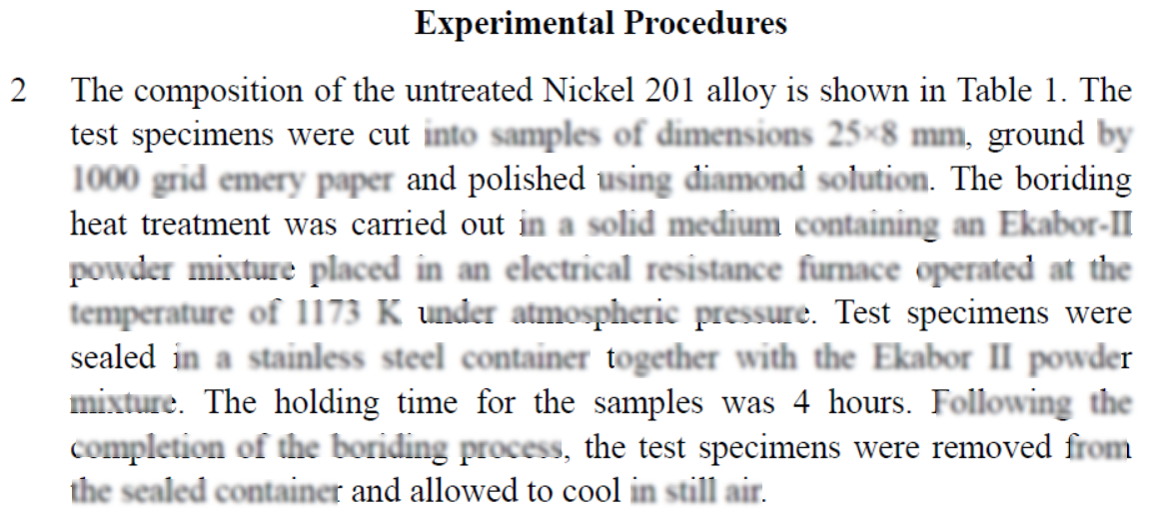

Those blurred clauses are placed to bring out more specific information and make the experimental procedure more accurate and convincing. By using detailed criterion, method and materials, the description can be easier to understand for readers. In this way, they can be regarded as additional info to the key points. Thus, it won’t make trouble understanding the procedure if we delete them.

Paragraph 3:

The microstructures of the polished and etched cross sections of the specimens were observed under an Olympus BX-60 optical microscope. The presence of borides formed in the coating layer was confirmed by means of X-ray diffraction (XRD) equipment (Shimadzu XRD 6000) using Cu Kα radiation. The distributions of the alloying elements within the boride layer (which accumulated in the boride teeth and between them) for Nickel 201 alloy were determined by electron dispersive spectroscopy (EDS) (LEO 1430VP) from the surface to interior. The thickness of the borides was measured by means of a digital thickness measuring instrument attached to an optical microscope (Olympus BX60). Thickness values given in the results section are averages of at least 10 measurements. The hardness measurements of the boride layer on each steel and untreated steel substrate were made on the cross sections using a Shimadzu HMV-2 Vickers indenter with a 50g load.

Paragraph 4:

The Daimler-Benz Rockwell-C adhesion test was used to assess the adhesion of the boride layers. The well-known Rockwell-C indentation test is prescribed by the VDI 3198 norm, as a destructive quality test for coated compounds [14–16]. The principle of this method is presented in upper right part of Fig. 1 [15]. A load of 1471N was applied to cause coating damage adjacent to the boundary of the indentation. Three indentations were conducted for each specimen and scanning electron microscopy was employed to evaluate the test.

***Task 7: Identify the types of information in brackets of different colors in paragraph 12, and discuss the reasons for tense-shifting (时态转换).***

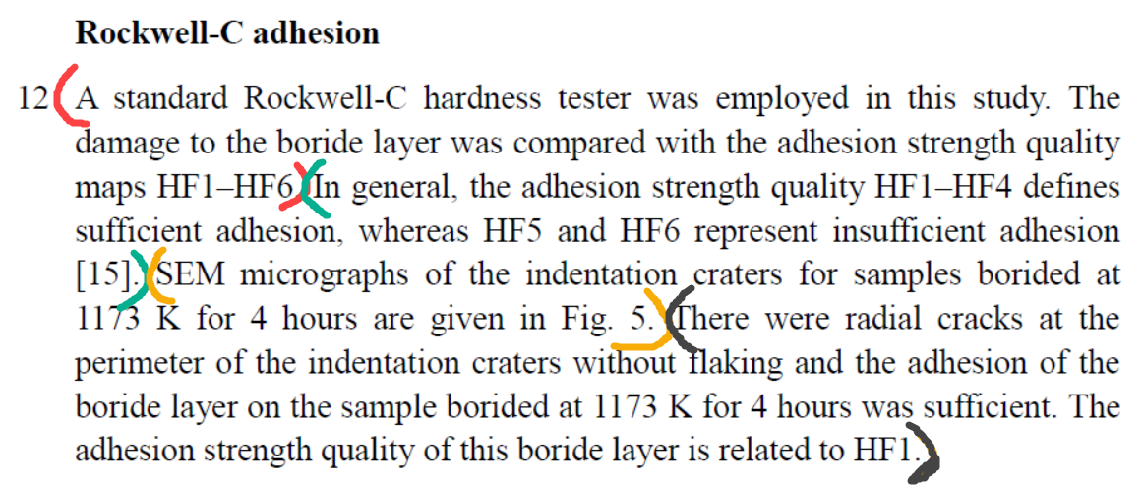

1. Introductory sentence to this paragraph
2. Background information of this test
3. Results of the test
4. Interpretation and discussion of the result.

The past tense is exploited to introduce the method, results and conclusions of the experiment which occurred in the past. And the present tense is employed to illustrate a general result of materials in normal state.