“Kernel Monitor: A Real-Time Linux System and Process Monitor Using the /proc Filesystem”
A Project Report Submitted in the partial fulfillment of the requirements for the award of the degree of

BACHELOR OF TECHNOLOGY
In

DEPARTMENT OF COMPUTER SCIENCE ENGINEERING

By

ANIKETH PANI KAKANUR 2520030184

ROHAAN JACOB VARIGANTI 2520030558

V. KARTHIK 2520030053

Under the Esteemed Guidance of

Dr. K. Anusha
Assistant Professor
Department of Computer Science and Engineering




K L (Deemed to be) University DEPARTMENT OF COMPUTER SCIENCE ENGINEERING
&

DEPARTMENT OF COMPUTER SCIENCE AND INFORMATION TECHNOL

Declaration

The Project Report entitled “Kernel Monitor: A Real-Time Linux System and Process Monitor Using the /proc Filesystem” is a record of Bonafide work of ANIKETH PANI KAKANUR - 2520030184, ROHAAN JACOB VARIGANTI - 2520030558, V. KARTHIK - 2520030053 submitted in
partial fulfillment for the award of B. Tech in Computer Science and Engineering (or) Computer Science and Information Technology to the K L University. The results embodied in this report have not been copied from any other departments/University/Institute.

ANIKETH PANI KAKANUR 2520030184

ROHAAN JACOB VARIGANTI 2520030558

V. KARTHIK 2520030053

K L (Deemed to be) University

DEPARTMENT OF COMPUTER SCIENCE ENGINEERING

CERTIFICATE

This is certify that the mini project based report entitled “Kernel Monitor: A Real-Time Linux System and Process Monitor Using the /proc Filesystem” is a bonafide work done and submitted by ANIKETH PANI KAKANUR - 2520030184, ROHAAN JACOB VARIGANTI - 2520030558, V. KARTHIK - 2520030053,
in partial fulfillment of the requirements for the award of the degree of BACHELOR OF TECHNOLOGY in Department of Computer Science Engineering, K L (Deemed to be University), during the academic year 2026-2027.

Signature of the Guide

Signature of the Course Coordinator Signature of the HOD

ACKNOWLEDGEMENT
The success in this project would not have been possible but for the timely help and guidance rendered by many people. Our wish to express my sincere thanks to all those who has assisted us in one way or the other for the completion of my project.

Our greatest appreciation to my Course Coordinator Dr. K. Anusha, and my guide Dr. K. Anusha, Department of Computer Science which cannot be expressed in words for his/her tremendous support, encouragement and guidance for this project.

We express our gratitude to Dr. P Venkateshwara Roa (CSE), Head of the Department for Computer Science Engineering for providing us with adequate facilities, ways and means by which we are able to complete this project-based Lab.

We thank all the members of teaching and non-teaching staff members, and also who have assisted me directly or indirectly for successful completion of this project. Finally, I sincerely thank my parents, friends and classmates for their kind help and cooperation during my work.

ANIKETH PANI KAKANUR 2520030184

ROHAAN JACOB VARIGANTI 2520030558

V. KARTHIK 2520030053
Abstract

Linux keeps detailed information about its CPU, memory and running processes, but reading it directly through system interfaces is difficult for a beginner. The raw files are plain text with fields identified only by position and counters that only mean something as a difference between two readings. To address this, our project focuses on the Design and Development of Kernel Monitor, a real-time system and process monitor for Linux written in C. Its core aim was to build a lightweight terminal tool that reads this information from user space, presents it clearly, and demonstrates the Operating Systems concepts it depends on.

The monitor reads the /proc filesystem with the ordinary open, read, close, opendir and readdir system calls and needs no root access and no kernel module. It reports CPU utilisation, memory and swap usage, load averages, uptime and the kernel version, and lists every process with its CPU share, memory share, state and thread count. A detail view adds the parent, process group, session, controlling terminal, foreground status and page fault rates. It rebuilds the process tree, logs process creation and termination, and sends SIGTERM, SIGKILL, SIGSTOP and SIGCONT to a chosen process after confirmation. The interface is built with ncurses, and a second thread collects the data so that the screen never waits for a scan.

Beyond the monitor, nine small demonstration programs reproduce a zombie, an orphan, a shell pipeline, a named pipe, job control, virtual memory behaviour, file system behaviour and thread synchronisation, so that every course outcome from CO-1 to CO-6 is applied in running code. The final program builds without warnings, uses 3.6 MB of memory, spends 0.30 percent of one CPU, and scans 37 processes in 2.82 ms on average. In summary, this project delivers a small, readable and complete tool that shows how an operating system's resources and processes can be observed and managed from user space.

Index

S. No. | Chapter | Topics / Subtopics | Page No.
 | Acknowledgement |  | i
 | Abstract |  | ii
1 | Introduction |  | 8–10
 |  | 1.1 Background of the Project | 8
 |  | 1.2 Problem Statement | 8
 |  | 1.3 Scope of the Project | 8
 |  | 1.4 Objectives of the Project | 9
 |  | 1.5 Importance of the Application | 9
 |  | 1.6 Target Users / Audience | 9
2 | OS Concepts and Background Study |  | 11–14
 |  | 2.1 Operating System Concepts Related to the Project | 11
 |  | 2.2 Existing Methods / Algorithms | 13
 |  | 2.3 Proposed Approach | 13
 |  | 2.4 Advantages of the Proposed Approach | 14
3 | System Requirements |  | 15–16
 |  | 3.1 Hardware Requirements | 15
 |  | 3.2 Software Requirements | 15
 |  | 3.3 Operating System Environment – Ubuntu / WSL | 15
 |  | 3.4 Development Tools and Compilers | 16
4 | Technology and Tools Used |  | 17–18
 |  | 4.1 C / C++ Programming | 17
 |  | 4.2 GCC Compiler | 17
 |  | 4.3 Linux System Calls | 17
 |  | 4.4 POSIX Threads / Synchronization | 18
 |  | 4.5 Linux Commands and Utilities | 18
 |  | 4.6 Other Tools / Libraries Used | 18
5 | System Architecture and Design |  | 19–22
 |  | 5.1 Overall System Architecture | 19
 |  | 5.2 System Workflow | 20
 |  | 5.3 Flowchart / Data Flow | 20
 |  | 5.4 Module Description | 21
 |  | 5.5 Input and Output Design | 22
6 | Implementation |  | 23–29
 |  | 6.1 Module-wise Implementation | 23
 |  | 6.2 Algorithm / Pseudocode | 24
 |  | 6.3 Core C / C++ Implementation | 24
 |  | 6.4 Linux System Calls / APIs Used | 25
 |  | 6.5 Process / Thread Implementation | 26
 |  | 6.6 IPC / Synchronization Implementation | 26
 |  | 6.7 Memory Management Implementation | 28
 |  | 6.8 Optional User Interface Implementation | 29
7 | Execution and Demonstration |  | 30–38
 |  | 7.1 Compilation in Ubuntu | 30
 |  | 7.2 Execution Commands | 30
 |  | 7.3 Sample Inputs and Outputs | 30
 |  | 7.4 Screenshots of Execution | 31
 |  | 7.5 Demonstration of OS Concepts | 38
8 | Conclusion |  | 39–40
 |  | 8.1 Summary of the Project | 39
 |  | 8.2 Objectives Achieved | 39
 |  | 8.3 Results Achieved | 39
 |  | 8.4 Skills and Learning Outcomes | 40
9 | References |  | 41–42
 |  | 9.1 Books | 41
 |  | 9.2 Research Papers | 41
 |  | 9.3 Linux / GNU Documentation | 41
 |  | 9.4 Online Resources | 41

CHAPTER -1 INTRODUCTION

1.1 Background of the Project
An operating system hides the machine from the programs that run on it. Behind every running program there is a process table, a scheduler that hands out CPU time, a memory manager that gives each process its own address space, and a file system that names everything. All of this state lives inside the kernel, and for most users it is invisible. Linux makes it visible on purpose. The kernel publishes its internal tables as a pseudo file system mounted at /proc, where every running process appears as a numbered directory and where files such as /proc/stat, /proc/meminfo and /proc/loadavg describe the whole machine. Reading these files needs no special library and no administrator rights, only the ordinary open(), read() and close() system calls.
Well known tools such as top, htop and ps are built on exactly this interface. They are useful, but they hide the mechanism. A student who uses them learns what the numbers are, not where the numbers come from. Kernel Monitor is a terminal application written in C that does the same job in the open: every figure on its screen is traced to a specific /proc file, a specific parsing function and a specific line of arithmetic, all in about 3,200 lines of readable source.
The project was proposed in Section 02 as Team 19 of the course Operating Systems and Systems Programming (25CS2104E). It began as a monitor for CPU, memory and processes, and was then extended so that every course outcome from CO-1 to CO-6 is applied in running code, either inside the monitor itself or in one of nine small demonstration programs that ship with it.

1.2 Problem Statement
Linux holds a great deal of information about system resources and running processes, but reaching and understanding it directly through system interfaces is hard for a beginner. The raw files are plain text with fields that are identified only by position, counters that only make sense as differences between two readings, and units that differ from file to file. The problem addressed by this project is to build a simple terminal-based monitor that collects and displays real-time system and process information through the /proc filesystem, POSIX APIs and Linux system calls, and that at the same time demonstrates the Operating Systems concepts it relies on.

1.3 Scope of the Project
In scope. The monitor reports CPU utilisation, memory and swap usage, load averages, uptime, the kernel version and the CPU count. It lists every process with its CPU share, memory share, state and thread count, sorted by CPU use. For a selected process it shows a detail view that includes its parent, process group, session, controlling terminal, foreground status, priority, open file descriptor count, page fault counts and the rate at which they are growing, its command line and its executable path. It rebuilds the process tree from parent links, logs process creation and termination events, and lets the user send SIGTERM, SIGKILL, SIGSTOP and SIGCONT to a process after a confirmation prompt. Nine demonstration programs cover pipes, named pipes, job control, virtual memory, file systems and thread synchronisation.
Out of scope. The monitor is a user-space program. It has no kernel module and no driver, it does not need root, and it does not change any system setting. It reads Linux data only, so it does not run on Windows or macOS, and under WSL2 it can see only the Linux processes inside the WSL virtual machine, not Windows processes. It does not report network traffic, disk throughput or temperatures.

1.4 Objectives of the Project
- To monitor CPU, memory, swap, uptime, load average and other system resources in real time.
- To display detailed information about running processes, including CPU usage, memory usage, state, threads and process relationships.
- To provide basic process control and event tracking using Linux signals and system calls.
- To demonstrate the /proc filesystem, POSIX APIs, process management, signals and ncurses through an interactive monitoring tool.
- To apply the remaining course outcomes in working code: inter-process communication and job control (CO-3), memory management (CO-4), file systems and file I/O (CO-5), and concurrency and synchronisation (CO-6).

1.5 Importance of the Application
The application matters for three reasons. First, it is a teaching instrument: each concept in the syllabus has a place in the code that can be read, run and observed, and the source marks those places with [CO-n] comments. Second, it is a practical tool: it starts instantly, uses 3.6 MB of memory and 0.30 percent of one CPU, and needs nothing but a terminal, so it is usable on a headless server or a remote shell where a graphical monitor is not available. Third, it shows how much of an operating system is reachable from user space. Everything the monitor knows, it learned by asking the kernel through documented interfaces.

1.6 Target Users / Audience
- Students of operating systems who want to see processes, signals, paging and file descriptors working rather than only described.
- Developers who need a small, dependency-light monitor for a terminal session, a container or a WSL2 instance.
- Instructors who need runnable material for a lecture, including a zombie, an orphan, a race condition and a deadlock that appear on demand.
- System administrators who want a quick, safe way to inspect a process and stop or resume it without leaving the terminal.

CHAPTER -2 OS CONCEPTS AND BACKGROUND STUDY

2.1 Operating System Concepts Related to the Project
The project is organised around the six course outcomes. The table below lists where each one is applied. The concepts are then explained in the order of the syllabus.
CO | Concept applied | Where it appears
CO-1 | User space and kernel space, system calls, /proc as a kernel file system, the shell's command execution path | proc_reader.c, main.c, pipeline
CO-2 | Process abstraction, PID and PPID, states, CPU accounting, creation and termination, zombie and orphan | process_monitor.c, zombie, orphan, busy
CO-3 | Signals and handlers, anonymous and named pipes, process groups, sessions and job control | process_control.c, main.c, pipeline, fifo, jobctl
CO-4 | Virtual memory, page tables, page faults, address space layout, copy-on-write, memory errors and debugging | page fault rates in the detail view, vmem
CO-5 | VFS, inodes, file descriptors, buffered and unbuffered I/O, memory-mapped files, ext4 | proc_reader.c, fileio
CO-6 | Threads, mutexes, condition variables, semaphores, races, deadlock, read-write locks, barriers | collector.c, threadsync

User space, kernel space and system calls (CO-1)
The processor runs in at least two privilege levels. The kernel runs in the privileged one and owns the hardware and every kernel data structure. Ordinary programs run in the unprivileged one and cannot touch kernel memory. A program asks the kernel for service through a system call, which is a controlled switch into kernel mode. Kernel Monitor never reads kernel memory. It uses open(), read(), close(), opendir(), readdir(), kill() and sysconf(), and the kernel decides what to reveal. The /proc file system is the clearest example: it is not stored on any disk, and every read is answered by kernel code that formats live data as text. Because it is reached through the Virtual File System, the same open() and read() that read a text file read the kernel's process table.

Processes and scheduling (CO-2)
A process is a program in execution with its own address space, descriptors and identity. Each has a process ID and a parent process ID, so the processes of a system form a tree rooted at the first process. A process is in one of a small set of states: running, sleeping, stopped or zombie. A zombie has finished but its parent has not collected its exit status, so the kernel keeps its table entry. An orphan is the opposite case, a live process whose parent has exited, and the kernel hands it to a new parent. The kernel does not publish a CPU percentage. It publishes cumulative clock ticks for each process, and a percentage is a rate computed from two readings and the real time between them. This is the central calculation of the monitor.

Signals, pipes and job control (CO-3)
A signal is an asynchronous notification delivered by the kernel. kill() does not necessarily kill: it asks the kernel to deliver a chosen signal. SIGTERM can be caught so a process can clean up, SIGKILL cannot be caught or ignored, and SIGSTOP and SIGCONT suspend and resume a process, which is the mechanism behind pressing Ctrl+Z and typing fg. A handler can interrupt a program at any instruction, so it must do almost nothing, and the monitor's handler only sets a flag. Pipes carry bytes between processes. An anonymous pipe joins related processes through inherited descriptors, and a named pipe (FIFO) has a name in the file system so unrelated processes can use it. Every process also belongs to a process group, and groups belong to a session. The terminal's foreground group receives keyboard signals, which is how a shell controls jobs.

Memory management (CO-4)
Every address a program uses is virtual. The kernel and the memory management unit translate each 4 KiB virtual page to a physical frame through page tables, and they fill the tables lazily. Mapping memory costs nothing until it is touched. The first touch of a page causes a page fault. A minor fault is resolved without disk I/O, for example by supplying a zero-filled frame, and a major fault needs a read from disk. After fork() the child shares the parent's frames, marked read-only, and a write fault makes a private copy, which is copy-on-write. An access to an unmapped or protected address makes the kernel send SIGSEGV. Errors that stay inside mapped memory, such as a leak or a one-element overflow, are invisible to the kernel and need tools like AddressSanitizer or Valgrind.

File systems and file I/O (CO-5)
Unix presents many different things as files. The Virtual File System gives one set of calls to ext4, /proc, /sys, tmpfs and device files. A file's identity is its inode. A directory entry is only a name paired with an inode number, so one inode can have several names (hard links), and the data is freed only when the link count reaches zero and no process holds the file open. A descriptor is an index into a per-process table that points to an open file description in the kernel, which holds the offset. dup() shares a description, while a second open() creates a new one. The C library adds a buffer in user space, so many small writes become few system calls, and mmap() maps a file's pages directly into the address space.

Concurrency and synchronisation (CO-6)
Threads are flows of execution inside one process that share its memory. That sharing is what makes them useful and what makes them dangerous. When two threads update the same variable, the result depends on timing, which is a race condition. A mutex gives mutual exclusion. A condition variable lets a thread sleep until a condition it needs becomes true, and it is always used with a mutex and a loop that rechecks the condition. A counting semaphore limits how many threads enter a region. A deadlock occurs when threads hold locks the others need, and it requires mutual exclusion, hold and wait, no preemption and a circular wait. Read-write locks and barriers cover the cases where many readers may share data or where threads must start together.

2.2 Existing Methods / Algorithms
Several established tools show process and system information on Linux.
Tool | How it works | Limitation for learning
ps | Prints one snapshot of the process table, taken by reading /proc | No live view, no control, no explanation of the figures
top | Refreshes a process list at an interval, computing CPU share from tick differences | Large code base, many options, source is hard to follow
htop | A richer ncurses front end over the same data | Same, plus a heavier dependency set
vmstat, free, uptime | Each reads one or two /proc files and prints a summary | Single purpose, no interactive view
Kernel tracing (perf, eBPF) | Instrument the kernel itself for fine-grained events | Needs privileges and kernel support, far beyond a teaching tool

The common algorithm behind the first four is the one Kernel Monitor uses: read cumulative counters from /proc, remember them, read them again after a measured interval, and divide the difference by the interval. The tools differ in presentation, not in method.

2.3 Proposed Approach
The proposed approach is a layered C program that keeps every concern in one place. A reader module wraps the system calls that open and read /proc files. A parser module turns their text into numbers and structures. Two monitor modules hold the system model and the process model and compute rates. A signal module is the only part that calls kill(). A user interface module draws four views with ncurses. A collector module runs the /proc sweep on its own thread, so the screen and keyboard are never blocked by a slow scan. Alongside the monitor, nine standalone programs recreate specific operating system situations on demand so that each one can be watched in the monitor.
Three decisions shape the design. Rates are computed from the measured time between samples and not from the configured interval, so a delayed sample cannot inflate a percentage. Process lists are kept sorted by PID so a process can be found by binary search. And the single lock shared by the two threads is held only for the short moment a new sample is swapped in or drawn, never while waiting.

2.4 Advantages of the Proposed Approach
- No privileges. It reads only world-readable /proc files, needs no root and no kernel module, and cannot damage the system apart from signals the user chooses to send.
- Small and fast. The binary is 60 KB, the resident memory is 3.6 MB, a full scan of 37 processes takes 2.82 ms on average, and the monitor itself uses 0.30 percent of one CPU.
- Responsive. The scan runs on a second thread, so keys and drawing never wait for it.
- Accurate rates. CPU and page fault rates use the measured interval and guard against a recycled PID.
- Readable. Each module has one job, the code is commented with the concept it demonstrates, and it builds with no warnings.
- Complete coverage. The monitor and the demonstration programs together apply all six course outcomes.

CHAPTER -3 SYSTEM REQUIREMENTS

3.1 Hardware Requirements
Kernel Monitor has very modest needs because it reads small text files and draws a text screen. The table gives the minimum for any machine and the hardware the project was actually developed and measured on.
Item | Minimum | Used for development and measurement
Processor | Any x86-64 processor | 12 logical CPUs
Memory | 64 MB free for the monitor and its build tools | The monitor itself holds 3.6 MB resident
Storage | A few MB for source, objects and binaries | Binary size 60 KB
Display | A terminal of 80 columns by 24 rows | Terminals of 120 by 36 characters and larger
Host machine | Any computer able to run Linux or WSL2 | Windows 11 laptop running WSL2

3.2 Software Requirements
Software | Purpose and version used
Linux kernel | Provides /proc and the system calls. Measured on 6.18.33.2-microsoft-standard-WSL2
GCC | C compiler with C11 support. Version 15.2.0 was used
GNU Make | Builds the monitor and the demonstration programs. Version 4.4.1
ncurses, wide-character build | Terminal user interface. Package libncurses-dev, version 6.6
POSIX threads | Part of the C library, linked with -pthread
Git | Version control and the installer. Version 2.53.0
tmux | Used to drive the full-screen monitor from scripts during testing. Version 3.6
AddressSanitizer | Bundled with GCC, used to find the planted leak and overflow in the vmem demonstration

3.3 Operating System Environment, Ubuntu and WSL
The development environment is Ubuntu 26.04.1 LTS running under Windows Subsystem for Linux 2 on a Windows 11 host. WSL2 runs a real Linux kernel in a lightweight virtual machine, so every system call and /proc file the project uses behaves as it does on a native installation. The application itself runs unchanged on any Linux distribution.
There are two WSL2 behaviours worth knowing. First, /proc belongs to the WSL virtual machine and not to Windows, so the monitor shows only the Linux processes inside it. A fresh instance runs about 40 to 50 processes, so a few workloads should be started to see a busy list. Second, WSL's Relay process registers as a child subreaper. When the orphan demonstration loses its parent, the kernel hands the orphan to the nearest subreaper, so on WSL the new parent is Relay, and on a normal Linux install it is process 1.

3.4 Development Tools and Compilers
The project is compiled with GCC using -std=gnu11 -Wall -Wextra -O2. The dialect is gnu11 and not c11 because strict C11 hides the POSIX declarations that the program is built on, such as fork() and pid_t. The monitor adds -pthread, -D_GNU_SOURCE and -D_XOPEN_SOURCE_EXTENDED and links -lncursesw. The wide-character library is required because the interface draws multibyte glyphs for the arrow keys and tree branches, and the 8-bit library would draw one broken cell per byte. The final build produces no warnings. A Makefile builds everything, and an installer script downloads the source, checks for the ncurses library and builds it with one command.

CHAPTER -4 TECHNOLOGY AND TOOLS USED

4.1 C / C++ Programming
The project was first proposed in C++ and was then ported to C, so that every call in the program is a plain POSIX or Linux call and nothing is hidden behind a class library. C suits this subject. Its data types map directly onto the kernel's, its memory is managed by hand so allocation is visible, and the operating system interfaces studied in the course are themselves defined as C functions. The port left the module boundaries unchanged. Each module became a header and a source file, and a structure holds what a class once held, for example km_process_monitor, km_system_monitor, km_collector and km_ui. Functions that operate on a structure take a pointer to it as their first parameter and carry a km_ prefix.

4.2 GCC Compiler
GCC compiles each source file into an object file and links them with the ncurses and pthread libraries. The warning flags -Wall and -Wextra are kept on at all times, and the code builds with none. The optimisation level -O2 is used for the release build, and make debug produces an unoptimised build with symbols for use with a debugger. GCC also supplies AddressSanitizer through -fsanitize=address, which the memory demonstration uses to catch bugs that the kernel cannot see.

4.3 Linux System Calls
System calls are the project's whole interface to the kernel. The table lists the ones used by the monitor and why.
System call or function | Purpose in the monitor
open(), read(), close() | Read each /proc file, looping until read() returns zero because /proc files report a size of zero
opendir(), readdir(), closedir() | Walk /proc and collect the numeric entries as PIDs, and count /proc/[pid]/fd entries
readlink() | Resolve /proc/[pid]/exe to the executable path
kill() | Deliver SIGTERM, SIGKILL, SIGSTOP or SIGCONT to a chosen process
sigaction() | Install the handler for SIGINT and SIGTERM that sets a quit flag
sysconf() | Read the clock ticks per second and the page size
clock_gettime() | Take monotonic timestamps so intervals cannot go negative
isatty() | Refuse to start when input or output is not a terminal
pthread_create(), pthread_join() | Start and stop the collector thread
pthread_mutex_lock(), pthread_cond_timedwait() | Guard the shared sample and sleep until the interval ends
pthread_sigmask() | Keep SIGINT, SIGTERM and SIGWINCH on the main thread

4.4 POSIX Threads / Synchronization
POSIX threads give the monitor its second thread and give the threadsync demonstration its examples. The monitor uses one mutex and one condition variable. The condition variable is created with CLOCK_MONOTONIC so a change of the wall clock cannot stretch or shorten a wait. The demonstration program covers mutexes, atomic operations from stdatomic.h, condition variables, counting semaphores from semaphore.h, a read-write lock and barriers, with a race condition and a deadlock shown on purpose and then fixed.

4.5 Linux Commands and Utilities
Command | Use during the project
ps -eo pid,ppid,stat,comm | Cross-check the monitor's PID, PPID and state columns, and see a zombie with state Z
cat /proc/[pid]/stat | Read the raw fields the parser decodes
ls -l /proc/self/fd | See descriptors and the (deleted) marker on an unlinked open file
strace -c | Count the system calls made by the fileio demonstration
tmux | Run the monitor inside a scripted terminal and capture its screen
make, gcc, git | Build, compile and version the project

4.6 Other Tools / Libraries Used
- ncurses (wide-character) draws the interface. It lets the program redraw only changed cells, handle resizes and read keys with a timeout.
- Git and GitHub hold the source at github.com/Cyanexani/2520030184_053_558-OSSP, and a one-command installer clones, builds and installs it.
- Shell scripts run the automated checks in tests/run_tests.sh and the installer, builder and uninstall scripts.

CHAPTER -5 SYSTEM ARCHITECTURE AND DESIGN

5.1 Overall System Architecture
Kernel Monitor is a layered program. Each layer calls only the layer below it, which keeps every module small and replaceable. Figure 5.1 shows the layers from the terminal at the top to the kernel at the bottom.
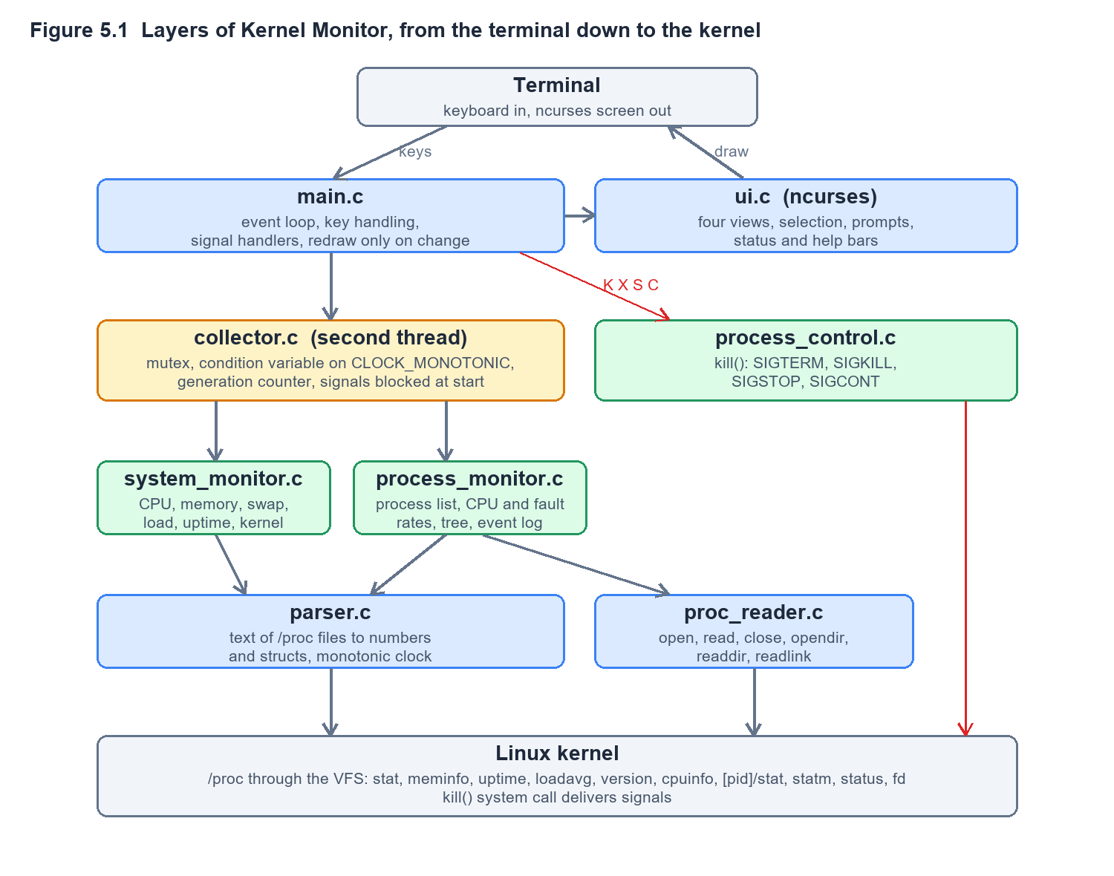
The monitor consists of about 3,200 lines of C in eight modules, listed below with their sizes.
Module | Lines | Responsibility
main.c | 336 | Entry point, signal handlers, key handling, the redraw decision
proc/proc_reader.c | 344 | The only place that opens /proc files, and the PID enumeration
utils/parser.c | 313 | Text to numbers, the monotonic clock helpers
system/system_monitor.c | 273 | CPU percentage, memory, swap, load, uptime, kernel version
process/process_monitor.c | 706 | Process model, CPU and fault rates, tree, event log
signals/process_control.c | 166 | The only place that calls kill()
collector/collector.c | 211 | The background thread, the mutex and the condition variable
ui/ui.c | 860 | Four ncurses views, selection, prompts, status and help bars

5.2 System Workflow
- Start. main() checks that standard input and output are terminals, sets the locale, installs the signal handlers, and initialises the system monitor, the process monitor and the ncurses interface.
- First sample. One sample is taken on the main thread so that the first frame already has data. No other thread exists yet, so no lock is needed.
- Collector starts. The collector thread is created with all signals blocked, so every signal stays with the main thread.
- Collector cycle. The collector sleeps on a condition variable until the interval ends, a refresh is requested or shutdown begins. It then scans /proc with the lock released and takes the lock only to publish the new sample.
- Main loop. The main thread waits for a key with a timeout, handles it, and redraws only when a new sample has been published, a key changed something or the terminal was resized.
- Process control. For K, X and S the user confirms first. The signal is sent through kill(), and the result, including any permission error, is shown in the status bar.
- Quit. Q, SIGINT or SIGTERM ends the loop. The collector is stopped and joined, and ncurses restores the terminal.

5.3 Flowchart / Data Flow
Figure 5.2 shows how the two threads cooperate. The collector does the slow work without the lock, and the main thread holds the lock only while drawing.
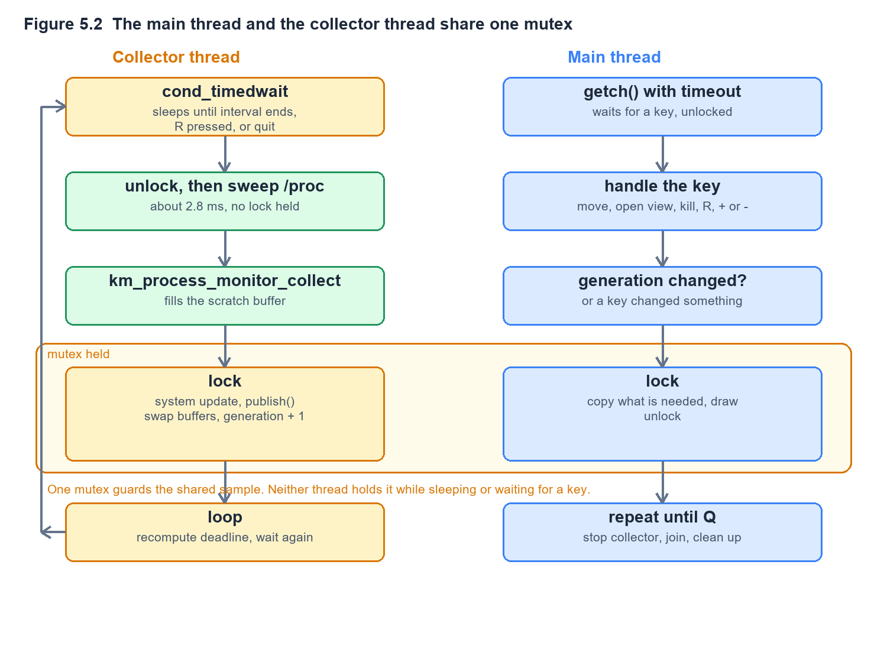
The data path for a single process is as follows. The PID list comes from a directory walk of /proc. For each PID the reader loads stat, statm, status, cmdline and exe. The parser decodes stat into a structure of named fields, and the monitor compares that structure with the one from the previous sample to produce rates. The new array replaces the old one by a pointer swap, and the old array becomes the next scratch buffer, so no copying is needed.
The two rate calculations are the same shape. For CPU the share of one processor is
cpu% = 100 * (utime2 + stime2 - utime1 - stime1) / (clock_ticks * seconds)

fault_rate = (faults2 - faults1) / seconds
where seconds is the measured gap between the two samples. If a counter has gone down, the PID has been reused by a different process, and the rate is reported as zero instead of a wrapped-around number.

5.4 Module Description
Module | Description | Owner
System monitoring and /proc collection | proc_reader, parser, system_monitor. Reads and decodes the machine-wide files and computes CPU, memory, swap and load figures | Aniketh Pani Kakanur
Process monitoring | process_monitor. Builds the process list, computes per-process rates, builds the tree and detects creation and exit events | Rohaan Jacob Variganti
Process control, interface and testing | process_control, ui, tests. Sends signals, draws the views, runs the automated and manual checks | V. Karthik
Collector thread and demonstrations | collector and the nine programs in demo/, added to cover CO-3 to CO-6 | Team

5.5 Input and Output Design
Input is the keyboard only. The keys are listed below.
Key | Action
Q | Quit
Up, Down | Move the selection. Page Up and Page Down move ten rows
Enter | Open the detail view of the selected process
T, E | Process tree view, event log view
B or Esc | Return to the process list
R | Refresh immediately
+, - | Change the update interval between 500 ms and 10 s in steps of 500 ms
K, X | Terminate (SIGTERM) or kill (SIGKILL) the selected process, after confirmation
S, C | Suspend (SIGSTOP, after confirmation) or resume (SIGCONT) the selected process

The highlight follows the process and not the row number. A process that climbs the CPU ranking cannot slide out from under the highlight between a keypress and its confirmation, so a signal can never go to the wrong process.
Output is a full-screen ncurses display with a header, a content area, a status line and a help bar. The header shows CPU, RAM, swap and load, plus the kernel version, uptime, CPU count and the time taken by the last scan. The content area shows one of four views: the process list, the process detail, the process tree or the event log. Values are colour coded, and the screen is redrawn only when something changed, which avoids flicker.

CHAPTER -6 IMPLEMENTATION

6.1 Module-wise Implementation

Reading /proc (proc_reader.c)
km_proc_read_file() opens a path with O_RDONLY | O_CLOEXEC and reads until the kernel returns zero bytes, retrying on EINTR. A loop is needed because /proc files report a size of zero, so there is nothing to preallocate or seek on. Thin wrappers name each file the monitor reads. km_proc_list_pids() calls opendir() on /proc, keeps directory entries whose names are all digits, and sorts the result with qsort(), so later lookups can use binary search. km_proc_count_fds() counts the entries of /proc/[pid]/fd.

Parsing (parser.c)
The parser turns text into values. A process name in /proc/[pid]/stat is written in parentheses and may itself contain spaces and parentheses, so the parser finds the last closing parenthesis and reads the remaining fields by position, numbered as in the proc(5) manual page. It extracts the state, parent PID, process group, session, terminal number, terminal foreground group, minor and major faults, user and system time, priority, nice value and thread count. The module also provides the monotonic clock helpers used for every interval.

System monitor (system_monitor.c)
CPU usage comes from the first line of /proc/stat, which sums the jiffies the machine has spent in each mode since boot. The monitor stores the previous totals and reports the share of the growth that was not idle time. Memory used is total minus free minus buffers minus cache, because buffers and the page cache are reclaimable. Swap, load averages, uptime and the kernel release are read from /proc/meminfo, /proc/loadavg, /proc/uptime and /proc/version.

Process monitor (process_monitor.c)
km_process_monitor_collect() lists the PIDs, reads each one into a scratch array, and compares it with the previous sample to compute CPU and fault rates. km_process_monitor_publish() detects creation and exit by comparing the two sorted arrays, then swaps the buffers. A process present now but not before has been created, and one present before but not now has terminated. Events go into a log that keeps the 100 most recent entries. km_process_tree_build() rebuilds the hierarchy from PPID links using two passes and flat arrays of child offsets, and a process whose parent is not in the sample becomes a root.

Process control (process_control.c)
km_send_signal() validates the PID, calls kill() and turns errno into a readable message: EPERM means the user is not allowed to signal that process, ESRCH means it no longer exists and EINVAL means the signal was invalid. Four small wrappers send SIGTERM, SIGKILL, SIGSTOP and SIGCONT.

Collector (collector.c)
The collector owns the second thread, the mutex and the condition variable. It exposes start, stop, lock, unlock, set-interval and request-refresh functions. Section 6.6 describes how it works in detail.

Interface (ui.c)
The interface keeps all ncurses calls in one module. Section 6.8 describes it.

6.2 Algorithm / Pseudocode

CPU percentage of a process
given previous sample P, current sample C, measured seconds S
if C.utime + C.stime < P.utime + P.stime: # PID was recycled
cpu = 0
else:
ticks = (C.utime + C.stime) - (P.utime + P.stime)
cpu = 100 * ticks / (clock_ticks_per_second * S)

Detecting creation and termination
for each process in the new sample:
if its PID is not in the old sample (binary search):
log CREATED
for each process in the old sample:
if its PID is not in the new sample:
log TERMINATED
swap the new array in as the current one

Building the process tree
pass 1: for each process p
parent = find(p.ppid)
if parent exists: child_count[parent] += 1
else: add p to roots
convert child_count into child_start offsets in one shared array
pass 2: for each process p with a parent
place p.pid into its parent's slice of the array

The collector loop
lock
loop:
while not stopping and not refresh_requested:
deadline = last_scan + interval
if cond_timedwait(deadline) timed out: break
if stopping: break
refresh_requested = false
unlock
scan /proc into the scratch buffer # slow, no lock
lock
update system figures, publish, generation += 1
unlock

6.3 Core C / C++ Implementation
The CPU calculation, from process_monitor.c:
static void calculate_cpu_usage(const km_process_monitor *m,
km_process_info *current,
const km_process_info *previous,
double seconds_elapsed) {
unsigned long long prev_total = previous->utime + previous->stime;
unsigned long long curr_total = current->utime + current->stime;
unsigned long long time_diff;

if (curr_total < prev_total) { /* recycled PID */
current->cpu_percent = 0.0;
return;
}
time_diff = curr_total - prev_total;
if (seconds_elapsed > 0.0 && m->clock_ticks > 0) {
current->cpu_percent = (100.0 * (double)time_diff) /
((double)m->clock_ticks * seconds_elapsed);
} else {
current->cpu_percent = 0.0;
}
}
Sending a signal, from process_control.c. The call to kill() is the project's only outbound inter-process communication:
ret = kill(pid, signal);
if (ret == 0) {
result.success = true;
snprintf(result.error_message, sizeof(result.error_message),
"Signal sent successfully");
return result;
}
switch (errno) {
case EINVAL: /* Invalid signal */
case EPERM: /* Permission denied (insufficient privileges) */
case ESRCH: /* Process does not exist */
...
}
The page fault rate, from process_monitor.c:
static void calculate_fault_rates(km_process_info *current,
const km_process_info *previous,
double seconds_elapsed) {
current->minflt_rate = 0.0;
current->majflt_rate = 0.0;
if (seconds_elapsed <= 0.0) return;
if (current->minflt >= previous->minflt)
current->minflt_rate =
(double)(current->minflt - previous->minflt) / seconds_elapsed;
if (current->majflt >= previous->majflt)
current->majflt_rate =
(double)(current->majflt - previous->majflt) / seconds_elapsed;
}

6.4 Linux System Calls / APIs Used
Section 4.3 lists the calls used by the monitor. The demonstration programs add the following.
API | Demo | Concept
fork(), execvp(), waitpid(), getppid() | zombie, orphan, pipeline, jobctl | Process creation and reaping
pipe(), dup2() | pipeline | Anonymous pipes, redirection
mkfifo() | fifo | Named pipes
setpgid(), getpgrp(), setsid(), getsid(), tcgetpgrp() | pipeline, jobctl | Process groups, sessions, job control
mmap(), munmap(), mprotect(), madvise(), msync() | vmem, fileio | Virtual memory, mapped files
getrusage(), sigsetjmp(), siglongjmp() | vmem | Fault counting, recovering from SIGSEGV
statfs(), stat(), lstat(), link(), symlink(), unlink(), dup(), lseek(), pread() | fileio | VFS, inodes, descriptors
pthread_*, sem_*, stdatomic.h | threadsync | Concurrency and synchronisation

6.5 Process / Thread Implementation

Processes
Three demonstration programs create process situations on demand. zombie forks a child that exits at once while the parent sleeps without calling wait(), so the child stays in state Z and the monitor shows it as Zombie with no CPU and no memory. After the hold the parent calls waitpid() and the entry disappears. orphan makes the parent exit after three seconds while the child keeps running and prints its parent PID each second, so the re-parenting is visible. busy burns a fixed slice of CPU between prints so it is almost always in state Running with a CPU share near 100 percent, and it handles SIGTERM and SIGINT so the difference between a catchable signal and SIGKILL can be shown from the K and X keys.
pipeline plays the part of a shell running ls | grep. It creates a pipe, forks two children, and in each uses dup2() to attach one end of the pipe to standard output or standard input before execvp(). Both children are placed in one new process group, which is what makes the pipeline a single job. The parent closes its copies of both ends so the reader can see end-of-file.

Threads
The monitor is a two-thread program. The main thread owns the keyboard, the screen and the signal handlers. The collector thread owns the /proc sweep. In threadsync, Part 1 shows that a thread has the same process ID as its creator but its own thread ID, and that a thread's write to a global is seen by the main thread while a forked child's write is not.

6.6 IPC / Synchronization Implementation

Signals
The monitor installs its handler with sigaction() and not signal(), so the behaviour is defined by the standard. The handler writes a volatile sig_atomic_t flag and returns. It does nothing else, because a handler can interrupt the program at any instruction and almost nothing is safe to call from it. The main loop checks the flag and shuts down in order. The collector thread blocks every signal around pthread_create(), so the new thread inherits a full mask and signals always arrive on the main thread, where the handler and ncurses expect them.

Pipes, FIFOs and job control
pipeline uses an anonymous pipe between two related processes. fifo uses a named pipe at /tmp/km-demo.fifo between any two processes. It shows that open() blocks until the other end opens, and that the reader sees end-of-file only when every writer has closed. jobctl forks three workers into one process group, then sends SIGSTOP, SIGCONT and SIGTERM to the whole group with a single kill(-pgid, sig), exactly as Ctrl+Z, fg and Ctrl+C do. It finally calls setsid() in a child to create a new session with no controlling terminal and shows that open("/dev/tty") then fails.

Mutex and condition variable in the collector
The collector uses one mutex and one condition variable. The wait is pthread_cond_timedwait() inside a while loop, because a wakeup only means "check again" and spurious wakeups are allowed. The deadline is recomputed after every wakeup, so a change of interval with + or - takes effect at once. The /proc sweep, which makes over a thousand system calls, runs without the lock, and the lock is taken only to swap the new sample in. The main thread takes the same lock only to draw. This keeps the critical section tiny and means a slow scan never delays a keypress. With a single lock there is no lock ordering, so the monitor cannot deadlock.
while (!c->stopping && !c->refresh_requested) {
struct timespec deadline = last;
add_ms(&deadline, c->interval_ms);
if (pthread_cond_timedwait(&c->wake, &c->lock, &deadline) == ETIMEDOUT)
break;
}
...
pthread_mutex_unlock(&c->lock);
km_process_monitor_collect(c->proc); /* slow, unlocked */
pthread_mutex_lock(&c->lock);
km_system_monitor_update(c->sys);
km_process_monitor_publish(c->proc);
c->generation++;

The threadsync demonstration
Part | Concept | What it shows
2 | Race condition | Four threads add 1 to a shared counter a million times each. With no lock about 2.6 million updates are lost in one run. A mutex and an atomic add both give the exact total
3 | Condition variables | A four-slot buffer with one producer and two consumers. The producer sleeps when the buffer is full instead of spinning
4 | Counting semaphore | Six threads share two permits, and never more than two are inside
5 | Deadlock | Two threads take two locks in opposite orders and each waits for the other. A timed lock lets the demo report it. Taking both locks in one fixed order removes the cycle
6 | Read-write lock and barrier | Three readers hold the lock together, while a writer is exclusive. A barrier starts all threads at the same moment

6.7 Memory Management Implementation
The monitor reports memory in two places. System memory is read from /proc/meminfo. Per-process memory comes from /proc/[pid]/statm, whose fields are counted in pages and multiplied by the page size, giving virtual size and resident size. The detail view also shows minor and major page faults and their rates per second, which makes demand paging visible: a process that touches new memory shows a burst of minor faults.
The vmem demonstration explains the mechanism in five parts.
Part | Concept | What it shows
1 | Address space layout | Addresses of code, initialised data, uninitialised data, the heap, a large allocation served by mmap(), libc and the stack, followed by /proc/self/maps
2 | Demand paging | Mapping 64 MiB costs 0 faults and 0 KiB. Reading every page costs 16384 faults and still 0 KiB, because the kernel maps its shared zero page. Writing every page costs another 16384 faults and adds 65536 KiB
3 | Page tables | Reads /proc/self/pagemap to show that only the four pages written are present. The frame numbers appear when run as root
4 | Copy-on-write | After fork() the child reads 4096 pages with 0 faults, then writes them with 4096 faults, while the parent still sees its original data
5 | Memory errors | Writing a read-only page raises SIGSEGV with SEGV_ACCERR. Writing through a null pointer raises it with SEGV_MAPERR. A handler reports each and recovers

Two more modes plant bugs that the kernel never notices. vmem leak allocates ten blocks of 100 bytes and never frees them. vmem overflow writes one element past the end of a heap array. Both run to completion without a fault. Built with -fsanitize=address, the first is reported as 1000 bytes leaked in 10 allocations, and the second as a heap-buffer-overflow, 0 bytes after a 32-byte region. Valgrind finds the same two bugs.
The file system side of the syllabus is covered by fileio, in six parts: the VFS and statfs() magic numbers across ext4, proc, sysfs, tmpfs, devpts and the Windows 9p mount; ext4's block size, fixed inode count and journal mode; hard links, symbolic links and unlink() while a file is open; independent and shared offsets after open() and dup(); 200,000 one-byte write() calls against fputc(), where the buffered version made about 4081 times fewer system calls; and a file changed through mmap() without any write().

6.8 Optional User Interface Implementation
The interface is built with the wide-character ncurses library. km_ui_initialize() starts ncurses in cbreak mode with echo off and the keypad enabled, hides the cursor, sets up the colour pairs, and puts a short timeout on input so the main loop can notice a published sample. The screen is divided into a header window, a content window, a status line and a help bar. The drawing code for each view is a separate function: draw_system_info(), draw_process_list(), draw_process_detail(), draw_process_tree() and draw_events(). Long text is truncated to the window width, and layout adapts to the terminal size; for example the scan time appears in the header only when the terminal is at least 90 columns wide.
The process list is sorted by CPU with the PID as tie-breaker. The selection is stored as a PID and not a row, so it follows its process. Prompts for K, X and S are drawn by km_ui_confirm(). The program redraws only when the collector's generation counter changed, a key changed something or the window was resized, which removes flicker and avoids needless work.

CHAPTER -7 EXECUTION AND DEMONSTRATION

7.1 Compilation in Ubuntu
Install the build tools and the wide-character ncurses library, then build with make.
sudo apt install build-essential libncurses-dev
git clone https://github.com/Cyanexani/2520030184_053_558-OSSP.git
cd 2520030184_053_558-OSSP
make
The build compiles each module with gcc -std=gnu11 -Wall -Wextra -O2 -pthread, links the monitor with -lncursesw -pthread, and then builds the nine demonstration programs. It finishes with the line Build complete: bin/kernel-monitor and prints no warnings. A one-command alternative downloads, installs dependencies, builds and runs:
curl -fsSL https://raw.githubusercontent.com/Cyanexani/\
2520030184_053_558-OSSP/main/install.sh | bash

7.2 Execution Commands
./bin/kernel-monitor # the monitor, press Q to quit
sudo make install # installs everything into /usr/local/bin
kernelmoni # shortcut to the monitor after install

./bin/zombie 30 # hold a zombie for 30 seconds
./bin/orphan 25 # parent exits, child is re-parented
./bin/busy # a process that stays Running
./bin/pipeline # what a shell does for ls | grep
./bin/fifo # a named pipe between two processes
./bin/jobctl 6 # process groups, six seconds per phase
./bin/vmem # virtual memory tour, sudo adds frame numbers
./bin/fileio # VFS, inodes, descriptors, buffering, mmap
./bin/threadsync # races, mutexes, semaphores, deadlock
The monitor refuses to start when its input or output is not a terminal, because ncurses cannot draw to a pipe, and it prints a clear message instead.

7.3 Sample Inputs and Outputs
The input is the keyboard. A typical session is: start the monitor, press Down to select a process, press Enter to see its details, press Esc to go back, press T for the tree, and press Q to quit. The output of the pipeline demonstration shows the steps a shell performs:
shell : pipe() gave read end fd 3 and write end fd 4
shell : forked ls as pid 458 and grep as pid 459
shell : both are in process group 458, mine is 321
shell : closed my copies of both ends, so the reader can see EOF
shell : ls (pid 458) exited with status 0
shell : grep (pid 459) exited with status 0
The race in threadsync produces output of this form. The number lost without a lock differs on every run, which is the nature of a race:
expected total 4000000
no lock 1355394 lost 2644606 updates 16.7 ms
mutex 4000000 lost 0 updates 118.9 ms
atomic 4000000 lost 0 updates 45.8 ms
The demand paging result from vmem:
step faults RSS change
mmap(64 MiB) 0 +0 KiB
read one byte of every page 16384 +0 KiB
write one byte of every page 16384 +65536 KiB

Measured performance
The figures below were taken from the running binary under four busy-loop processes, inside WSL2 on a 12-CPU machine.
Metric | Value
Own CPU usage | 0.30 percent, sampled over 10 seconds
Resident memory | 3.6 MB
Virtual memory | 77.5 MB, mostly a reserved 64 MB allocation arena and an 8 MB thread stack that are not yet touched
/proc scan, mean | 2.82 ms across 37 processes
/proc scan, worst of 20 | 3.9 ms
Threads and open descriptors | 2 threads, 3 descriptors
Binary size | 60 KB

The scan cost works out at roughly 0.076 ms per process. The extrapolations of about 15 ms at 200 processes and 38 ms at 500 are arithmetic, not measurements.

Verification
The automated script tests/run_tests.sh runs ten checks covering /proc availability, the ncurses library, the compiler, the build, the produced executable, per-process files, signal operations, statistics formats and the terminal environment, and all pass. tests/TEST_CASES.md documents a further eight categories of manual test cases. For the extended features the monitor was driven inside tmux: the thread count was confirmed as two, the detail view fields were compared with /proc, the +, - and R keys were proven by counting the collector thread's wakeups, and Q was confirmed to exit cleanly. All nine demonstration programs were run and their output checked.

7.4 Screenshots of Execution
The figures below are renderings of the captured terminal output of the monitor and of the demonstration programs.
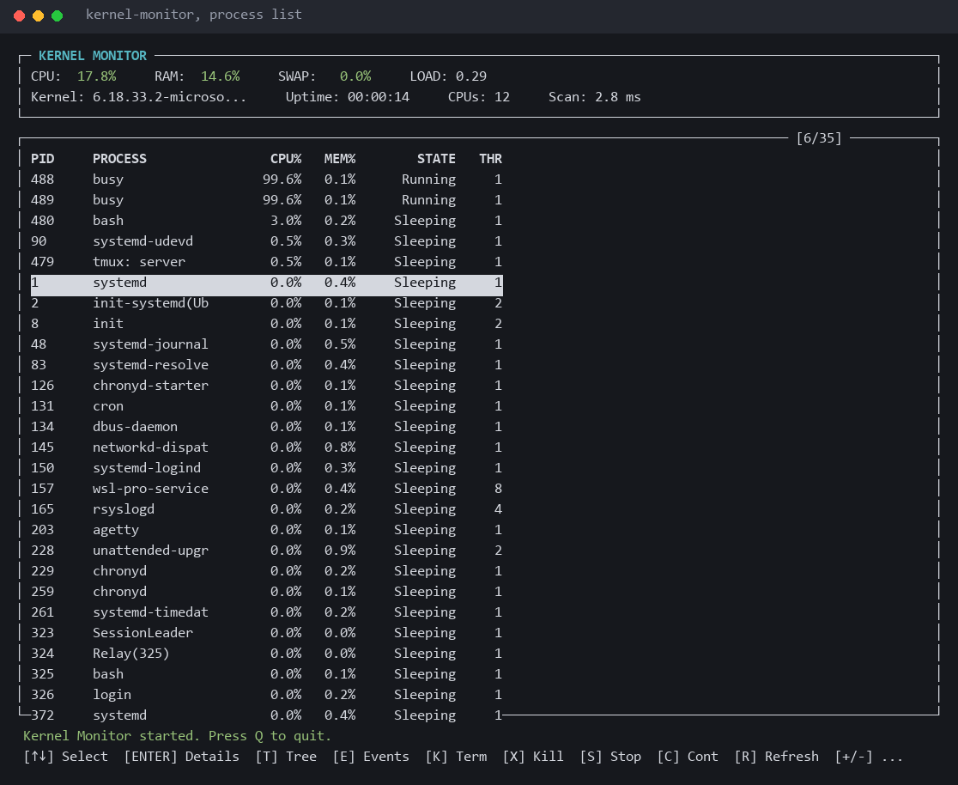
Figure 7.1 The process list with two busy processes at the top and the header showing the scan time
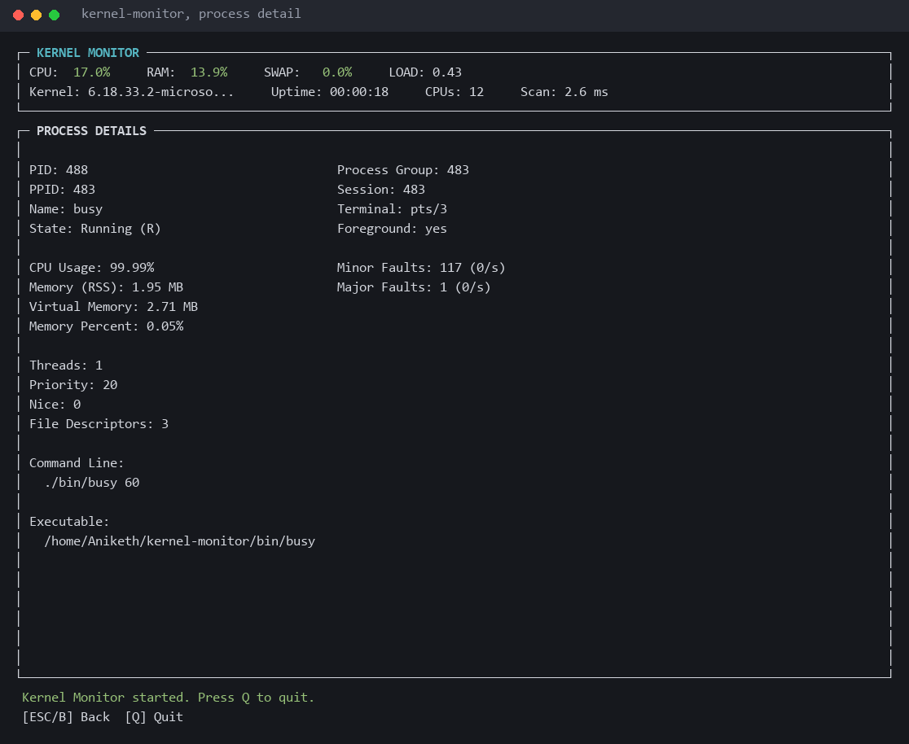
Figure 7.2 The detail view with process group, session, terminal, foreground status and page faults
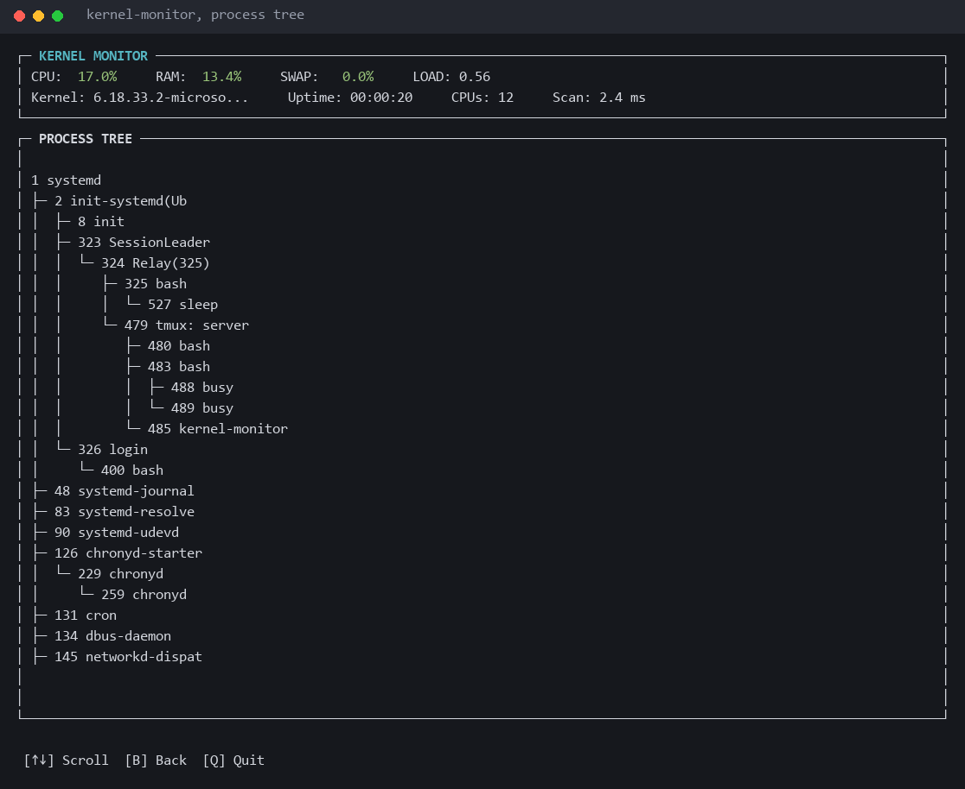
Figure 7.3 The process tree rebuilt from parent links
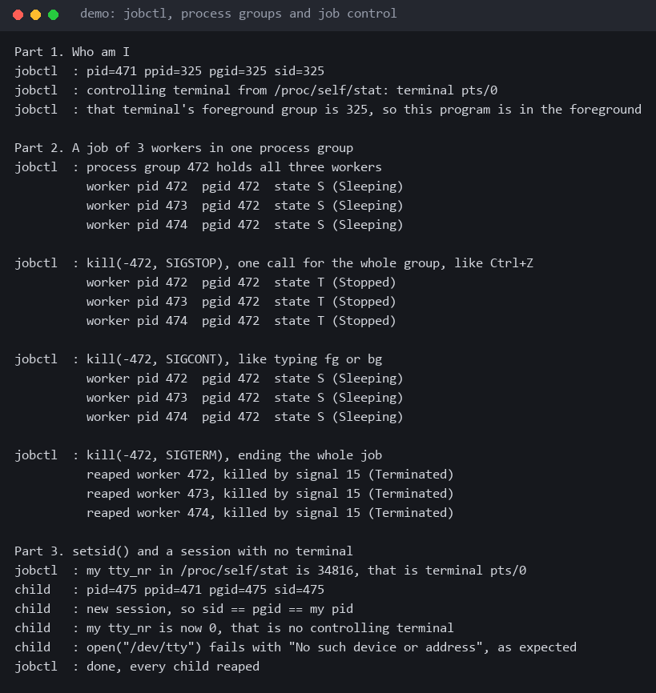
Figure 7.4 jobctl stopping, resuming and ending a whole process group
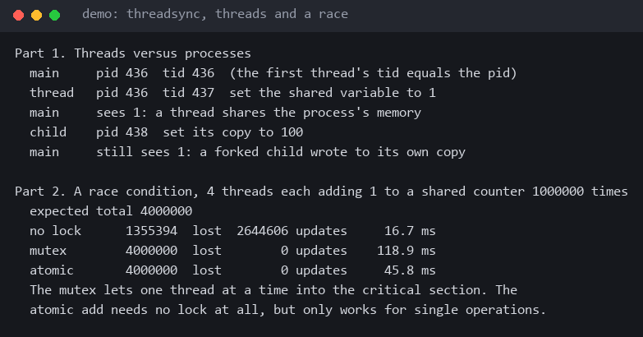
Figure 7.5 threadsync, a thread versus a forked child, and the race condition
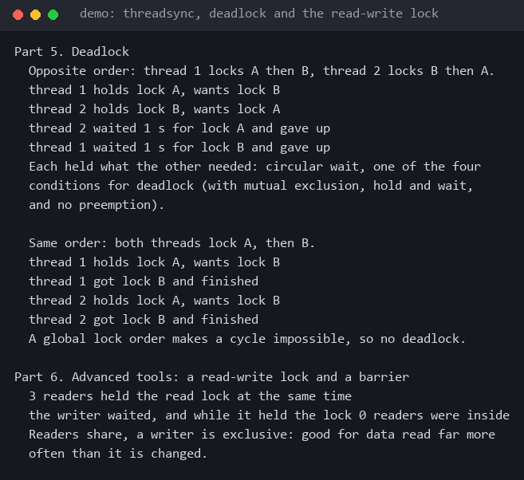
Figure 7.6 threadsync, deadlock with opposite lock order and the read-write lock
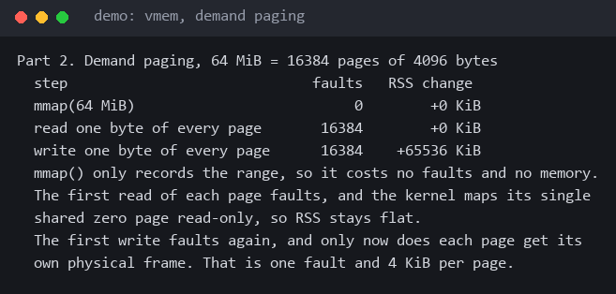
Figure 7.7 vmem, demand paging of 64 MiB
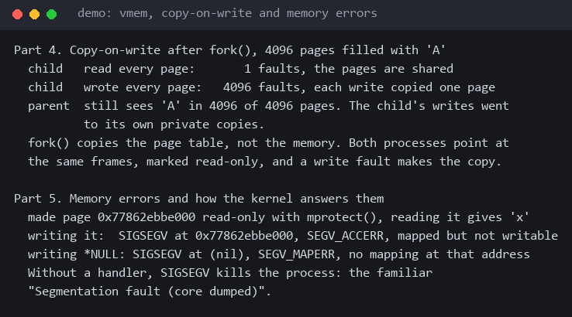
Figure 7.8 vmem, copy-on-write and the two kinds of segmentation fault
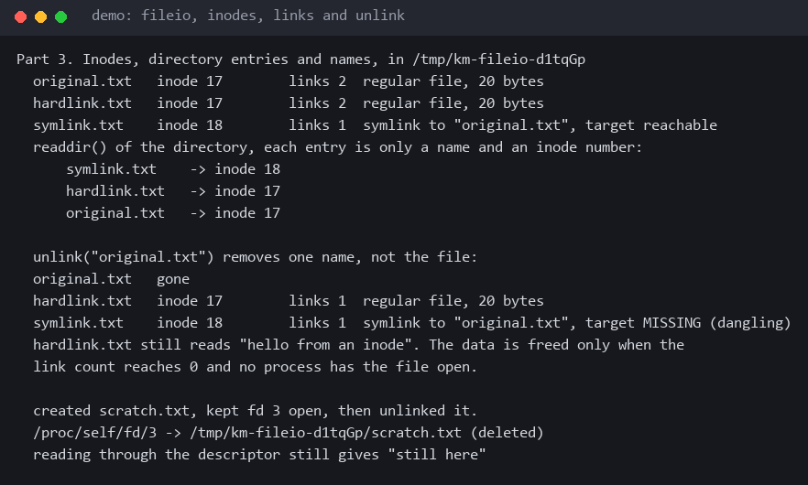
Figure 7.9 fileio, hard links, symbolic links and unlink
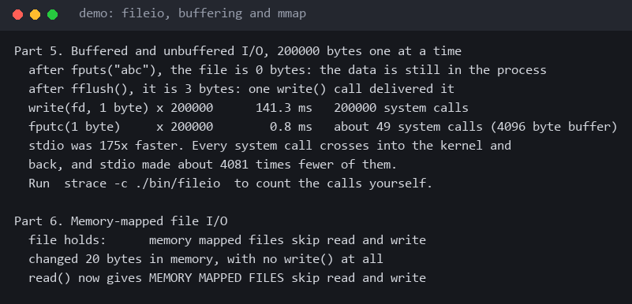
Figure 7.10 fileio, buffered versus unbuffered I/O and memory-mapped files

7.5 Demonstration of OS Concepts
CO | Concept | How to see it
CO-1 | System calls, /proc through the VFS | Press Enter on any process and compare each field with cat /proc/[pid]/stat
CO-2 | Zombie and orphan | Run ./bin/zombie 30 and watch the STATE column read Zombie. Run ./bin/orphan and press T to see where the orphan landed
CO-2 | CPU accounting | Run ./bin/busy, find it at the top of the list near 100 percent, and press K then X to compare SIGTERM and SIGKILL
CO-3 | Signals and job control | Run ./bin/jobctl 6 and watch the three workers share a group and flip to Stopped and back together
CO-3 | Pipes | Run ./bin/pipeline and ./bin/fifo
CO-4 | Page faults and paging | Select a process in the monitor and watch Minor Faults. Run ./bin/vmem for the full tour
CO-5 | Inodes and descriptors | Run ./bin/fileio and read Parts 3 and 4
CO-6 | Threads and locks | Run ./bin/threadsync, and note that the monitor itself runs two threads

CHAPTER -8 CONCLUSION

8.1 Summary of the Project
Kernel Monitor is a real-time Linux monitor written in C. It reads the /proc file system through the ordinary system calls and shows CPU, memory, swap, load, uptime, kernel version and a live process list. For any process it shows its state, memory, threads, parent, process group, session, terminal, page faults and descriptors. It rebuilds the process tree, logs creation and exit events, and lets the user send SIGTERM, SIGKILL, SIGSTOP and SIGCONT safely. It runs a collector thread so that the interface stays responsive, and it is accompanied by nine demonstration programs that recreate specific operating system situations. The whole program builds without warnings and uses 3.6 MB of memory and 0.30 percent of one CPU.

8.2 Objectives Achieved
Objective | Outcome
Monitor CPU, memory, swap, uptime and load in real time | Achieved. All are shown in the header and updated every 2 seconds by default, adjustable from 0.5 to 10 seconds
Display detailed process information | Achieved. List, detail view, tree and event log
Process control and event tracking with signals | Achieved. Four signals with confirmation, and a log of the last 100 events
Demonstrate /proc, POSIX APIs, processes, signals and ncurses | Achieved, and traced to the source by [CO-n] comments
Apply CO-3 to CO-6 in working code | Achieved through the detail view fields, the collector thread and the nine demonstration programs

8.3 Results Achieved
- A working monitor with a 60 KB binary, 3.6 MB resident memory and a 2.82 ms mean scan of 37 processes.
- CPU and page fault rates computed from measured intervals, with protection against recycled PIDs.
- A two-thread design in which a slow scan never delays a keypress, with a single lock and no possibility of deadlock.
- Nine runnable demonstration programs, each producing the situation it teaches: zombie, orphan, busy loop, shell pipeline, named pipe, job control, virtual memory, file system and thread synchronisation.
- A build with no compiler warnings, ten passing automated checks, and a documented set of manual test cases.
- Documentation for installation, use and each demonstration, and a public repository.
Limitations. The monitor is Linux only and, under WSL2, sees only the Linux side. The per-core CPU figures it keeps are averages since boot and not live rates. It does not report network or disk throughput. The extrapolated scan times for hundreds of processes have not been measured on a larger machine.
Future work. Live per-core rates, a sortable process list by memory or PID, search and filter, disk and network statistics from /proc/diskstats and /proc/net/dev, and a view of each process's memory map from /proc/[pid]/maps.

8.4 Skills and Learning Outcomes
- Reading and parsing kernel interfaces, and understanding why a counter must be turned into a rate before it means anything.
- Process management: states, parent and child relationships, zombies, orphans, process groups and sessions.
- Signal programming with sigaction(), the limits of what a handler may do, and the difference between catchable and uncatchable signals.
- Virtual memory: demand paging, page tables, copy-on-write and the two causes of a segmentation fault.
- File system internals: inodes, links, descriptors and open file descriptions, and the cost of unbuffered I/O.
- Concurrent programming with POSIX threads: races, mutexes, condition variables, semaphores, deadlock avoidance and keeping critical sections small.
- Building, testing and documenting a multi-module C project with Make, Git and shell scripts, working as a team of three.

CHAPTER -9 REFERENCES

9.1 Books
- A. Silberschatz, P. B. Galvin and G. Gagne, Operating System Concepts, 10th ed., Wiley, 2018.
- A. S. Tanenbaum and H. Bos, Modern Operating Systems, 4th ed., Pearson, 2014.
- M. Kerrisk, The Linux Programming Interface, No Starch Press, 2010.
- W. R. Stevens and S. A. Rago, Advanced Programming in the UNIX Environment, 3rd ed., Addison-Wesley, 2013.
- R. H. Arpaci-Dusseau and A. C. Arpaci-Dusseau, Operating Systems: Three Easy Pieces, Arpaci-Dusseau Books, 2018.
- B. W. Kernighan and D. M. Ritchie, The C Programming Language, 2nd ed., Prentice Hall, 1988.

9.2 Research Papers
- D. M. Ritchie and K. Thompson, "The UNIX Time-Sharing System," Communications of the ACM, vol. 17, no. 7, 1974.
- T. J. Killian, "Processes as Files," USENIX Summer Conference Proceedings, 1984.
- E. W. Dijkstra, "Cooperating Sequential Processes," Technical report EWD123, 1965.
- A. Mathur, M. Cao, S. Bhattacharya, A. Dilger, A. Tomas and L. Vivier, "The New ext4 Filesystem: Current Status and Future Plans," Proceedings of the Ottawa Linux Symposium, 2007.

9.3 Linux / GNU Documentation
- Linux manual pages: proc(5), kill(2), sigaction(2), signal(7), pipe(7), fifo(7), setsid(2), mmap(2), statfs(2), pthreads(7), sem_overview(7).
- The GNU C Library Reference Manual, Free Software Foundation.
- GCC, the GNU Compiler Collection, online documentation, Free Software Foundation.
- GNU Make Manual, Free Software Foundation.
- ncurses programming documentation, https://invisible-island.net/ncurses/.

9.4 Online Resources
- The Linux kernel documentation, The /proc Filesystem, https://docs.kernel.org/filesystems/proc.html.
- The Linux kernel documentation, Examining Process Page Tables (pagemap), https://docs.kernel.org/admin-guide/mm/pagemap.html.
- Linux man-pages online, https://man7.org/linux/man-pages/.
- Microsoft documentation for Windows Subsystem for Linux, https://learn.microsoft.com/windows/wsl/.
- Project repository, https://github.com/Cyanexani/2520030184_053_558-OSSP.

