OSSP Practical Programs

Program 1: First Come First Served (FCFS) CPU Scheduling
Aim
To write a C program to simulate the FCFS CPU scheduling algorithm and compute the waiting time and turnaround time of each process.
Algorithm
Step 1: Read the number of processes n, and each process's arrival time and burst time.
Step 2: Sort the processes by arrival time.
Step 3: Starting from clock = 0, execute each process in order: if the CPU is idle before the process arrives, advance the clock to the arrival time.
Step 4: Add the process's burst time to the clock to get its completion time.
Step 5: Turnaround time = completion time - arrival time; Waiting time = turnaround time - burst time.
Step 6: Compute and display the average waiting time and average turnaround time.
Program (FCFS.c)
#include <stdio.h>

struct Process {
int pid;
int arrival_time;
int burst_time;
int completion_time;
int waiting_time;
int turnaround_time;
};

int main(void) {
int n;
printf("Enter number of processes: ");
scanf("%d", &n);

struct Process p[n];
for (int i = 0; i < n; i++) {
p[i].pid = i + 1;
printf("Process %d - Arrival Time: ", p[i].pid);
scanf("%d", &p[i].arrival_time);
printf("Process %d - Burst Time: ", p[i].pid);
scanf("%d", &p[i].burst_time);
}

for (int i = 0; i < n - 1; i++) {
for (int j = i + 1; j < n; j++) {
if (p[j].arrival_time < p[i].arrival_time) {
struct Process tmp = p[i];
p[i] = p[j];
p[j] = tmp;
}
}
}

int clock = 0;
float total_wt = 0, total_tat = 0;

for (int i = 0; i < n; i++) {
if (clock < p[i].arrival_time)
clock = p[i].arrival_time;
clock += p[i].burst_time;
p[i].completion_time = clock;
p[i].turnaround_time = p[i].completion_time - p[i].arrival_time;
p[i].waiting_time = p[i].turnaround_time - p[i].burst_time;
total_wt += p[i].waiting_time;
total_tat += p[i].turnaround_time;
}

printf("\nPID\tArrival\tBurst\tCompletion\tTurnaround\tWaiting\n");
for (int i = 0; i < n; i++) {
printf("%d\t%d\t%d\t%d\t\t%d\t\t%d\n", p[i].pid, p[i].arrival_time,
p[i].burst_time, p[i].completion_time, p[i].turnaround_time,
p[i].waiting_time);
}

printf("\nAverage Waiting Time: %.2f\n", total_wt / n);
printf("Average Turnaround Time: %.2f\n", total_tat / n);

return 0;
}

Output
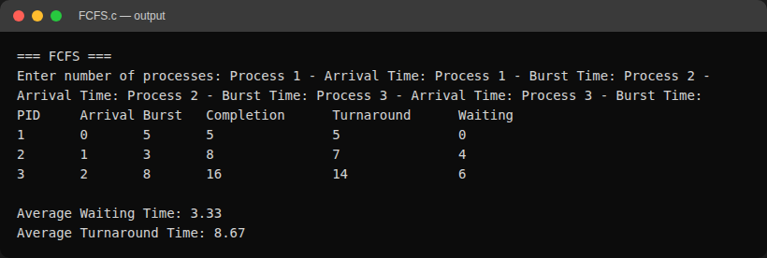

Program 2: Shortest Job First (SJF) - Non-Preemptive CPU Scheduling
Aim
To write a C program to simulate the non-preemptive SJF CPU scheduling algorithm and compute the waiting time and turnaround time of each process.
Algorithm
Step 1: Read the number of processes n, and each process's arrival time and burst time.
Step 2: At each scheduling point, among all processes that have arrived and are not yet completed, select the one with the smallest burst time.
Step 3: If no process has arrived yet, advance the clock by one unit and check again.
Step 4: Run the selected process to completion (non-preemptive), then compute its completion, turnaround and waiting time.
Step 5: Repeat until all processes are completed, then compute the averages.
Program (SJF.c)
#include <stdio.h>

struct Process {
int pid;
int arrival_time;
int burst_time;
int completion_time;
int waiting_time;
int turnaround_time;
int done;
};

int main(void) {
int n;
printf("Enter number of processes: ");
scanf("%d", &n);

struct Process p[n];
for (int i = 0; i < n; i++) {
p[i].pid = i + 1;
p[i].done = 0;
printf("Process %d - Arrival Time: ", p[i].pid);
scanf("%d", &p[i].arrival_time);
printf("Process %d - Burst Time: ", p[i].pid);
scanf("%d", &p[i].burst_time);
}

int completed = 0, clock = 0;
float total_wt = 0, total_tat = 0;

while (completed < n) {
int idx = -1;
int shortest = 1 << 30;

for (int i = 0; i < n; i++) {
if (!p[i].done && p[i].arrival_time <= clock &&
p[i].burst_time < shortest) {
shortest = p[i].burst_time;
idx = i;
}
}

if (idx == -1) {
clock++;
continue;
}

clock += p[idx].burst_time;
p[idx].completion_time = clock;
p[idx].turnaround_time = p[idx].completion_time - p[idx].arrival_time;
p[idx].waiting_time = p[idx].turnaround_time - p[idx].burst_time;
p[idx].done = 1;
completed++;

total_wt += p[idx].waiting_time;
total_tat += p[idx].turnaround_time;
}

printf("\nPID\tArrival\tBurst\tCompletion\tTurnaround\tWaiting\n");
for (int i = 0; i < n; i++) {
printf("%d\t%d\t%d\t%d\t\t%d\t\t%d\n", p[i].pid, p[i].arrival_time,
p[i].burst_time, p[i].completion_time, p[i].turnaround_time,
p[i].waiting_time);
}

printf("\nAverage Waiting Time: %.2f\n", total_wt / n);
printf("Average Turnaround Time: %.2f\n", total_tat / n);

return 0;
}

Output
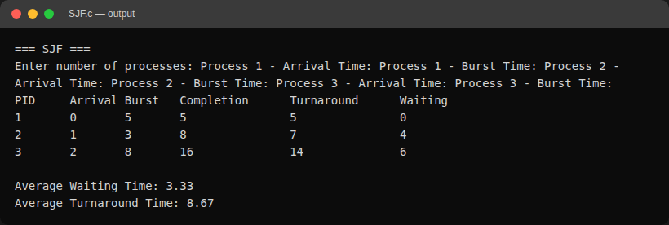

Program 3: Priority CPU Scheduling - Non-Preemptive
Aim
To write a C program to simulate non-preemptive priority CPU scheduling (lower number = higher priority) and compute the waiting time and turnaround time of each process.
Algorithm
Step 1: Read the number of processes n, and each process's arrival time, burst time and priority.
Step 2: At each scheduling point, among all processes that have arrived and are not yet completed, select the one with the lowest priority number; break ties by earlier arrival time.
Step 3: If no process has arrived yet, advance the clock by one unit and check again.
Step 4: Run the selected process to completion, then compute its completion, turnaround and waiting time.
Step 5: Repeat until all processes are completed, then compute the averages.
Program (Priority.c)
#include <stdio.h>

struct Process {
int pid;
int arrival_time;
int burst_time;
int priority;
int completion_time;
int waiting_time;
int turnaround_time;
int done;
};

int main(void) {
int n;
printf("Enter number of processes: ");
scanf("%d", &n);

struct Process p[n];
for (int i = 0; i < n; i++) {
p[i].pid = i + 1;
p[i].done = 0;
printf("Process %d - Arrival Time: ", p[i].pid);
scanf("%d", &p[i].arrival_time);
printf("Process %d - Burst Time: ", p[i].pid);
scanf("%d", &p[i].burst_time);
printf("Process %d - Priority (lower = higher priority): ", p[i].pid);
scanf("%d", &p[i].priority);
}

int completed = 0, clock = 0;
float total_wt = 0, total_tat = 0;

while (completed < n) {
int idx = -1;

for (int i = 0; i < n; i++) {
if (p[i].done || p[i].arrival_time > clock)
continue;
if (idx == -1 || p[i].priority < p[idx].priority ||
(p[i].priority == p[idx].priority &&
p[i].arrival_time < p[idx].arrival_time)) {
idx = i;
}
}

if (idx == -1) {
clock++;
continue;
}

clock += p[idx].burst_time;
p[idx].completion_time = clock;
p[idx].turnaround_time = p[idx].completion_time - p[idx].arrival_time;
p[idx].waiting_time = p[idx].turnaround_time - p[idx].burst_time;
p[idx].done = 1;
completed++;

total_wt += p[idx].waiting_time;
total_tat += p[idx].turnaround_time;
}

printf("\nPID\tArrival\tBurst\tPriority\tCompletion\tTurnaround\tWaiting\n");
for (int i = 0; i < n; i++) {
printf("%d\t%d\t%d\t%d\t\t%d\t\t%d\t\t%d\n", p[i].pid,
p[i].arrival_time, p[i].burst_time, p[i].priority,
p[i].completion_time, p[i].turnaround_time,
p[i].waiting_time);
}

printf("\nAverage Waiting Time: %.2f\n", total_wt / n);
printf("Average Turnaround Time: %.2f\n", total_tat / n);

return 0;
}

Output
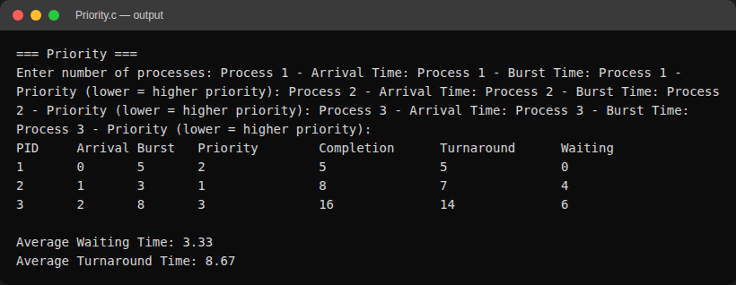

Program 4: Round Robin CPU Scheduling
Aim
To write a C program to simulate Round Robin CPU scheduling with a fixed time quantum and compute the waiting time and turnaround time of each process.
Algorithm
Step 1: Read the number of processes n, each process's arrival time and burst time, and the time quantum.
Step 2: Maintain a ready queue. Seed it with processes that have arrived at time 0.
Step 3: Repeatedly dequeue the process at the front of the queue and run it for min(remaining time, quantum).
Step 4: After running, enqueue any newly arrived processes, then re-enqueue the current process at the back if it still has remaining time; otherwise record its completion time.
Step 5: Continue until all processes are completed, then compute turnaround time, waiting time and the averages.
Program (RoundRobin.c)
#include <stdio.h>

struct Process {
int pid;
int arrival_time;
int burst_time;
int remaining_time;
int completion_time;
int waiting_time;
int turnaround_time;
int in_queue;
};

int main(void) {
int n, quantum;
printf("Enter number of processes: ");
scanf("%d", &n);

struct Process p[n];
for (int i = 0; i < n; i++) {
p[i].pid = i + 1;
p[i].in_queue = 0;
printf("Process %d - Arrival Time: ", p[i].pid);
scanf("%d", &p[i].arrival_time);
printf("Process %d - Burst Time: ", p[i].pid);
scanf("%d", &p[i].burst_time);
p[i].remaining_time = p[i].burst_time;
}

printf("Enter time quantum: ");
scanf("%d", &quantum);

int queue[1000], front = 0, rear = 0;
int clock = 0, completed = 0;
float total_wt = 0, total_tat = 0;

for (int i = 0; i < n; i++) {
if (p[i].arrival_time <= clock && !p[i].in_queue) {
queue[rear++] = i;
p[i].in_queue = 1;
}
}

while (completed < n) {
if (front == rear) {
clock++;
for (int i = 0; i < n; i++) {
if (p[i].arrival_time <= clock && !p[i].in_queue &&
p[i].remaining_time > 0) {
queue[rear++] = i;
p[i].in_queue = 1;
}
}
continue;
}

int idx = queue[front++];
int run = p[idx].remaining_time < quantum ? p[idx].remaining_time
: quantum;
clock += run;
p[idx].remaining_time -= run;

for (int i = 0; i < n; i++) {
if (p[i].arrival_time <= clock && !p[i].in_queue &&
p[i].remaining_time > 0) {
queue[rear++] = i;
p[i].in_queue = 1;
}
}

if (p[idx].remaining_time > 0) {
queue[rear++] = idx;
} else {
p[idx].completion_time = clock;
p[idx].turnaround_time =
p[idx].completion_time - p[idx].arrival_time;
p[idx].waiting_time = p[idx].turnaround_time - p[idx].burst_time;
total_wt += p[idx].waiting_time;
total_tat += p[idx].turnaround_time;
completed++;
}
}

printf("\nPID\tArrival\tBurst\tCompletion\tTurnaround\tWaiting\n");
for (int i = 0; i < n; i++) {
printf("%d\t%d\t%d\t%d\t\t%d\t\t%d\n", p[i].pid, p[i].arrival_time,
p[i].burst_time, p[i].completion_time, p[i].turnaround_time,
p[i].waiting_time);
}

printf("\nAverage Waiting Time: %.2f\n", total_wt / n);
printf("Average Turnaround Time: %.2f\n", total_tat / n);

return 0;
}

Output
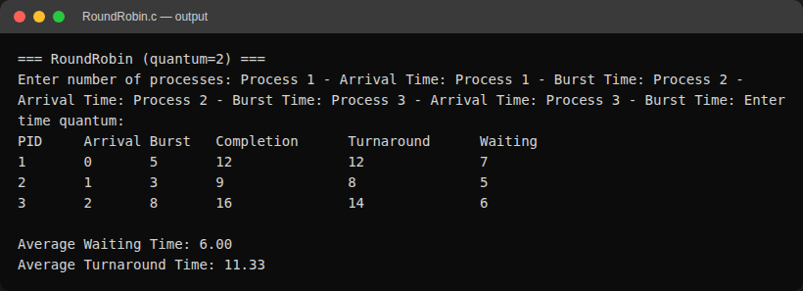

Program 5: Inter-Process Communication using Unnamed Pipes
Aim
To write a C program demonstrating two-way communication between a parent and child process using unnamed pipes (pipe() system call).
Algorithm
Step 1: Create two pipes: one for parent-to-child communication, one for child-to-parent communication.
Step 2: Fork a child process.
Step 3: In the child: close the unused pipe ends, read the message written by the parent, print it, then write an acknowledgement back to the parent.
Step 4: In the parent: close the unused pipe ends, write a message to the child, then read and print the child's acknowledgement.
Step 5: Parent waits for the child to terminate before exiting.
Program (pipes.c)
#include <stdio.h>
#include <stdlib.h>
#include <string.h>
#include <unistd.h>
#include <sys/wait.h>

#define MSG_SIZE 256

int main(void) {
int parent_to_child[2];
int child_to_parent[2];

if (pipe(parent_to_child) == -1 || pipe(child_to_parent) == -1) {
perror("pipe");
exit(EXIT_FAILURE);
}

pid_t pid = fork();
if (pid < 0) {
perror("fork");
exit(EXIT_FAILURE);
}

if (pid == 0) {
close(parent_to_child[1]);
close(child_to_parent[0]);

char buf[MSG_SIZE];
ssize_t n = read(parent_to_child[0], buf, sizeof(buf) - 1);
buf[n] = '\0';
printf("[child %d] received: %s\n", getpid(), buf);

const char *ack = "message received";
write(child_to_parent[1], ack, strlen(ack) + 1);

close(parent_to_child[0]);
close(child_to_parent[1]);
exit(EXIT_SUCCESS);
} else {
close(parent_to_child[0]);
close(child_to_parent[1]);

const char *msg = "hello from parent";
write(parent_to_child[1], msg, strlen(msg) + 1);

char buf[MSG_SIZE];
ssize_t n = read(child_to_parent[0], buf, sizeof(buf) - 1);
buf[n] = '\0';
printf("[parent %d] child replied: %s\n", getpid(), buf);

close(parent_to_child[1]);
close(child_to_parent[0]);
wait(NULL);
}

return 0;
}

Output
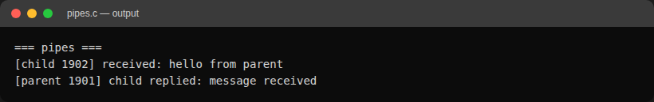

Program 6: Inter-Process Communication using Unix Domain Sockets
Aim
To write a C client-server program pair using AF_UNIX domain sockets, where the server echoes back client messages in upper case.
Algorithm
Step 1: Server: create an AF_UNIX socket, bind it to a filesystem path, and listen for a connection.
Step 2: Server: accept a client connection, then repeatedly read a message, convert it to upper case, and write it back, until the client sends "quit".
Step 3: Client: create an AF_UNIX socket and connect to the server's path.
Step 4: Client: repeatedly read a line from the user, send it to the server, and print the server's reply, until the user types "quit".
Step 5: Both sides close their sockets; the server removes the socket file on exit.
Program (domain_socket_server.c)
#include <stdio.h>
#include <stdlib.h>
#include <string.h>
#include <ctype.h>
#include <unistd.h>
#include <sys/socket.h>
#include <sys/un.h>

#define SOCKET_PATH "/tmp/ossp_domain.sock"
#define BUF_SIZE 256

int main(void) {
int server_fd, client_fd;
struct sockaddr_un addr;
char buf[BUF_SIZE];

server_fd = socket(AF_UNIX, SOCK_STREAM, 0);
if (server_fd == -1) {
perror("socket");
exit(EXIT_FAILURE);
}

unlink(SOCKET_PATH);

memset(&addr, 0, sizeof(addr));
addr.sun_family = AF_UNIX;
strncpy(addr.sun_path, SOCKET_PATH, sizeof(addr.sun_path) - 1);

if (bind(server_fd, (struct sockaddr *)&addr, sizeof(addr)) == -1) {
perror("bind");
exit(EXIT_FAILURE);
}

if (listen(server_fd, 1) == -1) {
perror("listen");
exit(EXIT_FAILURE);
}

printf("[server] listening on %s\n", SOCKET_PATH);

client_fd = accept(server_fd, NULL, NULL);
if (client_fd == -1) {
perror("accept");
exit(EXIT_FAILURE);
}

ssize_t n;
while ((n = read(client_fd, buf, sizeof(buf) - 1)) > 0) {
buf[n] = '\0';
if (strcmp(buf, "quit") == 0)
break;
for (int i = 0; buf[i]; i++)
buf[i] = toupper((unsigned char)buf[i]);
printf("[server] echoing: %s\n", buf);
write(client_fd, buf, strlen(buf));
}

close(client_fd);
close(server_fd);
unlink(SOCKET_PATH);
return 0;
}

Program (domain_socket_client.c)
#include <stdio.h>
#include <stdlib.h>
#include <string.h>
#include <unistd.h>
#include <sys/socket.h>
#include <sys/un.h>

#define SOCKET_PATH "/tmp/ossp_domain.sock"
#define BUF_SIZE 256

int main(void) {
int sock_fd;
struct sockaddr_un addr;
char buf[BUF_SIZE];

sock_fd = socket(AF_UNIX, SOCK_STREAM, 0);
if (sock_fd == -1) {
perror("socket");
exit(EXIT_FAILURE);
}

memset(&addr, 0, sizeof(addr));
addr.sun_family = AF_UNIX;
strncpy(addr.sun_path, SOCKET_PATH, sizeof(addr.sun_path) - 1);

if (connect(sock_fd, (struct sockaddr *)&addr, sizeof(addr)) == -1) {
perror("connect");
exit(EXIT_FAILURE);
}

printf("Connected. Type messages ('quit' to exit).\n");
while (fgets(buf, sizeof(buf), stdin)) {
buf[strcspn(buf, "\n")] = '\0';
write(sock_fd, buf, strlen(buf));

if (strcmp(buf, "quit") == 0)
break;

ssize_t n = read(sock_fd, buf, sizeof(buf) - 1);
if (n <= 0)
break;
buf[n] = '\0';
printf("[server said]: %s\n", buf);
}

close(sock_fd);
return 0;
}

Output
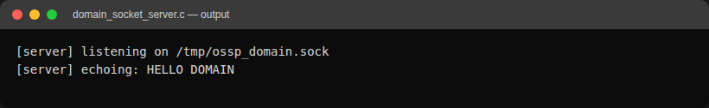
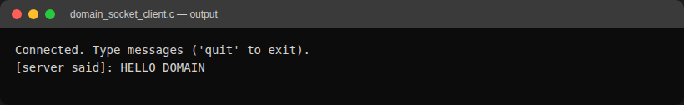

Program 7: Client-Server Communication using TCP Sockets
Aim
To write a C client-server program pair using AF_INET TCP sockets over localhost, where the server echoes back client messages in upper case.
Algorithm
Step 1: Server: create an AF_INET/SOCK_STREAM socket, bind it to a port on localhost, and listen for a connection.
Step 2: Server: accept a client connection, then repeatedly read a message, convert it to upper case, and write it back, until the client sends "quit".
Step 3: Client: create an AF_INET/SOCK_STREAM socket and connect to the server's address and port.
Step 4: Client: repeatedly read a line from the user, send it to the server, and print the server's reply, until the user types "quit".
Step 5: Both sides close their sockets when done.
Program (tcp_server.c)
#include <stdio.h>
#include <stdlib.h>
#include <string.h>
#include <ctype.h>
#include <unistd.h>
#include <arpa/inet.h>
#include <sys/socket.h>

#define PORT 5555
#define BUF_SIZE 256

int main(void) {
int server_fd, client_fd;
struct sockaddr_in addr;
char buf[BUF_SIZE];
int opt = 1;

server_fd = socket(AF_INET, SOCK_STREAM, 0);
if (server_fd == -1) {
perror("socket");
exit(EXIT_FAILURE);
}
setsockopt(server_fd, SOL_SOCKET, SO_REUSEADDR, &opt, sizeof(opt));

memset(&addr, 0, sizeof(addr));
addr.sin_family = AF_INET;
addr.sin_addr.s_addr = INADDR_ANY;
addr.sin_port = htons(PORT);

if (bind(server_fd, (struct sockaddr *)&addr, sizeof(addr)) == -1) {
perror("bind");
exit(EXIT_FAILURE);
}

if (listen(server_fd, 1) == -1) {
perror("listen");
exit(EXIT_FAILURE);
}

printf("[server] listening on port %d\n", PORT);

socklen_t addrlen = sizeof(addr);
client_fd = accept(server_fd, (struct sockaddr *)&addr, &addrlen);
if (client_fd == -1) {
perror("accept");
exit(EXIT_FAILURE);
}

printf("[server] client connected: %s\n", inet_ntoa(addr.sin_addr));

ssize_t n;
while ((n = read(client_fd, buf, sizeof(buf) - 1)) > 0) {
buf[n] = '\0';
if (strcmp(buf, "quit") == 0)
break;
for (int i = 0; buf[i]; i++)
buf[i] = toupper((unsigned char)buf[i]);
printf("[server] echoing: %s\n", buf);
write(client_fd, buf, strlen(buf));
}

close(client_fd);
close(server_fd);
return 0;
}

Program (tcp_client.c)
#include <stdio.h>
#include <stdlib.h>
#include <string.h>
#include <unistd.h>
#include <arpa/inet.h>
#include <sys/socket.h>

#define PORT 5555
#define BUF_SIZE 256

int main(void) {
int sock_fd;
struct sockaddr_in addr;
char buf[BUF_SIZE];

sock_fd = socket(AF_INET, SOCK_STREAM, 0);
if (sock_fd == -1) {
perror("socket");
exit(EXIT_FAILURE);
}

memset(&addr, 0, sizeof(addr));
addr.sin_family = AF_INET;
addr.sin_port = htons(PORT);
inet_pton(AF_INET, "127.0.0.1", &addr.sin_addr);

if (connect(sock_fd, (struct sockaddr *)&addr, sizeof(addr)) == -1) {
perror("connect");
exit(EXIT_FAILURE);
}

printf("Connected to server. Type messages ('quit' to exit).\n");
while (fgets(buf, sizeof(buf), stdin)) {
buf[strcspn(buf, "\n")] = '\0';
write(sock_fd, buf, strlen(buf));

if (strcmp(buf, "quit") == 0)
break;

ssize_t n = read(sock_fd, buf, sizeof(buf) - 1);
if (n <= 0)
break;
buf[n] = '\0';
printf("[server said]: %s\n", buf);
}

close(sock_fd);
return 0;
}

Output
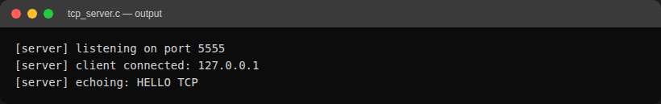
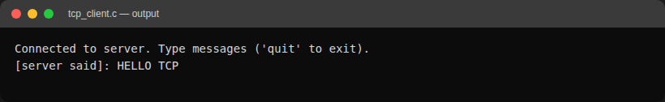

Program 8: File Operations using Low-Level System Calls
Aim
To write a C program demonstrating file creation, writing, appending and reading using the low-level POSIX system calls open(), read(), write() and close().
Algorithm
Step 1: Open (or create/truncate) a file for writing and write an initial line of text, then close it.
Step 2: Re-open the file in append mode and write a second line, then close it.
Step 3: Re-open the file in read-only mode, read its full contents in chunks, and print them to the screen.
Step 4: Close the file.
Program (file_ops.c)
#include <stdio.h>
#include <stdlib.h>
#include <string.h>
#include <unistd.h>
#include <fcntl.h>

#define FILE_NAME "demo_file.txt"
#define BUF_SIZE 256

int main(void) {
int fd;
char buf[BUF_SIZE];
ssize_t n;

fd = open(FILE_NAME, O_CREAT | O_WRONLY | O_TRUNC, 0644);
if (fd == -1) {
perror("open (create)");
exit(EXIT_FAILURE);
}
const char *line1 = "This is the first line.\n";
write(fd, line1, strlen(line1));
close(fd);
printf("Created %s and wrote initial content.\n", FILE_NAME);

fd = open(FILE_NAME, O_WRONLY | O_APPEND);
if (fd == -1) {
perror("open (append)");
exit(EXIT_FAILURE);
}
const char *line2 = "This is an appended line.\n";
write(fd, line2, strlen(line2));
close(fd);
printf("Appended a second line.\n");

fd = open(FILE_NAME, O_RDONLY);
if (fd == -1) {
perror("open (read)");
exit(EXIT_FAILURE);
}

printf("\n--- File contents ---\n");
while ((n = read(fd, buf, sizeof(buf) - 1)) > 0) {
buf[n] = '\0';
printf("%s", buf);
}
printf("---------------------\n");
close(fd);

return 0;
}

Output
