OSSP Skill Programs

Program 1: Command-Line Tokenizer
Aim
To write a C program that splits a shell-style input line into whitespace-separated tokens, as a reusable building block for a shell.
Algorithm
Step 1: Read a line of input from the user.
Step 2: Use strtok() with delimiters (space, tab, newline) to repeatedly extract tokens from the line.
Step 3: Store each token pointer in an array until no tokens remain or the array is full.
Step 4: Print the number of tokens found and each token.
Program (tokenizer.c)
#include <stdio.h>
#include <stdlib.h>
#include <string.h>

#define MAX_TOKENS 64
#define DELIMS " \t\r\n"

char **tokenize(char *line, int *count) {
char **tokens = malloc(MAX_TOKENS * sizeof(char *));
int n = 0;

char *tok = strtok(line, DELIMS);
while (tok != NULL && n < MAX_TOKENS - 1) {
tokens[n++] = tok;
tok = strtok(NULL, DELIMS);
}
tokens[n] = NULL;
*count = n;
return tokens;
}

int main(void) {
char line[1024];

printf("Enter a line to tokenize: ");
if (fgets(line, sizeof(line), stdin) == NULL)
return 0;

int count;
char **tokens = tokenize(line, &count);

printf("Token count: %d\n", count);
for (int i = 0; i < count; i++)
printf(" [%d] \"%s\"\n", i, tokens[i]);

free(tokens);
return 0;
}

Output
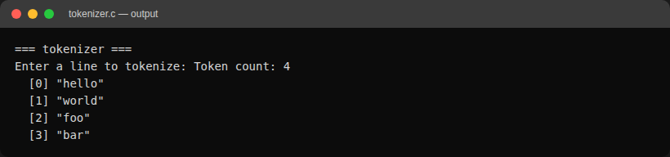

Program 2: Simple Shell Command Loop
Aim
To write a C program implementing a basic shell: a read-tokenize-fork-exec loop that runs external commands, with 'cd' and 'exit' as built-ins.
Algorithm
Step 1: Print a prompt and read a command line from the user.
Step 2: Tokenize the line into a command and its arguments.
Step 3: If the command is 'exit', terminate the loop.
Step 4: If the command is 'cd', call chdir() directly in the shell process (a child cannot change the parent's working directory).
Step 5: Otherwise, fork a child process; in the child, use execvp() to run the command; the parent waits for the child to finish.
Step 6: Repeat until the user exits or end-of-input is reached.
Program (simple_shell.c)
#include <stdio.h>
#include <stdlib.h>
#include <string.h>
#include <unistd.h>
#include <sys/wait.h>

#define MAX_TOKENS 64
#define DELIMS " \t\r\n"

static int tokenize(char *line, char **tokens) {
int n = 0;
char *tok = strtok(line, DELIMS);
while (tok != NULL && n < MAX_TOKENS - 1) {
tokens[n++] = tok;
tok = strtok(NULL, DELIMS);
}
tokens[n] = NULL;
return n;
}

int main(void) {
char line[1024];
char *tokens[MAX_TOKENS];

while (1) {
printf("myshell> ");
fflush(stdout);

if (fgets(line, sizeof(line), stdin) == NULL) {
printf("\n");
break;
}

int n = tokenize(line, tokens);
if (n == 0)
continue;

if (strcmp(tokens[0], "exit") == 0)
break;

if (strcmp(tokens[0], "cd") == 0) {
if (n < 2 || chdir(tokens[1]) != 0)
fprintf(stderr, "cd: could not change directory\n");
continue;
}

pid_t pid = fork();
if (pid < 0) {
perror("fork");
continue;
}

if (pid == 0) {
execvp(tokens[0], tokens);
perror("exec");
exit(EXIT_FAILURE);
} else {
int status;
waitpid(pid, &status, 0);
}
}

return 0;
}

Output
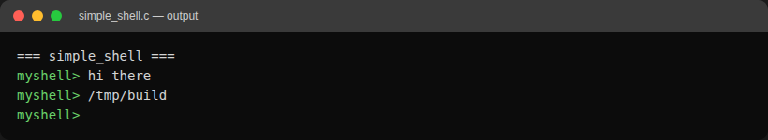

Program 3: Shell with Command History
Aim
To extend the simple shell with a command history feature: every command is stored, 'history' lists them, and '!n' re-executes history entry n.
Algorithm
Step 1: On each loop iteration, read a command line as in the simple shell.
Step 2: If the line is 'history', print all stored commands with their index.
Step 3: If the line starts with '!', parse the number n, look up history entry n, echo it, add it to history again, tokenize it and execute it.
Step 4: Otherwise, store the raw line in the history buffer, then tokenize and execute it via fork/exec (or handle 'cd' as a built-in) as in the simple shell.
Step 5: On 'exit' or end-of-input, free the history buffer and terminate.
Program (shell_history.c)
#include <stdio.h>
#include <stdlib.h>
#include <string.h>
#include <unistd.h>
#include <sys/wait.h>

#define MAX_TOKENS 64
#define MAX_HISTORY 100
#define DELIMS " \t\r\n"

static char *history[MAX_HISTORY];
static int history_count = 0;

static int tokenize(char *line, char **tokens) {
int n = 0;
char *tok = strtok(line, DELIMS);
while (tok != NULL && n < MAX_TOKENS - 1) {
tokens[n++] = tok;
tok = strtok(NULL, DELIMS);
}
tokens[n] = NULL;
return n;
}

static void add_history(const char *line) {
if (history_count < MAX_HISTORY) {
history[history_count++] = strdup(line);
} else {
free(history[0]);
memmove(history, history + 1, (MAX_HISTORY - 1) * sizeof(char *));
history[MAX_HISTORY - 1] = strdup(line);
}
}

static void print_history(void) {
for (int i = 0; i < history_count; i++)
printf("%4d %s", i + 1, history[i]);
}

static void execute_tokens(char **tokens, int n) {
if (n == 0)
return;

if (strcmp(tokens[0], "cd") == 0) {
if (n < 2 || chdir(tokens[1]) != 0)
fprintf(stderr, "cd: could not change directory\n");
return;
}

pid_t pid = fork();
if (pid < 0) {
perror("fork");
return;
}

if (pid == 0) {
execvp(tokens[0], tokens);
perror("exec");
exit(EXIT_FAILURE);
} else {
int status;
waitpid(pid, &status, 0);
}
}

int main(void) {
char line[1024];
char *tokens[MAX_TOKENS];

while (1) {
printf("myshell> ");
fflush(stdout);

if (fgets(line, sizeof(line), stdin) == NULL) {
printf("\n");
break;
}

if (line[0] == '\n')
continue;

if (strcmp(line, "exit\n") == 0)
break;

if (strcmp(line, "history\n") == 0) {
print_history();
continue;
}

if (line[0] == '!') {
int idx = atoi(line + 1);
if (idx < 1 || idx > history_count) {
fprintf(stderr, "history: no such entry\n");
continue;
}
char entry_copy[1024];
strncpy(entry_copy, history[idx - 1], sizeof(entry_copy) - 1);
entry_copy[sizeof(entry_copy) - 1] = '\0';
printf("%s", entry_copy);
fflush(stdout);
add_history(entry_copy);
char exec_copy[1024];
strncpy(exec_copy, entry_copy, sizeof(exec_copy) - 1);
exec_copy[sizeof(exec_copy) - 1] = '\0';
int n = tokenize(exec_copy, tokens);
execute_tokens(tokens, n);
continue;
}

add_history(line);

char copy[1024];
strncpy(copy, line, sizeof(copy) - 1);
copy[sizeof(copy) - 1] = '\0';
int n = tokenize(copy, tokens);
execute_tokens(tokens, n);
}

for (int i = 0; i < history_count; i++)
free(history[i]);

return 0;
}

Output
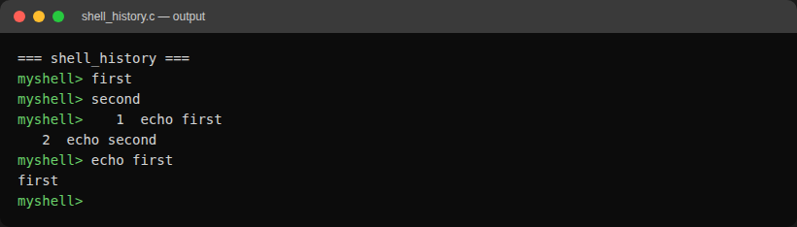
Errors Encountered & Fix
1. Compiler warning: unused function
While building the history-recall path, a leftover helper function (run_command) was left in the file after its logic was inlined directly into main(). Compiling with -Wall -Wextra flagged it:
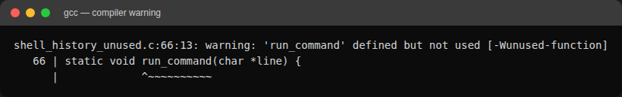
Fix: removed the unused run_command function (and its now-unnecessary forward declaration) since its body had already been folded into main(). Recompiling produced no warnings.
2. Output appearing in the wrong order for the '!n' history recall
The '!n' command is supposed to first echo the recalled command line, then run it. Testing '!1' after running 'echo first' showed the child process's output ("first") printed BEFORE the echoed command line ("echo first"), which is backwards:
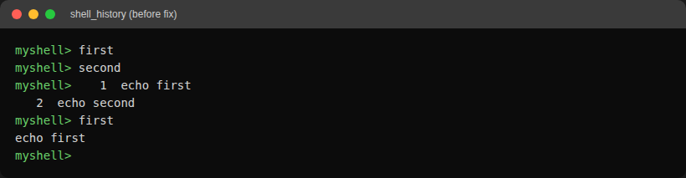
Cause: printf() output to stdout is fully buffered when not connected to an interactive terminal, so the parent's printf("%s", entry_copy) call was sitting in libc's buffer while the forked child (running via execvp) wrote its own output straight through. The child's write reached the screen first even though the parent's printf executed first in program order.
Fix: added fflush(stdout) right after printing the recalled command, forcing it out before the child process runs. The corrected order is visible in the Output section above ("echo first" is printed before "first").

Program 4: Keyboard Input Handler
Aim
To write a C program that captures keyboard input one byte at a time in raw terminal mode, handles Backspace and Enter itself, and manages a fixed-size input buffer.
Algorithm
Step 1: Save the terminal settings with tcgetattr(), turn off ICANON and ECHO with tcsetattr(), and register atexit() and SIGINT handlers that restore them.
Step 2: Read one byte at a time with read(). Printable characters are added to a 256-byte buffer and echoed by the program.
Step 3: On Backspace (127 or 8) remove the last character and erase it on screen with "\b \b".
Step 4: When the buffer is full ring the bell instead of overflowing it.
Step 5: On Enter print the finished line, its length and a hex dump of its bytes; stop on 'exit' or Ctrl-D on an empty line.
Program (keyboard_input.c)
#include <stdio.h>
#include <stdlib.h>
#include <string.h>
#include <signal.h>
#include <termios.h>
#include <unistd.h>

#define BUF_SIZE 256

static struct termios original;
static int raw_mode = 0;

static void restore_terminal(void) {
if (raw_mode)
tcsetattr(STDIN_FILENO, TCSAFLUSH, &original);
}

static void on_sigint(int sig) {
(void)sig;
restore_terminal();
_exit(130);
}

static void enable_raw_mode(void) {
struct termios raw;

if (tcgetattr(STDIN_FILENO, &original) == -1) {
perror("tcgetattr");
exit(EXIT_FAILURE);
}
raw = original;
raw.c_lflag &= ~(ICANON | ECHO);
raw.c_cc[VMIN] = 1;
raw.c_cc[VTIME] = 0;
if (tcsetattr(STDIN_FILENO, TCSAFLUSH, &raw) == -1) {
perror("tcsetattr");
exit(EXIT_FAILURE);
}
raw_mode = 1;
atexit(restore_terminal);
signal(SIGINT, on_sigint);
}

int main(void) {
char buf[BUF_SIZE];
int len = 0;
unsigned char c;

if (isatty(STDIN_FILENO))
enable_raw_mode();

printf("Type a line and press Enter. Backspace edits, Ctrl-D or 'exit' quits.\n> ");
fflush(stdout);

while (read(STDIN_FILENO, &c, 1) == 1) {
if (c == '\r' || c == '\n') {
buf[len] = '\0';
printf("\nline: \"%s\" (%d bytes)\nhex :", buf, len);
for (int i = 0; i < len; i++)
printf(" %02x", (unsigned char)buf[i]);
printf("\n");
if (strcmp(buf, "exit") == 0)
break;
len = 0;
printf("> ");
} else if (c == 127 || c == 8) {
if (len > 0) {
len--;
printf("\b \b");
}
} else if (c == 4) {
if (len == 0)
break;
} else if (c >= 32 && c < 127) {
if (len < BUF_SIZE - 1) {
buf[len++] = c;
putchar(c);
} else {
putchar('\a');
}
}
fflush(stdout);
}

printf("\n");
return 0;
}
Output
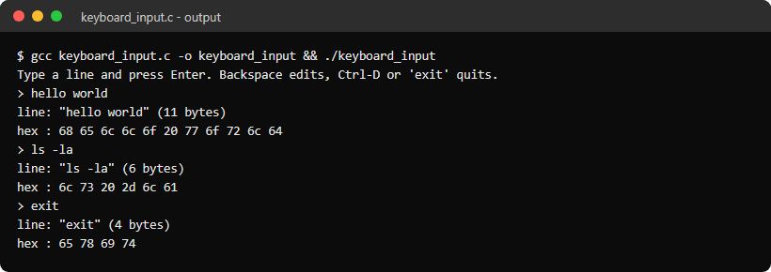

Program 5: Command History Navigation using Escape Sequences
Aim
To write a C program that stores entered commands and lets the user move through previous and next commands with the Up and Down arrow keys, redrawing the line with terminal escape sequences.
Algorithm
Step 1: Switch the terminal to raw mode as in the previous program.
Step 2: Recognise the arrow keys from their escape sequences: ESC [ A for Up and ESC [ B for Down.
Step 3: Up copies the previous history entry into the line buffer and Down the next one; past the newest entry the line becomes empty.
Step 4: Redraw the line with \r (start of line) and \033[K (clear to end of line) followed by the prompt and the buffer.
Step 5: On Enter store the line in a 50-entry history (dropping the oldest when full, skipping repeats); 'history' lists it and 'exit' quits.
Program (history_navigation.c)
#include <stdio.h>
#include <stdlib.h>
#include <string.h>
#include <signal.h>
#include <termios.h>
#include <unistd.h>

#define BUF_SIZE 256
#define MAX_HISTORY 50
#define PROMPT "hist> "

static struct termios original;
static int raw_mode = 0;
static char *history[MAX_HISTORY];
static int history_count = 0;

static void restore_terminal(void) {
if (raw_mode)
tcsetattr(STDIN_FILENO, TCSAFLUSH, &original);
}

static void on_sigint(int sig) {
(void)sig;
restore_terminal();
_exit(130);
}

static void enable_raw_mode(void) {
struct termios raw;

if (tcgetattr(STDIN_FILENO, &original) == -1) {
perror("tcgetattr");
exit(EXIT_FAILURE);
}
raw = original;
raw.c_lflag &= ~(ICANON | ECHO);
raw.c_cc[VMIN] = 1;
raw.c_cc[VTIME] = 0;
if (tcsetattr(STDIN_FILENO, TCSAFLUSH, &raw) == -1) {
perror("tcsetattr");
exit(EXIT_FAILURE);
}
raw_mode = 1;
atexit(restore_terminal);
signal(SIGINT, on_sigint);
}

/* \r goes back to column 0 and \033[K clears the rest of the line */
static void redraw(const char *buf) {
printf("\r\033[K" PROMPT "%s", buf);
fflush(stdout);
}

static void add_history(const char *line) {
if (history_count > 0 && strcmp(history[history_count - 1], line) == 0)
return;
if (history_count == MAX_HISTORY) {
free(history[0]);
memmove(history, history + 1, (MAX_HISTORY - 1) * sizeof(char *));
history_count--;
}
history[history_count++] = strdup(line);
}

int main(void) {
char buf[BUF_SIZE] = "";
int len = 0;
int pos = 0;
unsigned char c;

if (isatty(STDIN_FILENO))
enable_raw_mode();
printf("Up and Down arrows browse history, 'history' lists it, 'exit' quits.\n");
redraw(buf);

while (read(STDIN_FILENO, &c, 1) == 1) {
if (c == 27) {
unsigned char seq[2];
if (read(STDIN_FILENO, &seq[0], 1) != 1 || read(STDIN_FILENO, &seq[1], 1) != 1)
break;
if (seq[0] != '[')
continue;
if (seq[1] == 'A' && pos > 0) {
pos--;
snprintf(buf, sizeof(buf), "%s", history[pos]);
} else if (seq[1] == 'B' && pos < history_count) {
pos++;
if (pos == history_count)
buf[0] = '\0';
else
snprintf(buf, sizeof(buf), "%s", history[pos]);
}
len = strlen(buf);
redraw(buf);
} else if (c == '\r' || c == '\n') {
printf("\n");
if (len > 0) {
if (strcmp(buf, "exit") == 0)
break;
if (strcmp(buf, "history") == 0) {
for (int i = 0; i < history_count; i++)
printf("%4d %s\n", i + 1, history[i]);
} else {
printf("you entered: %s\n", buf);
}
add_history(buf);
}
len = 0;
buf[0] = '\0';
pos = history_count;
redraw(buf);
} else if (c == 127 || c == 8) {
if (len > 0) {
buf[--len] = '\0';
redraw(buf);
}
} else if (c == 4) {
if (len == 0)
break;
} else if (c >= 32 && c < 127 && len < BUF_SIZE - 1) {
buf[len++] = c;
buf[len] = '\0';
putchar(c);
fflush(stdout);
}
}

printf("\n");
for (int i = 0; i < history_count; i++)
free(history[i]);
return 0;
}
Output
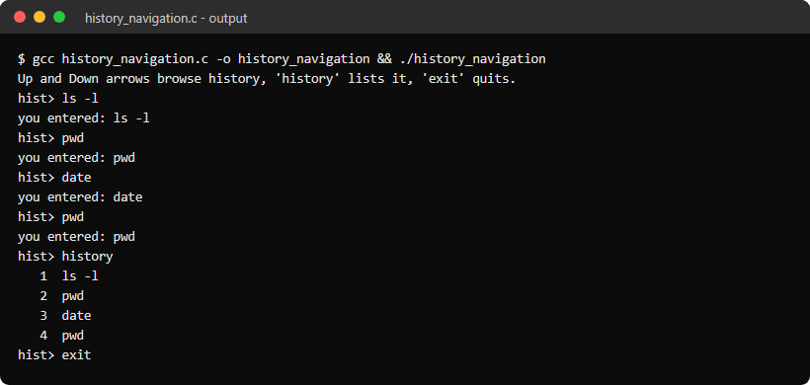

Program 6: Dynamic Buffer Manager
Aim
To write a C program that reads lines of any length into a buffer that grows with realloc(), so it can never overflow, and stores the lines in a linked list.
Algorithm
Step 1: Start every line with an 8-byte buffer from malloc().
Step 2: Read characters with getchar(); when the buffer is full, double its size with realloc() and print the growth.
Step 3: At the end of the line terminate the string and record the largest capacity used.
Step 4: Store each line in a new linked-list node (text, length, next pointer) appended at the tail.
Step 5: At end of input print the list and totals, then free every node and its text.
Program (dynamic_buffer.c)
#include <stdio.h>
#include <stdlib.h>

#define START_SIZE 8

struct line_node {
char *text;
size_t len;
struct line_node *next;
};

static size_t peak_capacity = 0;

/* Reads one line of any length, doubling the buffer whenever it is full */
static char *read_line(size_t *out_len) {
size_t cap = START_SIZE;
size_t len = 0;
int c;
char *buf = malloc(cap);
if (buf == NULL)
return NULL;

while ((c = getchar()) != EOF && c != '\n') {
if (len + 1 == cap) {
char *bigger = realloc(buf, cap * 2);
if (bigger == NULL) {
free(buf);
return NULL;
}
printf(" buffer grown: %zu -> %zu bytes\n", cap, cap * 2);
buf = bigger;
cap *= 2;
}
buf[len++] = c;
}
if (c == EOF && len == 0) {
free(buf);
return NULL;
}

buf[len] = '\0';
if (cap > peak_capacity)
peak_capacity = cap;
*out_len = len;
return buf;
}

int main(void) {
struct line_node *head = NULL;
struct line_node *tail = NULL;
int lines = 0;
size_t bytes = 0;
size_t len;
char *text;

printf("Type lines of any length, Ctrl-D to finish.\n");
while ((text = read_line(&len)) != NULL) {
struct line_node *node = malloc(sizeof(struct line_node));
if (node == NULL) {
perror("malloc");
free(text);
break;
}
node->text = text;
node->len = len;
node->next = NULL;
if (tail == NULL)
head = node;
else
tail->next = node;
tail = node;
lines++;
bytes += len;
}

printf("\nStored lines (linked list):\n");
int i = 1;
for (struct line_node *n = head; n != NULL; n = n->next)
printf("%2d len %-3zu %s\n", i++, n->len, n->text);
printf("\nLines: %d, bytes stored: %zu, largest buffer: %zu bytes\n", lines, bytes, peak_capacity);

int freed = 0;
while (head != NULL) {
struct line_node *next = head->next;
free(head->text);
free(head);
head = next;
freed++;
}
printf("Freed %d nodes\n", freed);
return 0;
}
Output
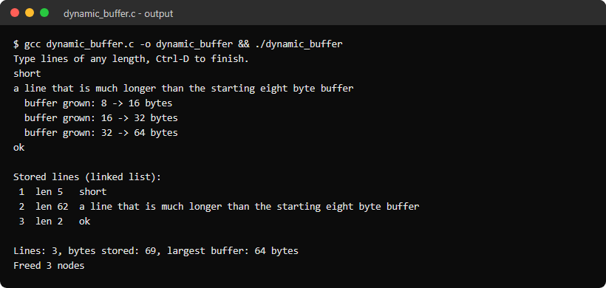

Program 7: Token Parser
Aim
To write a C program that splits a command line into token structures, identifying words and the shell operators |, ||, &&, &, ;, <, > and >> even when they are written without spaces.
Algorithm
Step 1: Define an enum of token types and a struct token holding the type, the text and the column.
Step 2: Scan the line, skipping spaces and tabs.
Step 3: Check two-character operators (||, &&, >>) first, then the single-character ones (|, &, ;, <, >).
Step 4: Anything else is a WORD that runs until whitespace or an operator character.
Step 5: Store tokens in an array that grows with realloc() and print a table of index, type, column and text.
Program (token_parser.c)
#include <stdio.h>
#include <stdlib.h>
#include <string.h>
#include <ctype.h>

enum token_type {
WORD, PIPE, OR, AND, BACKGROUND, SEMICOLON, REDIRECT_IN, REDIRECT_OUT, APPEND
};

static const char *type_names[] = {
"WORD", "PIPE", "OR", "AND", "BACKGROUND", "SEMICOLON", "REDIRECT_IN", "REDIRECT_OUT", "APPEND"
};

struct token {
enum token_type type;
char *text;
int column;
};

static int tokenize(const char *line, struct token **out) {
int cap = 8, n = 0, i = 0;
struct token *tokens = malloc(cap * sizeof(struct token));

while (line[i] != '\0') {
if (isspace((unsigned char)line[i])) {
i++;
continue;
}

int start = i;
enum token_type type;
if (strncmp(line + i, "||", 2) == 0) {
type = OR;
i += 2;
} else if (strncmp(line + i, "&&", 2) == 0) {
type = AND;
i += 2;
} else if (strncmp(line + i, ">>", 2) == 0) {
type = APPEND;
i += 2;
} else if (line[i] == '|') {
type = PIPE;
i++;
} else if (line[i] == '&') {
type = BACKGROUND;
i++;
} else if (line[i] == ';') {
type = SEMICOLON;
i++;
} else if (line[i] == '<') {
type = REDIRECT_IN;
i++;
} else if (line[i] == '>') {
type = REDIRECT_OUT;
i++;
} else {
type = WORD;
while (line[i] != '\0' && !isspace((unsigned char)line[i]) && strchr("|&;<>", line[i]) == NULL)
i++;
}

if (n == cap) {
cap *= 2;
tokens = realloc(tokens, cap * sizeof(struct token));
}
tokens[n].type = type;
tokens[n].text = strndup(line + start, i - start);
tokens[n].column = start + 1;
n++;
}

*out = tokens;
return n;
}

int main(void) {
char line[1024];
struct token *tokens;

while (1) {
printf("tokens> ");
fflush(stdout);
if (fgets(line, sizeof(line), stdin) == NULL) {
printf("\n");
break;
}
line[strcspn(line, "\n")] = '\0';
if (strcmp(line, "exit") == 0)
break;

int n = tokenize(line, &tokens);
printf("%-3s %-13s %-6s %s\n", "#", "TYPE", "COLUMN", "TEXT");
for (int i = 0; i < n; i++) {
printf("%-3d %-13s %-6d %s\n", i, type_names[tokens[i].type], tokens[i].column, tokens[i].text);
free(tokens[i].text);
}
printf("%d tokens\n", n);
free(tokens);
}
return 0;
}
Output
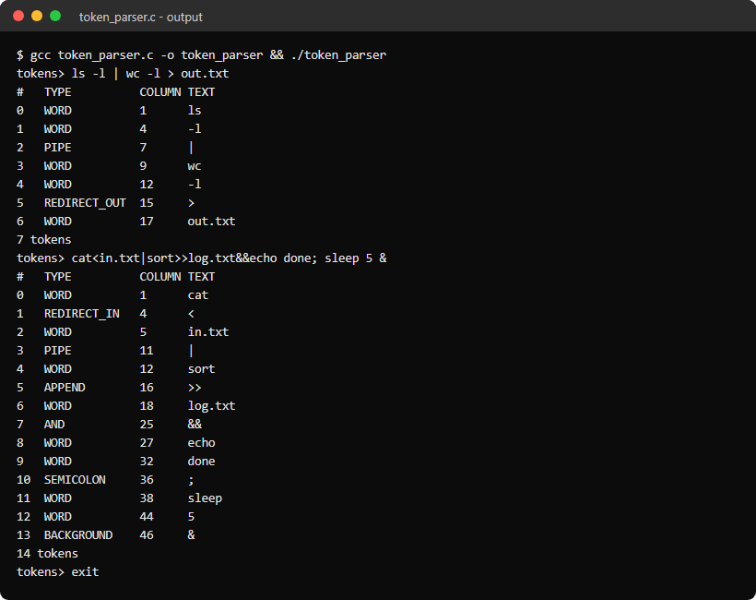

Program 8: Syntax Parser and Parse Tree
Aim
To write a C program that parses a command line with a recursive descent parser, builds a parse tree of lists, pipelines and commands, prints it, and reports syntax errors like bash does.
Algorithm
Step 1: Tokenise the line as in the token parser, ending with an END token.
Step 2: parse_command() collects words into argv and redirections (<, >, >> followed by a file name).
Step 3: parse_pipeline() parses commands separated by |, and parse_list() parses pipelines separated by ;, &&, || or &.
Step 4: If a token appears where it is not allowed, stop and report "syntax error near unexpected token" with its column, or "unexpected end of input".
Step 5: On success print the tree indented by level: LIST, PIPELINE, COMMAND with its argv and redirects, and the operators between pipelines.
Program (syntax_parser.c)
#include <stdio.h>
#include <stdlib.h>
#include <string.h>
#include <ctype.h>

#define MAX_TOKENS 64
#define MAX_ARGS 16
#define MAX_REDIRS 4
#define MAX_CMDS 8
#define MAX_PIPELINES 8

enum token_type { WORD, PIPE, OR, AND, BACKGROUND, SEMICOLON, REDIRECT_IN, REDIRECT_OUT, APPEND, END };

struct token {
enum token_type type;
char text[64];
int column;
};

struct command {
char *argv[MAX_ARGS];
int argc;
struct token *redirs[MAX_REDIRS];
char *files[MAX_REDIRS];
int nredirs;
};

struct pipeline {
struct command cmds[MAX_CMDS];
int count;
};

struct list {
struct pipeline pipelines[MAX_PIPELINES];
const char *ops[MAX_PIPELINES];
int count;
};

static struct token tokens[MAX_TOKENS];
static int ntokens, pos;
static char error[128];

static int tokenize(const char *line) {
int i = 0;
ntokens = 0;
while (line[i] != '\0' && ntokens < MAX_TOKENS - 1) {
if (isspace((unsigned char)line[i])) {
i++;
continue;
}
struct token *t = &tokens[ntokens++];
int start = i, len = 1;
if (strncmp(line + i, "||", 2) == 0) {
t->type = OR;
len = 2;
} else if (strncmp(line + i, "&&", 2) == 0) {
t->type = AND;
len = 2;
} else if (strncmp(line + i, ">>", 2) == 0) {
t->type = APPEND;
len = 2;
} else if (line[i] == '|') {
t->type = PIPE;
} else if (line[i] == '&') {
t->type = BACKGROUND;
} else if (line[i] == ';') {
t->type = SEMICOLON;
} else if (line[i] == '<') {
t->type = REDIRECT_IN;
} else if (line[i] == '>') {
t->type = REDIRECT_OUT;
} else {
t->type = WORD;
len = 0;
while (line[i + len] != '\0' && !isspace((unsigned char)line[i + len]) &&
strchr("|&;<>", line[i + len]) == NULL)
len++;
}
snprintf(t->text, sizeof(t->text), "%.*s", len, line + start);
t->column = start + 1;
i += len;
}
tokens[ntokens].type = END;
strcpy(tokens[ntokens].text, "end of input");
return ntokens;
}

static int unexpected(void) {
struct token *t = &tokens[pos];
if (t->type == END)
snprintf(error, sizeof(error), "syntax error: unexpected end of input after `%s'",
pos > 0 ? tokens[pos - 1].text : "");
else
snprintf(error, sizeof(error), "syntax error near unexpected token `%s' (column %d)",
t->text, t->column);
return -1;
}

/* command := ( WORD | redirect )+ */
static int parse_command(struct command *c) {
c->argc = 0;
c->nredirs = 0;
while (tokens[pos].type == WORD || tokens[pos].type == REDIRECT_IN ||
tokens[pos].type == REDIRECT_OUT || tokens[pos].type == APPEND) {
if (tokens[pos].type == WORD) {
if (c->argc < MAX_ARGS - 1)
c->argv[c->argc++] = tokens[pos].text;
pos++;
} else {
struct token *op = &tokens[pos++];
if (tokens[pos].type != WORD)
return unexpected();
if (c->nredirs < MAX_REDIRS) {
c->redirs[c->nredirs] = op;
c->files[c->nredirs++] = tokens[pos].text;
}
pos++;
}
}
if (c->argc == 0)
return unexpected();
c->argv[c->argc] = NULL;
return 0;
}

/* pipeline := command ( "|" command )* */
static int parse_pipeline(struct pipeline *p) {
p->count = 0;
if (parse_command(&p->cmds[p->count++]) < 0)
return -1;
while (tokens[pos].type == PIPE && p->count < MAX_CMDS) {
pos++;
if (parse_command(&p->cmds[p->count++]) < 0)
return -1;
}
return 0;
}

/* list := pipeline ( (";" | "&&" | "||" | "&") pipeline )* [ ";" | "&" ] */
static int parse_list(struct list *l) {
l->count = 0;
while (l->count < MAX_PIPELINES) {
if (parse_pipeline(&l->pipelines[l->count]) < 0)
return -1;
l->ops[l->count] = NULL;
l->count++;

enum token_type t = tokens[pos].type;
if (t == END)
return 0;
if (t != SEMICOLON && t != AND && t != OR && t != BACKGROUND)
return unexpected();
l->ops[l->count - 1] = tokens[pos].text;
pos++;
if (tokens[pos].type == END && (t == SEMICOLON || t == BACKGROUND))
return 0;
}
return unexpected();
}

static void print_tree(struct list *l) {
printf("LIST\n");
for (int i = 0; i < l->count; i++) {
struct pipeline *p = &l->pipelines[i];
printf(" PIPELINE\n");
for (int j = 0; j < p->count; j++) {
struct command *c = &p->cmds[j];
printf(" COMMAND argv=[");
for (int k = 0; k < c->argc; k++)
printf("%s%s", k ? ", " : "", c->argv[k]);
printf("] redirects=[");
for (int k = 0; k < c->nredirs; k++)
printf("%s%s %s", k ? ", " : "", c->redirs[k]->text, c->files[k]);
printf("]\n");
}
if (l->ops[i] != NULL)
printf(" OPERATOR %s\n", l->ops[i]);
}
}

int main(void) {
char line[1024];
struct list *tree = malloc(sizeof(struct list));
if (tree == NULL) {
perror("malloc");
exit(EXIT_FAILURE);
}

while (1) {
printf("parse> ");
fflush(stdout);
if (fgets(line, sizeof(line), stdin) == NULL) {
printf("\n");
break;
}
line[strcspn(line, "\n")] = '\0';
if (strcmp(line, "exit") == 0)
break;
if (tokenize(line) == 0)
continue;

pos = 0;
if (parse_list(tree) < 0)
printf("%s\n", error);
else
print_tree(tree);
}

free(tree);
return 0;
}
Output
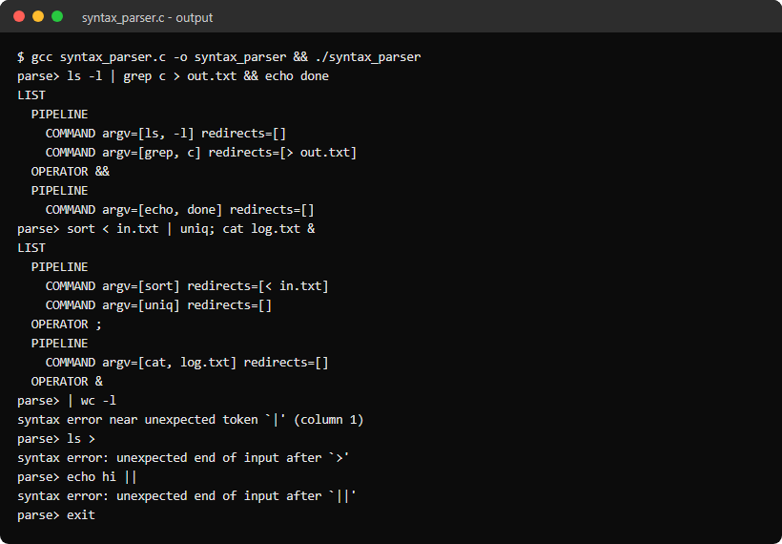

Program 9: Single Quote Parser
Aim
To write a C program that splits a line into words where text inside single quotes is kept exactly as typed: spaces are preserved and $VAR, backslashes and double quotes are not special.
Algorithm
Step 1: Skip leading whitespace and start a new word.
Step 2: On a single quote, copy every character up to the closing quote without any interpretation.
Step 3: Outside quotes, expand $NAME from the environment with getenv() to show the difference.
Step 4: Join adjacent quoted and unquoted parts into one word, ending the word at unquoted whitespace.
Step 5: Report an unterminated single quote, otherwise print each word in brackets.
Program (single_quote_parser.c)
#include <stdio.h>
#include <stdlib.h>
#include <string.h>
#include <ctype.h>

#define MAX_WORDS 32
#define MAX_LEN 256

static void append(char *word, int *len, const char *s) {
while (*s != '\0' && *len < MAX_LEN - 1)
word[(*len)++] = *s++;
}

/* Returns the number of words, or -1 when a single quote is not closed */
static int split_words(const char *line, char words[][MAX_LEN]) {
int n = 0, i = 0;

while (n < MAX_WORDS) {
while (isspace((unsigned char)line[i]))
i++;
if (line[i] == '\0')
break;

char *w = words[n];
int len = 0;
while (line[i] != '\0' && !isspace((unsigned char)line[i])) {
if (line[i] == '\'') {
i++;
while (line[i] != '\0' && line[i] != '\'') {
if (len < MAX_LEN - 1)
w[len++] = line[i];
i++;
}
if (line[i] == '\0')
return -1;
i++;
} else if (line[i] == '$' && (isalpha((unsigned char)line[i + 1]) || line[i + 1] == '_')) {
char name[64];
int j = 0;
i++;
while ((isalnum((unsigned char)line[i]) || line[i] == '_') && j < 63)
name[j++] = line[i++];
name[j] = '\0';
const char *value = getenv(name);
if (value != NULL)
append(w, &len, value);
} else {
if (len < MAX_LEN - 1)
w[len++] = line[i];
i++;
}
}
w[len] = '\0';
n++;
}
return n;
}

int main(void) {
char line[1024];
char words[MAX_WORDS][MAX_LEN];

while (1) {
printf("squote> ");
fflush(stdout);
if (fgets(line, sizeof(line), stdin) == NULL) {
printf("\n");
break;
}
line[strcspn(line, "\n")] = '\0';
if (strcmp(line, "exit") == 0)
break;

int n = split_words(line, words);
if (n < 0) {
printf("error: unterminated single quote\n");
continue;
}
for (int i = 0; i < n; i++)
printf(" word %d: [%s]\n", i, words[i]);
}
return 0;
}
Output
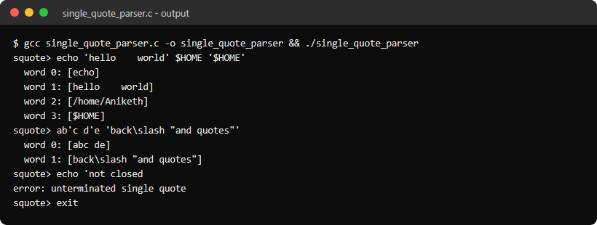

Program 10: Double Quote Parser
Aim
To write a C program that splits a line into words where double quotes preserve spaces but still allow variable expansion of $NAME and ${NAME}.
Algorithm
Step 1: Scan the line word by word, ending a word at unquoted whitespace.
Step 2: Inside double quotes keep spaces, and treat a backslash as special only before ", \ and $.
Step 3: Expand $NAME and ${NAME} with getenv(), both inside and outside the quotes.
Step 4: Keep single quotes inside double quotes as ordinary characters.
Step 5: Report an unterminated double quote, otherwise print each word in brackets.
Program (double_quote_parser.c)
#include <stdio.h>
#include <stdlib.h>
#include <string.h>
#include <ctype.h>

#define MAX_WORDS 32
#define MAX_LEN 256

static void add_char(char *word, int *len, char c) {
if (*len < MAX_LEN - 1)
word[(*len)++] = c;
}

/* Expands $NAME or ${NAME} starting at line[*i] == '$' */
static void expand(const char *line, int *i, char *word, int *len) {
char name[64];
int j = 0;
int braces = line[*i + 1] == '{';

(*i) += braces ? 2 : 1;
while ((isalnum((unsigned char)line[*i]) || line[*i] == '_') && j < 63)
name[j++] = line[(*i)++];
name[j] = '\0';
if (braces && line[*i] == '}')
(*i)++;

if (j == 0) {
add_char(word, len, '$');
return;
}
const char *value = getenv(name);
if (value != NULL) {
while (*value != '\0')
add_char(word, len, *value++);
}
}

/* Returns the number of words, or -1 when a double quote is not closed */
static int split_words(const char *line, char words[][MAX_LEN]) {
int n = 0, i = 0;

while (n < MAX_WORDS) {
while (isspace((unsigned char)line[i]))
i++;
if (line[i] == '\0')
break;

char *w = words[n];
int len = 0;
while (line[i] != '\0' && !isspace((unsigned char)line[i])) {
if (line[i] == '"') {
i++;
while (line[i] != '\0' && line[i] != '"') {
if (line[i] == '\\' && strchr("\"\\$", line[i + 1]) != NULL && line[i + 1] != '\0') {
add_char(w, &len, line[i + 1]);
i += 2;
} else if (line[i] == '$') {
expand(line, &i, w, &len);
} else {
add_char(w, &len, line[i++]);
}
}
if (line[i] == '\0')
return -1;
i++;
} else if (line[i] == '$') {
expand(line, &i, w, &len);
} else {
add_char(w, &len, line[i++]);
}
}
w[len] = '\0';
n++;
}
return n;
}

int main(void) {
char line[1024];
char words[MAX_WORDS][MAX_LEN];

while (1) {
printf("dquote> ");
fflush(stdout);
if (fgets(line, sizeof(line), stdin) == NULL) {
printf("\n");
break;
}
line[strcspn(line, "\n")] = '\0';
if (strcmp(line, "exit") == 0)
break;

int n = split_words(line, words);
if (n < 0) {
printf("error: unterminated double quote\n");
continue;
}
for (int i = 0; i < n; i++)
printf(" word %d: [%s]\n", i, words[i]);
}
return 0;
}
Output
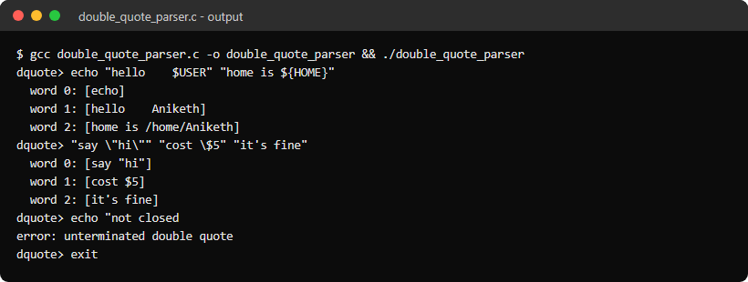

Program 11: Escaped Character Parser
Aim
To write a C program that processes backslash escapes the way a shell does (escaped spaces and special symbols) and also interprets escape sequences the way echo -e does.
Algorithm
Step 1: Shell view: split the line into words and print unescaped |, <, >, & and ; as separate operators.
Step 2: A backslash makes the next character ordinary, so "\ " keeps a space in the word and \| or \; become plain text.
Step 3: Report an error if the line ends with a backslash.
Step 4: echo -e view: replace \n, \t, \\, \a, \xHH (hex) and \0NNN (octal) with the characters they stand for.
Step 5: Print both views so the two meanings of the backslash can be compared.
Program (escape_parser.c)
#include <stdio.h>
#include <stdlib.h>
#include <string.h>
#include <ctype.h>

#define MAX_LEN 256

/* Shell rules: a backslash makes the next character an ordinary character */
static int shell_words(const char *line) {
int i = 0;
char word[MAX_LEN];

while (1) {
while (isspace((unsigned char)line[i]))
i++;
if (line[i] == '\0')
return 0;
if (strchr("|<>&;", line[i]) != NULL) {
printf(" operator: %c\n", line[i]);
i++;
continue;
}

int len = 0;
while (line[i] != '\0' && !isspace((unsigned char)line[i]) && strchr("|<>&;", line[i]) == NULL) {
if (line[i] == '\\') {
if (line[i + 1] == '\0') {
printf("error: line ends with an escape character\n");
return -1;
}
i++;
}
if (len < MAX_LEN - 1)
word[len++] = line[i];
i++;
}
word[len] = '\0';
printf(" word : [%s]\n", word);
}
}

static int hex_value(char c) {
if (isdigit((unsigned char)c))
return c - '0';
return tolower((unsigned char)c) - 'a' + 10;
}

/* echo -e rules: \n, \t, \\, \a, \xHH and \0NNN become the bytes they name */
static void echo_e(const char *s) {
printf("echo -e view:\n");
for (int i = 0; s[i] != '\0'; i++) {
if (s[i] != '\\' || s[i + 1] == '\0') {
putchar(s[i]);
continue;
}
i++;
if (s[i] == 'n') {
putchar('\n');
} else if (s[i] == 't') {
putchar('\t');
} else if (s[i] == '\\') {
putchar('\\');
} else if (s[i] == 'a') {
printf("<BEL>");
} else if (s[i] == 'x' && isxdigit((unsigned char)s[i + 1])) {
int value = 0;
for (int k = 0; k < 2 && isxdigit((unsigned char)s[i + 1]); k++)
value = value * 16 + hex_value(s[++i]);
putchar(value);
} else if (s[i] == '0') {
int value = 0;
for (int k = 0; k < 3 && s[i + 1] >= '0' && s[i + 1] <= '7'; k++)
value = value * 8 + (s[++i] - '0');
putchar(value);
} else {
putchar('\\');
putchar(s[i]);
}
}
putchar('\n');
}

int main(void) {
char line[1024];

while (1) {
printf("escape> ");
fflush(stdout);
if (fgets(line, sizeof(line), stdin) == NULL) {
printf("\n");
break;
}
line[strcspn(line, "\n")] = '\0';
if (strcmp(line, "exit") == 0)
break;

printf("shell view:\n");
if (shell_words(line) == 0)
echo_e(line);
}
return 0;
}
Output
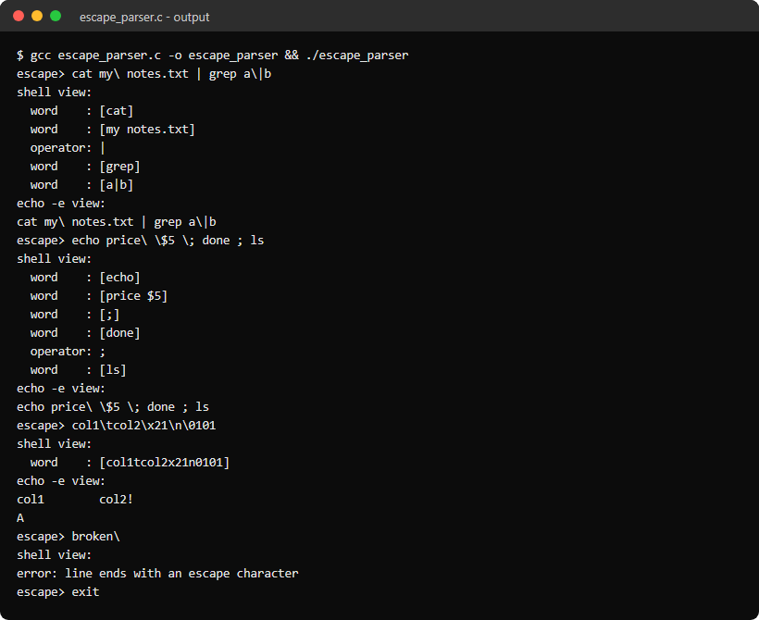

Program 12: Process Launcher
Aim
To write a C program that launches programs as child processes with fork() and execvp(), passes their arguments, and reports execution errors and exit status.
Algorithm
Step 1: Read a command line and split it into an argv array, printing each argument.
Step 2: fork() a child; the child prints its PID and its parent's PID and calls execvp().
Step 3: If execvp() fails, check errno: ENOENT means command not found (exit 127) and EACCES means permission denied (exit 126).
Step 4: The parent waits with waitpid().
Step 5: Print the exit status with WEXITSTATUS() or the signal with WTERMSIG().
Program (process_launcher.c)
#include <stdio.h>
#include <stdlib.h>
#include <string.h>
#include <errno.h>
#include <unistd.h>
#include <sys/wait.h>

#define MAX_ARGS 64
#define DELIMS " \t\r\n"

int main(void) {
char line[1024];
char *args[MAX_ARGS];

while (1) {
printf("launch> ");
fflush(stdout);
if (fgets(line, sizeof(line), stdin) == NULL) {
printf("\n");
break;
}

int n = 0;
char *tok = strtok(line, DELIMS);
while (tok != NULL && n < MAX_ARGS - 1) {
args[n++] = tok;
tok = strtok(NULL, DELIMS);
}
args[n] = NULL;
if (n == 0)
continue;
if (strcmp(args[0], "exit") == 0)
break;

for (int i = 0; i < n; i++)
printf("argv[%d] = %s\n", i, args[i]);
fflush(stdout);

pid_t pid = fork();
if (pid < 0) {
perror("fork");
continue;
}
if (pid == 0) {
printf("child pid %d, parent pid %d\n", getpid(), getppid());
fflush(stdout);
execvp(args[0], args);
if (errno == ENOENT) {
fprintf(stderr, "%s: command not found\n", args[0]);
_exit(127);
}
if (errno == EACCES) {
fprintf(stderr, "%s: permission denied\n", args[0]);
_exit(126);
}
perror(args[0]);
_exit(1);
}

int status;
waitpid(pid, &status, 0);
if (WIFEXITED(status))
printf("[pid %d] exited with status %d\n", pid, WEXITSTATUS(status));
else if (WIFSIGNALED(status))
printf("[pid %d] killed by signal %s\n", pid, strsignal(WTERMSIG(status)));
}
return 0;
}
Output
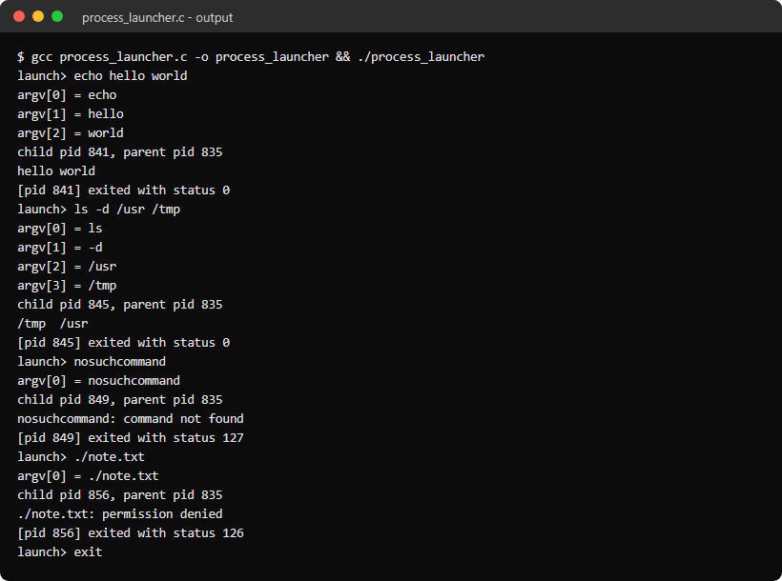

Program 13: Process Synchronizer using waitpid()
Aim
To write a C program that creates several child processes with different behaviour and monitors every change in their state with waitpid(): exit, kill, stop and continue.
Algorithm
Step 1: Create four children: A exits with 0 after 1 s, B exits with 3 after 2 s, C sleeps for 10 s, D stops itself with SIGSTOP.
Step 2: Poll with waitpid(-1, &status, WNOHANG), which returns 0 while no child has finished.
Step 3: Loop on waitpid() with WUNTRACED and WCONTINUED so stopped and continued children are reported as well.
Step 4: Decode each status with WIFEXITED/WEXITSTATUS, WIFSIGNALED/WTERMSIG, WIFSTOPPED/WSTOPSIG and WIFCONTINUED; send SIGCONT to D when it stops and SIGKILL to C after 1.5 s.
Step 5: When all four have terminated, print a summary table.
Program (process_sync.c)
#include <stdio.h>
#include <stdlib.h>
#include <string.h>
#include <signal.h>
#include <time.h>
#include <unistd.h>
#include <sys/wait.h>

#define CHILDREN 4

static struct timespec start;

static double elapsed(void) {
struct timespec now;
clock_gettime(CLOCK_MONOTONIC, &now);
return (now.tv_sec - start.tv_sec) + (now.tv_nsec - start.tv_nsec) / 1e9;
}

static pid_t spawn(char label) {
pid_t pid = fork();
if (pid < 0) {
perror("fork");
exit(EXIT_FAILURE);
}
if (pid > 0)
return pid;

switch (label) {
case 'A':
sleep(1);
_exit(0);
case 'B':
sleep(2);
_exit(3);
case 'C':
sleep(10);
_exit(0);
default:
raise(SIGSTOP);
sleep(1);
_exit(0);
}
}

int main(void) {
const char labels[CHILDREN] = {'A', 'B', 'C', 'D'};
pid_t pids[CHILDREN];
char result[CHILDREN][64];
int status, alive = CHILDREN, killed = 0;

clock_gettime(CLOCK_MONOTONIC, &start);
for (int i = 0; i < CHILDREN; i++)
pids[i] = spawn(labels[i]);
printf("A %d exits 0 after 1s, B %d exits 3 after 2s, C %d gets killed, D %d stops itself\n\n",
pids[0], pids[1], pids[2], pids[3]);

/* WNOHANG returns 0 straight away while no child has finished */
for (int i = 0; i < 3; i++) {
if (waitpid(-1, &status, WNOHANG) == 0)
printf("%.1fs poll: no child has finished yet\n", elapsed());
usleep(150000);
}

while (alive > 0) {
if (!killed && elapsed() >= 1.5) {
kill(pids[2], SIGKILL);
printf("%.1fs parent sends SIGKILL to C\n", elapsed());
killed = 1;
}

pid_t pid = waitpid(-1, &status, WUNTRACED | WCONTINUED | WNOHANG);
if (pid == 0) {
usleep(20000);
continue;
}
if (pid < 0) {
perror("waitpid");
break;
}

int i = 0;
while (i < CHILDREN && pids[i] != pid)
i++;
printf("%.1fs %c (%d) ", elapsed(), labels[i], pid);

if (WIFEXITED(status)) {
printf("exited with status %d\n", WEXITSTATUS(status));
snprintf(result[i], sizeof(result[i]), "exited, status %d", WEXITSTATUS(status));
alive--;
} else if (WIFSIGNALED(status)) {
printf("killed by signal %d (%s)\n", WTERMSIG(status), strsignal(WTERMSIG(status)));
snprintf(result[i], sizeof(result[i]), "killed by signal %d", WTERMSIG(status));
alive--;
} else if (WIFSTOPPED(status)) {
printf("stopped by signal %d, parent sends SIGCONT\n", WSTOPSIG(status));
kill(pid, SIGCONT);
} else if (WIFCONTINUED(status)) {
printf("continued\n");
}
}

printf("\nChild PID Result\n");
for (int i = 0; i < CHILDREN; i++)
printf("%-6c %-7d %s\n", labels[i], pids[i], result[i]);
return 0;
}
Output
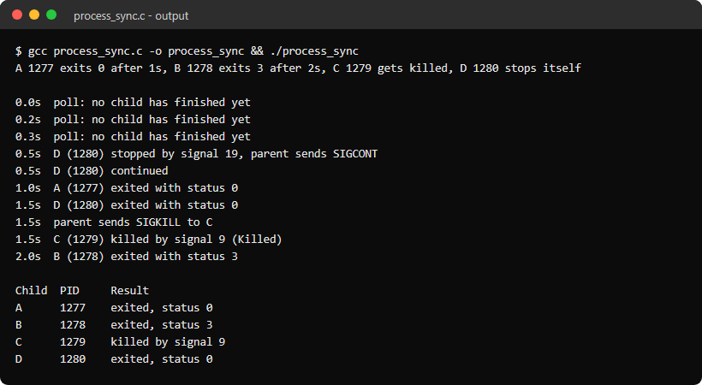

Program 14: PATH Resolver
Aim
To write a C program that finds the executable for a command name by searching the directories in the PATH environment variable and checking each candidate's type and permissions.
Algorithm
Step 1: If the name contains a '/', check that path directly.
Step 2: Otherwise read PATH with getenv() and split it on ':' with strsep(), treating an empty entry as the current directory.
Step 3: Build dir/name for each directory and stat() it.
Step 4: Classify it as not found, not a regular file, not executable (access(X_OK) fails) or FOUND.
Step 5: Print every directory checked and the first match, or report that the name is not in PATH.
Program (path_resolver.c)
#include <stdio.h>
#include <stdlib.h>
#include <string.h>
#include <unistd.h>
#include <sys/stat.h>

static const char *check(const char *path) {
struct stat st;
if (stat(path, &st) == -1)
return "not found";
if (!S_ISREG(st.st_mode))
return "found but not a regular file";
if (access(path, X_OK) != 0)
return "found but not executable";
return "FOUND";
}

static void resolve(const char *name) {
char full[1024];
char first[1024] = "";

printf("%s:\n", name);
if (strchr(name, '/') != NULL) {
const char *result = check(name);
printf(" %-36s %s\n", name, result);
if (strcmp(result, "FOUND") == 0)
snprintf(first, sizeof(first), "%s", name);
} else {
const char *path = getenv("PATH");
char *copy = strdup(path != NULL ? path : "");
char *rest = copy;
char *dir;

/* strsep keeps empty entries, and an empty entry means the current directory */
while ((dir = strsep(&rest, ":")) != NULL) {
if (*dir == '\0')
dir = ".";
snprintf(full, sizeof(full), "%s/%s", dir, name);
const char *result = check(full);
printf(" %-36s %s\n", full, result);
if (first[0] == '\0' && strcmp(result, "FOUND") == 0)
snprintf(first, sizeof(first), "%s", full);
}
free(copy);
}

if (first[0] != '\0')
printf("resolved: %s\n\n", first);
else
printf("%s: not found in PATH\n\n", name);
}

int main(int argc, char *argv[]) {
char line[1024];

if (argc > 1) {
for (int i = 1; i < argc; i++)
resolve(argv[i]);
return 0;
}

while (1) {
printf("resolve> ");
fflush(stdout);
if (fgets(line, sizeof(line), stdin) == NULL) {
printf("\n");
break;
}
line[strcspn(line, " \t\n")] = '\0';
if (strcmp(line, "exit") == 0)
break;
if (line[0] != '\0')
resolve(line);
}
return 0;
}
Output
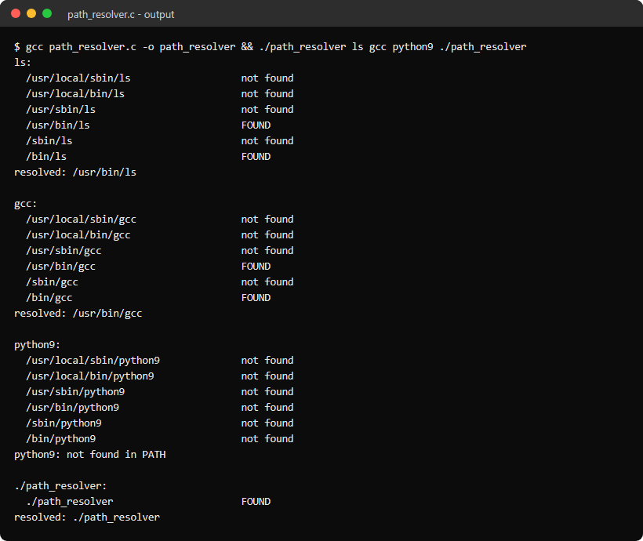

Program 15: Variable Expander
Aim
To write a C program that expands shell variable references in a line: $NAME, ${NAME}, ${NAME:-default}, $$ and $?, with warnings for undefined variables and support for nested variables.
Algorithm
Step 1: Keep a table of shell variables set with 'set NAME=value'; look names up there first and then in the environment.
Step 2: Copy text in single quotes unchanged.
Step 3: Replace $$ with the process ID and $? with the status of the previous line.
Step 4: Replace $NAME and ${NAME} with the value; use the default in ${NAME:-default} when it is unset or empty, otherwise print a warning for an unset name.
Step 5: If a value contains more $ references, expand it again one level deeper; stop with an error after 8 levels, which catches loops like A=$B and B=$A.
Program (variable_expander.c)
#include <stdio.h>
#include <stdlib.h>
#include <string.h>
#include <ctype.h>
#include <unistd.h>

#define MAX_VARS 32
#define MAX_DEPTH 8
#define OUT_SIZE 1024

struct var {
char name[64];
char value[256];
};

static struct var vars[MAX_VARS];
static int nvars = 0;
static int last_status = 0;

static const char *lookup(const char *name) {
for (int i = 0; i < nvars; i++) {
if (strcmp(vars[i].name, name) == 0)
return vars[i].value;
}
return getenv(name);
}

static int valid_name(const char *s) {
if (!isalpha((unsigned char)*s) && *s != '_')
return 0;
for (s++; *s != '\0'; s++) {
if (!isalnum((unsigned char)*s) && *s != '_')
return 0;
}
return 1;
}

static void set_var(const char *name, const char *value) {
int i = 0;
while (i < nvars && strcmp(vars[i].name, name) != 0)
i++;
if (i == MAX_VARS)
return;
if (i == nvars)
nvars++;
snprintf(vars[i].name, sizeof(vars[i].name), "%.63s", name);
snprintf(vars[i].value, sizeof(vars[i].value), "%.255s", value);
}

static void add(char *out, size_t *len, const char *s) {
while (*s != '\0' && *len < OUT_SIZE - 1)
out[(*len)++] = *s++;
out[*len] = '\0';
}

static int expand(const char *in, char *out, int depth) {
size_t len = 0;
out[0] = '\0';
if (depth > MAX_DEPTH)
return -1;

for (int i = 0; in[i] != '\0';) {
if (in[i] == '\'') {
for (i++; in[i] != '\0' && in[i] != '\''; i++) {
char c[2] = {in[i], '\0'};
add(out, &len, c);
}
if (in[i] == '\'')
i++;
continue;
}
if (in[i] != '$') {
char c[2] = {in[i++], '\0'};
add(out, &len, c);
continue;
}

char name[64] = "", def[256] = "", num[32];
int has_default = 0, j = 0;
i++;
if (in[i] == '$' || in[i] == '?') {
snprintf(num, sizeof(num), "%d", in[i] == '$' ? (int)getpid() : last_status);
add(out, &len, num);
i++;
continue;
}
if (in[i] == '{') {
for (i++; in[i] != '\0' && in[i] != '}' && in[i] != ':' && j < 63; i++)
name[j++] = in[i];
name[j] = '\0';
if (in[i] == ':' && in[i + 1] == '-') {
int k = 0;
for (i += 2; in[i] != '\0' && in[i] != '}' && k < 255; i++)
def[k++] = in[i];
def[k] = '\0';
has_default = 1;
}
if (in[i] == '}')
i++;
} else if (isalpha((unsigned char)in[i]) || in[i] == '_') {
while ((isalnum((unsigned char)in[i]) || in[i] == '_') && j < 63)
name[j++] = in[i++];
name[j] = '\0';
} else {
add(out, &len, "$");
continue;
}

const char *value = lookup(name);
if (value == NULL || value[0] == '\0') {
if (has_default)
value = def;
else if (value == NULL)
fprintf(stderr, "warning: %s is not set\n", name);
if (value == NULL)
value = "";
}

/* a value can hold more $ references, so expand it again one level deeper */
if (strchr(value, '$') != NULL) {
char nested[OUT_SIZE];
if (expand(value, nested, depth + 1) < 0)
return -1;
add(out, &len, nested);
} else {
add(out, &len, value);
}
}
return 0;
}

int main(void) {
char line[1024];
char out[OUT_SIZE];

while (1) {
printf("expand> ");
fflush(stdout);
if (fgets(line, sizeof(line), stdin) == NULL) {
printf("\n");
break;
}
line[strcspn(line, "\n")] = '\0';
if (strcmp(line, "exit") == 0)
break;

if (strncmp(line, "set ", 4) == 0) {
char *eq = strchr(line + 4, '=');
if (eq == NULL) {
printf("usage: set NAME=value\n");
last_status = 1;
continue;
}
*eq = '\0';
if (!valid_name(line + 4)) {
printf("set: `%s': not a valid name\n", line + 4);
last_status = 1;
continue;
}
set_var(line + 4, eq + 1);
printf("%s set to '%s'\n", line + 4, eq + 1);
last_status = 0;
continue;
}

if (expand(line, out, 0) < 0) {
printf("error: expansion depth exceeded\n");
last_status = 1;
} else {
printf("expanded: %s\n", out);
last_status = 0;
}
}
return 0;
}
Output
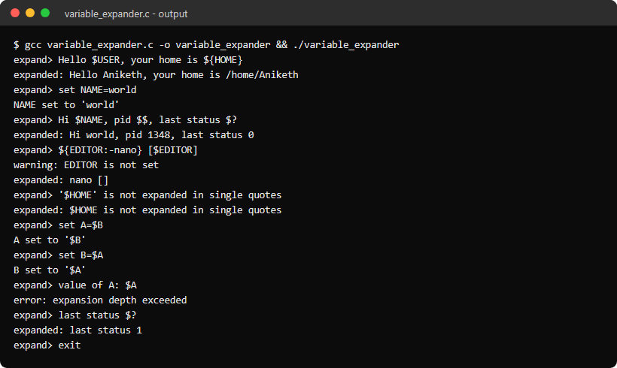

Program 16: Built-in Command Dispatch Table
Aim
To write a C program that identifies built-in commands through a dispatch table of names and function pointers and runs them inside the shell process, while other commands run as external programs.
Algorithm
Step 1: Define struct builtin with a name, a function pointer and a help text, and fill a table with cd, pwd, echo, help and exit.
Step 2: Read a command line and split it into arguments.
Step 3: Search the table for the command name; if found, call its function directly in the shell process.
Step 4: Otherwise fork() and execvp() the command as an external program and wait for it.
Step 5: cd must be a built-in: running it in the shell process changes the shell's own working directory, as pwd shows afterwards.
Program (builtin_dispatch.c)
#include <stdio.h>
#include <stdlib.h>
#include <string.h>
#include <unistd.h>
#include <sys/wait.h>

#define MAX_ARGS 64
#define DELIMS " \t\r\n"

struct builtin {
const char *name;
int (*fn)(char **argv);
const char *help;
};

static int sh_cd(char **argv) {
const char *dir = argv[1] != NULL ? argv[1] : getenv("HOME");
if (dir == NULL || chdir(dir) != 0)
perror("cd");
return 1;
}

static int sh_pwd(char **argv) {
char cwd[1024];
(void)argv;
if (getcwd(cwd, sizeof(cwd)) != NULL)
printf("%s\n", cwd);
else
perror("pwd");
return 1;
}

static int sh_echo(char **argv) {
for (int i = 1; argv[i] != NULL; i++)
printf("%s%s", i > 1 ? " " : "", argv[i]);
printf("\n");
return 1;
}

static int sh_exit(char **argv) {
(void)argv;
return 0;
}

static int sh_help(char **argv);

static struct builtin builtins[] = {
{"cd", sh_cd, "change the shell's own working directory"},
{"pwd", sh_pwd, "print the working directory"},
{"echo", sh_echo, "print the arguments"},
{"help", sh_help, "list the built-in commands"},
{"exit", sh_exit, "leave the shell"},
};

#define NUM_BUILTINS (int)(sizeof(builtins) / sizeof(builtins[0]))

static int sh_help(char **argv) {
(void)argv;
for (int i = 0; i < NUM_BUILTINS; i++)
printf(" %-5s %s\n", builtins[i].name, builtins[i].help);
printf("Anything else is run as an external program.\n");
return 1;
}

static void run_external(char **args) {
printf("[external] %s\n", args[0]);
fflush(stdout);
pid_t pid = fork();
if (pid < 0) {
perror("fork");
return;
}
if (pid == 0) {
execvp(args[0], args);
perror(args[0]);
_exit(127);
}
int status;
waitpid(pid, &status, 0);
printf("[external] pid %d exited with status %d\n", pid, WEXITSTATUS(status));
}

int main(void) {
char line[1024];
char *args[MAX_ARGS];
int running = 1;

while (running) {
printf("dispatch> ");
fflush(stdout);
if (fgets(line, sizeof(line), stdin) == NULL) {
printf("\n");
break;
}

int n = 0;
char *tok = strtok(line, DELIMS);
while (tok != NULL && n < MAX_ARGS - 1) {
args[n++] = tok;
tok = strtok(NULL, DELIMS);
}
args[n] = NULL;
if (n == 0)
continue;

int found = 0;
for (int i = 0; i < NUM_BUILTINS; i++) {
if (strcmp(args[0], builtins[i].name) == 0) {
printf("[builtin] %s\n", args[0]);
running = builtins[i].fn(args);
found = 1;
break;
}
}
if (!found)
run_external(args);
}
return 0;
}
Output
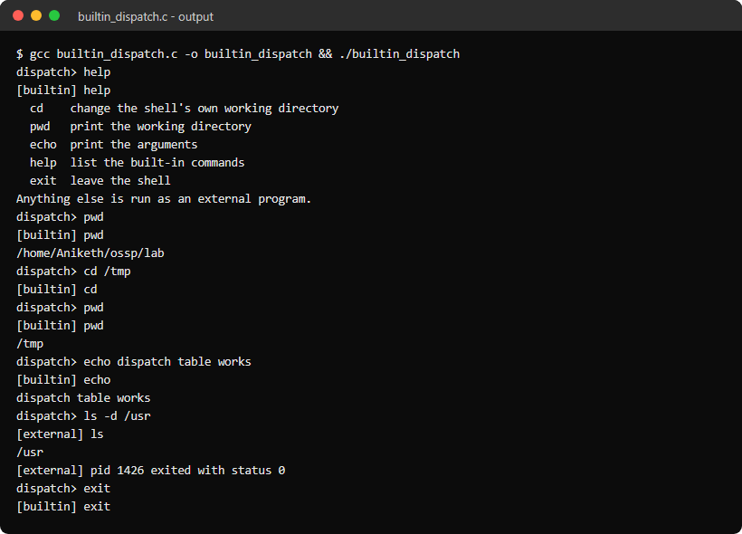

Program 17: Directory Changer (cd)
Aim
To write a C program that implements the cd command: change directories, validate paths, update PWD and OLDPWD, and report errors clearly.
Algorithm
Step 1: Show the current directory in the prompt using getcwd().
Step 2: Work out the target: no argument or ~ means $HOME, ~/dir is under $HOME, and - means $OLDPWD.
Step 3: Validate the target with stat(): report a missing path or one that is not a directory.
Step 4: Call chdir(); on failure print strerror(errno), for example Permission denied.
Step 5: On success set OLDPWD to the old directory and PWD to the new one with setenv(); pwd prints both getcwd() and $PWD.
Program (directory_changer.c)
#include <stdio.h>
#include <stdlib.h>
#include <string.h>
#include <errno.h>
#include <unistd.h>
#include <sys/stat.h>

static void change_dir(const char *arg) {
char target[1024];
const char *home = getenv("HOME");
int show = 0;

if (home == NULL)
home = "/";
if (arg == NULL || strcmp(arg, "~") == 0) {
snprintf(target, sizeof(target), "%s", home);
} else if (strncmp(arg, "~/", 2) == 0) {
snprintf(target, sizeof(target), "%s%s", home, arg + 1);
} else if (strcmp(arg, "-") == 0) {
const char *old = getenv("OLDPWD");
if (old == NULL) {
printf("cd: OLDPWD not set\n");
return;
}
snprintf(target, sizeof(target), "%s", old);
show = 1;
} else {
snprintf(target, sizeof(target), "%s", arg);
}

struct stat st;
if (stat(target, &st) == -1) {
printf("cd: %s: %s\n", target, strerror(errno));
return;
}
if (!S_ISDIR(st.st_mode)) {
printf("cd: %s: Not a directory\n", target);
return;
}

char *before = getcwd(NULL, 0);
if (chdir(target) == -1) {
printf("cd: %s: %s\n", target, strerror(errno));
free(before);
return;
}
char *now = getcwd(NULL, 0);
if (before != NULL)
setenv("OLDPWD", before, 1);
if (now != NULL)
setenv("PWD", now, 1);
if (show && now != NULL)
printf("%s\n", now);
free(before);
free(now);
}

int main(void) {
char line[1024];

while (1) {
char *cwd = getcwd(NULL, 0);
printf("cd-demo:%s$ ", cwd != NULL ? cwd : "?");
free(cwd);
fflush(stdout);
if (fgets(line, sizeof(line), stdin) == NULL) {
printf("\n");
break;
}

char *cmd = strtok(line, " \t\n");
char *arg = strtok(NULL, " \t\n");
if (cmd == NULL)
continue;
if (strcmp(cmd, "exit") == 0)
break;

if (strcmp(cmd, "cd") == 0) {
change_dir(arg);
} else if (strcmp(cmd, "pwd") == 0) {
char *now = getcwd(NULL, 0);
const char *pwd = getenv("PWD");
printf("getcwd(): %s\n$PWD : %s\n", now != NULL ? now : "?", pwd != NULL ? pwd : "(unset)");
free(now);
} else {
printf("%s: only cd, pwd and exit are supported here\n", cmd);
}
}
return 0;
}
Output
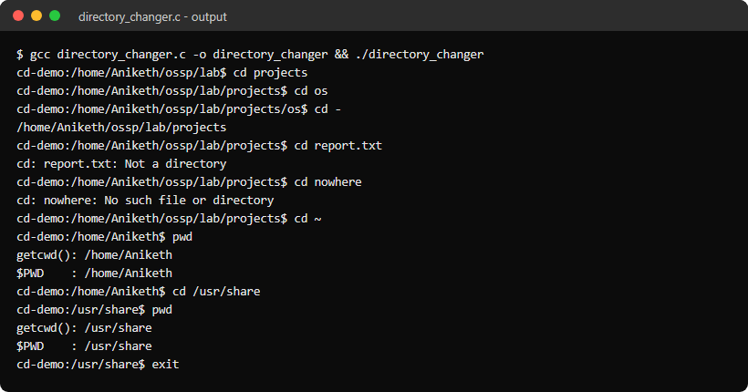

Program 18: Extended Built-ins with Shell State
Aim
To write a C program with a larger built-in dispatch table (cd, pwd, echo, export, unset, env, alias, unalias, history, type, help, exit) that keeps shell state between commands.
Algorithm
Step 1: Keep the state in the shell process: the last exit status ($?), an alias table, a history list and a command counter shown in the prompt.
Step 2: Store every line in the history and split it into arguments.
Step 3: If the first word is an alias, replace it with the alias text and split the line again.
Step 4: Run built-ins through the dispatch table; anything else is forked and executed, and its exit status becomes $?.
Step 5: type reports whether a name is an alias, a built-in or a program found in PATH; exit n leaves with status n.
Program (extended_builtins.c)
#include <stdio.h>
#include <stdlib.h>
#include <string.h>
#include <unistd.h>
#include <sys/wait.h>

#define MAX_ARGS 64
#define MAX_ALIASES 16
#define MAX_HISTORY 100
#define DELIMS " \t\r\n"

extern char **environ;

struct alias {
char name[32];
char value[256];
};

struct builtin {
const char *name;
int (*fn)(char **argv);
const char *help;
};

static struct alias aliases[MAX_ALIASES];
static int alias_count = 0;
static char *history[MAX_HISTORY];
static int history_count = 0;
static int last_status = 0;
static int running = 1;
static int exit_code = 0;

static int tokenize(char *line, char **args) {
int n = 0;
char *tok = strtok(line, DELIMS);
while (tok != NULL && n < MAX_ARGS - 1) {
args[n++] = tok;
tok = strtok(NULL, DELIMS);
}
args[n] = NULL;
return n;
}

static const char *find_alias(const char *name) {
for (int i = 0; i < alias_count; i++) {
if (strcmp(aliases[i].name, name) == 0)
return aliases[i].value;
}
return NULL;
}

static int sh_cd(char **argv) {
const char *dir = argv[1] != NULL ? argv[1] : getenv("HOME");
if (dir == NULL || chdir(dir) != 0) {
perror("cd");
return 1;
}
return 0;
}

static int sh_pwd(char **argv) {
char cwd[1024];
(void)argv;
if (getcwd(cwd, sizeof(cwd)) == NULL) {
perror("pwd");
return 1;
}
printf("%s\n", cwd);
return 0;
}

static int sh_echo(char **argv) {
for (int i = 1; argv[i] != NULL; i++) {
if (i > 1)
printf(" ");
if (strcmp(argv[i], "$?") == 0) {
printf("%d", last_status);
} else if (argv[i][0] == '$') {
const char *v = getenv(argv[i] + 1);
printf("%s", v != NULL ? v : "");
} else {
printf("%s", argv[i]);
}
}
printf("\n");
return 0;
}

static int sh_export(char **argv) {
for (int i = 1; argv[i] != NULL; i++) {
char *eq = strchr(argv[i], '=');
if (eq == NULL) {
printf("usage: export NAME=value\n");
return 1;
}
*eq = '\0';
setenv(argv[i], eq + 1, 1);
}
return 0;
}

static int sh_unset(char **argv) {
for (int i = 1; argv[i] != NULL; i++)
unsetenv(argv[i]);
return 0;
}

static int sh_env(char **argv) {
(void)argv;
for (char **e = environ; *e != NULL; e++)
printf("%s\n", *e);
return 0;
}

static int sh_alias(char **argv) {
if (argv[1] == NULL) {
for (int i = 0; i < alias_count; i++)
printf("alias %s='%s'\n", aliases[i].name, aliases[i].value);
return 0;
}
char *eq = strchr(argv[1], '=');
if (eq == NULL) {
const char *v = find_alias(argv[1]);
if (v == NULL) {
printf("alias: %s: not found\n", argv[1]);
return 1;
}
printf("alias %s='%s'\n", argv[1], v);
return 0;
}

/* everything after '=' is the alias text, including the other words */
char value[256] = "";
*eq = '\0';
snprintf(value, sizeof(value), "%s", eq + 1);
for (int i = 2; argv[i] != NULL; i++) {
strncat(value, " ", sizeof(value) - strlen(value) - 1);
strncat(value, argv[i], sizeof(value) - strlen(value) - 1);
}
int i = 0;
while (i < alias_count && strcmp(aliases[i].name, argv[1]) != 0)
i++;
if (i == MAX_ALIASES)
return 1;
if (i == alias_count)
alias_count++;
snprintf(aliases[i].name, sizeof(aliases[i].name), "%s", argv[1]);
snprintf(aliases[i].value, sizeof(aliases[i].value), "%s", value);
return 0;
}

static int sh_unalias(char **argv) {
for (int i = 0; i < alias_count; i++) {
if (argv[1] != NULL && strcmp(aliases[i].name, argv[1]) == 0) {
aliases[i] = aliases[--alias_count];
return 0;
}
}
printf("unalias: %s: not found\n", argv[1] != NULL ? argv[1] : "");
return 1;
}

static int sh_history(char **argv) {
(void)argv;
for (int i = 0; i < history_count; i++)
printf("%4d %s\n", i + 1, history[i]);
return 0;
}

static int sh_exit(char **argv) {
exit_code = argv[1] != NULL ? atoi(argv[1]) : last_status;
running = 0;
return exit_code;
}

static int sh_type(char **argv);
static int sh_help(char **argv);

static struct builtin builtins[] = {
{"cd", sh_cd, "change directory"},
{"pwd", sh_pwd, "print working directory"},
{"echo", sh_echo, "print arguments, $NAME and $? are expanded"},
{"export", sh_export, "export NAME=value to the environment"},
{"unset", sh_unset, "remove an environment variable"},
{"env", sh_env, "list the environment"},
{"alias", sh_alias, "define or list aliases"},
{"unalias", sh_unalias, "remove an alias"},
{"history", sh_history, "list previous commands"},
{"type", sh_type, "say how a name would be run"},
{"help", sh_help, "show this list"},
{"exit", sh_exit, "leave the shell, optionally with a status"},
};

#define NUM_BUILTINS (int)(sizeof(builtins) / sizeof(builtins[0]))

static int is_builtin(const char *name) {
for (int i = 0; i < NUM_BUILTINS; i++) {
if (strcmp(builtins[i].name, name) == 0)
return i;
}
return -1;
}

static int sh_type(char **argv) {
if (argv[1] == NULL)
return 1;
const char *a = find_alias(argv[1]);
if (a != NULL) {
printf("%s is aliased to '%s'\n", argv[1], a);
return 0;
}
if (is_builtin(argv[1]) >= 0) {
printf("%s is a shell builtin\n", argv[1]);
return 0;
}

const char *path = getenv("PATH");
char *copy = strdup(path != NULL ? path : "");
char full[1024];
int found = 0;
for (char *dir = strtok(copy, ":"); dir != NULL; dir = strtok(NULL, ":")) {
snprintf(full, sizeof(full), "%s/%s", dir, argv[1]);
if (access(full, X_OK) == 0) {
printf("%s is %s\n", argv[1], full);
found = 1;
break;
}
}
free(copy);
if (!found)
printf("%s: not found\n", argv[1]);
return found ? 0 : 1;
}

static int sh_help(char **argv) {
(void)argv;
for (int i = 0; i < NUM_BUILTINS; i++)
printf(" %-8s %s\n", builtins[i].name, builtins[i].help);
return 0;
}

static int run_external(char **args) {
pid_t pid = fork();
if (pid < 0) {
perror("fork");
return 1;
}
if (pid == 0) {
execvp(args[0], args);
fprintf(stderr, "%s: command not found\n", args[0]);
_exit(127);
}
int status;
waitpid(pid, &status, 0);
return WIFEXITED(status) ? WEXITSTATUS(status) : 128 + WTERMSIG(status);
}

int main(void) {
char line[1024];
char expanded[1024];
char *args[MAX_ARGS];

while (running) {
printf("[%d] ext$ ", history_count + 1);
fflush(stdout);
if (fgets(line, sizeof(line), stdin) == NULL) {
printf("\n");
break;
}
line[strcspn(line, "\n")] = '\0';
if (line[0] == '\0')
continue;
if (history_count < MAX_HISTORY)
history[history_count++] = strdup(line);

int n = tokenize(line, args);
if (n == 0)
continue;

/* replace an alias in the first word and split the line again */
const char *a = find_alias(args[0]);
if (a != NULL) {
snprintf(expanded, sizeof(expanded), "%s", a);
for (int i = 1; i < n; i++) {
strncat(expanded, " ", sizeof(expanded) - strlen(expanded) - 1);
strncat(expanded, args[i], sizeof(expanded) - strlen(expanded) - 1);
}
n = tokenize(expanded, args);
if (n == 0)
continue;
}

int b = is_builtin(args[0]);
if (b >= 0)
last_status = builtins[b].fn(args);
else
last_status = run_external(args);
}

for (int i = 0; i < history_count; i++)
free(history[i]);
return exit_code;
}
Output
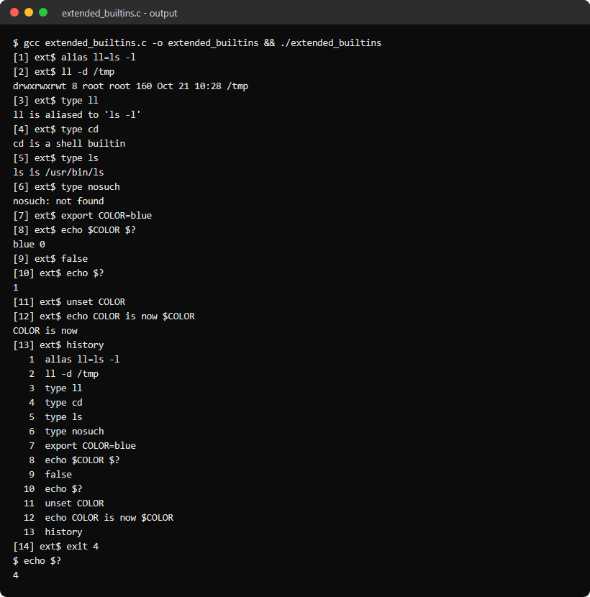

Program 19: Current Directory and Exit Handling
Aim
To write a C program that retrieves and displays the current directory, processes exit requests with a status code, and cleans up its resources before ending.
Algorithm
Step 1: Register a cleanup function with atexit() that frees the history list.
Step 2: Install a SIGINT handler without SA_RESTART, so Ctrl-C interrupts fgets() and the program prints a fresh prompt instead of dying.
Step 3: Show the current directory in the prompt, with $HOME shortened to ~; pwd uses getcwd(NULL, 0) so paths of any length work.
Step 4: exit with a number ends the program with that status, while a non-numeric argument is rejected.
Step 5: Ctrl-D (end of input) also exits, and the atexit() cleanup runs in every case.
Program (current_directory.c)
#include <stdio.h>
#include <stdlib.h>
#include <string.h>
#include <errno.h>
#include <signal.h>
#include <unistd.h>

#define MAX_HISTORY 100

static char *history[MAX_HISTORY];
static int history_count = 0;

static void cleanup(void) {
for (int i = 0; i < history_count; i++)
free(history[i]);
printf("cleanup: freed %d history entries\n", history_count);
}

static void on_sigint(int sig) {
(void)sig;
}

static void print_prompt(void) {
char *cwd = getcwd(NULL, 0);
const char *home = getenv("HOME");
size_t hl = home != NULL ? strlen(home) : 0;

if (cwd == NULL)
printf("?$ ");
else if (hl > 0 && strncmp(cwd, home, hl) == 0 && (cwd[hl] == '/' || cwd[hl] == '\0'))
printf("~%s$ ", cwd + hl);
else
printf("%s$ ", cwd);
free(cwd);
fflush(stdout);
}

int main(void) {
char line[1024];
struct sigaction sa;

atexit(cleanup);

/* no SA_RESTART, so Ctrl-C interrupts fgets and we can print a fresh prompt */
memset(&sa, 0, sizeof(sa));
sa.sa_handler = on_sigint;
sigemptyset(&sa.sa_mask);
sigaction(SIGINT, &sa, NULL);

while (1) {
print_prompt();
if (fgets(line, sizeof(line), stdin) == NULL) {
if (ferror(stdin) && errno == EINTR) {
clearerr(stdin);
printf("\n");
continue;
}
printf("exit\n");
exit(EXIT_SUCCESS);
}
line[strcspn(line, "\n")] = '\0';

char *cmd = strtok(line, " \t");
char *arg = strtok(NULL, " \t");
if (cmd == NULL)
continue;

if (strcmp(cmd, "pwd") == 0) {
/* getcwd(NULL, 0) allocates a buffer as long as the path needs */
char *cwd = getcwd(NULL, 0);
if (cwd == NULL) {
perror("getcwd");
continue;
}
printf("%s (%zu characters)\n", cwd, strlen(cwd));
free(cwd);
} else if (strcmp(cmd, "cd") == 0) {
const char *dir = arg != NULL ? arg : getenv("HOME");
if (dir == NULL || chdir(dir) == -1)
perror("cd");
} else if (strcmp(cmd, "exit") == 0) {
if (arg == NULL)
exit(EXIT_SUCCESS);
char *end;
long code = strtol(arg, &end, 10);
if (*end != '\0') {
printf("exit: %s: numeric argument required\n", arg);
continue;
}
exit((int)code);
} else if (history_count < MAX_HISTORY) {
history[history_count] = strdup(cmd);
history_count++;
printf("%s: not a command here, stored in history (%d)\n", cmd, history_count);
}
}
}
Output
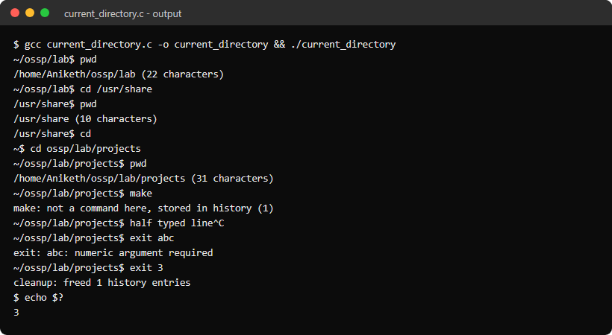

Program 20: Export Parser and Environment Variables
Aim
To write a C program that parses export syntax, validates variable names, updates the environment, and shows that only exported variables are passed to child processes.
Algorithm
Step 1: Split the line into words, keeping quoted text such as "hello world" together.
Step 2: NAME=value creates a shell-only variable that is not exported.
Step 3: export NAME=value and export NAME validate the name ([A-Za-z_][A-Za-z0-9_]*) and move the variable into the environment with setenv().
Step 4: export and export -p list the environment sorted as declare -x NAME="value"; unset removes a variable.
Step 5: Any other line runs as a child process with fork() and execvp(); printenv shows that a child sees only the exported variables.
Program (export_parser.c)
#include <stdio.h>
#include <stdlib.h>
#include <string.h>
#include <ctype.h>
#include <unistd.h>
#include <sys/wait.h>

#define MAX_ARGS 64
#define MAX_VARS 32

extern char **environ;

struct var {
char name[64];
char value[256];
};

static struct var shell_vars[MAX_VARS];
static int nvars = 0;

/* Splits on spaces but keeps quoted text together and drops the quotes */
static int tokenize(char *line, char **args) {
int n = 0;
char *src = line, *dst = line;

while (*src != '\0' && n < MAX_ARGS - 1) {
while (isspace((unsigned char)*src))
src++;
if (*src == '\0')
break;
args[n++] = dst;
char quote = 0;
while (*src != '\0' && (quote || !isspace((unsigned char)*src))) {
if (quote == 0 && (*src == '"' || *src == '\'')) {
quote = *src++;
} else if (quote != 0 && *src == quote) {
quote = 0;
src++;
} else {
*dst++ = *src++;
}
}
if (*src != '\0')
src++;
*dst++ = '\0';
}
args[n] = NULL;
return n;
}

static int valid_name(const char *s, size_t len) {
if (len == 0 || (!isalpha((unsigned char)s[0]) && s[0] != '_'))
return 0;
for (size_t i = 1; i < len; i++) {
if (!isalnum((unsigned char)s[i]) && s[i] != '_')
return 0;
}
return 1;
}

static int find_var(const char *name) {
for (int i = 0; i < nvars; i++) {
if (strcmp(shell_vars[i].name, name) == 0)
return i;
}
return -1;
}

static void remove_var(const char *name) {
int i = find_var(name);
if (i >= 0)
shell_vars[i] = shell_vars[--nvars];
}

static void set_shell_var(const char *name, const char *value) {
int i = find_var(name);
if (i < 0) {
if (nvars == MAX_VARS)
return;
i = nvars++;
}
snprintf(shell_vars[i].name, sizeof(shell_vars[i].name), "%s", name);
snprintf(shell_vars[i].value, sizeof(shell_vars[i].value), "%s", value);
}

static int compare(const void *a, const void *b) {
return strcmp(*(char *const *)a, *(char *const *)b);
}

static void list_exported(void) {
int n = 0;
for (char **e = environ; *e != NULL; e++)
n++;
char **sorted = malloc(n * sizeof(char *));
for (int i = 0; i < n; i++)
sorted[i] = environ[i];
qsort(sorted, n, sizeof(char *), compare);
for (int i = 0; i < n; i++) {
char *eq = strchr(sorted[i], '=');
printf("declare -x %.*s=\"%s\"\n", (int)(eq - sorted[i]), sorted[i], eq + 1);
}
free(sorted);
}

static void do_export(char **args) {
if (args[1] == NULL || strcmp(args[1], "-p") == 0) {
list_exported();
return;
}
for (int i = 1; args[i] != NULL; i++) {
char *eq = strchr(args[i], '=');
size_t len = eq != NULL ? (size_t)(eq - args[i]) : strlen(args[i]);
if (!valid_name(args[i], len)) {
printf("export: `%s': not a valid identifier\n", args[i]);
continue;
}
if (eq != NULL) {
*eq = '\0';
setenv(args[i], eq + 1, 1);
} else {
int v = find_var(args[i]);
setenv(args[i], v >= 0 ? shell_vars[v].value : "", 1);
}
remove_var(args[i]);
}
}

static void run_external(char **args) {
pid_t pid = fork();
if (pid < 0) {
perror("fork");
return;
}
if (pid == 0) {
execvp(args[0], args);
fprintf(stderr, "%s: command not found\n", args[0]);
_exit(127);
}
waitpid(pid, NULL, 0);
}

int main(void) {
char line[1024];
char *args[MAX_ARGS];

while (1) {
printf("export> ");
fflush(stdout);
if (fgets(line, sizeof(line), stdin) == NULL) {
printf("\n");
break;
}
line[strcspn(line, "\n")] = '\0';

int n = tokenize(line, args);
if (n == 0)
continue;
if (strcmp(args[0], "exit") == 0)
break;

char *eq = strchr(args[0], '=');
if (strcmp(args[0], "export") == 0) {
do_export(args);
} else if (strcmp(args[0], "unset") == 0) {
for (int i = 1; args[i] != NULL; i++) {
remove_var(args[i]);
unsetenv(args[i]);
}
} else if (strcmp(args[0], "set") == 0) {
for (int i = 0; i < nvars; i++)
printf("%s=%s (shell only)\n", shell_vars[i].name, shell_vars[i].value);
} else if (eq != NULL && n == 1 && valid_name(args[0], eq - args[0])) {
*eq = '\0';
if (getenv(args[0]) != NULL)
setenv(args[0], eq + 1, 1);
else
set_shell_var(args[0], eq + 1);
} else {
run_external(args);
}
}
return 0;
}
Output
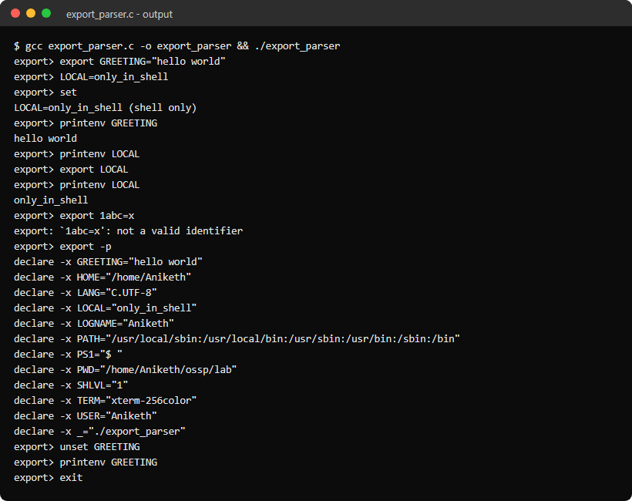

Program 21: Circular History Buffer
Aim
To write a C program that stores commands in a fixed-capacity circular buffer, evicts the oldest entry when full, and retrieves entries with !!, !n, !-n and !prefix.
Algorithm
Step 1: Keep a struct with an array of 5 entries, the index of the oldest entry, the count and the total number of commands ever stored.
Step 2: To add a command: if the buffer is full, free the oldest entry, store the new one in its slot and advance the start index; otherwise store it after the last entry.
Step 3: Map an absolute command number n to slot (start + n - first) % capacity, where first is the oldest number still stored.
Step 4: !! recalls the last command, !n command number n, !-n the nth most recent, and !prefix the newest command starting with prefix; a recalled command is stored again.
Step 5: Report "event not found" for entries that were evicted or never existed, and free all entries at exit.
Program (history_buffer.c)
#include <stdio.h>
#include <stdlib.h>
#include <string.h>
#include <ctype.h>

#define CAPACITY 5

struct history {
char *entries[CAPACITY];
int start;
int count;
long total;
};

static void add_entry(struct history *h, const char *line) {
if (h->count == CAPACITY) {
printf("evicted #%ld: %s\n", h->total - CAPACITY + 1, h->entries[h->start]);
free(h->entries[h->start]);
h->entries[h->start] = strdup(line);
h->start = (h->start + 1) % CAPACITY;
} else {
h->entries[(h->start + h->count) % CAPACITY] = strdup(line);
h->count++;
}
h->total++;
printf("stored #%ld: %s\n", h->total, line);
}

/* number is the absolute command number, counting from 1 */
static const char *get_entry(struct history *h, long number) {
long first = h->total - h->count + 1;
if (number < first || number > h->total)
return NULL;
return h->entries[(h->start + (number - first)) % CAPACITY];
}

static const char *recall(struct history *h, const char *event) {
if (strcmp(event, "!!") == 0)
return get_entry(h, h->total);
if (event[1] == '-' && isdigit((unsigned char)event[2]))
return get_entry(h, h->total - atol(event + 2) + 1);
if (isdigit((unsigned char)event[1]))
return get_entry(h, atol(event + 1));

for (long n = h->total; n > h->total - h->count; n--) {
const char *e = get_entry(h, n);
if (strncmp(e, event + 1, strlen(event + 1)) == 0)
return e;
}
return NULL;
}

int main(void) {
struct history h = {0};
char line[1024];

printf("History keeps the last %d commands.\n", CAPACITY);
while (1) {
printf("history> ");
fflush(stdout);
if (fgets(line, sizeof(line), stdin) == NULL) {
printf("\n");
break;
}
line[strcspn(line, "\n")] = '\0';
if (line[0] == '\0')
continue;
if (strcmp(line, "exit") == 0)
break;

if (strcmp(line, "history") == 0) {
for (long n = h.total - h.count + 1; n <= h.total; n++)
printf("%4ld %s\n", n, get_entry(&h, n));
} else if (line[0] == '!' && line[1] != '\0') {
const char *found = recall(&h, line);
if (found == NULL) {
printf("%s: event not found\n", line);
continue;
}
char *copy = strdup(found);
printf("recalled: %s\n", copy);
add_entry(&h, copy);
free(copy);
} else {
add_entry(&h, line);
}
}

for (int i = 0; i < h.count; i++)
free(h.entries[(h.start + i) % CAPACITY]);
return 0;
}
Output
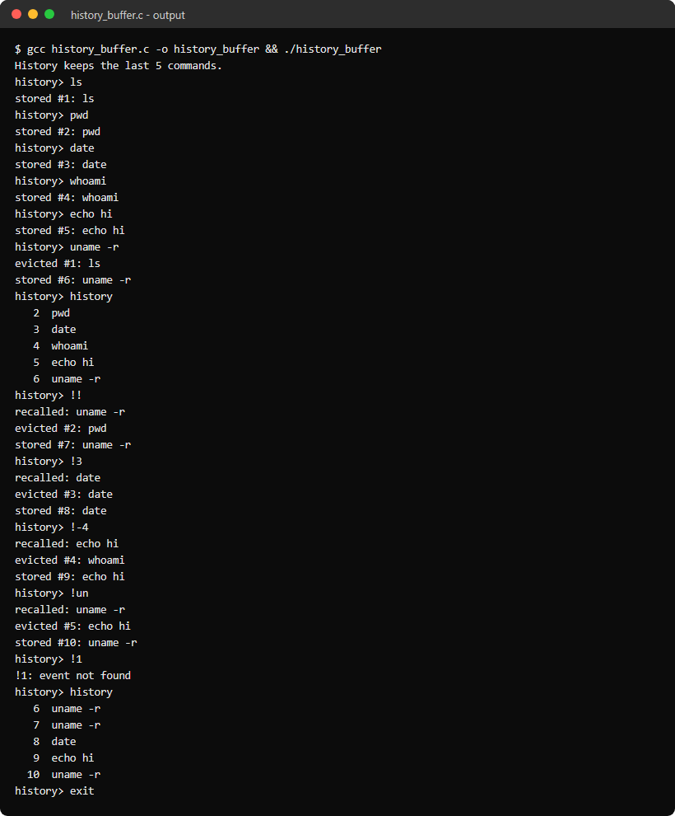

Program 22: Pipeline Structure
Aim
To write a C program that builds an explicit pipeline structure from a command line, prints how each stage is connected, and executes the stages in order connected by pipes.
Algorithm
Step 1: Split the line on '|' with strsep() and each part on whitespace into struct command, stored in struct pipeline; reject empty stages.
Step 2: Print every stage with its argv and where its stdin and stdout are connected (terminal or pipe number).
Step 3: Create count - 1 pipes and fork() one child per stage in order.
Step 4: In each child dup2() the previous pipe's read end onto stdin and the next pipe's write end onto stdout, close every pipe descriptor, then execvp().
Step 5: The parent closes all pipe ends, waits for every stage and prints each stage's exit status.
Program (pipeline_structure.c)
#include <stdio.h>
#include <stdlib.h>
#include <string.h>
#include <unistd.h>
#include <sys/wait.h>

#define MAX_ARGS 16
#define MAX_CMDS 8

struct command {
char *argv[MAX_ARGS];
int argc;
};

struct pipeline {
struct command cmds[MAX_CMDS];
int count;
};

static int parse_pipeline(char *line, struct pipeline *p) {
char *rest = line;
char *stage;

p->count = 0;
while ((stage = strsep(&rest, "|")) != NULL) {
if (p->count == MAX_CMDS) {
printf("too many commands, the limit is %d\n", MAX_CMDS);
return -1;
}
struct command *c = &p->cmds[p->count];
char *save;
c->argc = 0;
for (char *tok = strtok_r(stage, " \t\n", &save); tok != NULL && c->argc < MAX_ARGS - 1;
tok = strtok_r(NULL, " \t\n", &save))
c->argv[c->argc++] = tok;
c->argv[c->argc] = NULL;
if (c->argc == 0) {
printf("syntax error: empty command in pipeline\n");
return -1;
}
p->count++;
}
return 0;
}

static void print_pipeline(struct pipeline *p) {
printf("pipeline with %d stage%s, %d pipe%s\n", p->count, p->count == 1 ? "" : "s",
p->count - 1, p->count == 2 ? "" : "s");
for (int i = 0; i < p->count; i++) {
char in[16] = "terminal", out[16] = "terminal";
if (i > 0)
snprintf(in, sizeof(in), "pipe %d", i - 1);
if (i < p->count - 1)
snprintf(out, sizeof(out), "pipe %d", i);

printf(" stage %d: argv = [", i);
for (int j = 0; j < p->cmds[i].argc; j++)
printf("%s%s", j ? ", " : "", p->cmds[i].argv[j]);
printf("] stdin: %s stdout: %s\n", in, out);
}
}

static void run_pipeline(struct pipeline *p) {
int pipes[MAX_CMDS - 1][2];
pid_t pids[MAX_CMDS];
int started = 0;

for (int i = 0; i < p->count - 1; i++) {
if (pipe(pipes[i]) == -1) {
perror("pipe");
return;
}
}

for (int i = 0; i < p->count; i++) {
pids[i] = fork();
if (pids[i] < 0) {
perror("fork");
break;
}
if (pids[i] == 0) {
if (i > 0)
dup2(pipes[i - 1][0], STDIN_FILENO);
if (i < p->count - 1)
dup2(pipes[i][1], STDOUT_FILENO);
for (int j = 0; j < p->count - 1; j++) {
close(pipes[j][0]);
close(pipes[j][1]);
}
execvp(p->cmds[i].argv[0], p->cmds[i].argv);
perror(p->cmds[i].argv[0]);
_exit(127);
}
started++;
}

/* the parent must close its copies or the last reader never sees end of file */
for (int j = 0; j < p->count - 1; j++) {
close(pipes[j][0]);
close(pipes[j][1]);
}

int status[MAX_CMDS];
for (int i = 0; i < started; i++)
waitpid(pids[i], &status[i], 0);
for (int i = 0; i < started; i++)
printf(" stage %d (%s, pid %d) exited with status %d\n", i, p->cmds[i].argv[0], pids[i],
WEXITSTATUS(status[i]));
}

int main(void) {
char line[1024];
struct pipeline p;

while (1) {
printf("pipeline> ");
fflush(stdout);
if (fgets(line, sizeof(line), stdin) == NULL) {
printf("\n");
break;
}
line[strcspn(line, "\n")] = '\0';
if (strcmp(line, "exit") == 0)
break;
if (strspn(line, " \t") == strlen(line))
continue;

if (parse_pipeline(line, &p) < 0)
continue;
print_pipeline(&p);
printf("output:\n");
fflush(stdout);
run_pipeline(&p);
}
return 0;
}
Output
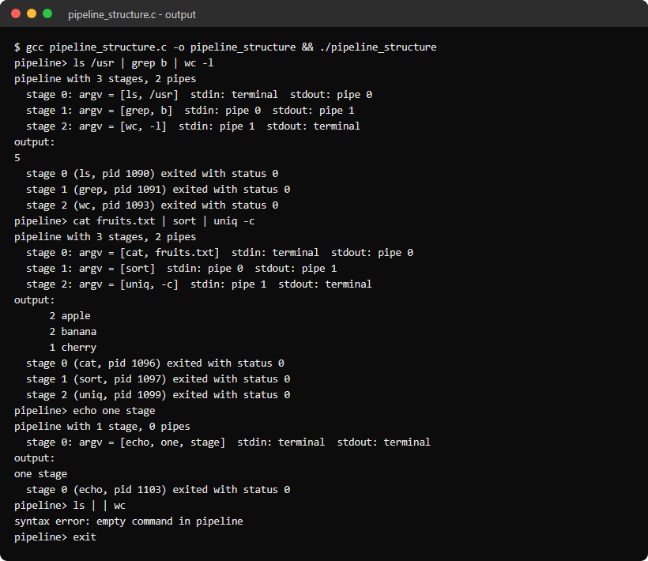

Program 23: Pipes and I/O Redirection
Aim
To write a C program that executes connected commands with pipes and with input and output redirection (<, > and >>), closing every descriptor that is no longer needed.
Algorithm
Step 1: Tokenise the line, recognising |, <, > and >> with or without spaces, and build the stages with an optional input file and output file.
Step 2: Print the plan: each stage's command and its stdin and stdout source.
Step 3: In each child, open the input file with O_RDONLY or the output file with O_TRUNC or O_APPEND, and dup2() it onto stdin or stdout.
Step 4: dup2() the pipe ends, close all pipe descriptors in the child and the parent, then execvp().
Step 5: Wait for all stages and print their status, and count the entries in /proc/self/fd before and after to show that no descriptors leak.
Program (pipe_redirection.c)
#include <stdio.h>
#include <stdlib.h>
#include <string.h>
#include <ctype.h>
#include <dirent.h>
#include <fcntl.h>
#include <unistd.h>
#include <sys/wait.h>

#define MAX_ARGS 16
#define MAX_CMDS 8
#define MAX_TOKENS 64

struct stage {
char *argv[MAX_ARGS];
int argc;
};

struct job {
struct stage stages[MAX_CMDS];
int count;
char *in_file;
char *out_file;
int append;
};

static char token_buf[MAX_TOKENS][256];

static int open_fds(void) {
int n = 0;
DIR *d = opendir("/proc/self/fd");
if (d == NULL)
return -1;
while (readdir(d) != NULL)
n++;
closedir(d);
/* leave out ".", ".." and the descriptor opendir itself used */
return n - 3;
}

static int tokenize(const char *line, char **tokens) {
int n = 0, i = 0;
while (line[i] != '\0' && n < MAX_TOKENS - 1) {
if (isspace((unsigned char)line[i])) {
i++;
continue;
}
int len = 0;
if (strncmp(line + i, ">>", 2) == 0) {
len = 2;
} else if (strchr("|<>", line[i]) != NULL) {
len = 1;
} else {
while (line[i + len] != '\0' && !isspace((unsigned char)line[i + len]) &&
strchr("|<>", line[i + len]) == NULL)
len++;
}
snprintf(token_buf[n], sizeof(token_buf[n]), "%.*s", len, line + i);
tokens[n] = token_buf[n];
n++;
i += len;
}
tokens[n] = NULL;
return n;
}

static int parse(char **tokens, int n, struct job *job) {
memset(job, 0, sizeof(*job));
job->count = 1;
for (int i = 0; i < n; i++) {
struct stage *s = &job->stages[job->count - 1];
if (strcmp(tokens[i], "|") == 0) {
if (s->argc == 0 || job->count == MAX_CMDS) {
printf("syntax error: empty command in pipeline\n");
return -1;
}
job->count++;
} else if (strcmp(tokens[i], "<") == 0 || strcmp(tokens[i], ">") == 0 ||
strcmp(tokens[i], ">>") == 0) {
if (i + 1 == n || strchr("|<>", tokens[i + 1][0]) != NULL) {
printf("syntax error: missing file name after `%s'\n", tokens[i]);
return -1;
}
if (tokens[i][0] == '<') {
job->in_file = tokens[++i];
} else {
job->append = tokens[i][1] == '>';
job->out_file = tokens[++i];
}
} else if (s->argc < MAX_ARGS - 1) {
s->argv[s->argc++] = tokens[i];
}
}
if (job->stages[job->count - 1].argc == 0) {
printf("syntax error: empty command in pipeline\n");
return -1;
}
return 0;
}

static void print_plan(struct job *job) {
for (int i = 0; i < job->count; i++) {
char in[300] = "terminal", out[300] = "terminal";
if (i == 0 && job->in_file != NULL)
snprintf(in, sizeof(in), "file %s", job->in_file);
else if (i > 0)
snprintf(in, sizeof(in), "pipe %d", i - 1);
if (i == job->count - 1 && job->out_file != NULL)
snprintf(out, sizeof(out), "file %s (%s)", job->out_file, job->append ? "append" : "truncate");
else if (i < job->count - 1)
snprintf(out, sizeof(out), "pipe %d", i);

printf(" stage %d: %s", i, job->stages[i].argv[0]);
for (int j = 1; j < job->stages[i].argc; j++)
printf(" %s", job->stages[i].argv[j]);
printf(" stdin: %s stdout: %s\n", in, out);
}
}

static void child(struct job *job, int i, int pipes[][2]) {
if (i == 0 && job->in_file != NULL) {
int fd = open(job->in_file, O_RDONLY);
if (fd == -1) {
perror(job->in_file);
_exit(1);
}
dup2(fd, STDIN_FILENO);
close(fd);
}
if (i == job->count - 1 && job->out_file != NULL) {
int flags = O_WRONLY | O_CREAT | (job->append ? O_APPEND : O_TRUNC);
int fd = open(job->out_file, flags, 0644);
if (fd == -1) {
perror(job->out_file);
_exit(1);
}
dup2(fd, STDOUT_FILENO);
close(fd);
}
if (i > 0)
dup2(pipes[i - 1][0], STDIN_FILENO);
if (i < job->count - 1)
dup2(pipes[i][1], STDOUT_FILENO);
for (int j = 0; j < job->count - 1; j++) {
close(pipes[j][0]);
close(pipes[j][1]);
}
execvp(job->stages[i].argv[0], job->stages[i].argv);
perror(job->stages[i].argv[0]);
_exit(127);
}

static void run(struct job *job) {
int pipes[MAX_CMDS - 1][2];
pid_t pids[MAX_CMDS];
int started = 0;

for (int i = 0; i < job->count - 1; i++) {
if (pipe(pipes[i]) == -1) {
perror("pipe");
return;
}
}
for (int i = 0; i < job->count; i++) {
pids[i] = fork();
if (pids[i] < 0) {
perror("fork");
break;
}
if (pids[i] == 0)
child(job, i, pipes);
started++;
}
for (int j = 0; j < job->count - 1; j++) {
close(pipes[j][0]);
close(pipes[j][1]);
}
int status[MAX_CMDS];
for (int i = 0; i < started; i++)
waitpid(pids[i], &status[i], 0);
for (int i = 0; i < started; i++)
printf(" stage %d (pid %d) exited with status %d\n", i, pids[i], WEXITSTATUS(status[i]));
}

int main(void) {
char line[1024];
char *tokens[MAX_TOKENS];
struct job job;

while (1) {
printf("redirect> ");
fflush(stdout);
if (fgets(line, sizeof(line), stdin) == NULL) {
printf("\n");
break;
}
line[strcspn(line, "\n")] = '\0';
if (strcmp(line, "exit") == 0)
break;

int n = tokenize(line, tokens);
if (n == 0 || parse(tokens, n, &job) < 0)
continue;

int before = open_fds();
print_plan(&job);
fflush(stdout);
run(&job);
printf(" open descriptors in this process: %d before, %d after\n", before, open_fds());
}
return 0;
}
Output
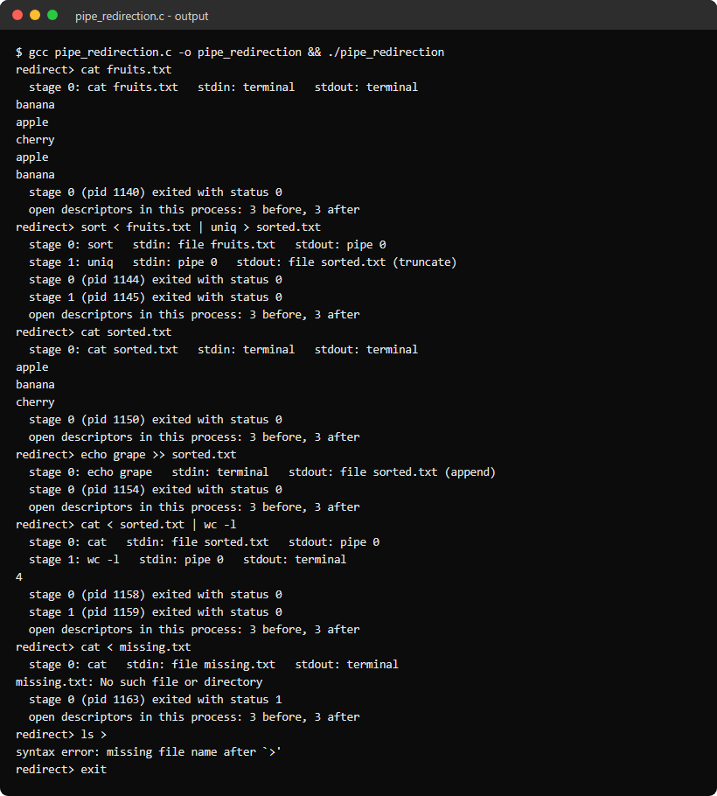

Program 24: Mini Shell
Aim
To write a small Unix shell in C that combines the previous programs: quoting, escapes, variable expansion, built-in commands, pipelines, I/O redirection, command lists and background jobs.
Algorithm
Step 1: Print a prompt with the user name and the current directory, and save each line in the history.
Step 2: Tokenise one command at a time up to ; or &, handling single quotes, double quotes, backslash escapes and $NAME, ${NAME} and $?, so each variable is expanded after the previous command has finished.
Step 3: Parse the tokens into pipeline stages with < > >> redirections. Run cd, pwd, echo, export, unset, history, help and exit inside the shell.
Step 4: Run other commands by forking one child per stage and connecting them with pipes and dup2(). Children restore the default SIGINT action, while the shell ignores Ctrl-C.
Step 5: A command ending in & runs in the background in its own process group; before each prompt the shell reaps finished jobs with waitpid(WNOHANG) and prints Done.
Program (mini_shell.c)
#include <stdio.h>
#include <stdlib.h>
#include <string.h>
#include <ctype.h>
#include <fcntl.h>
#include <signal.h>
#include <unistd.h>
#include <sys/wait.h>

#define MAX_TOKENS 128
#define MAX_ARGS 32
#define MAX_STAGES 8
#define MAX_JOBS 16
#define MAX_HISTORY 100

enum { T_WORD, T_PIPE, T_IN, T_OUT, T_APPEND, T_BG, T_SEMI };

struct token {
int type;
char *text;
};

struct stage {
char *argv[MAX_ARGS];
int argc;
};

struct command {
struct stage stages[MAX_STAGES];
int count;
char *in_file;
char *out_file;
int append;
};

struct job {
int used;
pid_t pids[MAX_STAGES];
int done[MAX_STAGES];
int count;
char text[256];
};

struct buffer {
char *data;
size_t len, cap;
};

static struct job jobs[MAX_JOBS];
static char *history[MAX_HISTORY];
static int history_count = 0;
static int last_status = 0;
static int running = 1;

static void buf_add(struct buffer *b, char c) {
if (b->len + 2 > b->cap) {
b->cap = b->cap ? b->cap * 2 : 32;
b->data = realloc(b->data, b->cap);
}
b->data[b->len++] = c;
b->data[b->len] = '\0';
}

static void buf_add_str(struct buffer *b, const char *s) {
while (*s != '\0')
buf_add(b, *s++);
}

/* line[*i] is '$': append the value of $?, $NAME or ${NAME} */
static void expand_var(const char *line, int *i, struct buffer *w) {
char name[64];
int j = 0, k = *i + 1;

if (line[k] == '?') {
char num[16];
snprintf(num, sizeof(num), "%d", last_status);
buf_add_str(w, num);
*i = k + 1;
return;
}
int braces = line[k] == '{';
if (braces)
k++;
while ((isalnum((unsigned char)line[k]) || line[k] == '_') && j < 63)
name[j++] = line[k++];
name[j] = '\0';
if (braces && line[k] == '}')
k++;
if (j == 0) {
buf_add(w, '$');
*i = *i + 1;
return;
}
const char *value = getenv(name);
if (value != NULL)
buf_add_str(w, value);
*i = k;
}

/*
* Reads one command starting at line[*pos], stopping after ; or & so that
* $? and $VAR are expanded only when the previous command has finished.
* *sep is set to T_SEMI, T_BG or -1 at the end of the line.
*/
static int tokenize(const char *line, int *pos, struct token *t, int *sep) {
int n = 0, i = *pos;

*sep = -1;
while (line[i] != '\0' && n < MAX_TOKENS) {
char c = line[i];
if (isspace((unsigned char)c)) {
i++;
continue;
}
if (c == ';' || c == '&') {
*sep = c == ';' ? T_SEMI : T_BG;
i++;
break;
}
if (strchr("|<>", c) != NULL) {
t[n].text = NULL;
if (c == '>' && line[i + 1] == '>') {
t[n].type = T_APPEND;
i++;
} else {
t[n].type = c == '|' ? T_PIPE : c == '<' ? T_IN : T_OUT;
}
n++;
i++;
continue;
}

struct buffer w = {NULL, 0, 0};
int quoted = 0;
while (line[i] != '\0' && !isspace((unsigned char)line[i]) && strchr("|<>&;", line[i]) == NULL) {
if (line[i] == '\\') {
if (line[i + 1] != '\0')
buf_add(&w, line[i + 1]);
i += line[i + 1] != '\0' ? 2 : 1;
} else if (line[i] == '\'') {
for (i++; line[i] != '\0' && line[i] != '\''; i++)
buf_add(&w, line[i]);
if (line[i] == '\0')
goto unterminated;
i++;
quoted = 1;
} else if (line[i] == '"') {
i++;
while (line[i] != '\0' && line[i] != '"') {
if (line[i] == '\\' && line[i + 1] != '\0' && strchr("\"\\$", line[i + 1]) != NULL) {
buf_add(&w, line[i + 1]);
i += 2;
} else if (line[i] == '$') {
expand_var(line, &i, &w);
} else {
buf_add(&w, line[i++]);
}
}
if (line[i] == '\0')
goto unterminated;
i++;
quoted = 1;
} else if (line[i] == '$') {
expand_var(line, &i, &w);
} else {
buf_add(&w, line[i++]);
}
}
if (w.len > 0 || quoted) {
t[n].type = T_WORD;
t[n].text = w.data != NULL ? w.data : strdup("");
n++;
}
continue;

unterminated:
free(w.data);
for (int k = 0; k < n; k++)
free(t[k].text);
return -1;
}
*pos = i;
return n;
}

static int parse(struct token *t, int end, struct command *cmd) {
memset(cmd, 0, sizeof(*cmd));
cmd->count = 1;
for (int k = 0; k < end; k++) {
struct stage *s = &cmd->stages[cmd->count - 1];
if (t[k].type == T_WORD) {
if (s->argc < MAX_ARGS - 1)
s->argv[s->argc++] = t[k].text;
} else if (t[k].type == T_PIPE) {
if (s->argc == 0 || cmd->count == MAX_STAGES) {
fprintf(stderr, "syntax error near `|'\n");
return -1;
}
cmd->count++;
} else {
if (k + 1 >= end || t[k + 1].type != T_WORD) {
fprintf(stderr, "syntax error: missing file name for redirection\n");
return -1;
}
if (t[k].type == T_IN) {
cmd->in_file = t[k + 1].text;
} else {
cmd->out_file = t[k + 1].text;
cmd->append = t[k].type == T_APPEND;
}
k++;
}
}
if (cmd->stages[cmd->count - 1].argc == 0) {
fprintf(stderr, "syntax error: missing command\n");
return -1;
}
return 0;
}

static int builtin(char **argv) {
if (strcmp(argv[0], "cd") == 0) {
const char *dir = argv[1];
if (dir == NULL)
dir = getenv("HOME");
else if (strcmp(dir, "-") == 0)
dir = getenv("OLDPWD");
char *old = getcwd(NULL, 0);
if (dir == NULL || chdir(dir) != 0) {
perror("cd");
free(old);
return 1;
}
if (old != NULL)
setenv("OLDPWD", old, 1);
free(old);
char *now = getcwd(NULL, 0);
if (now != NULL)
setenv("PWD", now, 1);
if (argv[1] != NULL && strcmp(argv[1], "-") == 0 && now != NULL)
printf("%s\n", now);
free(now);
return 0;
}
if (strcmp(argv[0], "pwd") == 0) {
char *cwd = getcwd(NULL, 0);
if (cwd == NULL) {
perror("pwd");
return 1;
}
printf("%s\n", cwd);
free(cwd);
return 0;
}
if (strcmp(argv[0], "echo") == 0) {
for (int i = 1; argv[i] != NULL; i++)
printf("%s%s", i > 1 ? " " : "", argv[i]);
printf("\n");
return 0;
}
if (strcmp(argv[0], "export") == 0) {
for (int i = 1; argv[i] != NULL; i++) {
char *eq = strchr(argv[i], '=');
if (eq == NULL)
continue;
*eq = '\0';
setenv(argv[i], eq + 1, 1);
*eq = '=';
}
return 0;
}
if (strcmp(argv[0], "unset") == 0) {
for (int i = 1; argv[i] != NULL; i++)
unsetenv(argv[i]);
return 0;
}
if (strcmp(argv[0], "history") == 0) {
for (int i = 0; i < history_count; i++)
printf("%4d %s\n", i + 1, history[i]);
return 0;
}
if (strcmp(argv[0], "help") == 0) {
printf("built-ins: cd [dir|-], pwd, echo, export NAME=value, unset NAME, history, help, exit [n]\n");
printf("also: cmd | cmd, < file, > file, >> file, cmd ; cmd, cmd &, 'quotes', \"quotes\", $VAR, $?\n");
return 0;
}
if (strcmp(argv[0], "exit") == 0) {
running = 0;
return argv[1] != NULL ? atoi(argv[1]) : last_status;
}
return -1;
}

static void describe(struct command *cmd, char *out, size_t size) {
out[0] = '\0';
for (int i = 0; i < cmd->count; i++) {
for (int j = 0; j < cmd->stages[i].argc; j++) {
strncat(out, cmd->stages[i].argv[j], size - strlen(out) - 1);
strncat(out, " ", size - strlen(out) - 1);
}
if (i < cmd->count - 1)
strncat(out, "| ", size - strlen(out) - 1);
}
out[strlen(out) - 1] = '\0';
}

static void start_child(struct command *cmd, int i, int pipes[][2], int background) {
signal(SIGINT, SIG_DFL);
/* a background job gets its own process group so Ctrl-C does not reach it */
if (background)
setpgid(0, 0);
if (i == 0 && cmd->in_file != NULL) {
int fd = open(cmd->in_file, O_RDONLY);
if (fd == -1) {
perror(cmd->in_file);
_exit(1);
}
dup2(fd, STDIN_FILENO);
close(fd);
}
if (i == cmd->count - 1 && cmd->out_file != NULL) {
int fd = open(cmd->out_file, O_WRONLY | O_CREAT | (cmd->append ? O_APPEND : O_TRUNC), 0644);
if (fd == -1) {
perror(cmd->out_file);
_exit(1);
}
dup2(fd, STDOUT_FILENO);
close(fd);
}
if (i > 0)
dup2(pipes[i - 1][0], STDIN_FILENO);
if (i < cmd->count - 1)
dup2(pipes[i][1], STDOUT_FILENO);
for (int j = 0; j < cmd->count - 1; j++) {
close(pipes[j][0]);
close(pipes[j][1]);
}
execvp(cmd->stages[i].argv[0], cmd->stages[i].argv);
fprintf(stderr, "%s: command not found\n", cmd->stages[i].argv[0]);
_exit(127);
}

static void run_command(struct command *cmd, int background) {
int pipes[MAX_STAGES - 1][2];
pid_t pids[MAX_STAGES];
int started = 0;

if (!background && cmd->count == 1 && cmd->in_file == NULL && cmd->out_file == NULL) {
int status = builtin(cmd->stages[0].argv);
if (status >= 0) {
last_status = status;
return;
}
}

for (int i = 0; i < cmd->count - 1; i++) {
if (pipe(pipes[i]) == -1) {
perror("pipe");
return;
}
}
fflush(stdout);
for (int i = 0; i < cmd->count; i++) {
pids[i] = fork();
if (pids[i] < 0) {
perror("fork");
break;
}
if (pids[i] == 0)
start_child(cmd, i, pipes, background);
started++;
}
for (int j = 0; j < cmd->count - 1; j++) {
close(pipes[j][0]);
close(pipes[j][1]);
}

if (background) {
int id = 0;
while (id < MAX_JOBS && jobs[id].used)
id++;
if (id == MAX_JOBS) {
fprintf(stderr, "too many background jobs\n");
return;
}
struct job *job = &jobs[id];
job->used = 1;
job->count = started;
for (int i = 0; i < started; i++) {
job->pids[i] = pids[i];
job->done[i] = 0;
}
describe(cmd, job->text, sizeof(job->text));
printf("[%d] %d\n", id + 1, pids[started - 1]);
last_status = 0;
return;
}

for (int i = 0; i < started; i++) {
int status;
waitpid(pids[i], &status, 0);
if (i == started - 1)
last_status = WIFEXITED(status) ? WEXITSTATUS(status) : 128 + WTERMSIG(status);
}
}

static void reap_jobs(void) {
for (int id = 0; id < MAX_JOBS; id++) {
if (!jobs[id].used)
continue;
int finished = 1;
for (int i = 0; i < jobs[id].count; i++) {
if (jobs[id].done[i])
continue;
pid_t r = waitpid(jobs[id].pids[i], NULL, WNOHANG);
if (r == 0)
finished = 0;
else
jobs[id].done[i] = 1;
}
if (finished) {
printf("[%d] Done %s\n", id + 1, jobs[id].text);
jobs[id].used = 0;
}
}
}

static void print_prompt(void) {
const char *user = getenv("USER");
const char *home = getenv("HOME");
char *cwd = getcwd(NULL, 0);
size_t hl = home != NULL ? strlen(home) : 0;

printf("%s@ossp:", user != NULL ? user : "user");
if (cwd != NULL && hl > 0 && strncmp(cwd, home, hl) == 0 && (cwd[hl] == '/' || cwd[hl] == '\0'))
printf("~%s$ ", cwd + hl);
else
printf("%s$ ", cwd != NULL ? cwd : "?");
free(cwd);
fflush(stdout);
}

int main(void) {
char line[1024];
struct token tokens[MAX_TOKENS];
struct command cmd;

signal(SIGINT, SIG_IGN);

while (running) {
reap_jobs();
print_prompt();
if (fgets(line, sizeof(line), stdin) == NULL) {
printf("\n");
break;
}
line[strcspn(line, "\n")] = '\0';
if (line[0] == '\0')
continue;
if (history_count < MAX_HISTORY)
history[history_count++] = strdup(line);

int pos = 0, sep;
while (running && line[pos] != '\0') {
int n = tokenize(line, &pos, tokens, &sep);
if (n < 0) {
fprintf(stderr, "syntax error: unterminated quote\n");
last_status = 2;
break;
}
if (n > 0) {
if (parse(tokens, n, &cmd) == 0)
run_command(&cmd, sep == T_BG);
else
last_status = 2;
}
for (int k = 0; k < n; k++)
free(tokens[k].text);
}
}

for (int i = 0; i < history_count; i++)
free(history[i]);
return last_status;
}
Output
