326 Final Project Code

2023-05-08

# Load Libraries

library(dplyr)

##   
## Attaching package: 'dplyr'

## The following objects are masked from 'package:stats':  
##   
## filter, lag

## The following objects are masked from 'package:base':  
##   
## intersect, setdiff, setequal, union

library(ggplot2)  
library(descr)   
library(tidyverse)

## ── Attaching packages  
## ───────────────────────────────────────  
## tidyverse 1.3.2 ──

## ✔ tibble 3.1.8 ✔ purrr 0.3.5  
## ✔ tidyr 1.2.1 ✔ stringr 1.4.1  
## ✔ readr 2.1.3 ✔ forcats 0.5.2  
## ── Conflicts ────────────────────────────────────────── tidyverse_conflicts() ──  
## ✖ dplyr::filter() masks stats::filter()  
## ✖ dplyr::lag() masks stats::lag()

library(labelled)  
library(janitor)

##   
## Attaching package: 'janitor'  
##   
## The following object is masked from 'package:descr':  
##   
## crosstab  
##   
## The following objects are masked from 'package:stats':  
##   
## chisq.test, fisher.test

library(pastecs)

##   
## Attaching package: 'pastecs'  
##   
## The following object is masked from 'package:tidyr':  
##   
## extract  
##   
## The following objects are masked from 'package:dplyr':  
##   
## first, last

library(haven)  
library(readstata13)  
library(sna)

## Loading required package: statnet.common  
##   
## Attaching package: 'statnet.common'  
##   
## The following objects are masked from 'package:base':  
##   
## attr, order  
##   
## Loading required package: network  
##   
## 'network' 1.18.1 (2023-01-24), part of the Statnet Project  
## * 'news(package="network")' for changes since last version  
## * 'citation("network")' for citation information  
## * 'https://statnet.org' for help, support, and other information  
##   
## sna: Tools for Social Network Analysis  
## Version 2.7-1 created on 2023-01-24.  
## copyright (c) 2005, Carter T. Butts, University of California-Irvine  
## For citation information, type citation("sna").  
## Type help(package="sna") to get started.

library(GGally)

## Registered S3 method overwritten by 'GGally':  
## method from   
## +.gg ggplot2

library(reshape2)

##   
## Attaching package: 'reshape2'  
##   
## The following object is masked from 'package:tidyr':  
##   
## smiths

library(viridis)

## Loading required package: viridisLite

library(lme4)

## Loading required package: Matrix  
##   
## Attaching package: 'Matrix'  
##   
## The following objects are masked from 'package:tidyr':  
##   
## expand, pack, unpack

library(sjPlot)  
library(MASS)

##   
## Attaching package: 'MASS'  
##   
## The following object is masked from 'package:dplyr':  
##   
## select

library(lme4)  
library(naniar)  
library(lattice)

# Import Data - Read Complete Data (network measures, all covars)

main <- read_csv("Data-Stata/our_data/main_326.csv")

## Rows: 1577 Columns: 76  
## ── Column specification ────────────────────────────────────────────────────────  
## Delimiter: ","  
## dbl (76): youthidCUF, classidCUF.x, schoolidCUF, schtype_geRV, y1_sex, y1_do...  
##   
## ℹ Use `spec()` to retrieve the full column specification for this data.  
## ℹ Specify the column types or set `show_col_types = FALSE` to quiet this message.

Check normality of outcome variable:

main <- main |>   
 filter(y1_sat2>0)  
  
  
shapiro.test(main$y1_sat2) # p-value < 0.05 implying that the distribution of the outcome are significantly different from normal

##   
## Shapiro-Wilk normality test  
##   
## data: main$y1_sat2  
## W = 0.95473, p-value < 2.2e-16

# create a Q-Q plot  
qqnorm(main$y1_sat2)  
qqline(main$y1_sat2)

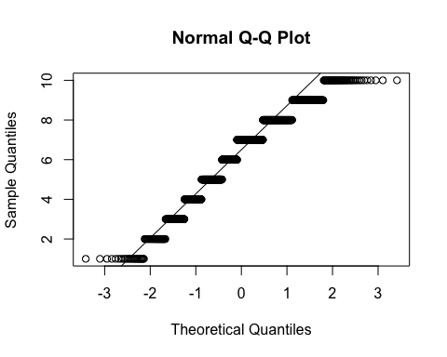

hist(main$y1_sat2)

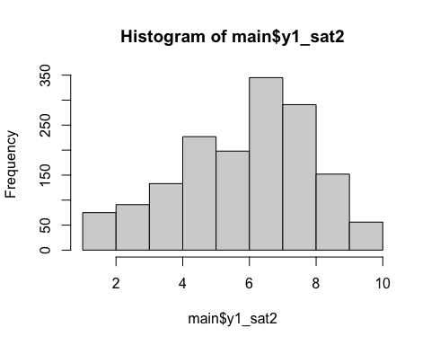

# Covariates:

Explore Covariate Distributions

covars <- c("youthidCUF","classidCUF","schoolidCUF","schtype_geRV","y1_sex","y1_doby","y1_nationRV","y1_lpsc1","y1_lpsc2","y1_lpsc3","y1_lpsc4","y1_fact","y1_sat2","y1_sat1", "y1_pbsch1","y1_pbsch2","y1_vict1","y1_vict2","y1_vict3","y1_pdisc1","y1_date", "y1_fcoh1","y1_fcoh2","y1_fcoh3","y1_fcoh4","y1_fcoh5","y1_pdem1","y1_pdem2","y1_pdem3","y1_pdem4","y1_pdem5","y1_pdem6","y1_pdem7","y1_pinv1","y1_pinv2","y1_pinv3", "y1_migage", "y1_educm3", "y1_educf3", "y1_gradem_geCUF", "y1_gradesc_geCUF", "y1_gradee_geCUF", "y1_repeat", "y1_iseimG", "y1_iseifG", "y1_edasp1CS", "y1_edasp2CS", "y1_edasp3CS", "y1_sspm", "y1_sspsc", "y1_sspe", "y1_seff1", "y1_seff2", "y1_valed1", "y1_asch2", "y1_asch1", "y1_tenc1", "y1_tenc2", "y1_tenc3", "y1_idsc", "y1_club", "y1_generationGCUF")  
  
  
main <- main |>   
 mutate_at(vars(setdiff(covars, 'y1_migage')), ~ ifelse(. < 0, NA, .))  
  
  
ggplot(main, aes(x = schtype_geRV)) +   
 geom_bar()

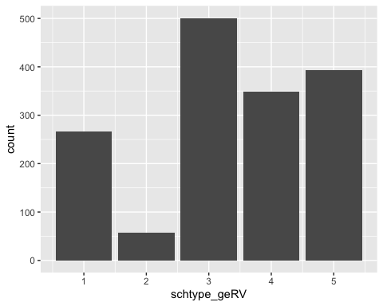

# plot nationality  
ggplot(main, aes(x = y1_nationRV)) +   
 geom_bar()

## Warning: Removed 15 rows containing non-finite values (`stat_count()`).

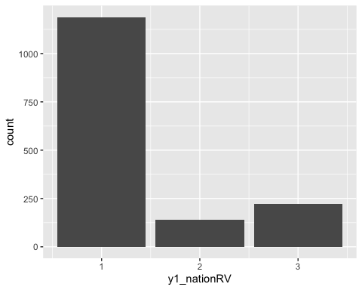

# plot age  
ggplot(main, aes(x = y1_doby)) +   
 geom_histogram()

## `stat_bin()` using `bins = 30`. Pick better value with `binwidth`.

## Warning: Removed 3 rows containing non-finite values (`stat_bin()`).

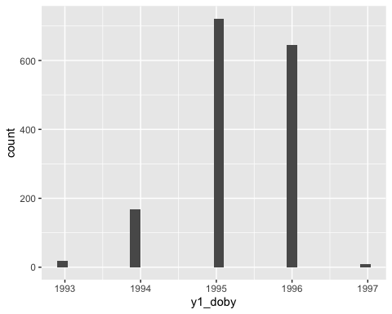

# plot y1_cot_sum  
ggplot(main, aes(x = y1_cot_sum)) +   
 geom_histogram()

## `stat_bin()` using `bins = 30`. Pick better value with `binwidth`.

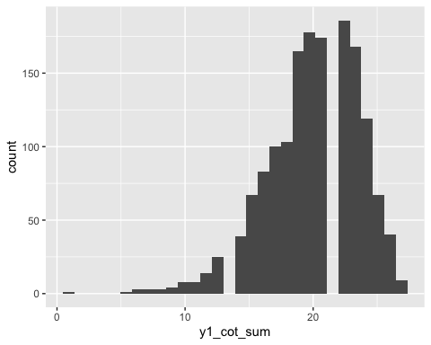

# plot y1_lat_sum  
ggplot(main, aes(x = y1_lat_sum)) +   
 geom_histogram()

## `stat_bin()` using `bins = 30`. Pick better value with `binwidth`.

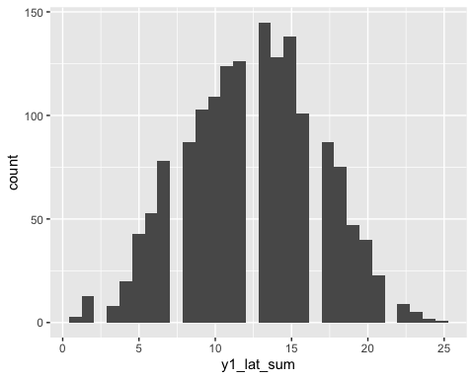

# plot sex  
ggplot(main, aes(x = y1_sex)) +   
 geom_bar()

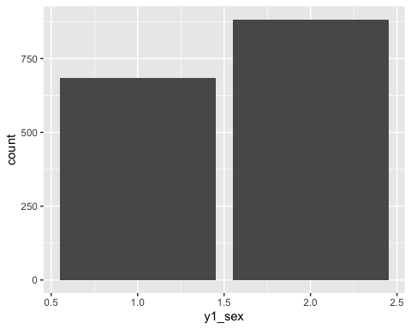

# plot Y1_migage  
ggplot(main, aes(x = y1_migage)) +   
 geom_histogram()

## `stat_bin()` using `bins = 30`. Pick better value with `binwidth`.

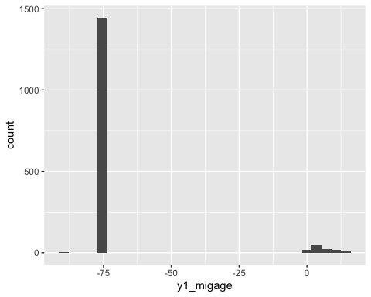

# plot Y1_nationRV  
ggplot(main, aes(x = y1_nationRV)) +   
 geom_bar()

## Warning: Removed 15 rows containing non-finite values (`stat_count()`).



# plot Y1_edasp1cs  
ggplot(main, aes(x = y1_edasp1CS)) +   
 geom_histogram()

## `stat_bin()` using `bins = 30`. Pick better value with `binwidth`.

## Warning: Removed 25 rows containing non-finite values (`stat_bin()`).

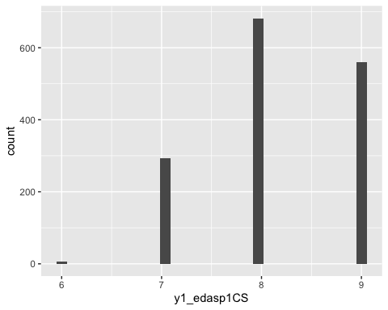

# plot Y1_edasp2cs  
ggplot(main, aes(x = y1_edasp2CS)) +   
 geom_histogram()

## `stat_bin()` using `bins = 30`. Pick better value with `binwidth`.

## Warning: Removed 96 rows containing non-finite values (`stat_bin()`).

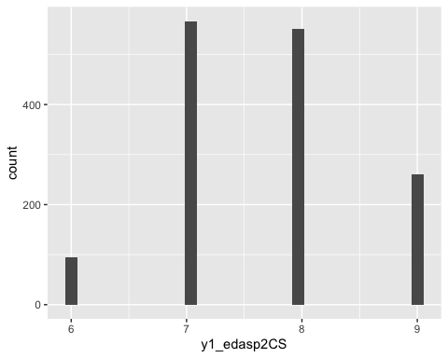

# plot Y1_edasp3cs  
ggplot(main, aes(x = y1_edasp3CS)) +   
 geom_histogram()

## `stat_bin()` using `bins = 30`. Pick better value with `binwidth`.

## Warning: Removed 175 rows containing non-finite values (`stat_bin()`).

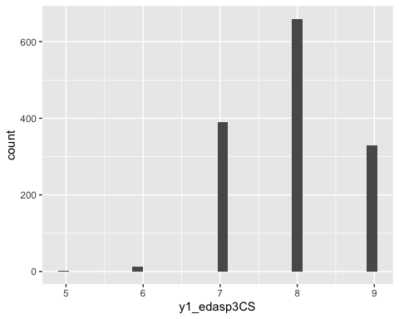

# plot Y1_sspm  
ggplot(main, aes(x = y1_sspm)) +   
 geom_histogram()

## `stat_bin()` using `bins = 30`. Pick better value with `binwidth`.

## Warning: Removed 1 rows containing non-finite values (`stat_bin()`).

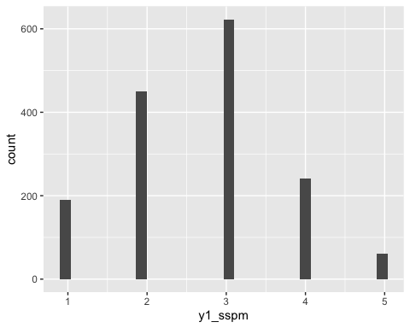

# plot Y1_sspsc  
ggplot(main, aes(x = y1_sspsc)) +   
 geom_histogram()

## `stat_bin()` using `bins = 30`. Pick better value with `binwidth`.

## Warning: Removed 2 rows containing non-finite values (`stat_bin()`).

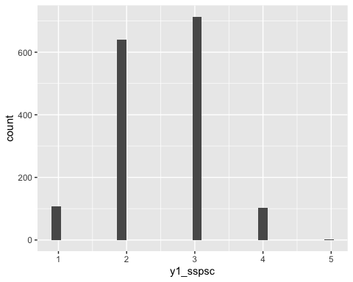

# plot Y1_sspe  
ggplot(main, aes(x = y1_sspe)) +   
 geom_histogram()

## `stat_bin()` using `bins = 30`. Pick better value with `binwidth`.

## Warning: Removed 3 rows containing non-finite values (`stat_bin()`).

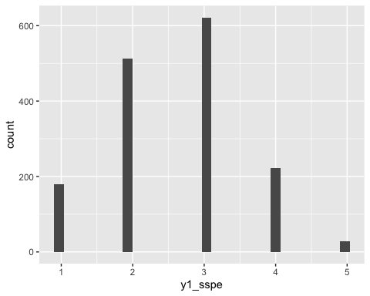

# plot Y1_gradem_geCUF  
ggplot(main, aes(x = y1_gradem_geCUF)) +   
 geom_bar()

## Warning: Removed 35 rows containing non-finite values (`stat_count()`).

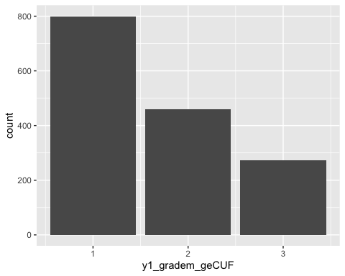

# plot Y1_grades_geCUF  
ggplot(main, aes(x = y1_gradesc_geCUF)) +   
 geom_bar()

## Warning: Removed 39 rows containing non-finite values (`stat_count()`).

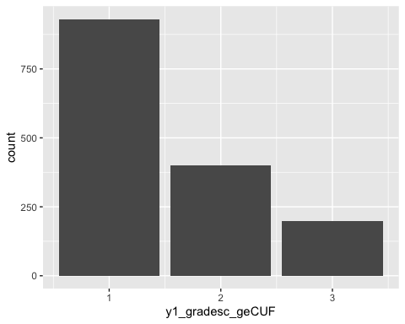

# plot Y1_gradee_geCUF  
ggplot(main, aes(x = y1_gradee_geCUF)) +   
 geom_bar()

## Warning: Removed 38 rows containing non-finite values (`stat_count()`).

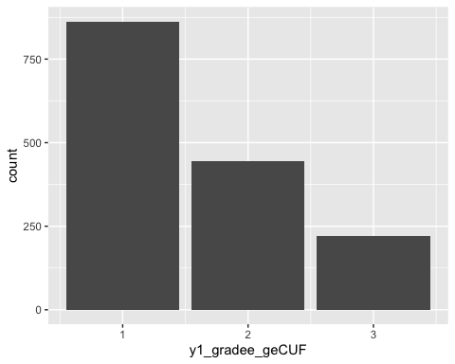

# plot Y1_repeat  
ggplot(main, aes(x = y1_repeat)) +   
 geom_bar()

## Warning: Removed 4 rows containing non-finite values (`stat_count()`).

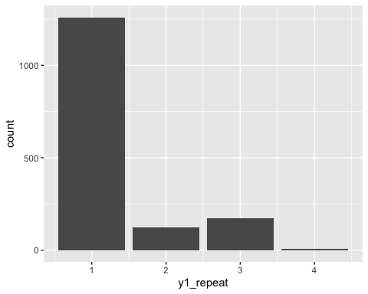

# plot Y1_seff1  
ggplot(main, aes(x = y1_seff1)) +   
 geom_histogram()

## `stat_bin()` using `bins = 30`. Pick better value with `binwidth`.

## Warning: Removed 3 rows containing non-finite values (`stat_bin()`).

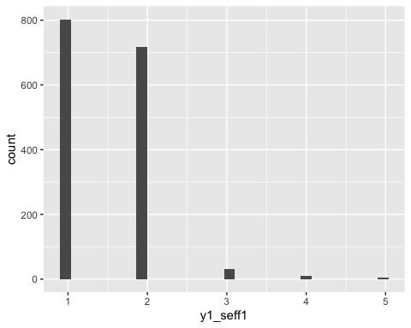

# plot Y1_asch1  
ggplot(main, aes(x = y1_asch1)) +   
 geom_histogram()

## `stat_bin()` using `bins = 30`. Pick better value with `binwidth`.

## Warning: Removed 5 rows containing non-finite values (`stat_bin()`).

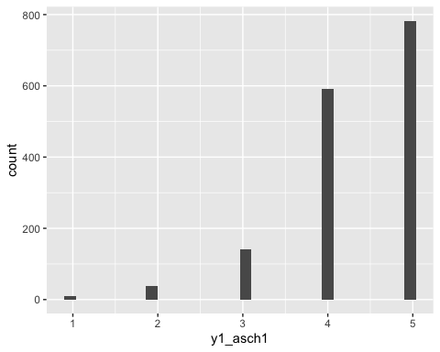

# plot Y1_asach2  
ggplot(main, aes(x = y1_asch2)) +   
 geom_histogram()

## `stat_bin()` using `bins = 30`. Pick better value with `binwidth`.

## Warning: Removed 6 rows containing non-finite values (`stat_bin()`).

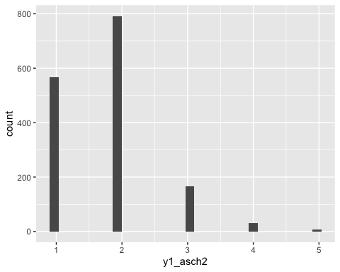

# plot Y1_valed1  
ggplot(main, aes(x = y1_valed1)) +   
 geom_histogram()

## `stat_bin()` using `bins = 30`. Pick better value with `binwidth`.

## Warning: Removed 3 rows containing non-finite values (`stat_bin()`).

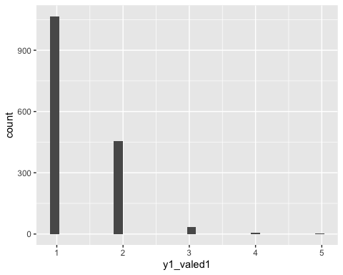

# MLM Analyses

## Clean/prep data for MLM analyses

main <- main |>   
 #create age variable  
 mutate(age = 2010 - main$y1_doby) |>   
 #create immigrant variable  
 mutate(immigrant = if_else(y1_generationGCUF == 0, 0, 1)) |>   
 #reverse code some of the likert (numeric) items:  
 mutate(  
 Y1_fact = 5 - y1_fact,  
 y1_vict1 = 5 - y1_vict1,  
 y1_vict2 = 5 - y1_vict2,  
 y1_vict3 = 5 - y1_vict3,  
 y1_pdisc1 = 5 - y1_pdisc1,  
 y1_fcoh1 = 5 - y1_fcoh1,  
 y1_idsc = 5 - y1_idsc  
 ) |>   
 mutate(  
 Y1_pbsch1 = 6 - y1_pbsch1,  
 y1_pbsch2 = 6 - y1_pbsch2,  
 y1_pdem1 = 6 - y1_pdem1,  
 y1_pdem2 = 6 - y1_pdem2,  
 y1_pdem3 = 6 - y1_pdem3,  
 y1_pdem4 = 6 - y1_pdem4,  
 y1_pdem5 = 6 - y1_pdem5,  
 y1_pdem6 = 6 - y1_pdem6,  
 y1_pdem7 = 6 - y1_pdem7,  
 y1_sspm = 6 - y1_sspm,  
 y1_sspsc = 6 - y1_sspsc,  
 y1_sspe = 6 - y1_sspe,  
 y1_seff1 = 6 - y1_seff1,  
 y1_seff2 = 6 - y1_seff2,  
 y1_asch2 = 6 - y1_asch2,  
 y1_valed1 = 6 - y1_valed1,  
 y1_tenc1 = 6 - y1_tenc1,  
 y1_tenc2 = 6 - y1_tenc2,  
 y1_tenc3 = 6 - y1_tenc3  
 )  
  
   
  
d_clean <- main |>   
 # change gender/ nationality / school type as factor  
 mutate(sex = as.factor(y1_sex),  
 immigrant = as.factor(immigrant),  
 schooltype = as.factor(schtype_geRV),  
 nationality = as.factor(y1_nationRV),  
 repeated_year = as.factor (y1_repeat),  
 mom_university = as.factor(y1_educm3),  
 dad_university = as.factor(y1_educf3),  
 club_member = as.factor(y1_club)) |>   
 #calculate composites:  
 mutate(sch_problem_behaviors = rowMeans(cbind(y1_pbsch1, y1_pbsch2)),  
 victimization = rowSums(cbind(y1_vict1, y1_vict2, y1_vict3)),  
 family_cohesion = rowMeans(cbind(y1_fcoh1, y1_fcoh2, y1_fcoh3)),  
 parent_support = rowMeans(cbind(y1_pdem1, y1_pdem5, y1_pdem6, y1_pdem7)),  
 parent_strict = rowMeans(cbind(y1_pdem2, y1_pdem3, y1_pdem4)),  
 subj_school_perform = rowMeans(cbind(y1_sspm, y1_sspsc, y1_sspe)),  
 sch_confidence = rowMeans(cbind(y1_seff2, y1_seff1, y1_asch1)),  
 sch_important = rowMeans(cbind(y1_asch2, y1_valed1)),  
 teacher_support = rowMeans(cbind(y1_tenc1, y1_tenc2)),  
 unfair_teach = y1_tenc3,  
 identity_german = y1_idsc,  
 ISEI_mom = y1_iseimG,  
 ISEI_dad = y1_iseifG,  
 ISEI_parent = ifelse(is.na(ISEI_dad), ISEI_mom,  
 ifelse(is.na(ISEI_mom), ISEI_dad,  
 rowMeans(cbind(ISEI_dad,ISEI_mom)))),  
 mig_age = y1_migage,  
 sch_discrimination = y1_pdisc1,  
 cant_afford = y1_fact,  
 german_skills = rowMeans(cbind(y1_lpsc1, y1_lpsc2, y1_lpsc3, y1_lpsc4)),  
 age = as.numeric(age),  
 class_size = as.numeric(class_size),  
 sch_satisfaction = as.numeric(y1_sat2),  
 lang_test = as.numeric(y1_lat_sum),  
 cog_test = as.numeric(y1_cot_sum))   
  
d_analysis <- d_clean |>   
 dplyr::select(lang_test, cog_test, sch_satisfaction, class_size, age, german_skills, cant_afford, sch_discrimination, mig_age, ISEI_dad, ISEI_mom, identity_german, unfair_teach, teacher_support, sch_important, sch_confidence, subj_school_perform, parent_strict, parent_support, family_cohesion, victimization, club_member, dad_university, mom_university, repeated_year, nationality, schooltype, immigrant, sex, youthidCUF, classidCUF, schoolidCUF, pos_indegree, pos_outdegree, pos_isolate, neg_indegree, neg_outdegree, neg_isolate, n_mutual_bfs, non_reciprocal, ISEI_parent)

Mean-center and recode dummy variables

numeric_vars <- c("age", "mig_age", "class_size", "subj_school_perform", "cog_test", "lang_test", "ISEI_parent", "victimization", "neg_indegree", "neg_outdegree", "n_mutual_bfs", "pos_indegree", "pos_outdegree", "non_reciprocal")  
  
numeric_vars <- setNames(numeric_vars, str_c(numeric_vars, "_c"))   
numeric_vars

## age_c mig_age_c class_size_c   
## "age" "mig_age" "class_size"   
## subj_school_perform_c cog_test_c lang_test_c   
## "subj_school_perform" "cog_test" "lang_test"   
## ISEI_parent_c victimization_c neg_indegree_c   
## "ISEI_parent" "victimization" "neg_indegree"   
## neg_outdegree_c n_mutual_bfs_c pos_indegree_c   
## "neg_outdegree" "n_mutual_bfs" "pos_indegree"   
## pos_outdegree_c non_reciprocal_c   
## "pos_outdegree" "non_reciprocal"

d_analysis <- d_analysis |>   
 mutate(across(numeric_vars, ~ as.numeric(.))) |>   
 mutate(across(numeric_vars, ~. - mean(., na.rm = TRUE))) |>   
 mutate(german = if_else(nationality == 3, 0, 1)) |>   
 mutate(repeated_year = if_else(repeated_year ==1, 0, 1)) |>   
 mutate(mom_university = if_else(mom_university ==2, 0, 1)) |>   
 mutate(dad_university = if_else(dad_university ==2, 0, 1)) |>   
 mutate(club_member = if_else(club_member ==2, 0, 1)) |>   
 mutate(sch_combo = if_else(schooltype == 2, 1, 0)) |>   
 mutate(sch_int = if_else(schooltype==3, 1, 0)) |>   
 mutate(sch_comp = if_else(schooltype==4, 1,0)) |>   
 mutate(sch_secondary = if_else(schooltype==5, 1,0)) |>   
 mutate(sch_specneed = if_else(schooltype==6, 1,0)) |>   
 mutate(sexgirl = if_else(sex == 2, 1, 0))

## Warning: Using an external vector in selections was deprecated in tidyselect 1.1.0.  
## ℹ Please use `all_of()` or `any_of()` instead.  
## # Was:  
## data %>% select(numeric_vars)  
##   
## # Now:  
## data %>% select(all_of(numeric_vars))  
##   
## See <https://tidyselect.r-lib.org/reference/faq-external-vector.html>.

miss_var_summary(d_analysis)

## # A tibble: 62 × 3  
## variable n_miss pct_miss  
## <chr> <int> <dbl>  
## 1 dad_university 365 23.3   
## 2 mom_university 279 17.8   
## 3 ISEI_dad 224 14.3   
## 4 ISEI_mom 208 13.3   
## 5 cant_afford 79 5.04  
## 6 ISEI_parent 62 3.95  
## 7 ISEI_parent_c 62 3.95  
## 8 club_member 37 2.36  
## 9 identity_german 21 1.34  
## 10 family_cohesion 17 1.08  
## # … with 52 more rows

#get rid of highly missing vars to maximize sample:  
d_analysis <- d_analysis |>   
 dplyr::select(-c(mom_university, dad_university, ISEI_mom, ISEI_dad)) |>   
 na.omit()

write_csv(d_analysis, "Data-Stata/our_data/d_analysis_326.csv")

d_analysis <- read_csv("Data-Stata/our_data/d_analysis_326.csv")

## Rows: 1337 Columns: 58  
## ── Column specification ────────────────────────────────────────────────────────  
## Delimiter: ","  
## dbl (58): lang_test, cog_test, sch_satisfaction, class_size, age, german_ski...  
##   
## ℹ Use `spec()` to retrieve the full column specification for this data.  
## ℹ Specify the column types or set `show_col_types = FALSE` to quiet this message.

m1: no random intercepts

# m1 <- glm(sch_satisfaction ~ 1, data = d_analysis,  
# family = gaussian(link = "log"))  
  
m1 <- lm(sch_satisfaction ~ 1, data = d_analysis)  
summary(m1)

##   
## Call:  
## lm(formula = sch_satisfaction ~ 1, data = d_analysis)  
##   
## Residuals:  
## Min 1Q Median 3Q Max   
## -5.3957 -1.3957 0.6043 1.6043 3.6043   
##   
## Coefficients:  
## Estimate Std. Error t value Pr(>|t|)   
## (Intercept) 6.3957 0.0547 116.9 <2e-16 ***  
## ---  
## Signif. codes: 0 '***' 0.001 '**' 0.01 '*' 0.05 '.' 0.1 ' ' 1  
##   
## Residual standard error: 2 on 1336 degrees of freedom

*Hi Emma, great work. And for your question, it would be better to add variables one by one and compare the models to be able to interpret the results more clearly.

## Hypothesis 1: Null Model (Intercept-Only)

The null hypothesis here is that there is no correlation between students within different classes and schools on the outcome: school satisfaction. The alternative would be that there is systematic between-class and between-school variation in students’ school satisfaction ratings.

m2: random intercepts (class)

m2 <- lmer(sch_satisfaction ~ (1 | classidCUF), data = d_analysis,  
 REML = F)  
summary(m2)

## Linear mixed model fit by maximum likelihood ['lmerMod']  
## Formula: sch_satisfaction ~ (1 | classidCUF)  
## Data: d_analysis  
##   
## AIC BIC logLik deviance df.resid   
## 5651.1 5666.7 -2822.5 5645.1 1334   
##   
## Scaled residuals:   
## Min 1Q Median 3Q Max   
## -2.7704 -0.6948 0.2663 0.7790 1.8652   
##   
## Random effects:  
## Groups Name Variance Std.Dev.  
## classidCUF (Intercept) 0.07285 0.2699   
## Residual 3.92462 1.9811   
## Number of obs: 1337, groups: classidCUF, 159  
##   
## Fixed effects:  
## Estimate Std. Error t value  
## (Intercept) 6.39306 0.05885 108.6

ICC:

randompar <- as_tibble(VarCorr(m2))  
randompar

## # A tibble: 2 × 5  
## grp var1 var2 vcov sdcor  
## <chr> <chr> <chr> <dbl> <dbl>  
## 1 classidCUF (Intercept) <NA> 0.0729 0.270  
## 2 Residual <NA> <NA> 3.92 1.98

var_class <- randompar[1,4]  
var_pupil <- randompar[2,4]  
var_class / (var_pupil + var_class)

## vcov  
## 1 0.01822504

.072 / (.072 + 3.92)

## [1] 0.01803607

1.8% of the variation in school satisfaction is on the class level

(2* logLik(m2)) - (2* logLik(m1))

## 'log Lik.' 1.544684 (df=3)

tab_model(m1, m2)

sch satisfaction

sch satisfaction

Predictors

Estimates

CI

p

Estimates

CI

p

(Intercept)

6.40

6.29 – 6.50

<0.001

6.39

6.28 – 6.51

<0.001

Random Effects

σ2

3.92

τ00

0.07 classidCUF

ICC

0.02

N

159 classidCUF

Observations

1337

1337

R2 / R2 adjusted

0.000 / 0.000

0.000 / 0.018

m3: random intercepts (school)

m3 <- lmer(sch_satisfaction ~ (1 | schoolidCUF/classidCUF), data = d_analysis,  
 REML = F, na.action = na.omit)  
summary(m3)

## Linear mixed model fit by maximum likelihood ['lmerMod']  
## Formula: sch_satisfaction ~ (1 | schoolidCUF/classidCUF)  
## Data: d_analysis  
##   
## AIC BIC logLik deviance df.resid   
## 5652.1 5672.9 -2822.1 5644.1 1333   
##   
## Scaled residuals:   
## Min 1Q Median 3Q Max   
## -2.7942 -0.7035 0.2577 0.7764 1.9073   
##   
## Random effects:  
## Groups Name Variance Std.Dev.  
## classidCUF:schoolidCUF (Intercept) 0.003925 0.06265   
## schoolidCUF (Intercept) 0.073681 0.27144   
## Residual 3.921374 1.98025   
## Number of obs: 1337, groups: classidCUF:schoolidCUF, 159; schoolidCUF, 97  
##   
## Fixed effects:  
## Estimate Std. Error t value  
## (Intercept) 6.39247 0.06235 102.5

anova(m3, m2)

## Data: d_analysis  
## Models:  
## m2: sch_satisfaction ~ (1 | classidCUF)  
## m3: sch_satisfaction ~ (1 | schoolidCUF/classidCUF)  
## npar AIC BIC logLik deviance Chisq Df Pr(>Chisq)  
## m2 3 5651.1 5666.7 -2822.6 5645.1   
## m3 4 5652.1 5672.9 -2822.1 5644.1 0.977 1 0.3229

tab_model(m2, m3)

sch satisfaction

sch satisfaction

Predictors

Estimates

CI

p

Estimates

CI

p

(Intercept)

6.39

6.28 – 6.51

<0.001

6.39

6.27 – 6.51

<0.001

Random Effects

σ2

3.92

3.92

τ00

0.07 classidCUF

0.00 classidCUF:schoolidCUF

0.07 schoolidCUF

ICC

0.02

0.02

N

159 classidCUF

159 classidCUF

97 schoolidCUF

Observations

1337

1337

Marginal R2 / Conditional R2

0.000 / 0.018

0.000 / 0.019

The variance explained at the school level overlaps strongly with that explained by class (we see classidCUF random effect variance –> 0)

Likely not suitable for 3 levels; we choose to only use the class-level from here on out. In addition, our only school-level variable (school type) did not seem to explain any of the variance in our school satisfaction outcome

## Hypothesis 2: Add Level 1 Predictors

The null hypothesis is that there is no relationship between level 1 (student-level) predictors (student’s social network measures (centrality, reciprocity), student-level demographic covariates) and outcome. The alternative is there is a relationship between network measures and school satisfaction

m4: add student-level covariates

# m4 <- lmer(sch_satisfaction ~ (1 | schoolidCUF) + (1 | classidCUF)  
# + pos_indegree + pos_outdegree + neg_indegree + neg_outdegree + pos_isolate + neg_isolate + n_mutual_bfs + non_reciprocal  
# + sex + lang_test + cog_test + age + nationality + immigrant, data = d_analysis,  
# REML = F, na.action = na.omit)  
# summary(m4)  
  
m4 <- lmer(sch_satisfaction ~ pos_indegree_c + pos_outdegree_c + neg_indegree_c + neg_outdegree_c + pos_isolate + neg_isolate + n_mutual_bfs_c + non_reciprocal_c  
 + sexgirl + lang_test_c + cog_test_c + age_c + immigrant + victimization_c + ISEI_parent_c  
 + (1 | classidCUF), data = d_analysis,  
 REML = F, na.action = na.omit)  
summary(m4)

## Linear mixed model fit by maximum likelihood ['lmerMod']  
## Formula:   
## sch_satisfaction ~ pos_indegree_c + pos_outdegree_c + neg_indegree_c +   
## neg_outdegree_c + pos_isolate + neg_isolate + n_mutual_bfs_c +   
## non_reciprocal_c + sexgirl + lang_test_c + cog_test_c + age_c +   
## immigrant + victimization_c + ISEI_parent_c + (1 | classidCUF)  
## Data: d_analysis  
##   
## AIC BIC logLik deviance df.resid   
## 5596.0 5689.6 -2780.0 5560.0 1319   
##   
## Scaled residuals:   
## Min 1Q Median 3Q Max   
## -2.8782 -0.6797 0.1482 0.7153 2.6276   
##   
## Random effects:  
## Groups Name Variance Std.Dev.  
## classidCUF (Intercept) 0.02565 0.1602   
## Residual 3.72115 1.9290   
## Number of obs: 1337, groups: classidCUF, 159  
##   
## Fixed effects:  
## Estimate Std. Error t value  
## (Intercept) 6.3924915 0.0970356 65.878  
## pos_indegree_c -0.0580063 0.0526550 -1.102  
## pos_outdegree_c -0.0509138 0.1332175 -0.382  
## neg_indegree_c -0.0502168 0.0220411 -2.278  
## neg_outdegree_c -0.0489885 0.0346058 -1.416  
## pos_isolate -1.4255082 0.5583677 -2.553  
## neg_isolate 0.5279666 0.4043975 1.306  
## n_mutual_bfs_c 0.3205211 0.1990452 1.610  
## non_reciprocal_c 0.1826782 0.1866764 0.979  
## sexgirl -0.0006857 0.1119994 -0.006  
## lang_test_c 0.0168574 0.0149601 1.127  
## cog_test_c 0.0190369 0.0166013 1.147  
## age_c -0.3029236 0.0808881 -3.745  
## immigrant -0.0184612 0.1203080 -0.153  
## victimization_c -0.0961348 0.0363668 -2.643  
## ISEI_parent_c -0.0093062 0.0032550 -2.859

##   
## Correlation matrix not shown by default, as p = 16 > 12.  
## Use print(x, correlation=TRUE) or  
## vcov(x) if you need it

anova(m4, m2)

## Data: d_analysis  
## Models:  
## m2: sch_satisfaction ~ (1 | classidCUF)  
## m4: sch_satisfaction ~ pos_indegree_c + pos_outdegree_c + neg_indegree_c + neg_outdegree_c + pos_isolate + neg_isolate + n_mutual_bfs_c + non_reciprocal_c + sexgirl + lang_test_c + cog_test_c + age_c + immigrant + victimization_c + ISEI_parent_c + (1 | classidCUF)  
## npar AIC BIC logLik deviance Chisq Df Pr(>Chisq)   
## m2 3 5651.1 5666.7 -2822.6 5645.1   
## m4 18 5596.0 5689.6 -2780.0 5560.0 85.075 15 8.15e-12 ***  
## ---  
## Signif. codes: 0 '***' 0.001 '**' 0.01 '*' 0.05 '.' 0.1 ' ' 1

tab_model(m2, m4)

sch satisfaction

sch satisfaction

Predictors

Estimates

CI

p

Estimates

CI

p

(Intercept)

6.39

6.28 – 6.51

<0.001

6.39

6.20 – 6.58

<0.001

pos indegree c

-0.06

-0.16 – 0.05

0.271

pos outdegree c

-0.05

-0.31 – 0.21

0.702

neg indegree c

-0.05

-0.09 – -0.01

0.023

neg outdegree c

-0.05

-0.12 – 0.02

0.157

pos isolate

-1.43

-2.52 – -0.33

0.011

neg isolate

0.53

-0.27 – 1.32

0.192

n mutual bfs c

0.32

-0.07 – 0.71

0.108

non reciprocal c

0.18

-0.18 – 0.55

0.328

sexgirl

-0.00

-0.22 – 0.22

0.995

lang test c

0.02

-0.01 – 0.05

0.260

cog test c

0.02

-0.01 – 0.05

0.252

age c

-0.30

-0.46 – -0.14

<0.001

immigrant

-0.02

-0.25 – 0.22

0.878

victimization c

-0.10

-0.17 – -0.02

0.008

ISEI parent c

-0.01

-0.02 – -0.00

0.004

Random Effects

σ2

3.92

3.72

τ00

0.07 classidCUF

0.03 classidCUF

ICC

0.02

0.01

N

159 classidCUF

159 classidCUF

Observations

1337

1337

Marginal R2 / Conditional R2

0.000 / 0.018

0.062 / 0.069

Model 4 does significantly better than model 2 (p < .001)! We reject the hypothesis that level 1 predictors do not explain our school satisfaction outcome

Calculate the r2s (explained variance) as explained in the lecture:

#classidCUF:  
(0.073 - 0.026)/0.073

## [1] 0.6438356

#residual:  
(3.92- 3.72)/3.92

## [1] 0.05102041

Now let’s see if the effects of network measures on school satisfaction varies across other level 1 predictors (e.g., immigrant status, gender).

age:

m4_ageint <- lmer(sch_satisfaction ~ pos_indegree_c + pos_outdegree_c + neg_indegree_c + neg_outdegree_c + pos_isolate + neg_isolate + n_mutual_bfs_c + non_reciprocal_c  
 + sexgirl + lang_test_c + cog_test_c + age_c + immigrant + victimization_c + ISEI_parent_c  
 + (1 | classidCUF) + age_c*pos_indegree_c + age_c*pos_outdegree_c + age_c*neg_indegree_c + age_c*neg_outdegree_c + age_c*pos_isolate + age_c*neg_isolate + age_c*n_mutual_bfs_c + age_c*non_reciprocal_c, data = d_analysis,  
 REML = F, na.action = na.omit)  
summary(m4_ageint)

## Linear mixed model fit by maximum likelihood ['lmerMod']  
## Formula:   
## sch_satisfaction ~ pos_indegree_c + pos_outdegree_c + neg_indegree_c +   
## neg_outdegree_c + pos_isolate + neg_isolate + n_mutual_bfs_c +   
## non_reciprocal_c + sexgirl + lang_test_c + cog_test_c + age_c +   
## immigrant + victimization_c + ISEI_parent_c + (1 | classidCUF) +   
## age_c * pos_indegree_c + age_c * pos_outdegree_c + age_c *   
## neg_indegree_c + age_c * neg_outdegree_c + age_c * pos_isolate +   
## age_c * neg_isolate + age_c * n_mutual_bfs_c + age_c * non_reciprocal_c  
## Data: d_analysis  
##   
## AIC BIC logLik deviance df.resid   
## 5605.9 5741.1 -2777.0 5553.9 1311   
##   
## Scaled residuals:   
## Min 1Q Median 3Q Max   
## -2.8558 -0.6868 0.1349 0.7183 2.7063   
##   
## Random effects:  
## Groups Name Variance Std.Dev.  
## classidCUF (Intercept) 0.02124 0.1457   
## Residual 3.70825 1.9257   
## Number of obs: 1337, groups: classidCUF, 159  
##   
## Fixed effects:  
## Estimate Std. Error t value  
## (Intercept) 6.396679 0.097069 65.899  
## pos_indegree_c -0.060986 0.053165 -1.147  
## pos_outdegree_c -0.048222 0.133864 -0.360  
## neg_indegree_c -0.055284 0.022134 -2.498  
## neg_outdegree_c -0.045895 0.034599 -1.326  
## pos_isolate -1.358837 0.617857 -2.199  
## neg_isolate 0.526362 0.410869 1.281  
## n_mutual_bfs_c 0.317627 0.199914 1.589  
## non_reciprocal_c 0.177184 0.188168 0.942  
## sexgirl -0.008009 0.112190 -0.071  
## lang_test_c 0.016913 0.014970 1.130  
## cog_test_c 0.018653 0.016611 1.123  
## age_c -0.302200 0.082376 -3.669  
## immigrant -0.021917 0.120306 -0.182  
## victimization_c -0.090249 0.036493 -2.473  
## ISEI_parent_c -0.009614 0.003250 -2.958  
## pos_indegree_c:age_c -0.003532 0.077544 -0.046  
## pos_outdegree_c:age_c 0.031243 0.197353 0.158  
## neg_indegree_c:age_c -0.048021 0.029815 -1.611  
## neg_outdegree_c:age_c 0.082931 0.048778 1.700  
## pos_isolate:age_c -0.211617 0.643750 -0.329  
## neg_isolate:age_c 0.132625 0.622149 0.213  
## n_mutual_bfs_c:age_c -0.086721 0.283105 -0.306  
## non_reciprocal_c:age_c -0.050942 0.270944 -0.188

##   
## Correlation matrix not shown by default, as p = 24 > 12.  
## Use print(x, correlation=TRUE) or  
## vcov(x) if you need it

anova(m4_ageint, m4)

## Data: d_analysis  
## Models:  
## m4: sch_satisfaction ~ pos_indegree_c + pos_outdegree_c + neg_indegree_c + neg_outdegree_c + pos_isolate + neg_isolate + n_mutual_bfs_c + non_reciprocal_c + sexgirl + lang_test_c + cog_test_c + age_c + immigrant + victimization_c + ISEI_parent_c + (1 | classidCUF)  
## m4_ageint: sch_satisfaction ~ pos_indegree_c + pos_outdegree_c + neg_indegree_c + neg_outdegree_c + pos_isolate + neg_isolate + n_mutual_bfs_c + non_reciprocal_c + sexgirl + lang_test_c + cog_test_c + age_c + immigrant + victimization_c + ISEI_parent_c + (1 | classidCUF) + age_c * pos_indegree_c + age_c * pos_outdegree_c + age_c * neg_indegree_c + age_c * neg_outdegree_c + age_c * pos_isolate + age_c * neg_isolate + age_c * n_mutual_bfs_c + age_c * non_reciprocal_c  
## npar AIC BIC logLik deviance Chisq Df Pr(>Chisq)  
## m4 18 5596.0 5689.6 -2780 5560.0   
## m4_ageint 26 5605.9 5741.1 -2777 5553.9 6.1113 8 0.6348

tab_model(m4, m4_ageint)

sch satisfaction

sch satisfaction

Predictors

Estimates

CI

p

Estimates

CI

p

(Intercept)

6.39

6.20 – 6.58

<0.001

6.40

6.21 – 6.59

<0.001

pos indegree c

-0.06

-0.16 – 0.05

0.271

-0.06

-0.17 – 0.04

0.252

pos outdegree c

-0.05

-0.31 – 0.21

0.702

-0.05

-0.31 – 0.21

0.719

neg indegree c

-0.05

-0.09 – -0.01

0.023

-0.06

-0.10 – -0.01

0.013

neg outdegree c

-0.05

-0.12 – 0.02

0.157

-0.05

-0.11 – 0.02

0.185

pos isolate

-1.43

-2.52 – -0.33

0.011

-1.36

-2.57 – -0.15

0.028

neg isolate

0.53

-0.27 – 1.32

0.192

0.53

-0.28 – 1.33

0.200

n mutual bfs c

0.32

-0.07 – 0.71

0.108

0.32

-0.07 – 0.71

0.112

non reciprocal c

0.18

-0.18 – 0.55

0.328

0.18

-0.19 – 0.55

0.347

sexgirl

-0.00

-0.22 – 0.22

0.995

-0.01

-0.23 – 0.21

0.943

lang test c

0.02

-0.01 – 0.05

0.260

0.02

-0.01 – 0.05

0.259

cog test c

0.02

-0.01 – 0.05

0.252

0.02

-0.01 – 0.05

0.262

age c

-0.30

-0.46 – -0.14

<0.001

-0.30

-0.46 – -0.14

<0.001

immigrant

-0.02

-0.25 – 0.22

0.878

-0.02

-0.26 – 0.21

0.855

victimization c

-0.10

-0.17 – -0.02

0.008

-0.09

-0.16 – -0.02

0.014

ISEI parent c

-0.01

-0.02 – -0.00

0.004

-0.01

-0.02 – -0.00

0.003

pos indegree c × age c

-0.00

-0.16 – 0.15

0.964

pos outdegree c × age c

0.03

-0.36 – 0.42

0.874

neg indegree c × age c

-0.05

-0.11 – 0.01

0.108

neg outdegree c × age c

0.08

-0.01 – 0.18

0.089

pos isolate × age c

-0.21

-1.47 – 1.05

0.742

neg isolate × age c

0.13

-1.09 – 1.35

0.831

n mutual bfs c × age c

-0.09

-0.64 – 0.47

0.759

non reciprocal c × age c

-0.05

-0.58 – 0.48

0.851

Random Effects

σ2

3.72

3.71

τ00

0.03 classidCUF

0.02 classidCUF

ICC

0.01

0.01

N

159 classidCUF

159 classidCUF

Observations

1337

1337

Marginal R2 / Conditional R2

0.062 / 0.069

0.067 / 0.072

immigrant status:

m4_immint <- lmer(sch_satisfaction ~ pos_indegree_c + pos_outdegree_c + neg_indegree_c + neg_outdegree_c + pos_isolate + neg_isolate + n_mutual_bfs_c + non_reciprocal_c  
 + sexgirl + lang_test_c + cog_test_c + age_c + immigrant + victimization_c + ISEI_parent_c  
 + (1 | classidCUF) + immigrant*pos_indegree_c + immigrant*pos_outdegree_c + immigrant*neg_indegree_c + immigrant*neg_outdegree_c + immigrant*pos_isolate + immigrant*neg_isolate + immigrant*n_mutual_bfs_c + immigrant*non_reciprocal_c, data = d_analysis,  
 REML = F, na.action = na.omit)  
#summary(m4_immint)  
  
anova(m4_immint, m4)

## Data: d_analysis  
## Models:  
## m4: sch_satisfaction ~ pos_indegree_c + pos_outdegree_c + neg_indegree_c + neg_outdegree_c + pos_isolate + neg_isolate + n_mutual_bfs_c + non_reciprocal_c + sexgirl + lang_test_c + cog_test_c + age_c + immigrant + victimization_c + ISEI_parent_c + (1 | classidCUF)  
## m4_immint: sch_satisfaction ~ pos_indegree_c + pos_outdegree_c + neg_indegree_c + neg_outdegree_c + pos_isolate + neg_isolate + n_mutual_bfs_c + non_reciprocal_c + sexgirl + lang_test_c + cog_test_c + age_c + immigrant + victimization_c + ISEI_parent_c + (1 | classidCUF) + immigrant * pos_indegree_c + immigrant * pos_outdegree_c + immigrant * neg_indegree_c + immigrant * neg_outdegree_c + immigrant * pos_isolate + immigrant * neg_isolate + immigrant * n_mutual_bfs_c + immigrant * non_reciprocal_c  
## npar AIC BIC logLik deviance Chisq Df Pr(>Chisq)  
## m4 18 5596.0 5689.6 -2780.0 5560.0   
## m4_immint 26 5603.3 5738.5 -2775.7 5551.3 8.6811 8 0.3699

tab_model(m4, m4_immint)

sch satisfaction

sch satisfaction

Predictors

Estimates

CI

p

Estimates

CI

p

(Intercept)

6.39

6.20 – 6.58

<0.001

6.40

6.21 – 6.59

<0.001

pos indegree c

-0.06

-0.16 – 0.05

0.271

-0.05

-0.18 – 0.07

0.427

pos outdegree c

-0.05

-0.31 – 0.21

0.702

0.01

-0.31 – 0.34

0.933

neg indegree c

-0.05

-0.09 – -0.01

0.023

-0.04

-0.09 – 0.01

0.109

neg outdegree c

-0.05

-0.12 – 0.02

0.157

-0.02

-0.11 – 0.06

0.590

pos isolate

-1.43

-2.52 – -0.33

0.011

-1.96

-3.44 – -0.47

0.010

neg isolate

0.53

-0.27 – 1.32

0.192

0.04

-0.97 – 1.05

0.943

n mutual bfs c

0.32

-0.07 – 0.71

0.108

0.16

-0.33 – 0.65

0.523

non reciprocal c

0.18

-0.18 – 0.55

0.328

0.00

-0.46 – 0.46

0.994

sexgirl

-0.00

-0.22 – 0.22

0.995

0.01

-0.21 – 0.23

0.930

lang test c

0.02

-0.01 – 0.05

0.260

0.02

-0.01 – 0.05

0.269

cog test c

0.02

-0.01 – 0.05

0.252

0.02

-0.01 – 0.05

0.224

age c

-0.30

-0.46 – -0.14

<0.001

-0.31

-0.47 – -0.15

<0.001

immigrant

-0.02

-0.25 – 0.22

0.878

-0.05

-0.29 – 0.19

0.688

victimization c

-0.10

-0.17 – -0.02

0.008

-0.10

-0.17 – -0.03

0.007

ISEI parent c

-0.01

-0.02 – -0.00

0.004

-0.01

-0.02 – -0.00

0.007

pos indegree c ×immigrant

-0.01

-0.23 – 0.20

0.902

pos outdegree c ×immigrant

-0.15

-0.70 – 0.39

0.582

neg indegree c ×immigrant

-0.03

-0.12 – 0.06

0.489

neg outdegree c ×immigrant

-0.08

-0.22 – 0.06

0.279

pos isolate × immigrant

1.15

-1.05 – 3.36

0.305

neg isolate × immigrant

1.22

-0.41 – 2.86

0.142

n mutual bfs c ×immigrant

0.39

-0.42 – 1.20

0.340

non reciprocal c ×immigrant

0.44

-0.31 – 1.20

0.249

Random Effects

σ2

3.72

3.69

τ00

0.03 classidCUF

0.03 classidCUF

ICC

0.01

0.01

N

159 classidCUF

159 classidCUF

Observations

1337

1337

Marginal R2 / Conditional R2

0.062 / 0.069

0.068 / 0.076

victimization:

m4_victint <- lmer(sch_satisfaction ~ pos_indegree_c + pos_outdegree_c + neg_indegree_c + neg_outdegree_c + pos_isolate + neg_isolate + n_mutual_bfs_c + non_reciprocal_c  
 + sexgirl + lang_test_c + cog_test_c + age_c + immigrant + victimization_c + ISEI_parent_c  
 + (1 | classidCUF) + victimization_c*pos_indegree_c + victimization_c*pos_outdegree_c + victimization_c*neg_indegree_c + victimization_c*neg_outdegree_c + victimization_c*pos_isolate + victimization_c*neg_isolate + victimization_c*n_mutual_bfs_c + victimization_c*non_reciprocal_c, data = d_analysis,  
 REML = F, na.action = na.omit)  
  
#summary(m4_victint)  
  
anova(m4_victint, m4)

## Data: d_analysis  
## Models:  
## m4: sch_satisfaction ~ pos_indegree_c + pos_outdegree_c + neg_indegree_c + neg_outdegree_c + pos_isolate + neg_isolate + n_mutual_bfs_c + non_reciprocal_c + sexgirl + lang_test_c + cog_test_c + age_c + immigrant + victimization_c + ISEI_parent_c + (1 | classidCUF)  
## m4_victint: sch_satisfaction ~ pos_indegree_c + pos_outdegree_c + neg_indegree_c + neg_outdegree_c + pos_isolate + neg_isolate + n_mutual_bfs_c + non_reciprocal_c + sexgirl + lang_test_c + cog_test_c + age_c + immigrant + victimization_c + ISEI_parent_c + (1 | classidCUF) + victimization_c * pos_indegree_c + victimization_c * pos_outdegree_c + victimization_c * neg_indegree_c + victimization_c * neg_outdegree_c + victimization_c * pos_isolate + victimization_c * neg_isolate + victimization_c * n_mutual_bfs_c + victimization_c * non_reciprocal_c  
## npar AIC BIC logLik deviance Chisq Df Pr(>Chisq)  
## m4 18 5596 5689.6 -2780 5560   
## m4_victint 26 5606 5741.2 -2777 5554 5.9791 8 0.6496

tab_model(m4, m4_victint)

sch satisfaction

sch satisfaction

Predictors

Estimates

CI

p

Estimates

CI

p

(Intercept)

6.39

6.20 – 6.58

<0.001

6.39

6.20 – 6.58

<0.001

pos indegree c

-0.06

-0.16 – 0.05

0.271

-0.05

-0.16 – 0.05

0.327

pos outdegree c

-0.05

-0.31 – 0.21

0.702

-0.05

-0.31 – 0.21

0.700

neg indegree c

-0.05

-0.09 – -0.01

0.023

-0.04

-0.09 – -0.00

0.049

neg outdegree c

-0.05

-0.12 – 0.02

0.157

-0.06

-0.12 – 0.01

0.105

pos isolate

-1.43

-2.52 – -0.33

0.011

-0.90

-2.11 – 0.30

0.142

neg isolate

0.53

-0.27 – 1.32

0.192

0.48

-0.33 – 1.29

0.245

n mutual bfs c

0.32

-0.07 – 0.71

0.108

0.32

-0.07 – 0.71

0.105

non reciprocal c

0.18

-0.18 – 0.55

0.328

0.19

-0.18 – 0.56

0.313

sexgirl

-0.00

-0.22 – 0.22

0.995

0.00

-0.22 – 0.22

0.998

lang test c

0.02

-0.01 – 0.05

0.260

0.02

-0.01 – 0.04

0.307

cog test c

0.02

-0.01 – 0.05

0.252

0.02

-0.01 – 0.05

0.251

age c

-0.30

-0.46 – -0.14

<0.001

-0.30

-0.46 – -0.15

<0.001

immigrant

-0.02

-0.25 – 0.22

0.878

-0.01

-0.25 – 0.23

0.932

victimization c

-0.10

-0.17 – -0.02

0.008

-0.08

-0.16 – -0.00

0.050

ISEI parent c

-0.01

-0.02 – -0.00

0.004

-0.01

-0.02 – -0.00

0.005

pos indegree c ×victimization c

0.02

-0.06 – 0.10

0.625

pos outdegree c ×victimization c

-0.05

-0.23 – 0.12

0.532

neg indegree c ×victimization c

0.00

-0.02 – 0.03

0.735

neg outdegree c ×victimization c

-0.00

-0.05 – 0.04

0.889

pos isolate ×victimization c

-0.44

-0.91 – 0.03

0.068

neg isolate ×victimization c

-0.04

-0.71 – 0.63

0.908

n mutual bfs c ×victimization c

0.03

-0.23 – 0.29

0.800

non reciprocal c ×victimization c

0.04

-0.20 – 0.28

0.751

Random Effects

σ2

3.72

3.71

τ00

0.03 classidCUF

0.02 classidCUF

ICC

0.01

0.01

N

159 classidCUF

159 classidCUF

Observations

1337

1337

Marginal R2 / Conditional R2

0.062 / 0.069

0.066 / 0.072

sex:

m4_sexint <- lmer(sch_satisfaction ~ pos_indegree_c + pos_outdegree_c + neg_indegree_c + neg_outdegree_c + pos_isolate + neg_isolate + n_mutual_bfs_c + non_reciprocal_c  
 + sexgirl + lang_test_c + cog_test_c + age_c + immigrant + victimization_c + ISEI_parent_c  
 + (1 | classidCUF) + sexgirl*pos_indegree_c + sexgirl*pos_outdegree_c + sexgirl*neg_indegree_c + sexgirl*neg_outdegree_c + sexgirl*pos_isolate + sexgirl*neg_isolate + sexgirl*n_mutual_bfs_c + sexgirl*non_reciprocal_c, data = d_analysis,  
 REML = F, na.action = na.omit)  
#summary(m4_sexint)  
  
anova(m4_sexint, m4)

## Data: d_analysis  
## Models:  
## m4: sch_satisfaction ~ pos_indegree_c + pos_outdegree_c + neg_indegree_c + neg_outdegree_c + pos_isolate + neg_isolate + n_mutual_bfs_c + non_reciprocal_c + sexgirl + lang_test_c + cog_test_c + age_c + immigrant + victimization_c + ISEI_parent_c + (1 | classidCUF)  
## m4_sexint: sch_satisfaction ~ pos_indegree_c + pos_outdegree_c + neg_indegree_c + neg_outdegree_c + pos_isolate + neg_isolate + n_mutual_bfs_c + non_reciprocal_c + sexgirl + lang_test_c + cog_test_c + age_c + immigrant + victimization_c + ISEI_parent_c + (1 | classidCUF) + sexgirl * pos_indegree_c + sexgirl * pos_outdegree_c + sexgirl * neg_indegree_c + sexgirl * neg_outdegree_c + sexgirl * pos_isolate + sexgirl * neg_isolate + sexgirl * n_mutual_bfs_c + sexgirl * non_reciprocal_c  
## npar AIC BIC logLik deviance Chisq Df Pr(>Chisq)  
## m4 18 5596.0 5689.6 -2780.0 5560.0   
## m4_sexint 26 5599.5 5734.6 -2773.7 5547.5 12.545 8 0.1285

tab_model(m4, m4_sexint)

sch satisfaction

sch satisfaction

Predictors

Estimates

CI

p

Estimates

CI

p

(Intercept)

6.39

6.20 – 6.58

<0.001

6.37

6.18 – 6.57

<0.001

pos indegree c

-0.06

-0.16 – 0.05

0.271

-0.01

-0.16 – 0.13

0.843

pos outdegree c

-0.05

-0.31 – 0.21

0.702

0.25

-0.15 – 0.64

0.219

neg indegree c

-0.05

-0.09 – -0.01

0.023

-0.05

-0.11 – 0.01

0.099

neg outdegree c

-0.05

-0.12 – 0.02

0.157

0.02

-0.08 – 0.12

0.685

pos isolate

-1.43

-2.52 – -0.33

0.011

-1.30

-2.96 – 0.36

0.124

neg isolate

0.53

-0.27 – 1.32

0.192

2.29

0.55 – 4.03

0.010

n mutual bfs c

0.32

-0.07 – 0.71

0.108

-0.23

-0.83 – 0.37

0.459

non reciprocal c

0.18

-0.18 – 0.55

0.328

-0.29

-0.87 – 0.28

0.314

sexgirl

-0.00

-0.22 – 0.22

0.995

0.03

-0.19 – 0.26

0.773

lang test c

0.02

-0.01 – 0.05

0.260

0.01

-0.01 – 0.04

0.332

cog test c

0.02

-0.01 – 0.05

0.252

0.02

-0.01 – 0.05

0.221

age c

-0.30

-0.46 – -0.14

<0.001

-0.30

-0.46 – -0.14

<0.001

immigrant

-0.02

-0.25 – 0.22

0.878

-0.03

-0.27 – 0.21

0.800

victimization c

-0.10

-0.17 – -0.02

0.008

-0.10

-0.17 – -0.03

0.007

ISEI parent c

-0.01

-0.02 – -0.00

0.004

-0.01

-0.02 – -0.00

0.003

pos indegree c × sexgirl

-0.09

-0.30 – 0.11

0.377

pos outdegree c × sexgirl

-0.50

-1.03 – 0.02

0.060

neg indegree c × sexgirl

-0.01

-0.09 – 0.08

0.860

neg outdegree c × sexgirl

-0.12

-0.26 – 0.01

0.075

pos isolate × sexgirl

-0.31

-2.52 – 1.91

0.786

neg isolate × sexgirl

-2.24

-4.20 – -0.28

0.025

n mutual bfs c × sexgirl

0.92

0.13 – 1.71

0.023

non reciprocal c ×sexgirl

0.78

0.04 – 1.53

0.039

Random Effects

σ2

3.72

3.69

τ00

0.03 classidCUF

0.02 classidCUF

ICC

0.01

0.01

N

159 classidCUF

159 classidCUF

Observations

1337

1337

Marginal R2 / Conditional R2

0.062 / 0.069

0.071 / 0.077

the effect of neg isolate, n mutual bfs, and non reciprocal friends on school satisfaction different for girls and boys. Specifically, it suggests that the negative effect of neg outdegree on school satisfaction is stronger for girls than for boy

None of these interaction effects significantly improve our model… we will just stick with m4? Or include?

## **Hypothesis 3 - Add level 2 (and 3?) predictors:**

The null hypothesis is that there is no significant relationship between level 2 and level 3 predictors and the outcome. In other words, classroom-level variables (e.g., class size) and school-level variables (school type, school stratum (by proportion immigrant students)) have no relationship to students’ school satisfaction. The alternative is that these class- and school-level variables do significantly correlate to school satisfaction.

*Note: we decided not to use school as level 3 in our model, but we can still include school type as a covariate

m5: add class-level predictors (class size)

Possible limitation: not more class-level or teacher-level variables (teacher experience, etc)

m5 <- lmer(sch_satisfaction ~ pos_indegree_c + pos_outdegree_c + neg_indegree_c + neg_outdegree_c + pos_isolate + neg_isolate + n_mutual_bfs_c + non_reciprocal_c  
 + sexgirl + lang_test_c + cog_test_c + age_c + immigrant + victimization_c + ISEI_parent_c  
 + (1 | classidCUF) + class_size_c + sexgirl*pos_indegree_c + sexgirl*pos_outdegree_c + sexgirl*neg_indegree_c + sexgirl*neg_outdegree_c + sexgirl*pos_isolate + sexgirl*neg_isolate + sexgirl*n_mutual_bfs_c + sexgirl*non_reciprocal_c, data = d_analysis,  
 REML = F, na.action = na.omit)  
summary(m5)

## Linear mixed model fit by maximum likelihood ['lmerMod']  
## Formula:   
## sch_satisfaction ~ pos_indegree_c + pos_outdegree_c + neg_indegree_c +   
## neg_outdegree_c + pos_isolate + neg_isolate + n_mutual_bfs_c +   
## non_reciprocal_c + sexgirl + lang_test_c + cog_test_c + age_c +   
## immigrant + victimization_c + ISEI_parent_c + (1 | classidCUF) +   
## class_size_c + sexgirl * pos_indegree_c + sexgirl * pos_outdegree_c +   
## sexgirl * neg_indegree_c + sexgirl * neg_outdegree_c + sexgirl *   
## pos_isolate + sexgirl * neg_isolate + sexgirl * n_mutual_bfs_c +   
## sexgirl * non_reciprocal_c  
## Data: d_analysis  
##   
## AIC BIC logLik deviance df.resid   
## 5599.3 5739.7 -2772.7 5545.3 1310   
##   
## Scaled residuals:   
## Min 1Q Median 3Q Max   
## -2.8510 -0.6811 0.1401 0.7026 2.7177   
##   
## Random effects:  
## Groups Name Variance Std.Dev.  
## classidCUF (Intercept) 0.01463 0.121   
## Residual 3.69078 1.921   
## Number of obs: 1337, groups: classidCUF, 159  
##   
## Fixed effects:  
## Estimate Std. Error t value  
## (Intercept) 6.378906 0.098700 64.629  
## pos_indegree_c -0.023224 0.075140 -0.309  
## pos_outdegree_c 0.248915 0.199304 1.249  
## neg_indegree_c -0.056836 0.029898 -1.901  
## neg_outdegree_c 0.021800 0.051577 0.423  
## pos_isolate -1.316602 0.845887 -1.556  
## neg_isolate 2.351061 0.889075 2.644  
## n_mutual_bfs_c -0.247152 0.306743 -0.806  
## non_reciprocal_c -0.305808 0.292782 -1.044  
## sexgirl 0.019450 0.113996 0.171  
## lang_test_c 0.011702 0.015040 0.778  
## cog_test_c 0.018931 0.016599 1.141  
## age_c -0.293090 0.081040 -3.617  
## immigrant -0.027311 0.120032 -0.228  
## victimization_c -0.095117 0.036300 -2.620  
## ISEI_parent_c -0.010411 0.003293 -3.161  
## class_size_c 0.022491 0.015311 1.469  
## pos_indegree_c:sexgirl -0.092268 0.104473 -0.883  
## pos_outdegree_c:sexgirl -0.503304 0.266844 -1.886  
## neg_indegree_c:sexgirl -0.004436 0.042823 -0.104  
## neg_outdegree_c:sexgirl -0.126815 0.069174 -1.833  
## pos_isolate:sexgirl -0.316468 1.128264 -0.280  
## neg_isolate:sexgirl -2.304513 1.001207 -2.302  
## n_mutual_bfs_c:sexgirl 0.922991 0.402068 2.296  
## non_reciprocal_c:sexgirl 0.784771 0.379029 2.070

##   
## Correlation matrix not shown by default, as p = 25 > 12.  
## Use print(x, correlation=TRUE) or  
## vcov(x) if you need it

anova(m5, m4)

## Data: d_analysis  
## Models:  
## m4: sch_satisfaction ~ pos_indegree_c + pos_outdegree_c + neg_indegree_c + neg_outdegree_c + pos_isolate + neg_isolate + n_mutual_bfs_c + non_reciprocal_c + sexgirl + lang_test_c + cog_test_c + age_c + immigrant + victimization_c + ISEI_parent_c + (1 | classidCUF)  
## m5: sch_satisfaction ~ pos_indegree_c + pos_outdegree_c + neg_indegree_c + neg_outdegree_c + pos_isolate + neg_isolate + n_mutual_bfs_c + non_reciprocal_c + sexgirl + lang_test_c + cog_test_c + age_c + immigrant + victimization_c + ISEI_parent_c + (1 | classidCUF) + class_size_c + sexgirl * pos_indegree_c + sexgirl * pos_outdegree_c + sexgirl * neg_indegree_c + sexgirl * neg_outdegree_c + sexgirl * pos_isolate + sexgirl * neg_isolate + sexgirl * n_mutual_bfs_c + sexgirl * non_reciprocal_c  
## npar AIC BIC logLik deviance Chisq Df Pr(>Chisq)  
## m4 18 5596.0 5689.6 -2780.0 5560.0   
## m5 27 5599.3 5739.7 -2772.7 5545.3 14.677 9 0.1002

tab_model(m4, m5)

sch satisfaction

sch satisfaction

Predictors

Estimates

CI

p

Estimates

CI

p

(Intercept)

6.39

6.20 – 6.58

<0.001

6.38

6.19 – 6.57

<0.001

pos indegree c

-0.06

-0.16 – 0.05

0.271

-0.02

-0.17 – 0.12

0.757

pos outdegree c

-0.05

-0.31 – 0.21

0.702

0.25

-0.14 – 0.64

0.212

neg indegree c

-0.05

-0.09 – -0.01

0.023

-0.06

-0.12 – 0.00

0.058

neg outdegree c

-0.05

-0.12 – 0.02

0.157

0.02

-0.08 – 0.12

0.673

pos isolate

-1.43

-2.52 – -0.33

0.011

-1.32

-2.98 – 0.34

0.120

neg isolate

0.53

-0.27 – 1.32

0.192

2.35

0.61 – 4.10

0.008

n mutual bfs c

0.32

-0.07 – 0.71

0.108

-0.25

-0.85 – 0.35

0.421

non reciprocal c

0.18

-0.18 – 0.55

0.328

-0.31

-0.88 – 0.27

0.296

sexgirl

-0.00

-0.22 – 0.22

0.995

0.02

-0.20 – 0.24

0.865

lang test c

0.02

-0.01 – 0.05

0.260

0.01

-0.02 – 0.04

0.437

cog test c

0.02

-0.01 – 0.05

0.252

0.02

-0.01 – 0.05

0.254

age c

-0.30

-0.46 – -0.14

<0.001

-0.29

-0.45 – -0.13

<0.001

immigrant

-0.02

-0.25 – 0.22

0.878

-0.03

-0.26 – 0.21

0.820

victimization c

-0.10

-0.17 – -0.02

0.008

-0.10

-0.17 – -0.02

0.009

ISEI parent c

-0.01

-0.02 – -0.00

0.004

-0.01

-0.02 – -0.00

0.002

class size c

0.02

-0.01 – 0.05

0.142

pos indegree c × sexgirl

-0.09

-0.30 – 0.11

0.377

pos outdegree c × sexgirl

-0.50

-1.03 – 0.02

0.059

neg indegree c × sexgirl

-0.00

-0.09 – 0.08

0.918

neg outdegree c × sexgirl

-0.13

-0.26 – 0.01

0.067

pos isolate × sexgirl

-0.32

-2.53 – 1.90

0.779

neg isolate × sexgirl

-2.30

-4.27 – -0.34

0.022

n mutual bfs c × sexgirl

0.92

0.13 – 1.71

0.022

non reciprocal c ×sexgirl

0.78

0.04 – 1.53

0.039

Random Effects

σ2

3.72

3.69

τ00

0.03 classidCUF

0.01 classidCUF

ICC

0.01

0.00

N

159 classidCUF

159 classidCUF

Observations

1337

1337

Marginal R2 / Conditional R2

0.062 / 0.069

0.073 / 0.076

Adding our class-level variable (class size) doesn’t seem to improve our model significantly. However, we want to interact it with the network measures later to see if networks matter more/less in smaller/bigger classes, so we’ll keep it

m6: add school-level predictors (school type, reference = lower secondary school

m6 <- lmer(sch_satisfaction ~ pos_indegree_c + pos_outdegree_c + neg_indegree_c + neg_outdegree_c + pos_isolate + neg_isolate + n_mutual_bfs_c + non_reciprocal_c  
 + sexgirl + lang_test_c + cog_test_c + age_c + immigrant + victimization_c + ISEI_parent_c  
 + (1 | classidCUF) + class_size_c + sexgirl*pos_indegree_c + sexgirl*pos_outdegree_c + sexgirl*neg_indegree_c + sexgirl*neg_outdegree_c + sexgirl*pos_isolate + sexgirl*neg_isolate + sexgirl*n_mutual_bfs_c + sexgirl*non_reciprocal_c + sch_combo + sch_int + sch_comp + sch_secondary, data = d_analysis,  
 REML = F, na.action = na.omit)

## boundary (singular) fit: see help('isSingular')

summary(m6)

## Linear mixed model fit by maximum likelihood ['lmerMod']  
## Formula:   
## sch_satisfaction ~ pos_indegree_c + pos_outdegree_c + neg_indegree_c +   
## neg_outdegree_c + pos_isolate + neg_isolate + n_mutual_bfs_c +   
## non_reciprocal_c + sexgirl + lang_test_c + cog_test_c + age_c +   
## immigrant + victimization_c + ISEI_parent_c + (1 | classidCUF) +   
## class_size_c + sexgirl * pos_indegree_c + sexgirl * pos_outdegree_c +   
## sexgirl * neg_indegree_c + sexgirl * neg_outdegree_c + sexgirl *   
## pos_isolate + sexgirl * neg_isolate + sexgirl * n_mutual_bfs_c +   
## sexgirl * non_reciprocal_c + sch_combo + sch_int + sch_comp +   
## sch_secondary  
## Data: d_analysis  
##   
## AIC BIC logLik deviance df.resid   
## 5601.9 5763.0 -2769.9 5539.9 1306   
##   
## Scaled residuals:   
## Min 1Q Median 3Q Max   
## -2.8146 -0.6927 0.1529 0.7144 2.7311   
##   
## Random effects:  
## Groups Name Variance Std.Dev.  
## classidCUF (Intercept) 0.00 0.000   
## Residual 3.69 1.921   
## Number of obs: 1337, groups: classidCUF, 159  
##   
## Fixed effects:  
## Estimate Std. Error t value  
## (Intercept) 6.541927 0.174800 37.425  
## pos_indegree_c -0.022465 0.075148 -0.299  
## pos_outdegree_c 0.242540 0.199213 1.217  
## neg_indegree_c -0.056977 0.029846 -1.909  
## neg_outdegree_c 0.022361 0.051477 0.434  
## pos_isolate -1.272816 0.844617 -1.507  
## neg_isolate 2.315914 0.888066 2.608  
## n_mutual_bfs_c -0.253117 0.306373 -0.826  
## non_reciprocal_c -0.294707 0.292503 -1.008  
## sexgirl 0.034006 0.113853 0.299  
## lang_test_c 0.021695 0.015795 1.374  
## cog_test_c 0.026124 0.016924 1.544  
## age_c -0.295727 0.081369 -3.634  
## immigrant 0.002019 0.121871 0.017  
## victimization_c -0.103641 0.036483 -2.841  
## ISEI_parent_c -0.009183 0.003412 -2.691  
## class_size_c 0.029777 0.016743 1.779  
## sch_combo -0.046196 0.315119 -0.147  
## sch_int -0.272723 0.185165 -1.473  
## sch_comp -0.011442 0.200366 -0.057  
## sch_secondary -0.345652 0.218611 -1.581  
## pos_indegree_c:sexgirl -0.093774 0.104479 -0.898  
## pos_outdegree_c:sexgirl -0.490371 0.266628 -1.839  
## neg_indegree_c:sexgirl -0.001235 0.042760 -0.029  
## neg_outdegree_c:sexgirl -0.133517 0.069126 -1.931  
## pos_isolate:sexgirl -0.302022 1.126303 -0.268  
## neg_isolate:sexgirl -2.249044 0.999825 -2.249  
## n_mutual_bfs_c:sexgirl 0.922059 0.401882 2.294  
## non_reciprocal_c:sexgirl 0.771660 0.378569 2.038

##   
## Correlation matrix not shown by default, as p = 29 > 12.  
## Use print(x, correlation=TRUE) or  
## vcov(x) if you need it

## optimizer (nloptwrap) convergence code: 0 (OK)  
## boundary (singular) fit: see help('isSingular')

anova(m6, m5)

## Data: d_analysis  
## Models:  
## m5: sch_satisfaction ~ pos_indegree_c + pos_outdegree_c + neg_indegree_c + neg_outdegree_c + pos_isolate + neg_isolate + n_mutual_bfs_c + non_reciprocal_c + sexgirl + lang_test_c + cog_test_c + age_c + immigrant + victimization_c + ISEI_parent_c + (1 | classidCUF) + class_size_c + sexgirl * pos_indegree_c + sexgirl * pos_outdegree_c + sexgirl * neg_indegree_c + sexgirl * neg_outdegree_c + sexgirl * pos_isolate + sexgirl * neg_isolate + sexgirl * n_mutual_bfs_c + sexgirl * non_reciprocal_c  
## m6: sch_satisfaction ~ pos_indegree_c + pos_outdegree_c + neg_indegree_c + neg_outdegree_c + pos_isolate + neg_isolate + n_mutual_bfs_c + non_reciprocal_c + sexgirl + lang_test_c + cog_test_c + age_c + immigrant + victimization_c + ISEI_parent_c + (1 | classidCUF) + class_size_c + sexgirl * pos_indegree_c + sexgirl * pos_outdegree_c + sexgirl * neg_indegree_c + sexgirl * neg_outdegree_c + sexgirl * pos_isolate + sexgirl * neg_isolate + sexgirl * n_mutual_bfs_c + sexgirl * non_reciprocal_c + sch_combo + sch_int + sch_comp + sch_secondary  
## npar AIC BIC logLik deviance Chisq Df Pr(>Chisq)  
## m5 27 5599.3 5739.7 -2772.7 5545.3   
## m6 31 5601.9 5763.0 -2769.9 5539.9 5.4878 4 0.2408

tab_model(m5, m6)

sch satisfaction

sch satisfaction

Predictors

Estimates

CI

p

Estimates

CI

p

(Intercept)

6.38

6.19 – 6.57

<0.001

6.54

6.20 – 6.88

<0.001

pos indegree c

-0.02

-0.17 – 0.12

0.757

-0.02

-0.17 – 0.12

0.765

pos outdegree c

0.25

-0.14 – 0.64

0.212

0.24

-0.15 – 0.63

0.224

neg indegree c

-0.06

-0.12 – 0.00

0.058

-0.06

-0.12 – 0.00

0.056

neg outdegree c

0.02

-0.08 – 0.12

0.673

0.02

-0.08 – 0.12

0.664

pos isolate

-1.32

-2.98 – 0.34

0.120

-1.27

-2.93 – 0.38

0.132

neg isolate

2.35

0.61 – 4.10

0.008

2.32

0.57 – 4.06

0.009

n mutual bfs c

-0.25

-0.85 – 0.35

0.421

-0.25

-0.85 – 0.35

0.409

non reciprocal c

-0.31

-0.88 – 0.27

0.296

-0.29

-0.87 – 0.28

0.314

sexgirl

0.02

-0.20 – 0.24

0.865

0.03

-0.19 – 0.26

0.765

lang test c

0.01

-0.02 – 0.04

0.437

0.02

-0.01 – 0.05

0.170

cog test c

0.02

-0.01 – 0.05

0.254

0.03

-0.01 – 0.06

0.123

age c

-0.29

-0.45 – -0.13

<0.001

-0.30

-0.46 – -0.14

<0.001

immigrant

-0.03

-0.26 – 0.21

0.820

0.00

-0.24 – 0.24

0.987

victimization c

-0.10

-0.17 – -0.02

0.009

-0.10

-0.18 – -0.03

0.005

ISEI parent c

-0.01

-0.02 – -0.00

0.002

-0.01

-0.02 – -0.00

0.007

class size c

0.02

-0.01 – 0.05

0.142

0.03

-0.00 – 0.06

0.076

pos indegree c × sexgirl

-0.09

-0.30 – 0.11

0.377

-0.09

-0.30 – 0.11

0.370

pos outdegree c × sexgirl

-0.50

-1.03 – 0.02

0.059

-0.49

-1.01 – 0.03

0.066

neg indegree c × sexgirl

-0.00

-0.09 – 0.08

0.918

-0.00

-0.09 – 0.08

0.977

neg outdegree c × sexgirl

-0.13

-0.26 – 0.01

0.067

-0.13

-0.27 – 0.00

0.054

pos isolate × sexgirl

-0.32

-2.53 – 1.90

0.779

-0.30

-2.51 – 1.91

0.789

neg isolate × sexgirl

-2.30

-4.27 – -0.34

0.022

-2.25

-4.21 – -0.29

0.025

n mutual bfs c × sexgirl

0.92

0.13 – 1.71

0.022

0.92

0.13 – 1.71

0.022

non reciprocal c ×sexgirl

0.78

0.04 – 1.53

0.039

0.77

0.03 – 1.51

0.042

sch combo

-0.05

-0.66 – 0.57

0.883

sch int

-0.27

-0.64 – 0.09

0.141

sch comp

-0.01

-0.40 – 0.38

0.954

sch secondary

-0.35

-0.77 – 0.08

0.114

Random Effects

σ2

3.69

3.69

τ00

0.01 classidCUF

0.00 classidCUF

ICC

0.00

N

159 classidCUF

159 classidCUF

Observations

1337

1337

Marginal R2 / Conditional R2

0.073 / 0.076

0.077 / NA

**Adding school type doesn’t significantly improve our model. Should we get rid??

Let’s stick with m5 for now

## **Hypothesis 4 - Add random slopes:**

The null hypothesis is the relationship between our student-level predictors (network measures and covariates) and the outcome are the same across all groups. In other words, the effect of the network measures on a student’s school satisfaction is constant within all of the classes and all of the schools. The alternative is that the effect of these student-level variables is not the same within all classes (level 2) and schools (level 3).

m7: **A model with random slopes,** Let’s allow the effects of our network measures to vary across classes

#Let 'Positive Out degree' vary:  
m7_rposout <- lmer(sch_satisfaction ~ pos_indegree_c + pos_outdegree_c + neg_indegree_c + neg_outdegree_c + pos_isolate + neg_isolate + n_mutual_bfs_c + non_reciprocal_c  
 + sexgirl + lang_test_c + cog_test_c + age_c + immigrant + victimization_c + ISEI_parent_c  
 + (1 | classidCUF) + class_size_c + sexgirl*pos_indegree_c + sexgirl*pos_outdegree_c + sexgirl*neg_indegree_c + sexgirl*neg_outdegree_c + sexgirl*pos_isolate + sexgirl*neg_isolate + sexgirl*n_mutual_bfs_c + sexgirl*non_reciprocal_c + (1 + pos_outdegree_c | classidCUF), data = d_analysis,  
 REML = F, na.action = na.omit)

## Warning in checkConv(attr(opt, "derivs"), opt$par, ctrl = control$checkConv, :  
## Model failed to converge with max|grad| = 0.00653148 (tol = 0.002, component 1)

summary(m7_rposout)

## Linear mixed model fit by maximum likelihood ['lmerMod']  
## Formula:   
## sch_satisfaction ~ pos_indegree_c + pos_outdegree_c + neg_indegree_c +   
## neg_outdegree_c + pos_isolate + neg_isolate + n_mutual_bfs_c +   
## non_reciprocal_c + sexgirl + lang_test_c + cog_test_c + age_c +   
## immigrant + victimization_c + ISEI_parent_c + (1 | classidCUF) +   
## class_size_c + sexgirl * pos_indegree_c + sexgirl * pos_outdegree_c +   
## sexgirl * neg_indegree_c + sexgirl * neg_outdegree_c + sexgirl *   
## pos_isolate + sexgirl * neg_isolate + sexgirl * n_mutual_bfs_c +   
## sexgirl * non_reciprocal_c + (1 + pos_outdegree_c | classidCUF)  
## Data: d_analysis  
##   
## AIC BIC logLik deviance df.resid   
## 5600.6 5756.6 -2770.3 5540.6 1307   
##   
## Scaled residuals:   
## Min 1Q Median 3Q Max   
## -2.8492 -0.6651 0.1482 0.7051 2.3093   
##   
## Random effects:  
## Groups Name Variance Std.Dev. Corr   
## classidCUF (Intercept) 2.800e-03 0.052917   
## classidCUF.1 (Intercept) 8.002e-05 0.008946   
## pos_outdegree_c 6.796e-02 0.260695 -0.81  
## Residual 3.591e+00 1.894945   
## Number of obs: 1337, groups: classidCUF, 159  
##   
## Fixed effects:  
## Estimate Std. Error t value  
## (Intercept) 6.368781 0.098418 64.712  
## pos_indegree_c -0.022839 0.074712 -0.306  
## pos_outdegree_c 0.230185 0.198731 1.158  
## neg_indegree_c -0.057560 0.029893 -1.926  
## neg_outdegree_c 0.026023 0.051379 0.506  
## pos_isolate -1.076457 0.907686 -1.186  
## neg_isolate 2.331561 0.880778 2.647  
## n_mutual_bfs_c -0.205527 0.306938 -0.670  
## non_reciprocal_c -0.259217 0.292958 -0.885  
## sexgirl 0.025420 0.114199 0.223  
## lang_test_c 0.010104 0.014983 0.674  
## cog_test_c 0.019214 0.016531 1.162  
## age_c -0.291556 0.081119 -3.594  
## immigrant -0.029717 0.119655 -0.248  
## victimization_c -0.088559 0.036268 -2.442  
## ISEI_parent_c -0.010366 0.003276 -3.164  
## class_size_c 0.022861 0.015209 1.503  
## pos_indegree_c:sexgirl -0.101666 0.104075 -0.977  
## pos_outdegree_c:sexgirl -0.488578 0.264837 -1.845  
## neg_indegree_c:sexgirl -0.008607 0.042860 -0.201  
## neg_outdegree_c:sexgirl -0.129822 0.069032 -1.881  
## pos_isolate:sexgirl -0.482304 1.211360 -0.398  
## neg_isolate:sexgirl -2.252828 0.994148 -2.266  
## n_mutual_bfs_c:sexgirl 0.900449 0.401513 2.243  
## non_reciprocal_c:sexgirl 0.743149 0.378606 1.963

##   
## Correlation matrix not shown by default, as p = 25 > 12.  
## Use print(x, correlation=TRUE) or  
## vcov(x) if you need it

## optimizer (nloptwrap) convergence code: 0 (OK)  
## Model failed to converge with max|grad| = 0.00653148 (tol = 0.002, component 1)

m7 <-lmer(sch_satisfaction ~ pos_indegree_c + pos_outdegree_c + neg_indegree_c + neg_outdegree_c + pos_isolate + neg_isolate + n_mutual_bfs_c + non_reciprocal_c  
 + sexgirl + lang_test_c + cog_test_c + age_c + immigrant + victimization_c + ISEI_parent_c  
 + (1 | classidCUF) + class_size_c + sexgirl*pos_indegree_c + sexgirl*pos_outdegree_c + sexgirl*neg_indegree_c + sexgirl*neg_outdegree_c + sexgirl*pos_isolate + sexgirl*neg_isolate + sexgirl*n_mutual_bfs_c + sexgirl*non_reciprocal_c + (1 + pos_outdegree_c | classidCUF) + (1 + pos_indegree_c | classidCUF) + (1 + neg_outdegree_c | classidCUF) + (1 + neg_indegree_c | classidCUF) + (1 + n_mutual_bfs_c | classidCUF) +(1 + non_reciprocal_c | classidCUF) + (pos_isolate | classidCUF) + (neg_isolate | classidCUF), data = d_analysis,  
 REML = F, na.action = na.omit)

## boundary (singular) fit: see help('isSingular')

#Let number of mutual friends vary  
m7_rnbfs <- lmer(sch_satisfaction ~ pos_indegree_c + pos_outdegree_c + neg_indegree_c + neg_outdegree_c + pos_isolate + neg_isolate + n_mutual_bfs_c + non_reciprocal_c  
 + sexgirl + lang_test_c + cog_test_c + age_c + immigrant + victimization_c + ISEI_parent_c  
 + (1 | classidCUF) + class_size_c + sexgirl*pos_indegree_c + sexgirl*pos_outdegree_c + sexgirl*neg_indegree_c + sexgirl*neg_outdegree_c + sexgirl*pos_isolate + sexgirl*neg_isolate + sexgirl*n_mutual_bfs_c + sexgirl*non_reciprocal_c + (1 + n_mutual_bfs_c | classidCUF) , data = d_analysis,  
 REML = F, na.action = na.omit)

## boundary (singular) fit: see help('isSingular')

summary(m7_rnbfs)

## Linear mixed model fit by maximum likelihood ['lmerMod']  
## Formula:   
## sch_satisfaction ~ pos_indegree_c + pos_outdegree_c + neg_indegree_c +   
## neg_outdegree_c + pos_isolate + neg_isolate + n_mutual_bfs_c +   
## non_reciprocal_c + sexgirl + lang_test_c + cog_test_c + age_c +   
## immigrant + victimization_c + ISEI_parent_c + (1 | classidCUF) +   
## class_size_c + sexgirl * pos_indegree_c + sexgirl * pos_outdegree_c +   
## sexgirl * neg_indegree_c + sexgirl * neg_outdegree_c + sexgirl *   
## pos_isolate + sexgirl * neg_isolate + sexgirl * n_mutual_bfs_c +   
## sexgirl * non_reciprocal_c + (1 + n_mutual_bfs_c | classidCUF)  
## Data: d_analysis  
##   
## AIC BIC logLik deviance df.resid   
## 5604.6 5760.5 -2772.3 5544.6 1307   
##   
## Scaled residuals:   
## Min 1Q Median 3Q Max   
## -2.8981 -0.6855 0.1430 0.7042 2.6918   
##   
## Random effects:  
## Groups Name Variance Std.Dev. Corr   
## classidCUF (Intercept) 0.00000 0.0000   
## classidCUF.1 (Intercept) 0.02056 0.1434   
## n_mutual_bfs_c 0.01571 0.1253 -1.00  
## Residual 3.65914 1.9129   
## Number of obs: 1337, groups: classidCUF, 159  
##   
## Fixed effects:  
## Estimate Std. Error t value  
## (Intercept) 6.379119 0.098917 64.489  
## pos_indegree_c -0.021877 0.075094 -0.291  
## pos_outdegree_c 0.235943 0.199195 1.184  
## neg_indegree_c -0.057758 0.029997 -1.925  
## neg_outdegree_c 0.021826 0.051623 0.423  
## pos_isolate -1.250321 0.854503 -1.463  
## neg_isolate 2.341996 0.884997 2.646  
## n_mutual_bfs_c -0.229780 0.307205 -0.748  
## non_reciprocal_c -0.285099 0.293052 -0.973  
## sexgirl 0.021478 0.113971 0.188  
## lang_test_c 0.011387 0.015041 0.757  
## cog_test_c 0.019245 0.016598 1.159  
## age_c -0.294519 0.081162 -3.629  
## immigrant -0.034851 0.119873 -0.291  
## victimization_c -0.094187 0.036348 -2.591  
## ISEI_parent_c -0.010240 0.003292 -3.110  
## class_size_c 0.022970 0.015301 1.501  
## pos_indegree_c:sexgirl -0.098433 0.104374 -0.943  
## pos_outdegree_c:sexgirl -0.496578 0.266481 -1.863  
## neg_indegree_c:sexgirl -0.003885 0.042869 -0.091  
## neg_outdegree_c:sexgirl -0.126933 0.069198 -1.834  
## pos_isolate:sexgirl -0.344750 1.139270 -0.303  
## neg_isolate:sexgirl -2.311470 0.997296 -2.318  
## n_mutual_bfs_c:sexgirl 0.917718 0.401928 2.283  
## non_reciprocal_c:sexgirl 0.773649 0.378947 2.042

##   
## Correlation matrix not shown by default, as p = 25 > 12.  
## Use print(x, correlation=TRUE) or  
## vcov(x) if you need it

## optimizer (nloptwrap) convergence code: 0 (OK)  
## boundary (singular) fit: see help('isSingular')

#Let negative in degree vary:  
m7_rnegin <- lmer(sch_satisfaction ~ pos_indegree_c + pos_outdegree_c + neg_indegree_c + neg_outdegree_c + pos_isolate + neg_isolate + n_mutual_bfs_c + non_reciprocal_c  
 + sexgirl + lang_test_c + cog_test_c + age_c + immigrant + victimization_c + ISEI_parent_c  
 + (1 | classidCUF) + class_size_c + sexgirl*pos_indegree_c + sexgirl*pos_outdegree_c + sexgirl*neg_indegree_c + sexgirl*neg_outdegree_c + sexgirl*pos_isolate + sexgirl*neg_isolate + sexgirl*n_mutual_bfs_c + sexgirl*non_reciprocal_c + (1 + neg_indegree_c | classidCUF), data = d_analysis,  
 REML = F, na.action = na.omit)

## boundary (singular) fit: see help('isSingular')

summary(m7_rnegin)

## Linear mixed model fit by maximum likelihood ['lmerMod']  
## Formula:   
## sch_satisfaction ~ pos_indegree_c + pos_outdegree_c + neg_indegree_c +   
## neg_outdegree_c + pos_isolate + neg_isolate + n_mutual_bfs_c +   
## non_reciprocal_c + sexgirl + lang_test_c + cog_test_c + age_c +   
## immigrant + victimization_c + ISEI_parent_c + (1 | classidCUF) +   
## class_size_c + sexgirl * pos_indegree_c + sexgirl * pos_outdegree_c +   
## sexgirl * neg_indegree_c + sexgirl * neg_outdegree_c + sexgirl *   
## pos_isolate + sexgirl * neg_isolate + sexgirl * n_mutual_bfs_c +   
## sexgirl * non_reciprocal_c + (1 + neg_indegree_c | classidCUF)  
## Data: d_analysis  
##   
## AIC BIC logLik deviance df.resid   
## 5605.3 5761.3 -2772.7 5545.3 1307   
##   
## Scaled residuals:   
## Min 1Q Median 3Q Max   
## -2.8522 -0.6788 0.1401 0.7026 2.7169   
##   
## Random effects:  
## Groups Name Variance Std.Dev. Corr  
## classidCUF (Intercept) 1.451e-08 0.0001204   
## classidCUF.1 (Intercept) 1.629e-02 0.1276157   
## neg_indegree_c 1.024e-04 0.0101187 1.00  
## Residual 3.688e+00 1.9205446   
## Number of obs: 1337, groups: classidCUF, 159  
##   
## Fixed effects:  
## Estimate Std. Error t value  
## (Intercept) 6.378732 0.098765 64.585  
## pos_indegree_c -0.023288 0.075120 -0.310  
## pos_outdegree_c 0.246864 0.199316 1.239  
## neg_indegree_c -0.056883 0.029998 -1.896  
## neg_outdegree_c 0.021363 0.051601 0.414  
## pos_isolate -1.312767 0.847126 -1.550  
## neg_isolate 2.350709 0.888442 2.646  
## n_mutual_bfs_c -0.243763 0.306810 -0.795  
## non_reciprocal_c -0.302714 0.292837 -1.034  
## sexgirl 0.019837 0.114011 0.174  
## lang_test_c 0.011714 0.015043 0.779  
## cog_test_c 0.018928 0.016604 1.140  
## age_c -0.292422 0.081072 -3.607  
## immigrant -0.027443 0.120046 -0.229  
## victimization_c -0.095138 0.036318 -2.620  
## ISEI_parent_c -0.010426 0.003293 -3.166  
## class_size_c 0.022552 0.015332 1.471  
## pos_indegree_c:sexgirl -0.092528 0.104432 -0.886  
## pos_outdegree_c:sexgirl -0.501420 0.266830 -1.879  
## neg_indegree_c:sexgirl -0.004396 0.042930 -0.102  
## neg_outdegree_c:sexgirl -0.126529 0.069193 -1.829  
## pos_isolate:sexgirl -0.314372 1.129653 -0.278  
## neg_isolate:sexgirl -2.303063 1.000461 -2.302  
## n_mutual_bfs_c:sexgirl 0.920249 0.402072 2.289  
## non_reciprocal_c:sexgirl 0.781855 0.379032 2.063

##   
## Correlation matrix not shown by default, as p = 25 > 12.  
## Use print(x, correlation=TRUE) or  
## vcov(x) if you need it

## optimizer (nloptwrap) convergence code: 0 (OK)  
## boundary (singular) fit: see help('isSingular')

anova(m7_rposout, m5)

## Data: d_analysis  
## Models:  
## m5: sch_satisfaction ~ pos_indegree_c + pos_outdegree_c + neg_indegree_c + neg_outdegree_c + pos_isolate + neg_isolate + n_mutual_bfs_c + non_reciprocal_c + sexgirl + lang_test_c + cog_test_c + age_c + immigrant + victimization_c + ISEI_parent_c + (1 | classidCUF) + class_size_c + sexgirl * pos_indegree_c + sexgirl * pos_outdegree_c + sexgirl * neg_indegree_c + sexgirl * neg_outdegree_c + sexgirl * pos_isolate + sexgirl * neg_isolate + sexgirl * n_mutual_bfs_c + sexgirl * non_reciprocal_c  
## m7_rposout: sch_satisfaction ~ pos_indegree_c + pos_outdegree_c + neg_indegree_c + neg_outdegree_c + pos_isolate + neg_isolate + n_mutual_bfs_c + non_reciprocal_c + sexgirl + lang_test_c + cog_test_c + age_c + immigrant + victimization_c + ISEI_parent_c + (1 | classidCUF) + class_size_c + sexgirl * pos_indegree_c + sexgirl * pos_outdegree_c + sexgirl * neg_indegree_c + sexgirl * neg_outdegree_c + sexgirl * pos_isolate + sexgirl * neg_isolate + sexgirl * n_mutual_bfs_c + sexgirl * non_reciprocal_c + (1 + pos_outdegree_c | classidCUF)  
## npar AIC BIC logLik deviance Chisq Df Pr(>Chisq)  
## m5 27 5599.3 5739.7 -2772.7 5545.3   
## m7_rposout 30 5600.6 5756.6 -2770.3 5540.6 4.7054 3 0.1947

anova(m7_rnbfs, m5)

## Data: d_analysis  
## Models:  
## m5: sch_satisfaction ~ pos_indegree_c + pos_outdegree_c + neg_indegree_c + neg_outdegree_c + pos_isolate + neg_isolate + n_mutual_bfs_c + non_reciprocal_c + sexgirl + lang_test_c + cog_test_c + age_c + immigrant + victimization_c + ISEI_parent_c + (1 | classidCUF) + class_size_c + sexgirl * pos_indegree_c + sexgirl * pos_outdegree_c + sexgirl * neg_indegree_c + sexgirl * neg_outdegree_c + sexgirl * pos_isolate + sexgirl * neg_isolate + sexgirl * n_mutual_bfs_c + sexgirl * non_reciprocal_c  
## m7_rnbfs: sch_satisfaction ~ pos_indegree_c + pos_outdegree_c + neg_indegree_c + neg_outdegree_c + pos_isolate + neg_isolate + n_mutual_bfs_c + non_reciprocal_c + sexgirl + lang_test_c + cog_test_c + age_c + immigrant + victimization_c + ISEI_parent_c + (1 | classidCUF) + class_size_c + sexgirl * pos_indegree_c + sexgirl * pos_outdegree_c + sexgirl * neg_indegree_c + sexgirl * neg_outdegree_c + sexgirl * pos_isolate + sexgirl * neg_isolate + sexgirl * n_mutual_bfs_c + sexgirl * non_reciprocal_c + (1 + n_mutual_bfs_c | classidCUF)  
## npar AIC BIC logLik deviance Chisq Df Pr(>Chisq)  
## m5 27 5599.3 5739.7 -2772.7 5545.3   
## m7_rnbfs 30 5604.6 5760.5 -2772.3 5544.6 0.7921 3 0.8513

anova(m7_rnegin, m5)

## Data: d_analysis  
## Models:  
## m5: sch_satisfaction ~ pos_indegree_c + pos_outdegree_c + neg_indegree_c + neg_outdegree_c + pos_isolate + neg_isolate + n_mutual_bfs_c + non_reciprocal_c + sexgirl + lang_test_c + cog_test_c + age_c + immigrant + victimization_c + ISEI_parent_c + (1 | classidCUF) + class_size_c + sexgirl * pos_indegree_c + sexgirl * pos_outdegree_c + sexgirl * neg_indegree_c + sexgirl * neg_outdegree_c + sexgirl * pos_isolate + sexgirl * neg_isolate + sexgirl * n_mutual_bfs_c + sexgirl * non_reciprocal_c  
## m7_rnegin: sch_satisfaction ~ pos_indegree_c + pos_outdegree_c + neg_indegree_c + neg_outdegree_c + pos_isolate + neg_isolate + n_mutual_bfs_c + non_reciprocal_c + sexgirl + lang_test_c + cog_test_c + age_c + immigrant + victimization_c + ISEI_parent_c + (1 | classidCUF) + class_size_c + sexgirl * pos_indegree_c + sexgirl * pos_outdegree_c + sexgirl * neg_indegree_c + sexgirl * neg_outdegree_c + sexgirl * pos_isolate + sexgirl * neg_isolate + sexgirl * n_mutual_bfs_c + sexgirl * non_reciprocal_c + (1 + neg_indegree_c | classidCUF)  
## npar AIC BIC logLik deviance Chisq Df Pr(>Chisq)  
## m5 27 5599.3 5739.7 -2772.7 5545.3   
## m7_rnegin 30 5605.3 5761.3 -2772.7 5545.3 0.0298 3 0.9986

**Singularity warning!

We get a singularity warning when including any network measures but the 3 listed above… none of them on their own significantly improve our model from m5

No evidence for random slopes???

m8: try a few more variables allowing for random slope (sex, age, immigrant)

m8 <- lmer(sch_satisfaction ~ pos_indegree_c + pos_outdegree_c + neg_indegree_c + neg_outdegree_c + pos_isolate + neg_isolate + n_mutual_bfs_c + non_reciprocal_c  
 + sexgirl + lang_test_c + cog_test_c + age_c + immigrant + victimization_c + ISEI_parent_c  
 + (1 | classidCUF) + class_size_c + sexgirl*pos_indegree_c + sexgirl*pos_outdegree_c + sexgirl*neg_indegree_c + sexgirl*neg_outdegree_c + sexgirl*pos_isolate + sexgirl*neg_isolate + sexgirl*n_mutual_bfs_c + sexgirl*non_reciprocal_c + (1 + immigrant | classidCUF) + (1 + sex | classidCUF) + (1 + age_c | classidCUF), data = d_analysis,  
 REML = F, na.action = na.omit)

## boundary (singular) fit: see help('isSingular')

summary(m8)

## Linear mixed model fit by maximum likelihood ['lmerMod']  
## Formula:   
## sch_satisfaction ~ pos_indegree_c + pos_outdegree_c + neg_indegree_c +   
## neg_outdegree_c + pos_isolate + neg_isolate + n_mutual_bfs_c +   
## non_reciprocal_c + sexgirl + lang_test_c + cog_test_c + age_c +   
## immigrant + victimization_c + ISEI_parent_c + (1 | classidCUF) +   
## class_size_c + sexgirl * pos_indegree_c + sexgirl * pos_outdegree_c +   
## sexgirl * neg_indegree_c + sexgirl * neg_outdegree_c + sexgirl *   
## pos_isolate + sexgirl * neg_isolate + sexgirl * n_mutual_bfs_c +   
## sexgirl * non_reciprocal_c + (1 + immigrant | classidCUF) +   
## (1 + sex | classidCUF) + (1 + age_c | classidCUF)  
## Data: d_analysis  
##   
## AIC BIC logLik deviance df.resid   
## 5614.2 5801.3 -2771.1 5542.2 1301   
##   
## Scaled residuals:   
## Min 1Q Median 3Q Max   
## -2.8720 -0.6685 0.1315 0.6992 2.5865   
##   
## Random effects:  
## Groups Name Variance Std.Dev. Corr   
## classidCUF (Intercept) 5.910e-10 2.431e-05   
## classidCUF.1 (Intercept) 0.000e+00 0.000e+00   
## immigrant 2.014e-01 4.488e-01 NaN   
## classidCUF.2 (Intercept) 4.327e-01 6.578e-01   
## sex 1.970e-01 4.438e-01 -1.00  
## classidCUF.3 (Intercept) 0.000e+00 0.000e+00   
## age_c 5.387e-09 7.340e-05 NaN   
## Residual 3.584e+00 1.893e+00   
## Number of obs: 1337, groups: classidCUF, 159  
##   
## Fixed effects:  
## Estimate Std. Error t value  
## (Intercept) 6.366344 0.099437 64.024  
## pos_indegree_c -0.015758 0.075045 -0.210  
## pos_outdegree_c 0.229477 0.199031 1.153  
## neg_indegree_c -0.060390 0.029909 -2.019  
## neg_outdegree_c 0.020688 0.051474 0.402  
## pos_isolate -1.269460 0.842442 -1.507  
## neg_isolate 2.369063 0.890294 2.661  
## n_mutual_bfs_c -0.235612 0.306836 -0.768  
## non_reciprocal_c -0.280494 0.292292 -0.960  
## sexgirl 0.027674 0.119474 0.232  
## lang_test_c 0.011318 0.015115 0.749  
## cog_test_c 0.019252 0.016556 1.163  
## age_c -0.297703 0.080887 -3.680  
## immigrant -0.021005 0.126425 -0.166  
## victimization_c -0.090623 0.036127 -2.508  
## ISEI_parent_c -0.010258 0.003289 -3.119  
## class_size_c 0.025534 0.015481 1.649  
## pos_indegree_c:sexgirl -0.096859 0.104401 -0.928  
## pos_outdegree_c:sexgirl -0.489866 0.265892 -1.842  
## neg_indegree_c:sexgirl 0.002892 0.042697 0.068  
## neg_outdegree_c:sexgirl -0.120779 0.069289 -1.743  
## pos_isolate:sexgirl -0.372252 1.128966 -0.330  
## neg_isolate:sexgirl -2.347568 1.001987 -2.343  
## n_mutual_bfs_c:sexgirl 0.923849 0.401676 2.300  
## non_reciprocal_c:sexgirl 0.765631 0.377659 2.027

##   
## Correlation matrix not shown by default, as p = 25 > 12.  
## Use print(x, correlation=TRUE) or  
## vcov(x) if you need it

## optimizer (nloptwrap) convergence code: 0 (OK)  
## boundary (singular) fit: see help('isSingular')

anova(m8, m5)

## Data: d_analysis  
## Models:  
## m5: sch_satisfaction ~ pos_indegree_c + pos_outdegree_c + neg_indegree_c + neg_outdegree_c + pos_isolate + neg_isolate + n_mutual_bfs_c + non_reciprocal_c + sexgirl + lang_test_c + cog_test_c + age_c + immigrant + victimization_c + ISEI_parent_c + (1 | classidCUF) + class_size_c + sexgirl * pos_indegree_c + sexgirl * pos_outdegree_c + sexgirl * neg_indegree_c + sexgirl * neg_outdegree_c + sexgirl * pos_isolate + sexgirl * neg_isolate + sexgirl * n_mutual_bfs_c + sexgirl * non_reciprocal_c  
## m8: sch_satisfaction ~ pos_indegree_c + pos_outdegree_c + neg_indegree_c + neg_outdegree_c + pos_isolate + neg_isolate + n_mutual_bfs_c + non_reciprocal_c + sexgirl + lang_test_c + cog_test_c + age_c + immigrant + victimization_c + ISEI_parent_c + (1 | classidCUF) + class_size_c + sexgirl * pos_indegree_c + sexgirl * pos_outdegree_c + sexgirl * neg_indegree_c + sexgirl * neg_outdegree_c + sexgirl * pos_isolate + sexgirl * neg_isolate + sexgirl * n_mutual_bfs_c + sexgirl * non_reciprocal_c + (1 + immigrant | classidCUF) + (1 + sex | classidCUF) + (1 + age_c | classidCUF)  
## npar AIC BIC logLik deviance Chisq Df Pr(>Chisq)  
## m5 27 5599.3 5739.7 -2772.7 5545.3   
## m8 36 5614.2 5801.3 -2771.1 5542.2 3.1577 9 0.9577

tab_model(m5, m8)

sch satisfaction

sch satisfaction

Predictors

Estimates

CI

p

Estimates

CI

p

(Intercept)

6.38

6.19 – 6.57

<0.001

6.37

6.17 – 6.56

<0.001

pos indegree c

-0.02

-0.17 – 0.12

0.757

-0.02

-0.16 – 0.13

0.834

pos outdegree c

0.25

-0.14 – 0.64

0.212

0.23

-0.16 – 0.62

0.249

neg indegree c

-0.06

-0.12 – 0.00

0.058

-0.06

-0.12 – -0.00

0.044

neg outdegree c

0.02

-0.08 – 0.12

0.673

0.02

-0.08 – 0.12

0.688

pos isolate

-1.32

-2.98 – 0.34

0.120

-1.27

-2.92 – 0.38

0.132

neg isolate

2.35

0.61 – 4.10

0.008

2.37

0.62 – 4.12

0.008

n mutual bfs c

-0.25

-0.85 – 0.35

0.421

-0.24

-0.84 – 0.37

0.443

non reciprocal c

-0.31

-0.88 – 0.27

0.296

-0.28

-0.85 – 0.29

0.337

sexgirl

0.02

-0.20 – 0.24

0.865

0.03

-0.21 – 0.26

0.817

lang test c

0.01

-0.02 – 0.04

0.437

0.01

-0.02 – 0.04

0.454

cog test c

0.02

-0.01 – 0.05

0.254

0.02

-0.01 – 0.05

0.245

age c

-0.29

-0.45 – -0.13

<0.001

-0.30

-0.46 – -0.14

<0.001

immigrant

-0.03

-0.26 – 0.21

0.820

-0.02

-0.27 – 0.23

0.868

victimization c

-0.10

-0.17 – -0.02

0.009

-0.09

-0.16 – -0.02

0.012

ISEI parent c

-0.01

-0.02 – -0.00

0.002

-0.01

-0.02 – -0.00

0.002

class size c

0.02

-0.01 – 0.05

0.142

0.03

-0.00 – 0.06

0.099

pos indegree c × sexgirl

-0.09

-0.30 – 0.11

0.377

-0.10

-0.30 – 0.11

0.354

pos outdegree c × sexgirl

-0.50

-1.03 – 0.02

0.059

-0.49

-1.01 – 0.03

0.066

neg indegree c × sexgirl

-0.00

-0.09 – 0.08

0.918

0.00

-0.08 – 0.09

0.946

neg outdegree c × sexgirl

-0.13

-0.26 – 0.01

0.067

-0.12

-0.26 – 0.02

0.082

pos isolate × sexgirl

-0.32

-2.53 – 1.90

0.779

-0.37

-2.59 – 1.84

0.742

neg isolate × sexgirl

-2.30

-4.27 – -0.34

0.022

-2.35

-4.31 – -0.38

0.019

n mutual bfs c × sexgirl

0.92

0.13 – 1.71

0.022

0.92

0.14 – 1.71

0.022

non reciprocal c ×sexgirl

0.78

0.04 – 1.53

0.039

0.77

0.02 – 1.51

0.043

Random Effects

σ2

3.69

3.58

τ00

0.01 classidCUF

0.00 classidCUF

0.00 classidCUF.1

0.43 classidCUF.2

0.00 classidCUF.3

τ11

0.20 classidCUF.1.immigrant

0.20 classidCUF.2.sex

0.00 classidCUF.3.age_c

ρ01

-1.00 classidCUF.2

ICC

0.00

N

159 classidCUF

159 classidCUF

Observations

1337

1337

Marginal R2 / Conditional R2

0.073 / 0.076

0.075 / NA

Still no evidence for model improvement with random slopes

## **Hypothesis 5 - Add cross-level interactions:**

The null hypothesis is that there is no systematic variation between student-level predictors (network measures, demographic covars) and outcome school satisfaction across different values of level 2 and level 3 (class- and school-level covariates). For example, the effect of network centrality doesn’t vary with the value of the class size, or the school type. The alternative is that there is cross-level interaction, and a class-level or school-level variable partly explains why the relationship between student-level network measures and school satisfaction varies across classes and schools.

m9: We now always add a covariance between intercept and slope.

m9 <- lmer(sch_satisfaction ~ pos_indegree_c + pos_outdegree_c + neg_indegree_c + neg_outdegree_c + pos_isolate + neg_isolate + n_mutual_bfs_c + non_reciprocal_c  
 + sexgirl + lang_test_c + cog_test_c + age_c + immigrant + victimization_c + ISEI_parent_c  
 + (1 | classidCUF) + class_size_c + sexgirl*pos_indegree_c + sexgirl*pos_outdegree_c + sexgirl*neg_indegree_c + sexgirl*neg_outdegree_c + sexgirl*pos_isolate + sexgirl*neg_isolate + sexgirl*n_mutual_bfs_c + sexgirl*non_reciprocal_c + class_size_c*pos_indegree + class_size_c*pos_outdegree + class_size_c*neg_indegree + class_size_c*neg_outdegree + class_size_c*pos_isolate + class_size_c*neg_isolate + class_size_c*n_mutual_bfs + class_size_c*non_reciprocal, data = d_analysis,  
 REML = F, na.action = na.omit)

## fixed-effect model matrix is rank deficient so dropping 6 columns / coefficients

summary(m9)

## Linear mixed model fit by maximum likelihood ['lmerMod']  
## Formula:   
## sch_satisfaction ~ pos_indegree_c + pos_outdegree_c + neg_indegree_c +   
## neg_outdegree_c + pos_isolate + neg_isolate + n_mutual_bfs_c +   
## non_reciprocal_c + sexgirl + lang_test_c + cog_test_c + age_c +   
## immigrant + victimization_c + ISEI_parent_c + (1 | classidCUF) +   
## class_size_c + sexgirl * pos_indegree_c + sexgirl * pos_outdegree_c +   
## sexgirl * neg_indegree_c + sexgirl * neg_outdegree_c + sexgirl *   
## pos_isolate + sexgirl * neg_isolate + sexgirl * n_mutual_bfs_c +   
## sexgirl * non_reciprocal_c + class_size_c * pos_indegree +   
## class_size_c * pos_outdegree + class_size_c * neg_indegree +   
## class_size_c * neg_outdegree + class_size_c * pos_isolate +   
## class_size_c * neg_isolate + class_size_c * n_mutual_bfs +   
## class_size_c * non_reciprocal  
## Data: d_analysis  
##   
## AIC BIC logLik deviance df.resid   
## 5612.0 5793.9 -2771.0 5542.0 1302   
##   
## Scaled residuals:   
## Min 1Q Median 3Q Max   
## -2.8492 -0.6820 0.1514 0.7041 2.3617   
##   
## Random effects:  
## Groups Name Variance Std.Dev.  
## classidCUF (Intercept) 0.01702 0.1305   
## Residual 3.67920 1.9181   
## Number of obs: 1337, groups: classidCUF, 159  
##   
## Fixed effects:  
## Estimate Std. Error t value  
## (Intercept) 6.363739 0.099856 63.729  
## pos_indegree_c -0.029699 0.075324 -0.394  
## pos_outdegree_c 0.249374 0.199622 1.249  
## neg_indegree_c -0.060976 0.031647 -1.927  
## neg_outdegree_c 0.021204 0.051699 0.410  
## pos_isolate -1.134722 0.860453 -1.319  
## neg_isolate 2.389495 0.913260 2.616  
## n_mutual_bfs_c -0.234959 0.307338 -0.764  
## non_reciprocal_c -0.301164 0.293453 -1.026  
## sexgirl 0.017349 0.113948 0.152  
## lang_test_c 0.012044 0.015050 0.800  
## cog_test_c 0.017957 0.016648 1.079  
## age_c -0.292475 0.081089 -3.607  
## immigrant -0.028557 0.120325 -0.237  
## victimization_c -0.094910 0.036332 -2.612  
## ISEI_parent_c -0.010330 0.003303 -3.127  
## class_size_c -0.097383 0.105038 -0.927  
## pos_indegree_c:sexgirl -0.083148 0.105111 -0.791  
## pos_outdegree_c:sexgirl -0.500891 0.268236 -1.867  
## neg_indegree_c:sexgirl -0.001868 0.043000 -0.043  
## neg_outdegree_c:sexgirl -0.119849 0.069516 -1.724  
## pos_isolate:sexgirl -0.256928 1.131703 -0.227  
## neg_isolate:sexgirl -2.293932 1.039002 -2.208  
## n_mutual_bfs_c:sexgirl 0.915129 0.405181 2.259  
## non_reciprocal_c:sexgirl 0.791722 0.380989 2.078  
## class_size_c:pos_indegree 0.001417 0.013808 0.103  
## class_size_c:pos_outdegree -0.023965 0.033712 -0.711  
## class_size_c:neg_indegree 0.002238 0.005671 0.395  
## class_size_c:neg_outdegree -0.005526 0.008722 -0.634  
## pos_isolate:class_size_c 0.206854 0.159034 1.301  
## neg_isolate:class_size_c -0.002151 0.097786 -0.022  
## class_size_c:n_mutual_bfs 0.051917 0.050992 1.018  
## class_size_c:non_reciprocal 0.047555 0.047051 1.011

##   
## Correlation matrix not shown by default, as p = 33 > 12.  
## Use print(x, correlation=TRUE) or  
## vcov(x) if you need it

## fit warnings:  
## fixed-effect model matrix is rank deficient so dropping 6 columns / coefficients

anova(m9, m5)

## Data: d_analysis  
## Models:  
## m5: sch_satisfaction ~ pos_indegree_c + pos_outdegree_c + neg_indegree_c + neg_outdegree_c + pos_isolate + neg_isolate + n_mutual_bfs_c + non_reciprocal_c + sexgirl + lang_test_c + cog_test_c + age_c + immigrant + victimization_c + ISEI_parent_c + (1 | classidCUF) + class_size_c + sexgirl * pos_indegree_c + sexgirl * pos_outdegree_c + sexgirl * neg_indegree_c + sexgirl * neg_outdegree_c + sexgirl * pos_isolate + sexgirl * neg_isolate + sexgirl * n_mutual_bfs_c + sexgirl * non_reciprocal_c  
## m9: sch_satisfaction ~ pos_indegree_c + pos_outdegree_c + neg_indegree_c + neg_outdegree_c + pos_isolate + neg_isolate + n_mutual_bfs_c + non_reciprocal_c + sexgirl + lang_test_c + cog_test_c + age_c + immigrant + victimization_c + ISEI_parent_c + (1 | classidCUF) + class_size_c + sexgirl * pos_indegree_c + sexgirl * pos_outdegree_c + sexgirl * neg_indegree_c + sexgirl * neg_outdegree_c + sexgirl * pos_isolate + sexgirl * neg_isolate + sexgirl * n_mutual_bfs_c + sexgirl * non_reciprocal_c + class_size_c * pos_indegree + class_size_c * pos_outdegree + class_size_c * neg_indegree + class_size_c * neg_outdegree + class_size_c * pos_isolate + class_size_c * neg_isolate + class_size_c * n_mutual_bfs + class_size_c * non_reciprocal  
## npar AIC BIC logLik deviance Chisq Df Pr(>Chisq)  
## m5 27 5599.3 5739.7 -2772.7 5545.3   
## m9 35 5612.0 5793.9 -2771.0 5542.0 3.3487 8 0.9106

tab_model(m5, m9)

sch satisfaction

sch satisfaction

Predictors

Estimates

CI

p

Estimates

CI

p

(Intercept)

6.38

6.19 – 6.57

<0.001

6.36

6.17 – 6.56

<0.001

pos indegree c

-0.02

-0.17 – 0.12

0.757

-0.03

-0.18 – 0.12

0.693

pos outdegree c

0.25

-0.14 – 0.64

0.212

0.25

-0.14 – 0.64

0.212

neg indegree c

-0.06

-0.12 – 0.00

0.058

-0.06

-0.12 – 0.00

0.054

neg outdegree c

0.02

-0.08 – 0.12

0.673

0.02

-0.08 – 0.12

0.682

pos isolate

-1.32

-2.98 – 0.34

0.120

-1.13

-2.82 – 0.55

0.187

neg isolate

2.35

0.61 – 4.10

0.008

2.39

0.60 – 4.18

0.009

n mutual bfs c

-0.25

-0.85 – 0.35

0.421

-0.23

-0.84 – 0.37

0.445

non reciprocal c

-0.31

-0.88 – 0.27

0.296

-0.30

-0.88 – 0.27

0.305

sexgirl

0.02

-0.20 – 0.24

0.865

0.02

-0.21 – 0.24

0.879

lang test c

0.01

-0.02 – 0.04

0.437

0.01

-0.02 – 0.04

0.424

cog test c

0.02

-0.01 – 0.05

0.254

0.02

-0.01 – 0.05

0.281

age c

-0.29

-0.45 – -0.13

<0.001

-0.29

-0.45 – -0.13

<0.001

immigrant

-0.03

-0.26 – 0.21

0.820

-0.03

-0.26 – 0.21

0.812

victimization c

-0.10

-0.17 – -0.02

0.009

-0.09

-0.17 – -0.02

0.009

ISEI parent c

-0.01

-0.02 – -0.00

0.002

-0.01

-0.02 – -0.00

0.002

class size c

0.02

-0.01 – 0.05

0.142

-0.10

-0.30 – 0.11

0.354

pos indegree c × sexgirl

-0.09

-0.30 – 0.11

0.377

-0.08

-0.29 – 0.12

0.429

pos outdegree c × sexgirl

-0.50

-1.03 – 0.02

0.059

-0.50

-1.03 – 0.03

0.062

neg indegree c × sexgirl

-0.00

-0.09 – 0.08

0.918

-0.00

-0.09 – 0.08

0.965

neg outdegree c × sexgirl

-0.13

-0.26 – 0.01

0.067

-0.12

-0.26 – 0.02

0.085

pos isolate × sexgirl

-0.32

-2.53 – 1.90

0.779

-0.26

-2.48 – 1.96

0.820

neg isolate × sexgirl

-2.30

-4.27 – -0.34

0.022

-2.29

-4.33 – -0.26

0.027

n mutual bfs c × sexgirl

0.92

0.13 – 1.71

0.022

0.92

0.12 – 1.71

0.024

non reciprocal c ×sexgirl

0.78

0.04 – 1.53

0.039

0.79

0.04 – 1.54

0.038

class size c × posindegree

0.00

-0.03 – 0.03

0.918

class size c × posoutdegree

-0.02

-0.09 – 0.04

0.477

class size c × negindegree

0.00

-0.01 – 0.01

0.693

class size c × negoutdegree

-0.01

-0.02 – 0.01

0.526

pos isolate × class sizec

0.21

-0.11 – 0.52

0.194

neg isolate × class sizec

-0.00

-0.19 – 0.19

0.982

class size c × n mutualbfs

0.05

-0.05 – 0.15

0.309

class size c × nonreciprocal

0.05

-0.04 – 0.14

0.312

Random Effects

σ2

3.69

3.68

τ00

0.01 classidCUF

0.02 classidCUF

ICC

0.00

0.00

N

159 classidCUF

159 classidCUF

Observations

1337

1337

Marginal R2 / Conditional R2

0.073 / 0.076

0.075 / 0.079

# Visualizations

ggplot(data = d_analysis,   
 aes(x = fct_reorder(as.character(classidCUF),   
 sch_satisfaction),  
 y = sch_satisfaction)) +   
 geom_point(size = 0.5,  
 alpha = 0.5) +  
 stat_summary(fun = "mean",   
 geom = "point",   
 shape = 21,   
 size = 2,   
 fill = "darkblue",  
 color = "#4D4F53")+  
 labs(y = 'School Satisfaction', x = 'Class ID')+  
 theme_classic() +  
 theme(axis.text.x = element_blank())

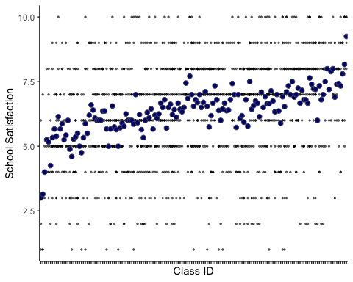

m_ols_b <- list()  
m_ols_fv <- list()  
  
unique_classidCUF <- unique(d_analysis$classidCUF)  
for (i in unique_classidCUF){  
 myclass <- filter(d_analysis, classidCUF == i)  
 mymodel <- lm(sch_satisfaction ~ neg_indegree, data = myclass)  
 m_ols_b[[i]] <- mymodel$coefficients[[2]]  
 m_ols_fv[[i]] <- mymodel$fitted.values  
}   
  
  
d_analysis |>  
 mutate(sch_satisfaction_hat_ols = unlist(m_ols_fv)) |>  
 ggplot(aes(x = neg_indegree,   
 y = sch_satisfaction_hat_ols,   
 group = as.factor(classidCUF))) +   
 geom_line() +   
 theme(legend.position = "none") +   
 xlab("Neg-Indegree") +  
 ylab("Predicted School Satisfaction") +  
 ggtitle("Sample of Random Slopes \n(Negatative Indegree Across Classes")+  
 theme_classic()

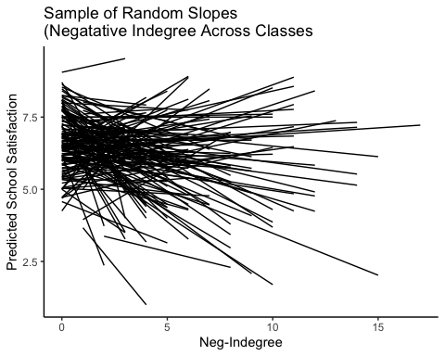

d_variables <- d_analysis |>   
 dplyr::select(ISEI_parent, victimization, pos_indegree, pos_outdegree, neg_indegree, neg_outdegree, neg_isolate, pos_isolate, n_mutual_bfs, non_reciprocal, sexgirl, age, immigrant, cog_test, lang_test)   
  
library(stargazer)

##   
## Please cite as:

## Hlavac, Marek (2022). stargazer: Well-Formatted Regression and Summary Statistics Tables.

## R package version 5.2.3. https://CRAN.R-project.org/package=stargazer

stargazer(as.data.frame(d_variables), type = "text", digits = 2)

##   
## ===============================================  
## Statistic N Mean St. Dev. Min Max   
## -----------------------------------------------  
## ISEI_parent 1,337 42.93 17.61 14.21 88.70  
## victimization 1,337 3.93 1.53 3 12   
## pos_indegree 1,337 2.93 1.79 0 10   
## pos_outdegree 1,337 3.92 1.29 0 5   
## neg_indegree 1,337 2.22 2.68 0 17   
## neg_outdegree 1,337 3.29 1.62 0 5   
## neg_isolate 1,337 0.02 0.14 0 1   
## pos_isolate 1,337 0.01 0.11 0 1   
## n_mutual_bfs 1,337 2.04 1.30 0 5   
## non_reciprocal 1,337 2.40 1.25 0 5   
## sexgirl 1,337 0.56 0.50 0 1   
## age 1,337 14.67 0.68 13 17   
## immigrant 1,337 0.36 0.48 0 1   
## cog_test 1,337 20.11 3.49 1 27   
## lang_test 1,337 12.84 4.21 1 25   
## -----------------------------------------------

Notes for future work:

Dealing with non-normality:

#new model <- glmmPQL()  
  
#or   
  
# m1 <- glmer(rep1 ~ male   
# + pped   
# + msesc   
# + (1 | classlid),   
# data = uthai1,   
# family = gaussian(link = "logit"),   
# na.action = na.omit)  
  
# consider using a gamma or inverse Gaussian family with a log link function in the generalized linear model (GLM).   
#   
  
# The log link function is commonly used with gamma and inverse Gaussian distributions, as it can help to model the relationship between the predictor variables and the outcome variable, particularly when the outcome variable is positively skewed.  
# Exampls:  
# model <- glm(y ~ x1 + x2, family = inverse.gaussian(link = "log"), data = mydata)  
# summary(model)

explore moderation: interplay of negative and positive ties; protective of victimization? of poor family environment?

# Cluster Analysis

What variables do I need to include to do cluster analysis??

# library(stats)  
# d_cluster <- d_analysis |>   
# dplyr::select(class_size, neg_indegree, neg_outdegree, pos_indegree, pos_outdegree, pos_isolate, neg_isolate, non_reciprocal, n_mutual_bfs, lang_test, cog_test)  
#   
# k = 3  
# my_clusters <- kmeans(d_cluster, k)