Ankur Acharjee

Chandigarh University

Lab File

**Car Stereo System**

**Circuit Diagram:**

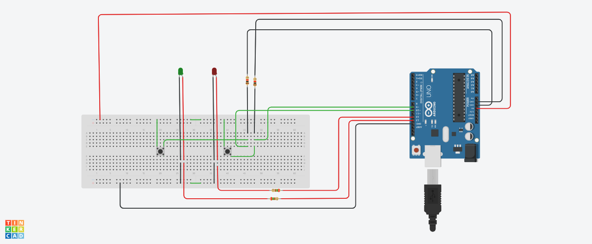

Theory:

Concept used:

Various concepts are used in this experiment as listed:

1. Programing in Arduino.
2. Connection with switch.
3. Working of LED with the help of switch.
4. Faraday’s Law of electromagnetic induction.

Learning and Observations:

1. learnt about Switch connections.
2. turn on LED with the help of switch.

Observations:

1. We observe that whenever the increase volume button is pressed, a Green Light is emitted for 20 ms & whenever the decrease volume button is pressed, a Red Light is emitted for 40 ms.
2. If we change the delay time in code the blinking time of LED also changes.
3. If we don’t connect the GND with the switch, then some current flows even if the switch is not pressed.
4. We can change the pattern of blinking of LED with some changes in code and we can set different patterns with the help of switch.
5. If we press volume increase button, then green LED should be turn on for 20ms and if we press volume decrease button, then red LED should be turn for 40ms.

Problems and Troubleshooting:

1. The switch is not grounded.
2. Connections are loose.
3. LED in not connected to the ground.

*Precautions:*

1. The connections should be proper.
2. The resistance of the ground should be heavier than the resistance of the Arduino Uno board.
3. Some sufficient source of the supply should be connected to the switch.
4. LED should be connected in proper orientation.

*Learning Outcomes:*

From this experiment we learn and acquire skills about:

1. Algorithms with which we turn on LED with the help of switch.
2. Importance of ground in branch of switch.