Base32解密

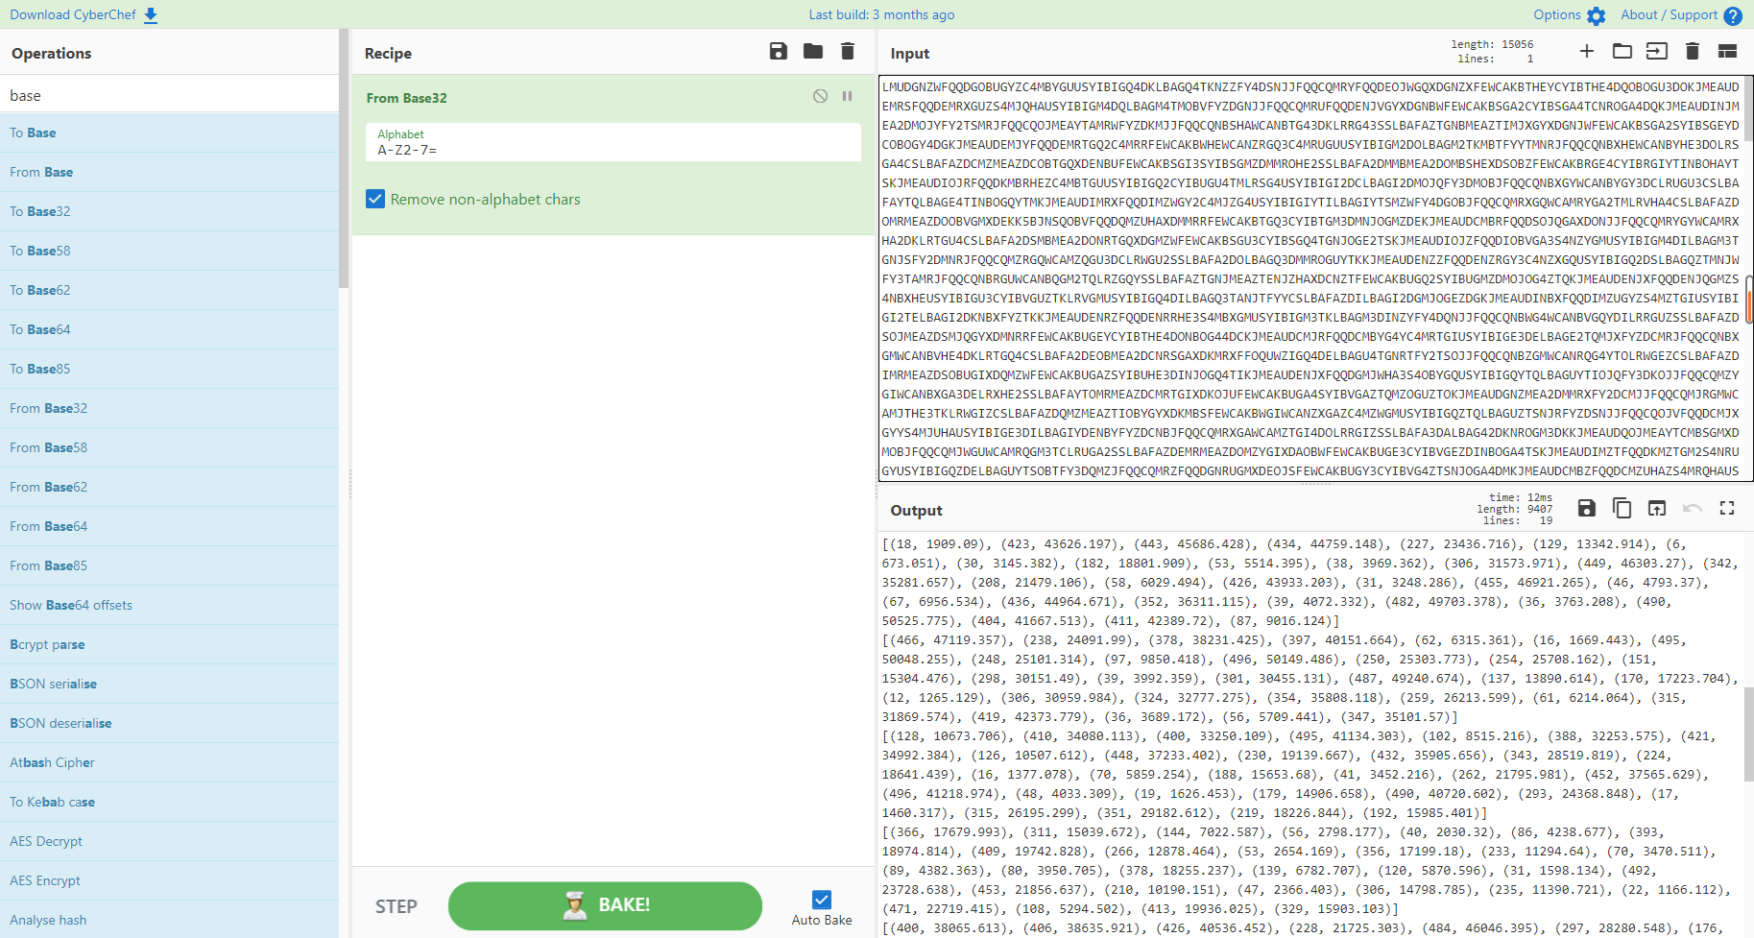

然后用线性拟合函数linefit()来拟合取y=ax+b中参数a，b，得到结果。

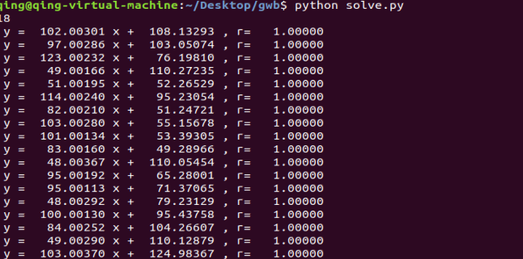

y = 102.00301 x + 108.13293 , r= 1.00000

y = 97.00286 x + 103.05074 , r= 1.00000

y = 123.00232 x + 76.19810 , r= 1.00000

y = 49.00166 x + 110.27235 , r= 1.00000

y = 51.00195 x + 52.26529 , r= 1.00000

y = 114.00240 x + 95.23054 , r= 1.00000

y = 82.00210 x + 51.24721 , r= 1.00000

y = 103.00280 x + 55.15678 , r= 1.00000

y = 101.00134 x + 53.39305 , r= 1.00000

y = 83.00160 x + 49.28966 , r= 1.00000

y = 48.00367 x + 110.05454 , r= 1.00000

y = 95.00192 x + 65.28001 , r= 1.00000

y = 95.00113 x + 71.37065 , r= 1.00000

y = 48.00292 x + 79.23129 , r= 1.00000

y = 100.00130 x + 95.43758 , r= 1.00000

y = 84.00252 x + 104.26607 , r= 1.00000

y = 49.00290 x + 110.12879 , r= 1.00000

y = 103.00370 x + 124.98367 , r= 1.00000

分别取整，转assica码，即为flag{L1n34r_R3g7e5S10n_A_G0Od_Th1ng}

Exp:

|  |
| --- |
| import matplotlib.pyplot as plt  import math    def linefit(x , y):  N = float(len(x))  sx,sy,sxx,syy,sxy=0,0,0,0,0  for i in range(0,int(N)):  sx += x[i]  sy += y[i]  sxx += x[i]*x[i]  syy += y[i]*y[i]  sxy += x[i]*y[i]  a = (sy*sx/N -sxy)/( sx*sx/N -sxx)  b = (sy - a*sx)/N  r = abs(sy*sx/N-sxy)/math.sqrt((sxx-sx*sx/N)*(syy-sy*sy/N))  return a,b,r  src = [  [(376, 38462.085), (485, 49579.895), (28, 2964.377), (390, 39888.567), (222, 22753.108), (388, 39685.235), (24, 2556.346), (204, 20916.088), (45, 4698.592), (9, 1026.251), (428, 43765.177), (334, 34176.356), (205, 21018.683), (218, 22344.21), (69, 7146.245), (347, 35503.166), (479, 48967.208), (213, 21834.244), (227, 23262.95), (460, 47029.989), (118, 12144.819), (491, 50192.035), (44, 4596.27), (241, 24690.668), (476, 48661.456), (18, 1944.416), (427, 43664.197), (214, 21936.838), (274, 28056.588), (272, 27853.2)],  [(85, 8348.621), (346, 33665.322), (101, 9900.75), (286, 27845.358), (490, 47634.336), (256, 24935.159), (499, 48507.783), (384, 37352.466), (314, 30561.655), (47, 4662.515), (279, 27166.774), (449, 43656.702), (415, 40358.941), (335, 32598.173), (445, 43269.738), (257, 25033.479), (56, 5535.53), (484, 47053.0), (24, 2431.123), (447, 43463.332), (252, 24547.35), (269, 26197.073), (375, 36478.885), (467, 45404.153), (299, 29106.661), (410, 39874.781), (111, 10870.232), (162, 15817.212), (473, 45985.348), (428, 41620.527)],  [(482, 59363.599), (493, 60717.612), (242, 29842.836), (403, 49645.494), (257, 31687.884), (418, 51490.659), (382, 47062.795), (172, 21232.594), (409, 50383.537), (37, 4627.411), (113, 13975.622), (283, 34886.502), (62, 7702.363), (438, 53951.295), (95, 11761.148), (164, 20248.214), (270, 33287.123), (60, 7456.365), (89, 11023.68), (165, 20371.405), (222, 27382.086), (416, 51244.099), (433, 53335.646), (422, 51983.683), (29, 3643.292), (466, 57395.086), (109, 13483.208), (200, 24677.075), (371, 45710.712), (325, 40052.51)],  [(214, 10596.501), (338, 16672.817), (383, 18878.996), (198, 9813.117), (149, 7411.18), (439, 21621.139), (12, 698.274), (30, 1580.109), (425, 20935.333), (372, 18338.869), (52, 2658.353), (282, 13928.514), (421, 20740.908), (242, 11968.381), (223, 11037.519), (46, 2364.361), (314, 15497.448), (225, 11135.62), (210, 10400.927), (168, 8342.544), (104, 5206.607), (175, 8685.26), (437, 21523.478), (55, 2805.311), (419, 20642.936), (79, 3981.11), (473, 23287.359), (207, 10253.953), (379, 18682.114), (498, 24512.699)],  [(444, 22697.484), (201, 10303.965), (442, 22594.985), (268, 13720.463), (215, 11018.358), (64, 3316.136), (99, 5101.527), (117, 6019.476), (42, 2194.3), (235, 12037.331), (447, 22850.954), (491, 25093.206), (400, 20452.699), (409, 20911.527), (303, 15505.555), (430, 21983.053), (166, 8518.432), (91, 4693.31), (197, 10099.772), (147, 7549.539), (115, 5917.528), (390, 19942.57), (396, 20250.15), (386, 19739.285), (144, 7396.758), (185, 9488.074), (308, 15761.079), (299, 15301.183), (453, 23156.869), (326, 16678.433)],  [(157, 17994.029), (466, 53219.713), (298, 34067.876), (336, 38400.176), (404, 46152.114), (35, 4085.249), (370, 42277.13), (74, 8531.099), (38, 4427.459), (356, 40680.902), (461, 52649.548), (103, 11837.351), (287, 32814.011), (153, 17537.147), (105, 12065.227), (165, 18905.831), (383, 43758.064), (14, 1691.277), (149, 17081.899), (48, 5567.135), (60, 6935.317), (183, 20958.053), (425, 48546.553), (124, 14231.309), (154, 17651.315), (305, 34865.077), (225, 25745.798), (22, 2603.436), (260, 29735.779), (268, 30648.491)],  [(35, 2921.193), (74, 6119.615), (366, 30063.851), (84, 6939.611), (445, 36541.644), (266, 21864.537), (44, 3659.23), (21, 1773.203), (281, 23094.394), (446, 36625.1), (134, 11039.599), (224, 18419.597), (125, 10301.272), (187, 15386.092), (27, 2265.144), (384, 31540.715), (312, 25636.875), (81, 6693.404), (256, 21043.915), (272, 22355.386), (413, 33917.33), (466, 38263.262), (10, 871.15), (322, 26455.254), (491, 40314.018), (285, 23422.235), (299, 24569.304), (314, 25799.903), (472, 38756.921), (207, 17025.119)],  [(18, 1909.09), (423, 43626.197), (443, 45686.428), (434, 44759.148), (227, 23436.716), (129, 13342.914), (6, 673.051), (30, 3145.382), (182, 18801.909), (53, 5514.395), (38, 3969.362), (306, 31573.971), (449, 46303.27), (342, 35281.657), (208, 21479.106), (58, 6029.494), (426, 43933.203), (31, 3248.286), (455, 46921.265), (46, 4793.37), (67, 6956.534), (436, 44964.671), (352, 36311.115), (39, 4072.332), (482, 49703.378), (36, 3763.208), (490, 50525.775), (404, 41667.513), (411, 42389.72), (87, 9016.124)],  [(466, 47119.357), (238, 24091.99), (378, 38231.425), (397, 40151.664), (62, 6315.361), (16, 1669.443), (495, 50048.255), (248, 25101.314), (97, 9850.418), (496, 50149.486), (250, 25303.773), (254, 25708.162), (151, 15304.476), (298, 30151.49), (39, 3992.359), (301, 30455.131), (487, 49240.674), (137, 13890.614), (170, 17223.704), (12, 1265.129), (306, 30959.984), (324, 32777.275), (354, 35808.118), (259, 26213.599), (61, 6214.064), (315, 31869.574), (419, 42373.779), (36, 3689.172), (56, 5709.441), (347, 35101.57)],  [(128, 10673.706), (410, 34080.113), (400, 33250.109), (495, 41134.303), (102, 8515.216), (388, 32253.575), (421, 34992.384), (126, 10507.612), (448, 37233.402), (230, 19139.667), (432, 35905.656), (343, 28519.819), (224, 18641.439), (16, 1377.078), (70, 5859.254), (188, 15653.68), (41, 3452.216), (262, 21795.981), (452, 37565.629), (496, 41218.974), (48, 4033.309), (19, 1626.453), (179, 14906.658), (490, 40720.602), (293, 24368.848), (17, 1460.317), (315, 26195.299), (351, 29182.612), (219, 18226.844), (192, 15985.401)],  [(366, 17679.993), (311, 15039.672), (144, 7022.587), (56, 2798.177), (40, 2030.32), (86, 4238.677), (393, 18974.814), (409, 19742.828), (266, 12878.464), (53, 2654.169), (356, 17199.18), (233, 11294.64), (70, 3470.511), (89, 4382.363), (80, 3950.705), (378, 18255.237), (139, 6782.707), (120, 5870.596), (31, 1598.134), (492, 23728.638), (453, 21856.637), (210, 10190.151), (47, 2366.403), (306, 14798.785), (235, 11390.721), (22, 1166.112), (471, 22719.415), (108, 5294.502), (413, 19936.025), (329, 15903.103)],  [(400, 38065.613), (406, 38635.921), (426, 40536.452), (228, 21725.303), (484, 46046.395), (297, 28280.548), (176, 16786.046), (316, 30085.821), (35, 3390.384), (315, 29990.94), (421, 40060.658), (448, 42627.029), (396, 37685.191), (458, 43575.818), (366, 34836.594), (474, 45095.324), (476, 45287.017), (36, 3485.245), (473, 45000.45), (22, 2155.411), (409, 38920.804), (362, 34455.627), (196, 18685.953), (450, 42816.42), (86, 8235.263), (266, 25335.452), (427, 40631.459), (423, 40252.254), (115, 10990.549), (180, 17165.868)],  [(399, 37977.029), (141, 13467.056), (491, 46716.435), (236, 22491.873), (415, 39497.438), (239, 22776.126), (378, 35981.953), (404, 38452.185), (20, 1971.333), (392, 37312.171), (348, 33131.705), (68, 6531.521), (116, 11091.687), (24, 2351.378), (377, 35886.753), (352, 33511.265), (186, 17741.408), (64, 6151.27), (238, 22681.308), (156, 14891.645), (77, 7386.51), (264, 25151.192), (311, 29616.833), (481, 45766.877), (229, 21826.112), (124, 11851.454), (204, 19452.046), (74, 7101.408), (101, 9666.573), (23, 2256.442)],  [(462, 22255.567), (404, 19472.985), (148, 7183.731), (116, 5647.385), (54, 2671.354), (129, 6271.643), (396, 19089.092), (104, 5071.365), (351, 16928.509), (263, 12704.488), (231, 11167.616), (203, 9824.242), (433, 20865.24), (380, 18319.847), (19, 991.333), (170, 8239.438), (61, 3007.183), (77, 3775.341), (193, 9343.796), (160, 7759.819), (113, 5503.85), (459, 22113.195), (472, 22735.985), (497, 23937.354), (121, 5887.589), (346, 16687.957), (332, 16016.091), (461, 22207.374), (145, 7039.67), (101, 4927.526)],  [(356, 35695.781), (323, 32396.312), (99, 9995.636), (274, 27495.776), (284, 28495.424), (37, 3795.292), (114, 11495.772), (381, 38195.254), (415, 41595.773), (45, 4595.278), (205, 20596.234), (418, 41896.749), (282, 28296.166), (228, 22896.214), (338, 33896.127), (84, 8495.355), (237, 23795.222), (414, 41495.335), (247, 24795.385), (133, 13395.59), (177, 17795.921), (481, 48195.587), (399, 39995.328), (435, 43595.973), (476, 47696.302), (347, 34797.091), (75, 7595.72), (224, 22495.502), (402, 40296.272), (139, 13995.28)],  [(334, 28161.025), (74, 6320.272), (244, 20600.842), (94, 8000.706), (174, 14720.587), (99, 8420.104), (484, 40761.531), (493, 41517.869), (447, 37652.765), (49, 4220.412), (499, 42021.241), (298, 25137.81), (79, 6740.362), (169, 14301.015), (439, 36981.933), (216, 18249.141), (476, 40090.247), (462, 38913.015), (413, 34798.204), (480, 40424.342), (491, 41349.055), (150, 12704.648), (433, 36477.326), (13, 1196.272), (400, 33705.346), (114, 9680.556), (127, 10772.474), (62, 5312.143), (295, 24884.463), (230, 19425.274)],  [(95, 4765.293), (138, 6872.432), (433, 21328.028), (432, 21280.189), (418, 20592.642), (344, 16967.601), (6, 404.037), (280, 13830.566), (175, 8685.604), (107, 5353.385), (487, 23975.472), (311, 15349.847), (473, 23288.902), (137, 6823.531), (427, 21033.375), (181, 8980.196), (453, 22308.892), (411, 20249.344), (328, 16183.891), (462, 22750.113), (407, 20054.791), (480, 23630.328), (31, 1629.26), (26, 1384.165), (170, 8440.836), (160, 7950.83), (58, 2952.176), (451, 22210.281), (43, 2217.416), (258, 12752.142)],  [(353, 36485.204), (305, 31540.781), (117, 12176.054), (130, 13515.348), (25, 2700.292), (120, 12485.819), (436, 45035.347), (254, 26287.979), (168, 17429.391), (484, 49979.295), (283, 29274.878), (112, 11661.515), (285, 29480.534), (173, 17944.669), (188, 19489.607), (371, 38339.416), (110, 11455.441), (49, 5172.438), (176, 18253.645), (72, 7541.458), (23, 2494.27), (262, 27111.683), (95, 9910.366), (175, 18150.397), (185, 19180.361), (133, 13824.115), (229, 23712.332), (27, 2906.355), (129, 13412.875), (381, 39369.318)],  ]  print(len(src))  for i in src:  x = []  y = []  for j in i:  x.append(j[0])  y.append(j[1])  a,b,r=linefit(x,y)  print(" y = %10.5f x + %10.5f , r=%10.5f" % (a,b,r) )    plt.plot(x,y,'ro')  plt.plot([0,8],[b,a*8+b])    plt.show() |