Database Setup
In order to start using MongoDB, I first downloaded the packages for MongoDB and MongoDBCompass. I did not have to use MongoShell for this assignment, as MongoDBCompass allows databases to be built in a visual guided user interface format without the need for scripts. Scripts can still be used within the MongoShell provided inside of MongoDBCompass, and I did use basic commands to define some things. MongoDB is required to download whether shell or compass is used, as it is the server where data is actually stored in the user’s computer.
After downloading these two, I then opened MongoDBCompass. I then clicked the plus button next to “CONNECTIONS”. I named my connection “LibraryDatabaseAssignment2”. Once connected to this newly created connection, I clicked on the plus button next to its name. This prompts me to create a database and a collection. A collection is the equivalent to tables in an SQL database. I named my database “LibraryDatabaseAssignment2”, and I named the first collection “HOMELIBRARY”. Next, I created collections for the rest of my original tables from assignment 1. Their names were “NOTIFICATIONPREFERENCE”, “PATRON”, “PATRONACTIVITY”, and “PATRONTYPE”.
For each collection, I clicked on them and the green “ADD DATA” dropdown menu that was found within. The “Import JSON or CSV file” choice allows me to directly import each of the separate tables I exported as CSV files in assignment 1 into each collection. I imported “PATRON.csv” into the “PATRON” collection, I imported “HOMELIBRARY.csv” into the “HOMELIBRARY” collection, etc.
Each collection automatically assigned unique id addresses as indexes for each entity within them. Indexes are an equivalent of primary keys in MongoDB. I wanted to define the same primary keys used in the SQL database, so I used the “>_ Open MongoDB shell” button found in each collection. Inside of the shell, I entered in the below image’s command template in order to assign appropriate indexes for each collection.
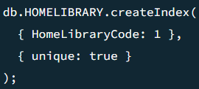
The above image shows that I turned “HomeLibraryCode” into an index for “HOMELIBRARY”. The “1” integer makes it so that the index is ordered in ascending fashion. “-1” would make the index be ordered in a descending fashion. The “unique: true” line makes it so that duplicate values cannot be used for the index. I copied this exact format for “PatronTypeCode” and “PATRONTYPE”, “PatronID” and “PATRON”, “PatronID” and “PATRONACTIVITY”, and “NotificationPreferenceCode” for “NOTIFICATIONPREFERENCE”. As for foreign keys, MongoDB’s documentation seems to entail that there is no exact equivalent. Relationships must be defined between specific entities one at a time through the use of the shell, however, these relationships are not automatically enforced for any new entities added to any of the collections. Since there are no traditional foreign keys, I did not implement any into this version of the library’s database.

Python Setup
I decided to use python to build an interactive application instead of C++ for MongoDB, as there are significantly less complex steps and fewer dependencies to download. Even though C++ is my most familiar language, the setup for MongoDB is significantly more complex than with mySQL. The attached Blackboard instructions for assignment 2 do not specifically state that I have to use the same programming language to use for my database application.
The only two preliminary downloads required for MongoDB can be performed in the shell of the user’s desired python-based integrative development environment. I used pyzo 4.19.0 for this assignment. I ran the commands “pip install dnspython” and “pip install pymongo” in pyzo’s shell separately. The following text from running these commands should be similar to the image below.
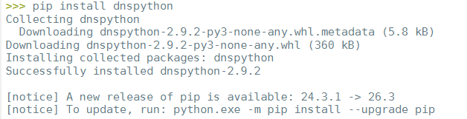
My python program starts by importing MongoClient from pymongo. It then imports ast, which is a package used to allow users of the program to input special characters into string variables without causing bugs. I then define the connection link for my database and open its client. All of these steps should look like the code in the below image.
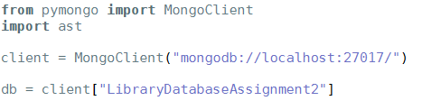
My main interface consists of a “while True” loop that repeatedly presents the user with seven different integers to input for different ways of interacting with the MongoDB database. Integers 1-6 will perform MongoDB queries, while integer 99 will break the “while True” loop and close the client. Each integer choice’s according code is structured similarly, (except for 99). They are all contained within “if” statements that check if the user’s input is equal to their integer, and then they allow the user to input the appropriate collections and queries they desire to perform on. After the query input, a “try-except” statement is used to output any errors in the query, instead of crashing the entire program. Within the “try” blocks are the logic for printing and operating the desired queries.
Option 1 prints each entity within a collection whose specified characteristic is equivalent to the user’s input. It collects an input collection and query from the user, and then it prints each matching entity and how many of those entities were found. The methods collection.find(query) and collection.count_documents(query) are used here. The below image shows an example of this process.
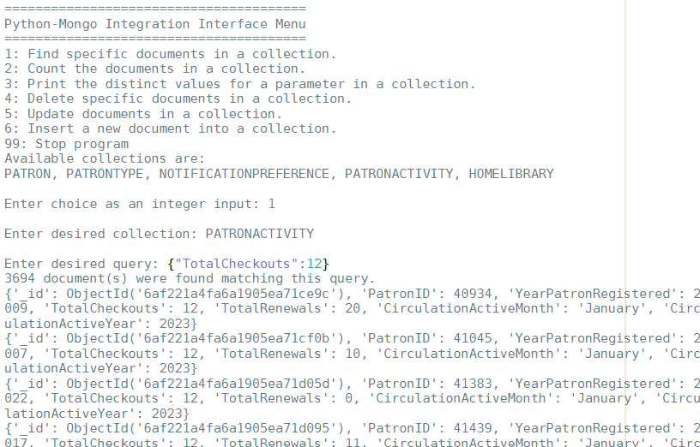
Option 2 prints the amount of entities within a collection. The user will input the desired collection, and then the program will count and print how many entities/documents were found. Only collection.count_documents() is used in this part. The below image shows an example of this option’s output.
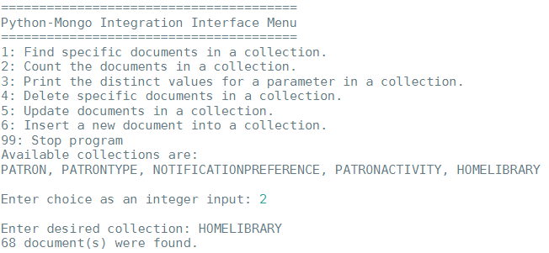
Option 3 will print all of the distinct values of a certain characteristic in a collection. The user inputs their desired collection and characteristic, and then the program prints each unique value of the combination. The method collection.distinct(characteristic) is used here. The below image shows this part of the program working.
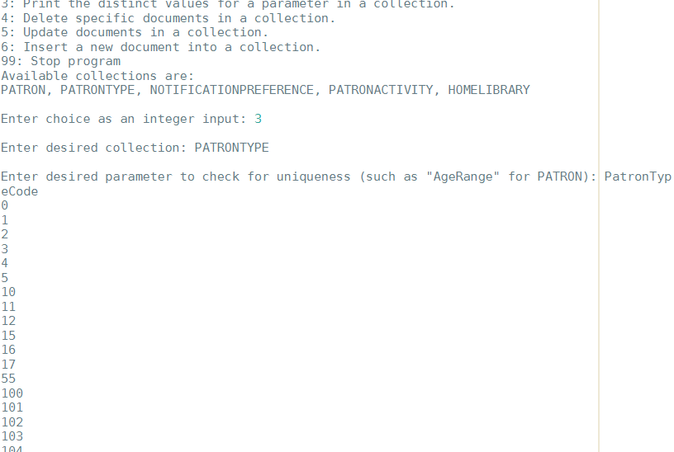
Option 4 allows the user to delete documents in a collection. The user inputs their desired collection and query that identifies which documents to delete. Documents are deleted with the use of collection.delete_many(query), and then the number of documents deleted is printed. The below image shows the output of this process.
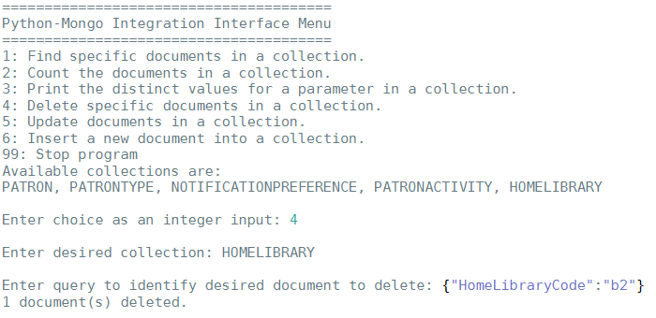
Option 5 allows the user to update documents in a collection. The user inputs their desired collection, query to identify what values need to be updated, and what the updates will be. Documents are updated with collection.update_many(query), and the number of documents updated is printed. The below image shows this process’s output.
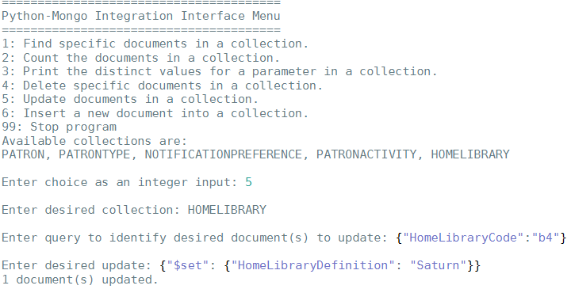
Option 6 allows the user to input a new entity into a collection. They choose their desired collection, and then they define the new document to be added. It is added with collection.insert_one(document). The below image shows this process.
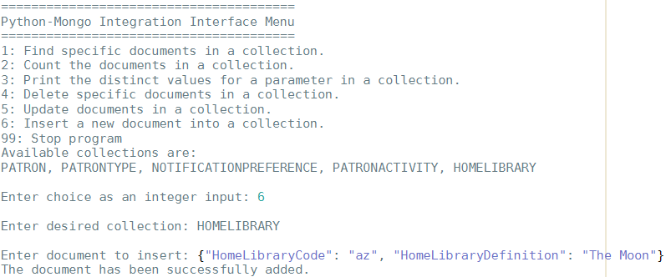
To view the entirety of the application’s code, refer to the below images or open the attached python file.


