Normalization
The library database has been split into five separate and convenient tables. PATRONTYPE contains PatronTypeDefinition and PatronTypeCode. PatronTypeCode is the primary key for the table, since this short string of letters alone determines what the definition is. HOMELIBRARY and NOTIFICATIONPREFERENCE follow this exact same sorting scheme, where their only columns are the code and definition, and the code is the primary key that determines the definition.
PATRON is a table with PatronID as a primary key. PatronID is a completely new characteristic not present in the original datasheet. It is an auto-incrementing integer that clearly defines the difference between each row in the original datasheet. PatronID is able to exist due to how each row in the original library datasheet represents a completely different patron. After PatronID, the codes from the previous three tables are present as foreign keys in PATRON. Additional columns in this table are AgeRange, ProvidedEmailAddress, and WithinSanFranciscoCounty.
PATRONACTIVITY is a table that uses PatronID as a primary key, but it is also a foreign key, because it originates from PATRON. The other columns in this table are YearPatronRegistered, TotalCheckouts, TotalRenewals, CirculationActiveYear, and CirculationActiveMonth. While everything in PATRONACTIVITY and PATRON are both decided by PatronID, I decided to split both tables since the specific characteristics are different in concept. PATRON has characteristics that are inherent in each person, such as their age or possession of an email. PATRONACTIVITY has characteristics that can be actively changed by each person, such as how many books they decide to check out or when they decide to register as a library patron.
Performance
To record how long it took to initialize this database, I ran my initialization script for it three different times. The below images show each run, and how long each table took to import their respective data.
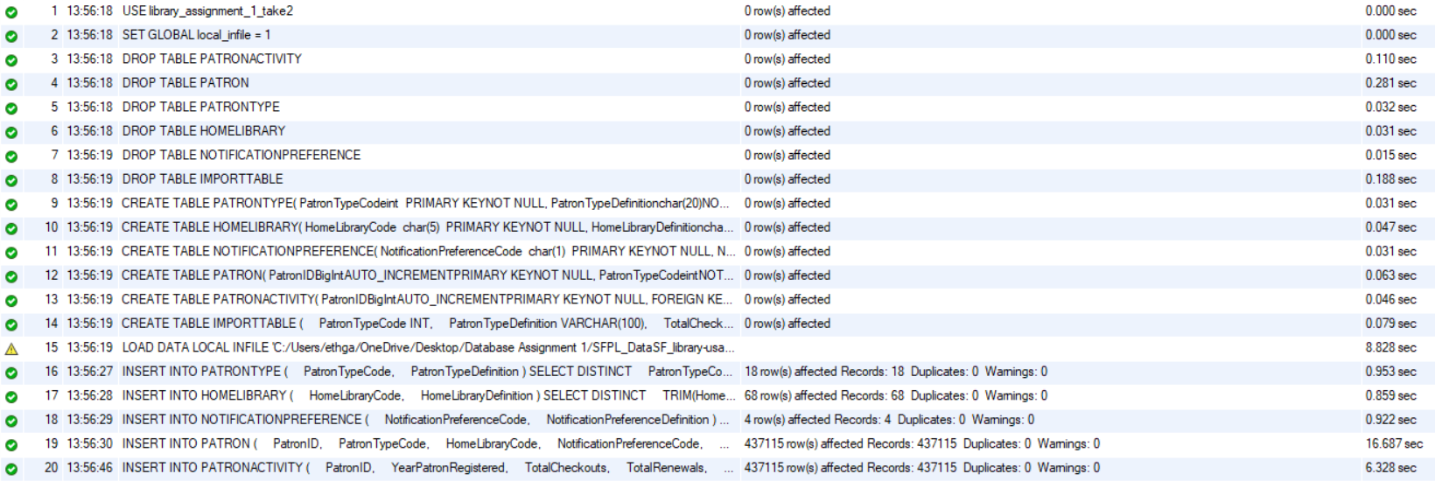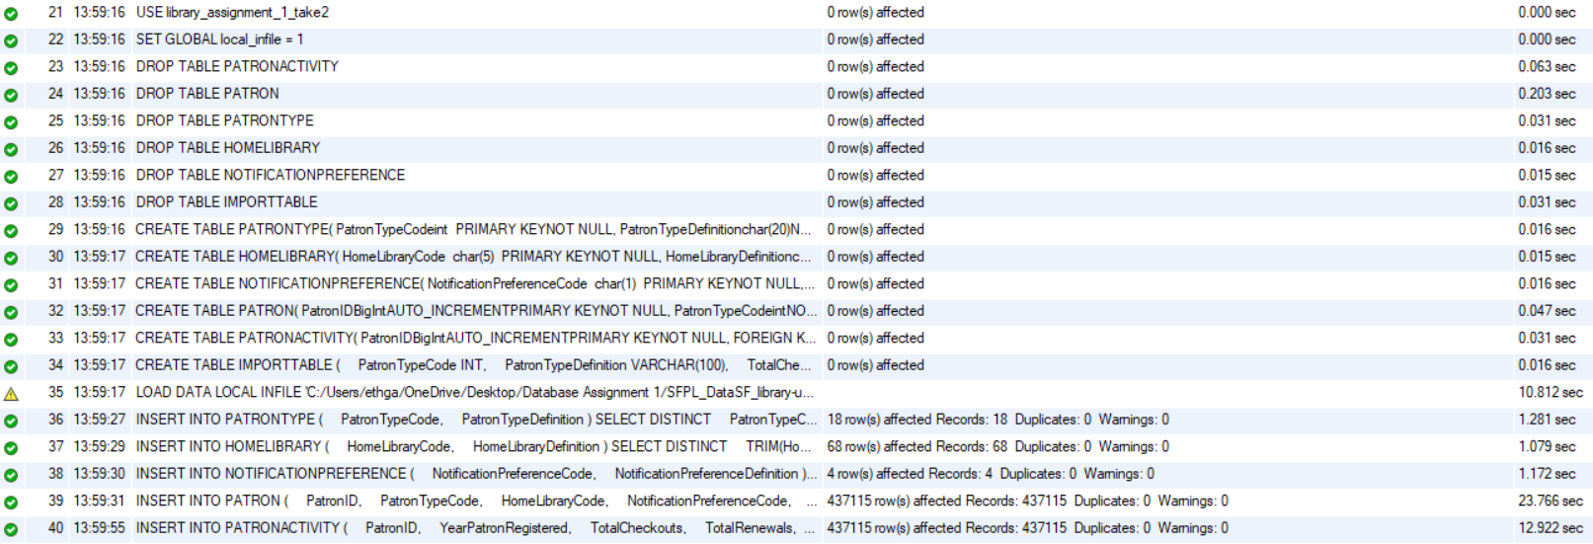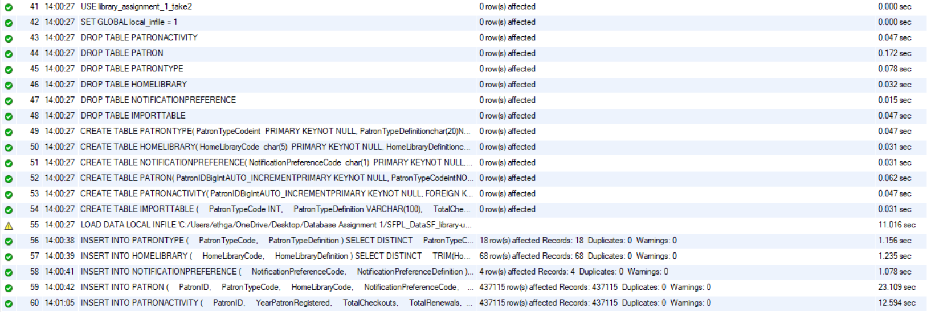
While dropping tables and defining them were all completed in less than a second, importing and transferring the library’s data took significantly more time. Importing all of the initial data from the datasheet takes about 10 seconds each run. Transferring the imported data into PATRONTYPE, NOTIFICATIONPREFERENCE, and HOMELIBRARY takes slightly over 1 second each. Data takes about 23 seconds to transfer to PATRONACTIVTY in most runs, and it takes about 12 seconds to transfer to PATRON in most runs.
Once a simplistic python application was created, queries printing every row of each table had their time recorded using an external stopwatch. Queries printing every row of PATRONTYPE, NOTIFICATIONPREFERENCE, and HOMELIBRARY were each near instant, as I could not start and stop my stopwatch fast enough to get an accurate record of their time. They all presumably took only some milliseconds to fully query. PATRON and PATRONACTIVITY were noticeably longer to query. It took about 3 minutes, 32 seconds, and 90 milliseconds to query all 437,115 rows of PATRON, and it took about 3 minutes, 23 seconds, and 08 milliseconds to query all 437,115 rows of PATRONACTIVITY. If it is relevant, my laptop that was used to run these queries has a base cpu speed of approximately 2.90 gigahertz.
Findings
The following screenshots showcase my findings of the library database from a selection of queries I ran, which all involve counts. The queries I ran were mentioned as examples under the github instructions and a few original ones.
The below image shows that 248,821 of the library patrons have renewed at least once.
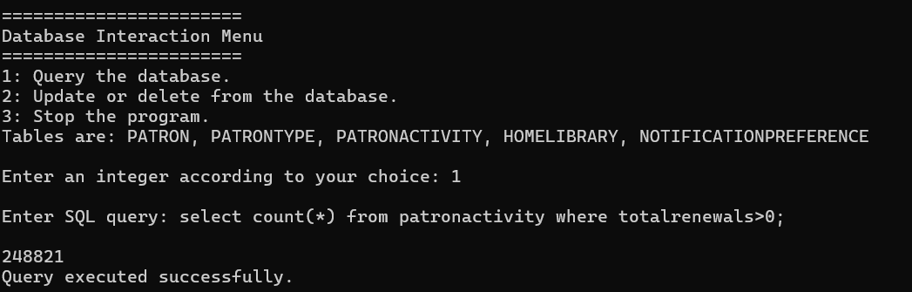
This next query showcased that there were 34,642 library patrons who were within the age range of 0 to 9 years old.
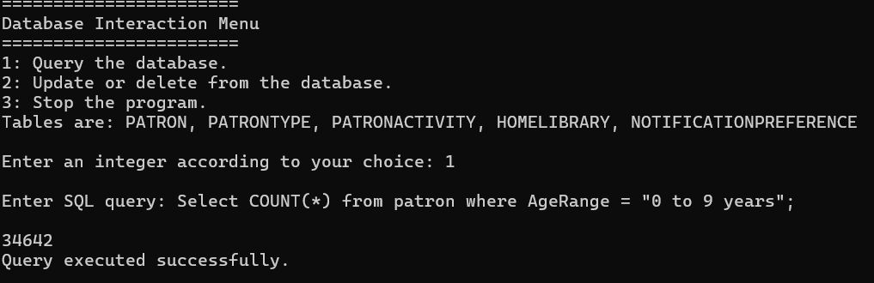
My next query showed that 275,266 of these people were repeat patrons, or in other words, they all had over 1 checkout.
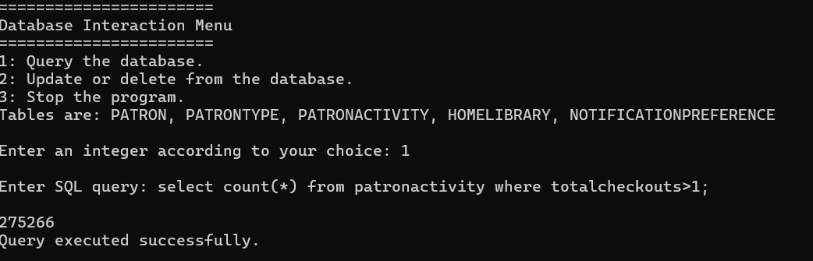
Next, I found that 369,259 of the patrons were registered to live within San Francisco County. This number is to be expected, as it is reasonable to assume that a majority of people signed up as patrons of a San Francisco library live around San Francisco.
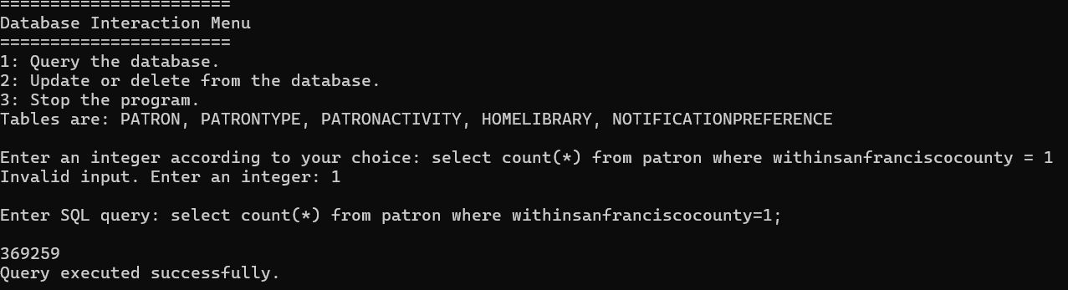
Lastly, I ran a query that read that 45,501 of the total patrons were not registered with their emails as their notification preference. This shows that the email outlet is the dominantly popular option when it comes to receiving notifications from this library.
