Database Setup
Before creating a schema and script, I right clicked on the SQL instance, and I went into the “Advanced” tab and wrote “OPT_LOCAL_INFILE=1” into the “others” text field. This is the only step needed before editing the schema and script.
The database implementation script starts by declaring the schema it uses. After this, a line is used to set local_infile to 1. Local_infile = 1 must be set both in the instance connection settings and the schema script in order to allow the importing of external data. After these lines, I have lines written to drop the tables created by future uses of this script. The drop lines must be in the reverse order in which they are created, due to the fact that tables cannot be dropped if other tables that still use their columns as foreign keys exist. The below image shows how the first section of code is formatted.
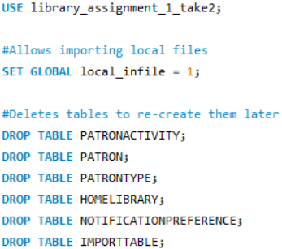
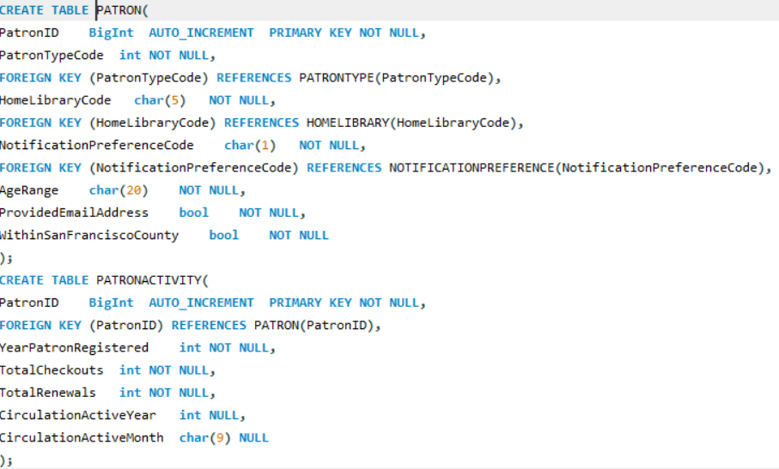
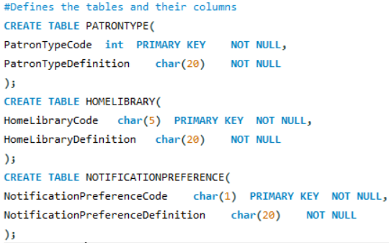
Next, five tables are defined in order to appropriately sort the imported data in a more normalized fashion. PATRONTYPE contains the columns with the titles of PatronTypeCode and PatronTypeDefinition. HOMELIBRARY contains HomeLibraryCode and HomeLibraryDefinition. NOTIFICATIONPREFERENCE contains NotificationPreferenceCode and NotificationPreferenceDefinition. PATRON contains PatronID, PatronTypeCode, HomeLibraryCode, NotificationPreferenceCode, AgeRange, ProvidedEmailAddress, and WithinSanFranciscoCounty. PATRONACTIVITY contains PatronID, YearPatronRegistered, TotalCheckouts, TotalRenewals, CirculationActiveYear, and CirculationActiveMonth. More information about why each column is sorted in this manner and how keys are defined can be found in the results documentation. The below images specifically show how each column is defined within each table.

Next, an IMPORTTABLE is defined. Every column from the excel datasheet is defined within this table with the same variable types they have in the previous table definitions. No keys are defined in IMPORTTABLE, except for the additional PatronID column. This table exists in order to seamlessly import the data from the excel sheet, as it is far easier to import if the import destination table is structured in the same way as the excel sheet. Another reason I performed the import process this way was because attempts with the table data import wizard always failed, and I could not figure out why.
The excel datasheet is then imported into IMPORTTABLE. However, it must first be converted into the .csv format (comma separated values). Once this is done, the “LOAD DATA LOCAL INFILE” function is used, and the first line is skipped due to being the columns’ names in the original file. PatronID is automatically filled and incremented, since it should be defined as an automatically incrementing integer.
Once the data is successfully imported, I then transferred the data from IMPORTTABLE into the other respective tables. Using INSERT INTO HOMELIBRARY with HOMELIBRARY’s columns listed, I then selected DISTINCT entities from the same columns in IMPORTTABLE where they are not null. This code is repeated two times for NOTIFICATIONPREFERENCE and PATRONTYPE with their respective columns used as parameters. The below image shows this chunk of code used for HOMELIBRARY.
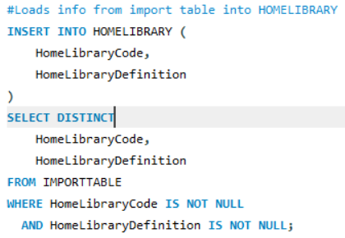
The PATRON table receives its transferred data in a similar manner to the last three tables, but it has a few key differences. The keyword DISTINCT is removed, as there are different patrons with completely identical cells. Additionally, there are CASE functions used in order to translate the excel sheet’s “TRUE” and “FALSE” values into binary values. This is done due to the fact that SQL will read these words as string values instead of boolean values, so they must be converted into values applicable for booleans. After these statements, JOIN commands are used in order to match the values of the foreign keys with the values of the tables in which they are primary keys. For example, HomeLibraryCode is matched with its value from the HOMELIBRARY table. The below images show how PATRON receives the imported data.

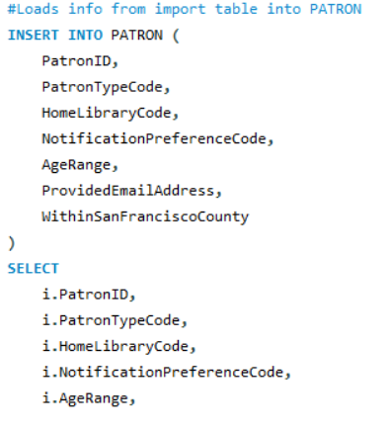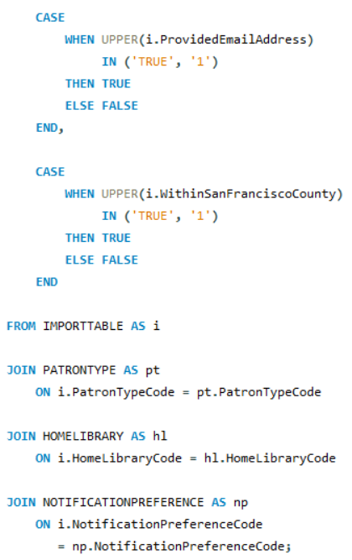
PATRONACTIVITY receives its imported data in the same way as the first three tables, except PatronID is joined with its value from PATRON and I did not use the DISTINCT keyword.
C++ Setup
To start my C++ integration for this SQL database, I went to this link: https://dev.mysql.com/downloads/connector/cpp/. I then downloaded the mysql-connector-c++-26.10.0-winx64 ZIP file package. This file needs to be extracted after it is downloaded. My C++ integrated development environment of choice was Microsoft Visual Studio.
The next step is to set up the necessary connections that allow my C++ project to successfully use the downloaded C++ integration package. I copied the mysqlcppconnx-2-vs14.dll file within the extracted package file, and then I pasted it into the main directory of the C++ project solution. Using the top two dropdown menus, I set the project configuration to Release x64. I then followed a series of menus in order to add a path to the “include” folder found within the download file. The menus are as follows: Project -> Properties -> Configuration Properties -> C/C++ -> General -> Additional Include Directories. I copied and pasted the path to this folder in this textbox. Then, I repeated this process for the “mysqlcppconnx.lib” file. The menus I went into for this are as follows: Project -> Properties -> Linker -> Input -> Additional -> Dependencies. I then copied and pasted the path to the .lib file into this textbox.
After finishing the preliminary configuration, I started writing the actual code for the implementation program. This was prefaced with #include statements for mysqlx/xdevapi.h, iostream, and string. I declared namespace usages for std and mysqlx. The below image shows these lines.
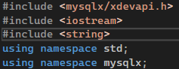
I then connected to the SQL instance by declaring a session with the appropriate credentials used as arguments for the function. This was done in a try-catch statement in order to notify the user of any connection problems rather than outright crashing the program in case of a connection error. My main user interface consists of a while loop used as a menu that would ask the user for one of three integers to be entered. If 1 is entered, the user will query the database. If 2 is entered, the user will update or delete from the database. If 3 is entered, the while loop will be stopped and the SQL session will close. Queries from option 1 are entered as user input in the exact same manner that a query would be written in SQL, using command words such as SELECT and FROM. The names of queried columns and the appropriate rows are then printed from top to bottom. Edits done using option 2 are entered as user input in the exact same manner that a user would write to update or delete existing rows in SQL. The difference in output is that the number of edited/deleted rows is printed, instead of every cell of every relevant row. Try-catch statements are used in option 1 and 2 in order to keep the program running in case of the user making a mistake with their SQL inputs. It also tells them the exact errors that occurred from their input. The bottom image shows the code used for options 1 and 2.
